LETTER OF TRANSMITTAL

This Letter of Transmittal is being sent in connection with the merger of Merge Acquisition Corp., a wholly owned subsidiary of Merge Healthcare Incorporated, with and into etrials Worldwide, Inc. This Letter of Transmittal should be promptly (a) completed and signed in the space provided below and on the space provided on the W–9, Substitute Form W–8BEN or other appropriate IRS Form W–8 included in this Letter of Transmittal and (b) mailed or delivered with your certificate(s) (“Certificate(s)”) formerly representing shares of common stock, par value $0.0001 per share, of etrials Worldwide, Inc. (“Common Stock ”) to American Stock Transfer & Trust Company, as exchange agent (“Exchange Agent”). Please read the accompanying instructions carefully.

DESCRIPTION OF SHARES OF COMMON STOCK TENDERED

Names(s) and Address(es) of Registered Holder(s) | Share Certificate(s) and Shares(s) Tendered
(Please Fill in, if blank) | (Please attach additional signed list, if necessary)
 |  | Total Number of Shares of Common
 | Common Stock Share | Stock Represented by Share
 |  | Certificate(s)(1)
 | Certificate Number(s)(1)

Total Shares

(1) Need not be completed by shareholders who deliver Shares by

book–entry transfer (“Book–Entry Shareholders”).

□ Check here if Share Certificates have been lost or mutilated.

PLEASE READ AND FOLLOW THE ACCOMPANYING INSTRUCTIONS CAREFULLY

Ladies and Gentlemen:

In accordance with the Agreement and Plan of Merger (the “Merger Agreement”) dated May 30, 2009, by and among Merge Healthcare Incorporated (“Merge Healthcare”), Merge Acquisition Corp. (“Merger Sub”), and etrials Worldwide, Inc. (the “Company”), providing for the merger of Merger Sub with and into the Company (the “Merger”), with the Company becoming a wholly–owned subsidiary of Merge Healthcare, the undersigned, the registered holder(s) of the stock certificates (the “Certificate(s)”) formerly representing shares of Common Stock of the Company hereby surrenders such Certificate(s) to you, as the Exchange Agent, in exchange for shares of Merge Healthcare common stock and cash in an amount determined in accordance with the terms of the Merger Agreement (the “Consideration”) and payable in the manner set forth in the Merger Agreement. Unless otherwise defined in this Letter of Transmittal, all defined terms contained in this Letter of Transmittal will have the meanings set forth in the Merger Agreement.

Effective upon the consummation of the transactions contemplated by the Merger Agreement, except for any rights expressly set forth in the Merger Agreement, including, but not limited to, the right to receive the undersigned’s Consideration with respect to the undersigned’s Common Stock of the Company, the undersigned hereby acknowledges that the undersigned is not aware of any claims of the undersigned against the Company or liabilities or obligations of the Company to the undersigned arising under any investor agreements of the Company or in connection with the issuance of any securities by the Company to its stockholders, or otherwise as a result of the undersigned having been a stockholder of the Company.

The undersigned acknowledges and agrees that it received notice as of its appraisal rights as required by Section 262 of the Delaware General Corporation Law (“DGCL”). By signing and delivering this Letter of Transmittal and surrendering the Certificate(s) herewith delivered to the Exchange Agent, the undersigned hereby waives any and all rights of appraisal and any dissenters’ rights to which the undersigned may have been entitled pursuant to Section 262 of the DGCL with respect to the transactions contemplated by the Merger Agreement.

The Exchange

The undersigned understands that the surrender of Certificate(s) will not be deemed to have been in acceptable form until receipt by the Exchange Agent of this Letter of Transmittal properly completed and signed, together with all required documents, in form satisfactory to Merge Healthcare acting reasonably (which may delegate power to make such determination in whole or in part to the Exchange Agent). All questions as to the documents, validity, form, eligibility and acceptance for payment of any Certificate(s) surrendered pursuant to any of the procedures described in this Letter of Transmittal will be determined by Merge Healthcare, acting reasonably (which may delegate power to make such determination in whole or in part to the Exchange Agent), and such determination will be final and binding. Delivery of Certificate(s) will be effected, and risk of loss and title to Certificate(s) will pass, only upon proper delivery to the Exchange Agent.

The undersigned hereby irrevocably constitutes the Exchange Agent, or its designee or appointee, as the undersigned’s true and lawful attorney–in–fact with respect to the Certificate(s) surrendered herewith, to deliver such Certificates(s) together with all accompanying evidences of authority, against receipt therefore (as the undersigned’s agent) of the undersigned’s Consideration with respect to the undersigned’s Common Stock of the Company as provided in the Merger Agreement and this Letter of Transmittal. This power is irrevocable and coupled with an interest, and shall not be affected by the undersigned’s death, incapacity, illness, dissolution or other inability to act.

The undersigned represents that (a) the undersigned is or are the sole record and beneficial owner of the Certificate(s) surrendered herewith and identified in the box on the cover page of this Letter of Transmittal, (b) the undersigned has or have good title to the shares of capital stock of the Company represented by such Certificates,

- the undersigned has or have the full right, power, legal capacity and authority to execute this Letter of Transmittal and sell, assign, transfer and surrender such Certificate(s), free and clear of all liens, claims and encumbrances and not subject to any adverse claim or any limitation or restriction on the sale, transfer or delivery of the Certificate(s), and

- no consent, approval or notice of or to any third party is required to sell, assign, transfer or surrender such Certificate(s).

The undersigned shall, upon request, execute and deliver any additional documents deemed appropriate or necessary by Merge Healthcare or the Exchange Agent (in each case, acting reasonably) in connection with the surrender of the Certificate(s). All authority conferred or agreed to be conferred in this Letter of Transmittal shall not be affected by, and shall survive, the death or incapacity of the undersigned and any obligation of the undersigned will be binding upon the successors, assigns, heirs, executors, administrators and legal representatives of the undersigned and shall not be affected by, and shall survive, the death or incapacity of the undersigned.

INSTRUCTIONS

  - Guarantee of Signatures. No signature on this Letter of Transmittal is required to be guaranteed if

- this Letter of Transmittal is signed by the registered holder(s) of the Certificate(s) transmitted herewith and such holder(s) has (have) not completed the instruction entitled “Special Payment Instructions” and/or “Special Delivery Instructions” on this Letter of Transmittal or (b) such Certificate(s) and/or Option Agreement(s) are transmitted for the account of a financial institution (including most banks, savings and loan associations and brokerage houses) that is a participant in the Securities Transfer Agents Medallion Program, the New York Stock Exchange Medallion Signature Program, or the Stock Exchange Medallion Program (each of the foregoing constituting an “Eligible Institution”).
IN ALL OTHER CASES, ALL SIGNATURES ON THIS LETTER OF TRANSMITTAL MUST BE GUARANTEED BY AN ELIGIBLE INSTITUTION. SEE INSTRUCTION 4.

  - Delivery of Letter of Transmittal and Certificates. Certificate(s) surrendered, as well as a properly completed and duly executed Letter of Transmittal, any signature guarantees, if necessary, and any other documents required by this Letter of Transmittal, must be delivered to the Exchange Agent at its address set forth on the cover of this Letter of Transmittal. Please do not send the Certificate(s) directly to the Company or Merge Healthcare. If any of the Certificate(s) of the undersigned have been lost, stolen, mutilated or destroyed, then please indicate this on the face of this Letter of Transmittal, or contact the Exchange Agent at 877–248–6417 (within the U.S.) or 718–921–8317 (outside the U.S.) and the Exchange Agent will send an Affidavit of Lost Certificate. The Exchange Agent will forward you additional documentation that you must complete in order to effectively surrender lost, stolen, mutilated or destroyed Certificate(s). All questions as to the documents, validity, form, eligibility and acceptance for payment of any Certificate(s) surrendered pursuant to any of the procedures described in this Letter of Transmittal will be determined by Merge Healthcare acting reasonably (which may delegate power to make such determination in whole or in part to the Exchange Agent), and such determination will be final and binding. Merge Healthcare (which may delegate power in whole or in part to the Exchange Agent) also reserves the absolute right to waive any defect or irregularity in the surrender of any Certificate or delivery of any Letter of Transmittal, and its interpretations of other terms and conditions of the Merger Agreement and this Letter of Transmittal (including these instructions) with respect to such irregularities or defects will be final and binding. Delivery of Certificate(s) will be effected, and risk of loss and title to Certificate(s) will pass, only upon proper delivery to the Exchange Agent. No alternative, conditional, irregular or contingent surrender of Certificate(s) or this Letter of Transmittal will be accepted. Delivery of documents to an address other than the address set forth on the cover of this Letter of Transmittal does not constitute delivery to the Exchange Agent. The surrender of Certificate(s) will be deemed made only when this Letter of Transmittal and any other documents are actually received by the Exchange Agent.

You are encouraged to return this Letter of Transmittal and the other required documentation as soon as possible and in no event later than January 20, 2010. After that date, the Exchange Agent will return any Consideration to Merge Healthcare, and you will need to look to Merge Healthcare for payment of your Consideration.

The method of delivery of Certificate(s) and the other required documents is at the option and risk of the tendering holder. If sent by mail, then registered mail with return receipt requested is recommended.

- Inadequate Space. If there is inadequate space to complete any box or to sign this Letter of Transmittal, the information or signatures required to be provided must be set forth on additional sheets substantially in the form of the corresponding portion of this Letter of Transmittal and attached to this Letter of Transmittal.

- Signature on Letter of Transmittal, Stock Powers and Endorsements.

  - If this Letter of Transmittal is signed by the registered holder(s) of the Certificate(s) surrendered hereby without any correction or change in the name of the registered holder(s), the signature(s) must correspond exactly with the name(s) as written on the face of the Certificate(s), without any change whatsoever. In the event the name of the registered holder(s) needs to be corrected or has changed (by marriage or otherwise), attach an additional sheet setting forth the change (see Instruction 3).

  - If any Certificate surrendered hereby is held of record by two or more joint holders, all such holders must sign this Letter of Transmittal.

  - If any Certificate or Option Agreement surrendered hereby is registered in different names on several Certificates, it will be necessary to complete, sign and submit as many separate Letters of Transmittal as there are different registrations of Certificates.

  - If this Letter of Transmittal is signed by the registered holder(s) of the Certificate(s) listed and transmitted hereby, no endorsements of Certificate(s) or separate stock powers are required.

  - If this Letter of Transmittal is signed by a person(s) other than the registered holder(s) of the Certificate(s) listed, the Certificate(s) must be endorsed or accompanied by appropriate stock powers, in either case signed exactly as the name of the registered holder(s) appears on the Certificate(s). Signatures on such Certificate(s) or stock powers must be guaranteed. See Instruction 1.

  - If this Letter of Transmittal or any Certificate or stock power is signed by a person(s) other than the registered holder(s) of the Certificate(s) listed and the signer(s) is acting in the capacity of trustee, executor, administrator, guardian, attorney–in–fact, officer of a corporation or any other person(s) acting in a fiduciary or representative capacity, such person(s) must so indicate when signing, and must submit proper evidence satisfactory to the Exchange Agent of authority to act.

- Payment and Special Payment and Delivery Instructions.

  - The undersigned understands that delivery of a check or wire transfer representing the cash portion of the Consideration will be made within ten (10) business days after the receipt by the Exchange Agent of Certificate(s) and this Letter of Transmittal and any other necessary documents completed in acceptable form. The undersigned understands that the amount of any check or wire transfer representing the cash portion of the Consideration will be reduced by any applicable withholding taxes. No interest shall accrue on any cash payments to be delivered hereunder.

  - If a check is to be issued in the name(s) of person(s) other than the signer(s) of this Letter of Transmittal or if a check is to be sent to someone other than the signer of this Letter of Transmittal or to an address other than that shown above, then the appropriate boxes on this Letter of Transmittal should be completed.

- Requests for Assistance and Additional Copies. Request for assistance may be directed to the Exchange Agent, 1–877–248–6417 (within the U.S.) or 718–921–8317 (outside the U.S.), Monday–Friday 9:00 a.m. – 5:00 p.m. New York City time. Additional copies of this Letter of Transmittal and the Certification of Taxpayer Identification Number on Substitute Form W–9 may be obtained from the Exchange Agent at the addresses and telephone number set forth herein.

- Form W–9. Each tendering holder who is a U.S. person is required to provide the Exchange Agent with a correct taxpayer identification number (“TIN”), generally the holder’s social security or federal employer identification number, on a Form W–9, which is provided below. You must cross out item (2) in the certification box on the Form W–9 if you are subject to backup withholding. Failure to provide the information on the form may subject the tendering holder to 28% federal income tax withholding on the payments made to the holder or other payee with respect to their Certificates or Option Agreements. The box in Part 3 of the form may be checked if the tendering holder has not been issued a TIN and has applied for a TIN or intends to apply for a TIN in the near future. If the box

in Part 3 is checked and the Exchange Agent is not provided with a TIN within sixty (60) days, then the Exchange Agent will withhold 28% of all payments of the Closing Payment until a TIN is provided to the Exchange Agent.

IRS Form W–8. Each tendering holder who is not a U.S. person is required to provide the Exchange Agent with the appropriate IRS Form W–8, accurately filled in. Failure to provide the appropriate IRS Form W–8, accurately filled in, may subject the tendering holder to 28% U.S. federal income tax withholding on the payments made to the holder or other payee with respect to their Certificates or Option Agreements. A Form W–8 BEN can be obtained from the Exchange Agent or at the link below. Please note that there are additional Form W–8's if the W–8BEN does not apply to your particular situation. The additional forms can be accessed at the following IRS links:

http://www.irs.gov/pub/irs–pdf/fw8ben.pdf

http://www.irs.gov/pub/irs–pdf/fw8eci.pdf

http://www.irs.gov/pub/irs–pdf/fw8imy.pdf

http://www.irs.gov/pub/irs–pdf/fw8exp.pdf

- Indication of Certificate Numbers and Numbers of Old Shares. This Letter of Transmittal should indicate the certificate numbers of the Certificate(s) surrendered hereby and the number of shares represented by each such Certificate.

- Miscellaneous. The Exchange Agent anticipates that it will provide notification of any defects in the deposit and surrender of any Certificate(s), but neither Merge Healthcare nor the Exchange Agent shall incur any liability for failure to give such notice.

- Stock Transfer Taxes. In the event that any transfer or other taxes become payable by reason of the issuance of a check in any name other than that of the record holder such transferee or assignee must pay such tax to Merge Healthcare or must establish to the satisfaction of Merge Healthcare that such tax has been paid or is not applicable.

 |  |  |  | SPECIAL PAYMENT INSTRUCTIONS |  |  |  |  |  |  |  |  |  | SPECIAL DELIVERY INSTRUCTIONS
 |  |  |  |  |  | (See Instructions 1, 4 and 5) |  |  |  |  |  |  |  | (See Instructions 1, 4 and 5)
 | To be completed ONLY if the check for the Closing Payment is to |  |  |  |  |  |  |  |  |  | To be completed ONLY if the check for the Closing Payment is to
 | be issued in the name of someone other than the undersigned, or |  |  |  |  |  |  |  |  |  | be sent to someone other than the undersigned, or to the undersigned
 | payment by wire transfer is requested. |  |  |  |  |  |  |  |  |  | at an address other than that below.
 | Issue check to: |  |  |  |  |  |  |  |  |  | Mail check to:
 | Name: |  |  |  |  |  |  |  |  |  | Name:
 |  |  |  |  |  | (Please print) |  |  |  |  |  |  |  | (Please print)
 | Address: |  |  |  |  |  |  |  |  |  | Address:
 | (Zip Code) |  |  |  |  |  |  |  |  |  | (Zip Code)
 | (Taxpayer Identification or Social Security No.) |  |  |  |  |  |  |  |  |  | (Taxpayer Identification or Social Security No.)
 |  |  |  |  |  | *** OR ***
 | Wire money to:
 | Account Name:
 |  |  |  |  |  | (Please print)
 | Account Number:
 | Bank Name and ABA Number:
 | (Taxpayer Identification or Social Security No.)

ALL STOCKHOLDERS MUST SIGN HERE

(Also complete Form W–9)

The undersigned acknowledges that the undersigned has thoroughly read this Letter of Transmittal and agrees to be bound by the terms and conditions set forth herein and in the accompanying materials.

The check or wire transfer representing the cash portion of the Consideration will be issued only in the name of the person(s) submitting this Letter of Transmittal and will be mailed to the address shown in the box on page one entitled “Name and Address of Registered Owner” unless the Special Payment Instructions or Special Delivery Instructions are completed.

Signature(s) of Registered Holder(s) or Agent

Dated:

(Must be signed by registered holder(s) exactly as name(s) on stock certificate(s) or on a security position listing or by person(s) authorized to become registered holder(s) by certificates and documents transmitted herewith. If signature is by an officer of a corporation, attorney–in– fact, executor, administrator, trustee, guardian or other person(s) acting in a fiduciary or representative capacity, then please set forth full title and see Instruction 4.)

Name(s):

(Please print)

Capacity (Full Title):

Address: (ZIP Code)

Area Code and Tel. No.:

Tax Identification or Social Security No.:

Wire money to:

Account Name:

(Please print)

Account Number:

Bank Name and ABA Number:

 |  |  |  |  | GUARANTEE OF SIGNATURE(S)
 |  |  |  |  | (If Required–See Instructions 1 and 4)
Authorized Signature:
Name(s):
 |  |  |  |  | (Please print)
Name of Firm:
Address: |  |  |  |  |  |  |  | (ZIP Code)
Area Code and Tel. No.: |  |  |  |  |  | Dated:

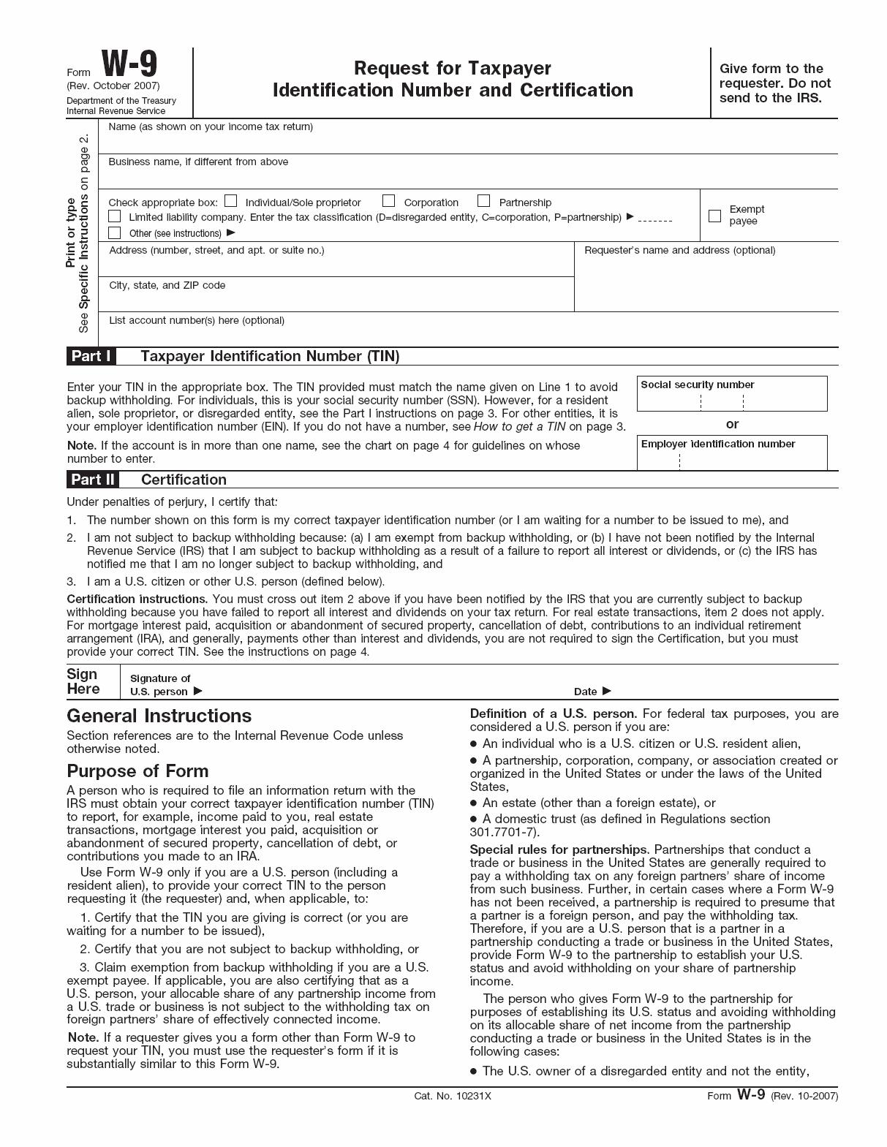
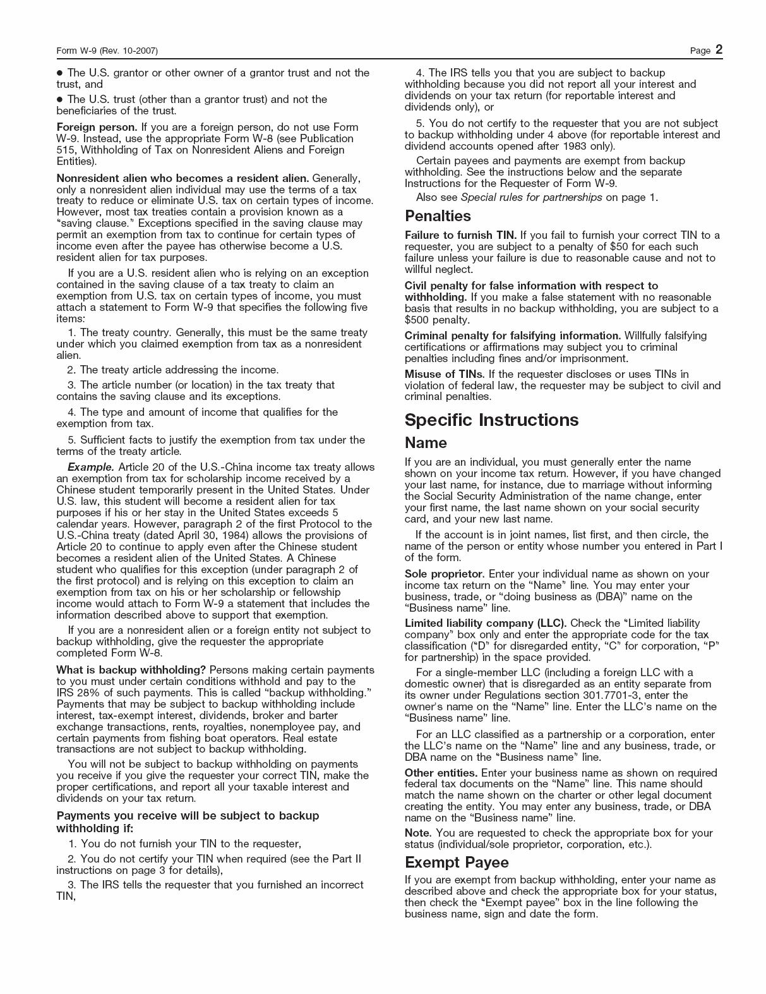
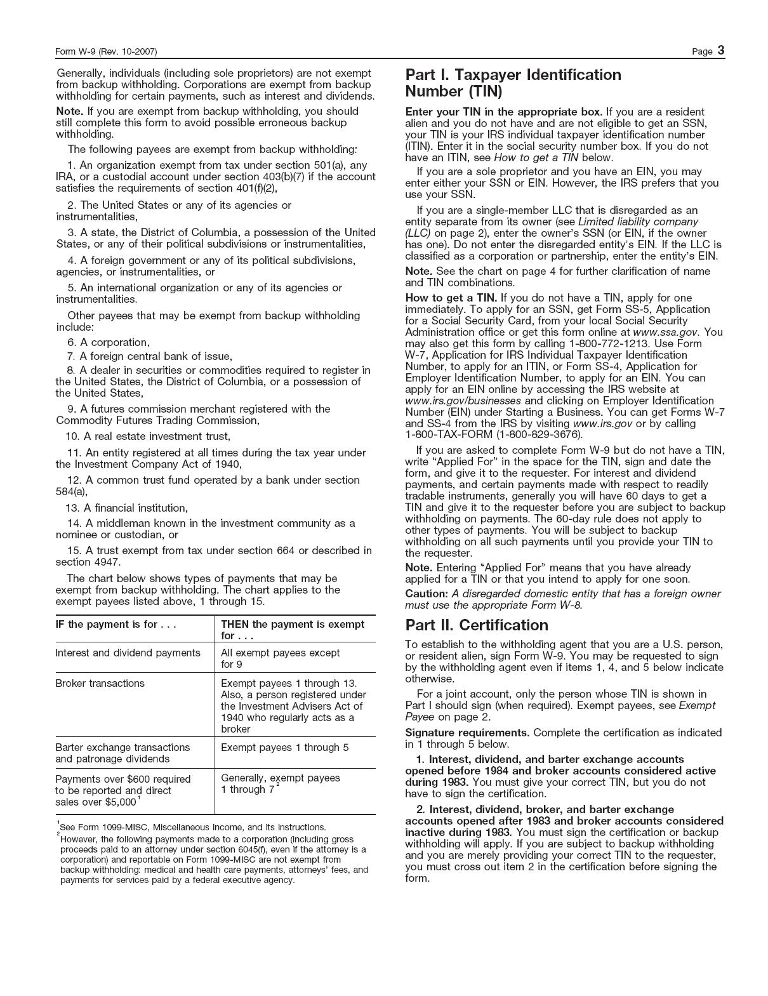
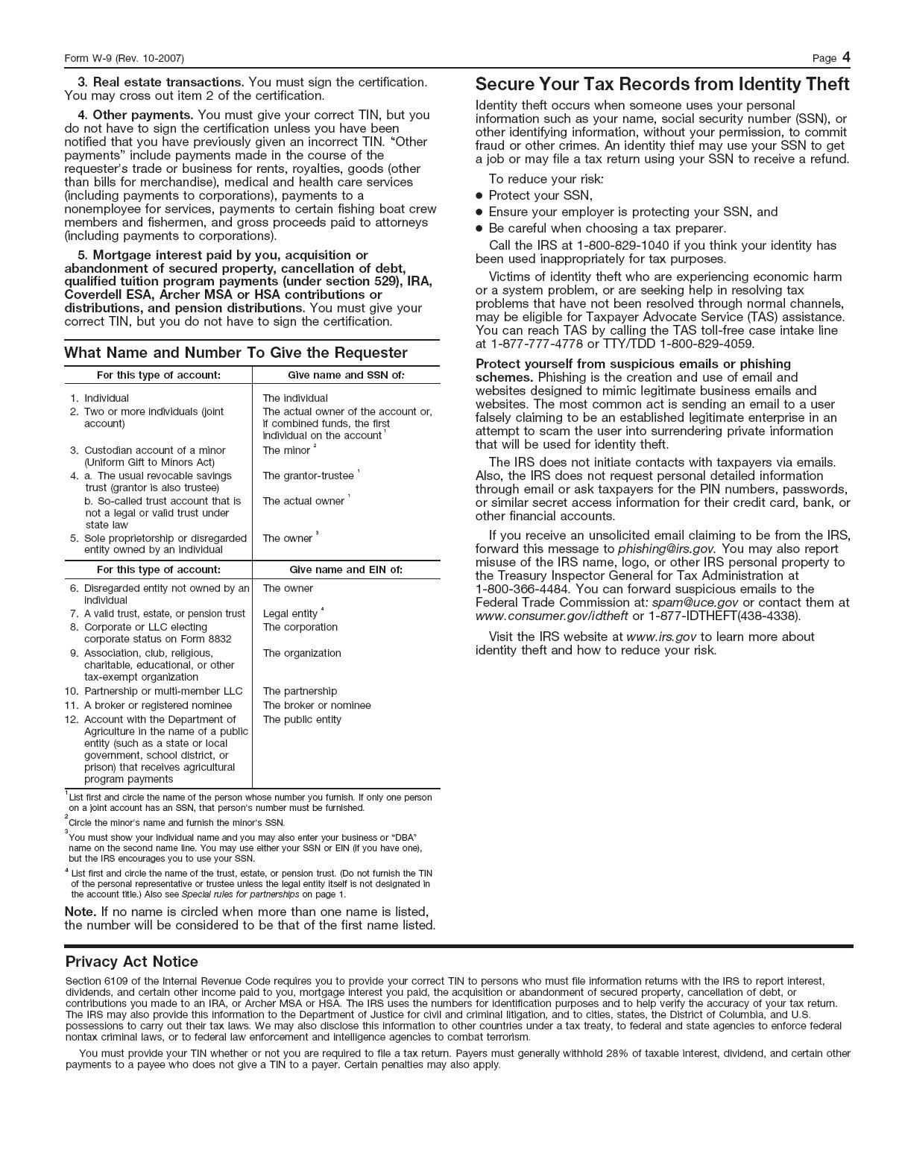

FOR INSTRUCTIONS OR ADDITIONAL INFORMATION CONTACT YOUR TAX CONSULTANT OR THE INTERNAL REVENUE SERVICE

http://www.irs.gov/pub/irs–pdf/iw9.pdf

PLEASE READ THE ACCOMPANYING INSTRUCTIONS CAREFULLY

IMPORTANT TAX INFORMATION

Under United States federal income tax laws, a holder who receives cash payments pursuant to the Merger is required to provide the Exchange Agent (as payer) with such holder’s correct TIN on the Form W–9 below (or otherwise establish a basis for exemption from backup withholding) and certify under penalty of perjury that such TIN is correct and that such holder is not subject to backup withholding. If such holder is an individual, the TIN is his or her social security number. If the Exchange Agent is not provided with the correct TIN, a $50 penalty may be imposed by the Internal Revenue Service, and the payment of any cash pursuant to the Merger may be subject to backup withholding.

Certain holders (including, among others, all corporations and foreign individuals and entities) are not subject to these backup withholding and reporting requirements. Exempt holders should indicate their exempt status on Form W–9. In order for a foreign individual to qualify as an exempt recipient, such individual must submit a Form W–8 BEN, signed under penalties of perjury, attesting to such individual’s exempt status. A Form W–8 BEN can be obtained from the Exchange Agent or at the link below. Please note that there are additional Form W–8's if the W–8BEN does not apply to your particular situation. The additional forms can be accessed at the following IRS links:

http://www.irs.gov/pub/irs–pdf/fw8ben.pdf

http://www.irs.gov/pub/irs–pdf/fw8eci.pdf
http://www.irs.gov/pub/irs–pdf/fw8imy.pdf
http://www.irs.gov/pub/irs–pdf/fw8exp.pdf

If backup withholding applies, the Exchange Agent is required to withhold at a rate not to exceed 28% of any payments made to the holder or other payee. Backup withholding is not an additional tax. Rather, the Federal income tax liability of persons subject to backup withholding will be reduced by the amount of tax withheld provided that the required information is given to the IRS. If withholding results in an overpayment of taxes, a refund may be obtained from the Internal Revenue Service.

Purpose of Form W–9

To prevent backup withholding on payments made with respect to Certificate(s), the holder is required to notify the Exchange Agent of such holder’s correct TIN by completing the form above, certifying that (1) the TIN provided on the Form W–9 is correct (or that such holder is awaiting a TIN), (2) such holder is not subject to backup withholding because (a) such holder is exempt from backup withholding, (b) such holder has not been notified by the Internal Revenue Service that he is subject to backup withholding as a result of a failure to report all interest or dividends or (c) the Internal Revenue Service has notified such holder that such holder is no longer subject to backup withholding and (3) such holder is a U.S. person (including a U.S. resident alien).

What Number to Give the Exchange Agent

The holder is required to give the Exchange Agent the TIN (i.e., social security number or employer identification number) of the holder of the Certificate(s) tendered hereby. If the Certificate(s) are held in more than one name or are not held in the name of the actual owner, consult the instructions following the Form W–9 for additional guidance on which number to report.

Certificate of Awaiting Taxpayer Identification Number

I certify under penalties of perjury that a taxpayer identification number has not been issued to me, and either (a) I have mailed or delivered an application to receive a taxpayer identification number to the appropriate Internal Revenue Service Center or Social Security Administration Office or (b) I intend to mail or deliver an application in the near future. I understand that if I do not provide a taxpayer identification number within sixty (60) days, 28% of all reportable payments made to me thereafter will be withheld until I provide a taxpayer identification number.

Signature: Date:

All inquiries regarding this form should be made directly to:

American Stock Transfer & Trust Company LLC

By Telephone: From within the U.S., Canada or Puerto Rico:

- 248–6417 (Toll Free) From outside the U.S.:
  - 921–8317

All inquiries regarding the Merger should be made directly to:

Merge Healthcare Incorporated

Attention: Ann Mayberry–French, General Counsel
6737 West Washington Street
Suite 2250
Milwaukee, WI 53214–5650
(414) 977–4000

