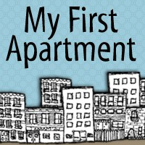
Apartment Hunter’s Checklist

Basics
Date of Visit: Date Available:
Address: Rent:
Bed/Bath: Landlord Contact Info:
Notes:

 | Practical
Nearest Grocery Nearest Laundromat: Nearest Gym: Nearby Friends:  Doorman/Intercom/None: |  | Commuting Time: Parking Avail/Type: Internet Avail/Type: Pets Allowed/Type:  Dishwasher: Y or N
Notes:

Feel
(Rank each category 1-5, with 1 the worst, 5 the best)
Size of Rooms: Closet Space:
Quality of Fixtures: Safety of Neighborhood:
Quality of Building: Congeniality of Landlord: Cleanliness of Common Areas:
Notes:

Name(s):

Roommates
(If searching for a share with new, unknown roommates)

Agree-ability: Cleanliness:
Politeness: Compatibility:
Notes:

Provided by MyFirstApartment.com

