WORKshEET • Ch Es T & BACK • DIs C 1
DATE / WEEK
Warm-Up (2:30 + 6:30)
01 ChEsT - standard Push-Ups | R | R | R | R | R
02 BACK - Wide Front Pull-Ups | R | R | R | R | R
03 ChEsT - Military Push-Ups | R | R | R | R | R
04 BACK - Reverse Grip Chin-Ups | R | R | R | R | R
Water Break (0:49)
05 ChEsT - Wide Fly Push-Ups | R | R | R | R | R
06 BACK - Closed Grip Overhand Pull-Ups | R | R | R | R | R
07 ChEsT - Decline Push-Ups | R | R | R | R | R
08 BACK - heavy Pants | R W | R W | R W | R W | R W
Water Break (0:47)
09 ChEsT - Diamond Push-Ups | R | R | R | R | R
10 BACK - Lawnmowers | R W | R W | R W | R W | R W
11 ChEsT - Dive-Bomber Push-Ups | R | R | R | R | R
12 BACK - Back Flys | R W | R W | R W | R W | R W
Water Break (1:04)
13 BACK - Wide Front Pull-Ups | R | R | R | R | R
14 ChEsT - standard Push-Ups | R | R | R | R | R
15 BACK - Reverse Grip Chin-Ups | R W | R W | R W | R W | R W
16 ChEsT - Military Push-Ups | R | R | R | R | R
Water Break (1:00)
17 BACK - Closed Grip Overhand Pull-Ups | R | R | R | R | R
18 ChEsT - Wide Fly Push-Ups | R | R | R | R | R
19 BACK - heavy Pants | R W | R W | R W | R W | R W
20 ChEsT - Decline Push-Ups | R | R | R | R | R
Water Break (0:37)
21 BACK - Lawnmowers | R W | R W | R W | R W | R W
22 ChEsT - Diamond Push-Ups | R | R | R | R | R
23 BACK - Back Flys | R W | R W | R W | R W | R W
24 ChEsT - Dive-Bomber Push-Ups | R | R | R | R | R
Cool Down (3:22) R: reps W: weight
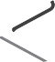

WORKshEET • shOULDERs & ARMs • DIsC 3
DATE / WEEK
Warm-Up (2:46 + 7:23)
01 shOULDERs - Alternating shoulder Presses | R W | R W | R W | R W | R W
02 BICEPs - In & Out Bicep Curls | R W | R W | R W | R W | R W
03 TRICEPs - Two-Arm Triceps Kickback | R W | R W | R W | R W | R W
04 shOULDERs - Alternating shoulder Presses | R W | R W | R W | R W | R W
05 BICEPs - In & Out Bicep Curls | R W | R W | R W | R W | R W
06 TRICEPs - Two-Arm Triceps Kickback | R W | R W | R W | R W | R W
Ballistic Stretch (0:30)
07 shOULDERs - Deep swimmer’s Presses | R W | R W | R W | R W | R W
08 BICEPs - Full supination Concentration Curls | R W | R W | R W | R W | R W
09 TRICEPs - Chair Dips | R | R | R | R | R
10 shOULDERs - Deep swimmer’s Presses | R W | R W | R W | R W | R W
11 BICEPs - Full supination Concentration Curls | R W | R W | R W | R W | R W
12 TRICEPs - Chair Dips | R | R | R | R | R
Ballistic Stretch (0:30)
13 shOULDERs - Upright Rows | R W | R W | R W | R W | R W
14 BICEPs - static Arm Curls | R W | R W | R W | R W | R W
15 TRICEPs - Flip-Grip Twist Triceps Kickbacks | R W | R W | R W | R W | R W
16 shOULDERs - Upright Rows | R W | R W | R W | R W | R W
17 BICEPs - static Arm Curls | R W | R W | R W | R W | R W
18 TRICEPs - Flip-Grip Twist Triceps Kickbacks | R W | R W | R W | R W | R W
Ballistic Stretch (0:34)
19 shOULDERs - seated Two-Angle shoulder Flys | R W | R W | R W | R W | R W
20 BICEPs - Crouching Cohen Curls | R W | R W | R W | R W | R W
21 TRICEPs - Lying-Down Triceps Extensions | R W | R W | R W | R W | R W
22 shOULDERs - seated Two-Angle shoulder Flys | R W | R W | R W | R W | R W
23 BICEPs - Crouching Cohen Curls | R W | R W | R W | R W | R W
24 TRICEPs - Lying-Down Triceps Extensions | R W | R W | R W | R W | R W
Ballistic Stretch (0:38)
25 shOULDERs - In & Out straight-Arm shoulder Flys | R W | R W | R W | R W | R W
26 BICEPs - Congdon Curls | R W | R W | R W | R W | R W
27 TRICEPs - side Tri-Rises | RT LT | RT LT | RT LT | RT LT | RT LT
28 shOULDERs - In & Out straight-Arm shoulder Flys | R W | R W | R W | R W | R W
29 BICEPs - Congdon Curls | R W | R W | R W | R W | R W
30 TRICEPs - side Tri-Rises | RT LT | RT LT | RT LT | RT LT | RT LT
Cool Down (3:29) R: reps W: weight RT: right LT: left

Equipment Required • Weights or resistance bands
- Bench or chair
Post-Workout Nutrition
Get better results and recover faster! No more than 1 hour after exercise, drink

WORKshEET • LEGs & BACK • DIs C 5
DATE / WEEK
 |  | Warm-Up (2:27 |  | + 7:34)
01 LEGs - Balanced Lunges |  | RT LT | RT LT |  | RT LT | RT LT |  | RT LT
02 LEGs - Calf-Raise squats |  | R W | R W |  | R W | R W |  | R W
03 BACK - Reverse Grip Chin-Ups |  | R | R |  | R | R |  | R
04 LEGs - super skaters |  | RT LT | RT LT |  | RT LT | RT LT |  | RT LT
05 LEGs - Wall squats |  | R sec | R sec |  | R sec | R sec |  | R sec
06 BACK - Wide Front Pull-Ups |  | R | R |  | R | R |  | R
07 LEGs - step Back Lunge |  | R W | R W |  | R W | R W |  | R W
08 LEGs - Alternating side Lunge |  | R W | R W |  | R W | R W |  | R W
09 BACK - Closed Grip Overhead Pull-Ups |  | R | R |  | R | R |  | R
10 LEGs - single-Leg Wall squat |  | R sec | R sec |  | R sec | R sec |  | R sec
11 LEGs - Deadlift squats |  | RT LT | RT LT |  | RT LT | RT LT |  | RT LT
12 BACK - switch Grip Pull-Ups  (switch every 2 reps) |  | R | R |  | R | R |  | R
 |  | Water Break |  | (2:00)
13 LEGs - Three-Way Lunge |  | RT LT | RT LT |  | RT LT | RT LT |  | RT LT
14 LEGs - sneaky Lunge |  | R | R |  | R | R |  | R
15 BACK - Reverse Grip Chin-Ups |  | R | R |  | R | R |  | R
16 LEGs - Chair salutations |  | R sec | R sec |  | R sec | R sec |  | R sec
17 LEGs - Toe-Roll Iso Lunge |  | R W | R W |  | R W | R W |  | R W
18 BACK - Wide Front Pull-Ups |  | R | R |  | R | R |  | R
19 LEGs - Groucho Walk |  | R sec | R sec |  | R sec | R sec |  | R sec
20 LEGs - Calf Raises | Toes Out Feet Parallel  Toes In | R W R W  R W | R W  R W R W |  | R W R W  R W | R W R W  R W |  | R W R W  R W
21 BACK - Closed Grip Overhand Pull-Ups |  | R | R |  | R | R |  | R
22 LEGs - 80/20 siebers-speed squats |  | RT LT | RT LT |  | RT LT | RT LT |  | RT LT
23 BACK - switch Grip Pull-Ups |  | R | R |  | R | R |  | R
 |  | Cool Down (4:18) |  |  |  | R: reps | W: weight |  | RT: right | LT: left

WORKshEET • CORE sYNERGIsTICs • DIsC 8
DATE / WEEK
Warm-Up (6:31 + 3:30)
01 stacked Foot / staggered hands Push-Ups (switch every 5 reps) | R | R | R | R | R
02 Banana Rolls (16 reps / 2 min) | R | R | R | R | R
03 Leaning Crescent Lunges | R W | R W | R W | R W | R W
04 squat Runs | R W | R W | R W | R W | R W
05 sphinx Push-Ups | R | R | R | R | R
06 Bow to Boat (4 sets/1:48 min) | R | R | R | R | R
07 Low Lateral skaters | R | R | R | R | R
08 Lunge & Reach | R W | R W | R W | R W | R W
Water Break (0:42)
09 Prison Cell Push-Ups | R | R | R | R | R
10 side hip Raise | RT LT | RT LT | RT LT | RT LT | RT LT
11 squat X-Press | R W | R W | R W | R W | R W
12 Plank to Chaturanga Run | R | R | R | R | R
13 Walking Push-Ups | R | R | R | R | R
14 superman Banana | R | R | R | R | R
15 Lunge Kickback Curl Press | R W | R W | R W | R W | R W
16 Towel hoppers | R | R | R | R | R
Water Break (0:44)
17 Reach high & Under Push-Ups | R | R | R | R | R
18 steam Engine | R | R | R | R | R
19 Dreya Rolls | R | R | R | R | R
20 Plan to Chaturanga Iso | R | R | R | R | R
21 halfback | R | R | R | R | R
22 Table Dip Leg Raises | R | R | R | R | R
Cool Down & Stretch (5:06) R: reps W: weight RT: right LT: left

Equipment Required • Weights or resistance bands
Post-Workout Nutrition
Get better results and recover faster! No more than 1 hour after exercise, drink

WORKshEET • ChEsT, shOULDERs, & TRICEPs • DIsC 9
DATE / WEEK
Warm-Up (8:52)
01 ChEsT - slow-Motion 3-in-1 Push-Ups | R | R | R | R | R
02 shOULDERs - In & Out shoulder Flys | R W | R W | R W | R W | R W
03 TRICEPs - Chair Dips | R | R | R | R | R
04 ChEsT - Plange Push-Ups | R | R | R | R | R
05 shOULDERs - Pike Presses | R | R | R | R | R
06 TRICEPs- side Tri-Rises | RT LT | RT LT | RT LT | RT LT | RT LT
07 ChEsT - Floor Flys (switch every 4 reps) | R | R | R | R | R
08 shOULDERs - scarecrows | R W | R W | R W | R W | R W
09 TRICEPs - Overhead Triceps Extensions | R W | R W | R W | R W | R W
10 ChEsT - Two-Twitch speed Push-Ups (4 Fast, 3 slow) | R | R | R | R | R
11 shOULDERs - Y-Presses | R W | R W | R W | R W | R W
12 TRICEPs - Lying Triceps Extensions | R W | R W | R W | R W | R W
Water Break (0:53)
13 ChEsT - side-to-side Push-Ups | R | R | R | R | R
14 shOULDERs - Pour Flys | R W | R W | R W | R W | R W
15 TRICEPs - side-Leaning Triceps  Extensions | R W | R W | R W | R W | R W
16 ChEsT - One-Arm Push-Ups | RT LT | RT LT | RT LT | RT LT | RT LT
17 shOULDERs - Weighted Circles  (2 X 20 reps) | R W | R W | R W | R W | R W
18 TRICEPs - Throw the Bomb | R W | R W | R W | R W | R W
19 ChEsT - Clap or Plyo Push-Ups | R | R | R | R | R
20 shOULDERs - slo-Mo Throws | R W | R W | R W | R W | R W
21 TRICEPs - Front-to-Back Triceps Extensions | R W | R W | R W | R W | R W
22 ChEsT - One-Arm Balance Push-Ups | R | R | R | R | R
23 shOULDERs - Fly-Row-Presses | R W | R W | R W | R W | R W
24 TRICEPs - Dumbbell Cross-Body Blows | R W | R W | R W | R W | R W
Cool Down (4:18) R: reps W: weight RT: right LT: left

WORKshEET |  |  | - BACK & BICEPs • DIs C 10
DATE / WEEK
Warm-Up (2:36 + 6:32)
01 BACK - Wide Front Pull-Ups | R | R | R |  | R | R
02 BACK - Lawnmowers | R W | R W | R W |  | R W | R W
03 BICEPs - Twenty-Ones | R W | R W | R W |  | R W | R W
04 BICEPs - One-Arm Cross-Body Curls | R W | R W | R W |  | R W | R W
05 BACK - switch Grip Pull-Ups  (switch every 2 reps) | R | R | R |  | R | R
06 BACK - Elbows-Out Lawnmowers | R W | R W | R W |  | R W | R W
07 BICEPs - standing Bicep Curls | R W | R W | R W |  | R W | R W
08 BICEPs - One-Arm Concentration Curls | R W | R W | R W |  | R W | R W
09 BACK - Corn Cob Pull-Ups | R | R | R |  | R | R
10 BACK - Reverse Grip Bent-Over Rows | R W | R W | R W |  | R W | R W
11 BICEPs - Open-Arm Curls | R W | R W | R W |  | R W | R W
12 BICEPs - static-Arm Curls | R W | R W | R W |  | R W | R W
Water Break (0:42)
13 BACK - Towel Pull-Ups (switch every 3) | R | R | R |  | R | R
14 BACK - Congdon Locomotives | R W | R W | R W |  | R W | R W
15 BICEPs - Crouching Cohen Curls | R W | R W | R W |  | R W | R W
16 BICEPs - One-Arm Corkscrew Curls | R W | R W | R W |  | R W | R W
17 BACK - Chin-Ups | R | R | R |  | R | R
18 BACK - seated Bent-Over Back Flys | R W | R W | R W |  | R W | R W
19 BICEPs - Curl-Up/hammer Downs | R W | R W | R W |  | R W | R W
20 BICEPs - hammer Curls | R W | R W | R W |  | R W | R W
21 BACK - Max Rep Pull-Ups | R | R | R |  | R | R
22 BACK - superman (6 x 10 seconds) | R | R | R |  | R | R
23 BICEPs - In-Out hammer Curls | R W | R W | R W |  | R W | R W
 | R W | R W | R W |  | R W | R W
24 BICEPs - strip-set Curls | R W | R W | R W |  | R W | R W
(4 rounds) | R W | R W | R W |  | R W | R W
 | R W | R W | R W |  | R W | R W
 | Cool Down (2:13) |  |  |  | R: reps W: weight |  | RT: right LT: left

Equipment Required • Weights or resistance bands
- P90X® Chin-Up Bar
(+ Chin-up Max, if you struggle with pull-ups)
- Bench or chair
- Towel
Post-Workout Nutrition
Get better results and recover faster! No more than 1 hour after exercise, drink
12 ounces of water mixed with 2 scoops of P90X Results and Recovery Formula®.

Need more P90X worksheets? Go to P90Xworksheets.com

WORKshEET • AB RIPPER X • DIsC 12
DATE / WEEK
01 IN & OUTs  Target - 25 | R | R | R | R | R
02 sEATED BICYCLEs  Target - 25 | R | R | R | R | R
03 REvERsE BICYCLEs  Target - 25 | R | R | R | R | R
04 sEATED CRUNChY FROGs  Target - 25 | R | R | R | R | R
05 CROssED LEG/WIDE LEG sIT-UPs  Target - 25 | R | R | R | R | R
06 FIFER sCIssORs  Target - 25 | R | R | R | R | R
07 hIP ROCK ’N’ RAIsE  Target - 25 | R | R | R | R | R
08 PULsE-UPs (hEELs TO hEAvEN)  Target - 25 | R | R | R | R | R
09 ROLL-UP/ v-UP COMBOs  Target - 25 | R | R | R | R | R
10 OBLIqUE v-UPs  Target - 25 | R | R | R | R | R
11 LEG CLIMBs  Target - 25 | R | R | R | R | R
12 MAsON (KAYAK) TWIsT  Target - 25 | R | R | R | R | R
Cool Down & Stretch (0:51) R: reps
Equipment Required • Mat Post-Workout Nutrition
Get better results and recover faster! No more than 1 hour after exercise, drink
12 ounces of water mixed with 2 scoops of P90X Results and Recovery Formula®.

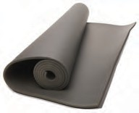
Need more P90X worksheets? Go to P90Xworksheets.com

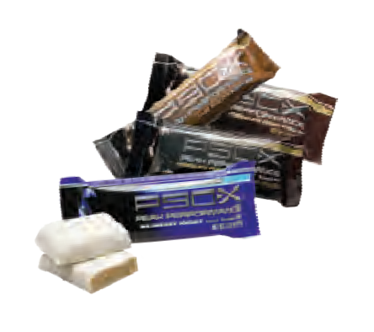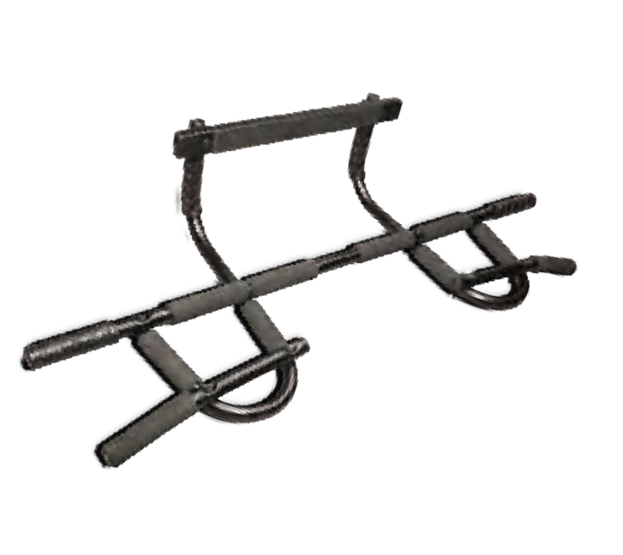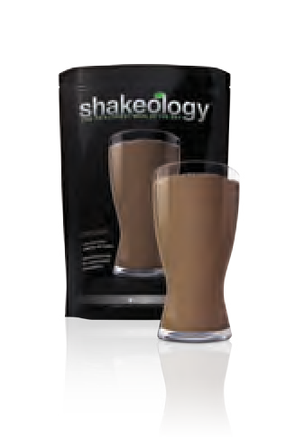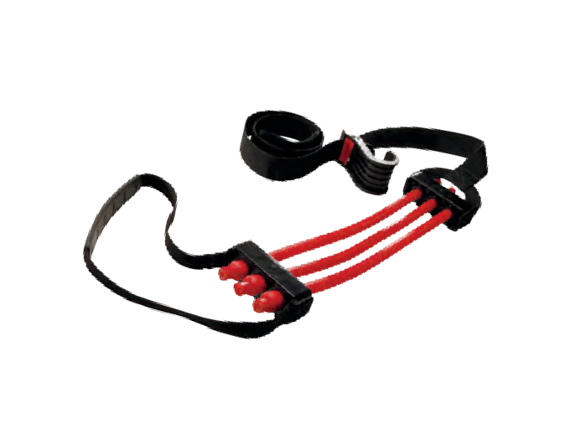
Bring It!™ Use these recommended items with P90X®. To order, visit Beachbody.com
Tony horton’s Powerstands©
Beachbody© Jump Mat
P90X
Peak Performance Protein Bars
shakeology©
P90X Peak health Formula™
P90X Results and Recovery Formula
P90X
Chin-Up Bar
P90X
Chin-Up Max

