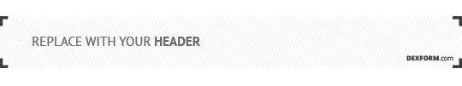
Product Scope Statement

Product Name
Date
Submitted by

1. Product Description

2. Target Audience

3. Project Requirements

4. Project Assumptions

5. Project Deliverables

1. Product Description
Explain what the product is, and how it will function/operate. Explain the ultimate intended purpose of the product. This should serve as a brief introduction. Provide some background about the history of how the product concept was conceived. Include technical drawings or photographs when possible. If any files or documents are being included with the Product scope please list the file names along with the product description.

2. Target Audience
Identify the consumer who would want to purchase the product. What would drive them to purchase this products over other products available in the market? Show examples of market research where possible.

3. Project Requirements
Identify the high level requirements of the product that will be developed. Remember that this is not a detailed list of system requirements or specifications at this point. The requirements might be at a level that is sufficient for performing an alternatives analysis to identify vendors and service providers that can meet the requirements. For example will the product need software development? Would the product require plastic parts to be molded?

4. Project Assumptions
Assumptions are conditions at the start of the project that must be considered. For example, when developing a new device was a similar device developed prior? Is there a product that could offer in site or ground work to the development of the new product?

5. Project Deliverables
Identify the features in in point form that the product must. The intent of this section is to list the product or system deliverables. Break this in to two sections, mandatory and optional. Optional features may be considered based on cost, ability and time frame but are not a mandatory requirement to the product moving forward.

