Business Requirements
Document (BRD)

for

Hardlines Item

BRG: Align

Version: 0.0.4

Date: 20040810



Change Request Reference

Refer to Change Request (CR) Number(s): | 03-000137
CR Submitter(s): | Andrew Hearn
Date of CR Submission to GSMP: | 20031007

DOCUMENT HISTORY

Document Number: | 0.0.4
Document Version: | 0.0.4
Document Date : | 20040810

Document Summary

Document Title: | Hardlines Item
Owner: | BRG: Align  Chairperson:
Status: | (check one box) ◻ DRAFT X Approved
BRD Template Version: | 1.2

Document Change History

Date of Change | Version | Reason for  Change | Summary of Change | Model Build # | CR #
20040528 | 0.0.1 | First draft of BRD | Conversion of UCCnet Business Requirements into First Draft BRD |  | 03-000137
20040628 | 0.0.2 | Incorporation of Class Diagram  Posted for public review | - Added class diagram  - Added Definitions for enumerated values in section 3.1.1  - Removed “Type” from all class names  - Changed Situational to Optional for attributes  - Added example in section 4.0
20040720 | 0.0.3 | Incorporated public review comments changes  Posted in Eroom for vote. | - Added section 2.1.2 Moved some hardlines attributes to Trading Partner Neutral  - Added additional definitions in 3.1.1  - Class Diagrams changed to reflect requirements 3.1.2→3.1.7  - Sample Data changed to reflect new requirement
20040810 | 0.0.4 | To be compliant to the 1.3.2. Standards | Moved following classes from Trading Partner Neutral to the Hardlines extension  - Ordering and Selling Unit of Measure  - Security Tag Information  - Trade Item Finish  - Trade Item Import Identification  Replaced Class Diagrams 3.1.3→3.1.7 as information is contained in Hardlines Trade Item Extension class diagram  Added 3.1.3 Enumeration Class Diagram for the Hardlines Trade Item

Chapter | Page

1 General Information 1
1.1 Problem Statement / Business Need 1
1.2 Objective 1
1.3 Audience 1
1.4 Artefacts 1
1.5 References 1
1.6 Acknowledgements 2
1.6.1 Align BRG Members 2
1.6.2 Hardlines Task/ Project Group Participants 2
1.6.3 Global Business Process Modellers (GBPM) 3
2 Business Process View 4
2.1 Requirements 4
2.1.1 Business Requirements For Hardlines Item Attributes Requirements 5
2.1.2 Technical Requirements (optional) 16
2.2 Use Case Actor Descriptions 16
2.3 Use Case Scenario 16
2.3.1 Use Case Diagram 16
2.3.2 Use Case Description 16
2.4 Activity Diagram 17
3 Data View 17
3.1 Data Description 17
3.1.1 Data Description for Hardlines Item enumerated classes 17
3.1.2 Class Diagram Hardlines Trade Item Extension 19
3.1.3 Class Diagram Enumeration Classes for Hardlines Trade Item Extension 20
4 Examples 21
5 Appendices 22
5.1 Implementation Considerations 22
5.2 Relationship with the EAN.UCC General Business Model (GBM) 22

General Information

Problem Statement / Business Need
The Voluntary Interindustry Commerce Standards Organization (VICS) Data Synchronization Subcommittee has reviewed the existing Trade Item Data Model and compared those attributes to current business process requirements in this industry. Industry unique materials and processes exist which requires additional attributes to completely and properly convey the data supporting current business processes in this industry. This document both defines and describes those additional attributes that have been identified as necessary to support current Hardlines industry business requirements. This includes new attributes and new Data Validation Rules.

Objective
The North American Hardlines industry has begun the process of data synchronization and these implementations necessitate the changes and additions to the EAN.UCC standards as documented to support these efforts. The objective is to create a business message standard supporting communication of trade item data attributes for the Hardlines industry.

Audience
The audience of the standards would be any participant in the global supply chain specifically the Hardlines Industry.

Artefacts

Artefact name | Artefact description
Business Requirements Version 1.1 Date 20040412 | Business Requirements Item Attribute Requirements Hardlines Industry Sector.

References
- EAN.UCC System
- GSMP Manual
- Object Management Group
- W3C

Acknowledgements

Align BRG Members
Function | Name | Company / organisation
BRG Chair | Jim Funk | S.C Johnson, Inc
BRG Member
BRG Process Manager | Andrew Hearn | Uniform Code Council

Hardlines Task/ Project Group Participants
Function | Name | Company / organisation
Participant | John Blind | Kodak
Participant | Lee Bowers | Lowe's
Participant | Sue Brozas | UCCnet
Participant | Minka Car | ACNielsen
Participant | Claudia Chmella | SINFOS GmbH
Participant | Denis Conway | The NPD Group
Participant | Robert Fassberg | QRS Corporation
Participant | Kevin Ferber | EDS
Participant | Dan Gallagher | TR2
Participant | Jean-Christophe Gilbert | EAN-France
Participant | Whitney Gilliam | Springs Industries, Inc
Participant | Paula Giovanetti | Ecworkshops.com
Participant | Mike Harris | Velosel Corporation
Participant | Bruce Hawkins | Wal-Mart Stores, Inc
Participant | Andrew Hearn | Uniform Code Council
Participant | Donna Howells | UDEX Ltd.
Participant | Emma James | ACNielsen
Participant | Shahid Javed | Transora
Participant | Mae Kemp | Lowe's
Participant | Rita Laur | ECCC
Participant | Zoltan Patkai | EAN International
Participant | Randy Rajagopal | Velosel Corporation
Participant | Rich Richardson | Uniform Code Council
Participant | Larry Rushing | HAHT Commerce
Participant | John Ryu | Uniform Code Council
Participant | Steve Shultz | TR2
Participant | Inderjeet Singh | Velosel Corporation
Participant | Thomas Smith | AGSA.US
Participant | Tan Soon | SANC
Participant | Peggy Spofford | 3M
Participant | Jim Sykes | UCCnet
Participant | Jen Xiques | UCCnet

Global Business Process Modellers (GBPM)
Function | Name | Organisation
Modeller | John Ryu | Uniform Code Council
Peer Reviewer | Eric Kauz | Uniform Code Council

Business Process View

Requirements
The following format is used to define the new Attributes
Name
Class Name

Cardinality:
- M – Mandatory
- O-- Optional
- D – Dependent (must supply business rules)

Multiple Occurrences:
- Y – Yes
- N - No
Data Type:
- Text Description (70 Characters with Language Qualifier) Multiple Occurrences
- Description (70 Characters with Language Qualifier) Single Occurrence
- Long Text Description (1000 Characters with Language Qualifier) Multiple Occurrences
- Long Description (1000 Characters with Language Qualifier) Single Occurrences
- Measurement (Decimal Value & Unit Of Measure) Multiple Occurrences
- Measurement Value (Decimal Value & Unit Of Measure) Single Occurrences
- Amount (Decimal Value & ISO Currency Code)
- Boolean (true / false)
- String (Used for codes - no language code)
- Date (CCYY-MM-DD)
- Date & Time (both date & time must be specified - CCYY-MM-DDTHH:MM:SS)
- Decimal (+- nnn.nnn)
- Integer (no decimal point)
- Percentage (Format 9.99 could use Measurement)
- GTIN (EAN·UCC defined type: 14-digit value)

Size (This will restrict the type either through the Schema or validation rules e.g. if the Attribute type was Text Long and the size was 350 then the Attribute would be restricted to 350 characters.)
Definition
Example
Business Rules (Industry Sector Best Practices)
Validation Rules (Validation Rules and Dependency Rules)
External Code List Name & Source
Code List Values and Descriptions (For EAN·UCC maintained code lists)

Business Requirements For Hardlines Item Attributes Requirements

Number | Statement | Rationale
1 | Hardlines Trade Item class is mandatory with the following attributes and their respective requirements.
1.1 | Is Trade Item Recalled  Class Name: HardlinesTradeItem  Attribute Name: isTradeItemRecalled  Cardinality: M  Multiple Occurrences: N  Type: Boolean  Size: true / false  Definition: An indicator for the Trade Item to determine if the Manufacturer or Supplier has recalled the product. This is a true/false (Boolean) where 'true' indicates the Trade Item has been recalled.  Example: None  Business Rules: None  Validation Rules: Acceptable values are: 'true' or 'false' * ‘true’ and ‘false’ have to be spelled out and in lowercase  External Code List Name N/A  External Code List Source: N/A
1.2 | Model Number  Class Name: HardlinesTradeItem  Attribute Name: modelNumber  Cardinality: O  Multiple Occurrences: N  Type: String  Size: 70  Definition: Additional Vendor identification number, which defines the configuration of the product over and above the Item number.  Example: Appliance model number, 123WKX  Business Rules: Add Attribute to EAN.UCC standards as alternate Item number is not adequate for Hardlines. Alternate Item number or model number is required for each Item.  Validation Rules: If Item is flagged as a consumer unit, either the model number or manufacturer’s part number must be populated. The value entered cannot breach the size of 70.  External Code List Name: N/A  External Code List Source: N/A
1.3 | Pieces Per Trade Item  Class Name: HardlinesTradeItem  Attribute Name: piecesPerTradeItem  Cardinality: O  Multiple Occurrences: N  Type: Measurement  Size: 15  Definition: Numeric value to indicate number of physical pieces used to make up the Consumer Unit. Used if there is more than one piece in one Trade Item.  Example: '5' = value to indicate number of pieces used to construct a wheelbarrow; '2' = value to indicate number of pieces which make up a trash can.  Business Rules: None  Validation Rules: The value entered cannot breach the size of 15.  External Code List Name N/A  External Code List Source: N/A
2 | Nesting Information class is optional and repeatable with the following attribute and their respective requirements.
2.1 | Nesting Increment  Class Name: NestingInformation  Attribute Name: nestingIncrement  Cardinality: O  Multiple Occurrences: Y  Type: Measurement  Size: 15  Definition: Indicates the incremental height of Trade Items nested together.  Example: 2 garbage cans nested together, the height between the lip of the lower can to the lip on the upper can  Business Rules: None  Validation Rules: If nestingIncrement is populated, stackingFactor must be populated. The value entered cannot breach the size of 15.  External Code List Name : N/A  External Code List Source: N/A
3 | Ordering and Selling Unit Of Measure class is optional. It contains the following attributes and their respective requirements.
3.1 | Ordering Unit of Measure  Class Name: OrderingAndSellingUnitOfMeasure  Attribute Name: orderingUnitOfMeasure  Cardinality: O  Multiple Occurrences: N  Type: String  Size: 70  Definition: The alternate Unit of Measure of how Trade Items are ordered by the Retailer under one Unit of Measure, but sold under another Unit of Measure.  Example: Spool of wire ordered by the spool and sold by lineal foot; Lumber ordered by board footage and sold by piece.  Business Rules: None  Validation Rules: EAN.UCC standards reference the UN/CEFACT Recommendation 20 list for the possible Unit of Measure. The value entered cannot breach the size of 70.  External Code List Name : UN/CEEFACT Recommendation No. 20  External Code List Source: UN/CEFACT
3.2 | Selling Unit of Measure  Class Name: OrderingAndSellingUnitOfMeasure  Attribute Name: sellingUnitOfMeasure  Cardinality: O  Multiple Occurrences: N  Type: String  Size: 70  Definition: Describes the measurement used for selling unit of the Trade Item to the end consumer. A Trade Item may have only one Unit of Measure. How is this Item sold?  Example: Each, pair, case, roll, set box, by the foot, by the sheet  Business Rules: None  Validation Rules: The Retailers require this if the Item is marked as a Consumer Unit. Only values from the enumerated list can be chosen from the UN/CEFACT Recommendation 20. The value entered should not breach the size of 70.  External Code List Name : UN/CEEFACT Recommendation No. 20  External Code List Source: UN/CEFACT
4 | Out of Box Information class is optional and repeatable with the following attributes and their respective requirements.
4.1 | Depth  Class Name: OutOfBoxInformation  Attribute Name: depth  Cardinality: D  Multiple Occurrences: Y  Type: Measurement  Size: 15  Definition: The measurement of the depth of the actual Trade Item. These dimensions should be used for Items that do not require assembly but differ in size when removed from the packaging.  Example: Stove or refrigerator  Business Rules: It is mandatory to supply all three types of dimension depth, height, and width if there is Out of Box Information.  Validation Rules: If the Out of Box dimensions are entered, the isOutOfBoxProvided Attribute is implied ‘true’. If height and width are populated, then this Attribute needs to be populated. The value entered cannot breach the size of 15.  External Code List Name : N/A  External Code List Source: N/A
4.2 | Height  Class Name: OutOfBoxInformation  Attribute Name: height  Cardinality: D  Multiple Occurrences: Y  Type: Measurement  Size: 15  Definition: The measurement of the height of the actual Trade Item. These dimensions should be used for Items that do not require assembly but differ in size when removed from the packaging.  Example: Stove or refrigerator  Business Rules: It is mandatory to supply all three types of dimension depth, height, and width if there is Out of Box Information.  Validation Rules: If the Out of Box dimensions are entered, the isOutOfBoxProvided Attribute is implied ‘true’. If depth and width are populated, then this Attribute needs to be populated. The value entered cannot breach the size of 15.  External Code List Name : N/A  External Code List Source: N/A
4.3 | Width  Class Name: OutOfBoxInformation  Attribute Name: width  Cardinality: D  Multiple Occurrences: Y  Type: Measurement  Size: 15  Definition: The measurement of the width of the actual Trade Item. These dimensions should be used for Items that do not require assembly but differ in size when removed from the packaging.  Example: Stove or refrigerator  Business Rules: It is mandatory to supply all three types of dimension depth, height, and width if there is Out of Box Information.  Validation Rules: If the Out of Box dimensions are entered, the isOutOfBoxProvided Attribute is implied ‘true’. If depth and height are populated, than this Attribute needs to be populated. The value entered cannot breach the size of 15.  External Code List Name: N/A  External Code List Source: N/A
5 | Right of Return For Non Sold Trade Item class is mandatory with the following attribute and their respective requirements.
5.1 | Return Goods Policy  Class Name: RightOfReturnForNonSoldTradeItem  Attribute Name: returnGoodsPolicy  Cardinality: M  Multiple Occurrences: N  Type: String  Size: 70  Definition: A code that describes the policy for defective, damaged or non-salable goods. Values include: DFC - Destroy for Credit; RFC - Return for Credit, HFI - Hold for Inspection or CFA - Call for Authorization.  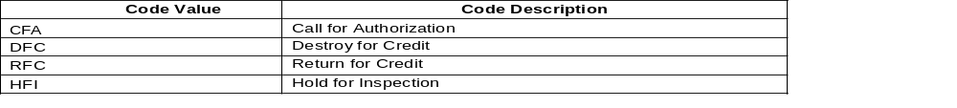Example: None  Business Rules: None  Validation Rules: Only choices from the enumerated list can be chosen. The value entered cannot breach the size of 70  External Code List Name : N/A  External Code List Source: N/A  Code List Values  This list of Code Values are contained within 'RightOfReturnForNonSoldTradeItemCodeList'
6.0 | Security Tag Information class is optional with the following attributes and their respective requirements.
6.1 | Security Tag Location  Class Name: SecurityTagInformation  Attribute Name: securityTagLocation  Cardinality: O  Multiple Occurrences: N  Type: String  Size: 70  Definition: This is a code to indicate where the EAS tag is located on the Trade Item. O = On outside of Trade Item; C = Concealed inside Trade Item; I = integrated inside Trade Item.  Example: None  Business Rules: None  Validation Rules: Used on Consumer Units only. Only choices from the enumerated list can be chosen. The value entered cannot breach the size of 70.  External Code List Name : N/A  External Code List Source: N/A  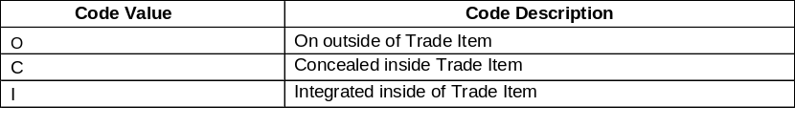Code List Values:  The list of Code Values are contained within 'SecurityTagLocationCodeTypeList'
6.2 | Security Tag Type  Class Name: SecurityTagInformation  Attribute Name: securityTagType  Cardinality: O  Multiple Occurrences: N  Type: String  Size: 70  Definition: This is a code to indicate the type of EAS tag located on the Trade Item. AM = Acousto-Magnetic; EM = Electro-Magnetic; INK = Ink or dye; M = Microwave; RF = Radio Frequency  Example: None  Business Rules: None  Validation Rules: Used on Consumer Units only. Only choices from the enumerated list can be chosen. The value entered cannot breach the size of 70.  External Code List Name: N/A  External Code List Source: N/A  Code List Values:  The list of Code Values are contained within 'SecurityTagTypeList'
  Code Value | Code Description
  AM | Acousto-Magnetic EAS Tag
  EM | Electro-Magnetic EAS Tag
  INK | Ink or Dye EAS Tag
  M | Microwave EAS Tag
  RF | Radio Frequency EAS Tag
7 | Trade Item Finish class is optional with the following attribute and respective requirements.
7.1 | Trade Item Finish Description  Class Name: Trade Item Finish  Attribute Name: tradeItemFinishDescription  Cardinality: M  Multiple Occurrences: N  Type: Description  Size: 70  Definition: Additional Attribute which defines the outer surface/appearance of the product.  Example: Antique brass, bright brass, oak or walnut finish  Business Rules: Until approved in the standards, use of “color” Attribute to define finish is acceptable.  Validation Rules: Would only need to be added on Consumer Unit Items, The value entered cannot breach the size of 70.  External Code List Name: N/A  External Code List Source: N/A
8 | Trade Item Import Identification class is optional and repeatable with the following attributes and their respective requirements.
8.1 | Import Classification Type  Class Name: TradeItemImportIdentification  Attribute Name: importClassificationType  Cardinality: O  Multiple Occurrences: N  Type: String  Size: 70  Definition: This is a code to indicate the type of import classification for the Trade Item. CBS NL = Netherlands Import Code; HCDCS = Harmonized Commodity Description and Coding System; HS KN TARIC = Customs tariff and INTRASTAT Code; HTS = Harmonized Tariff Schedule of the United States; ICN = INTRASTAT Combined Nomenclature; TARIC = Tarif Intégré de la Communauté  Example: None  Business Rules: None  Validation Rules: Only choices from the enumerated list can be chosen. The value entered cannot breach the size of 70.  External Code List Name: N/A  External Code List Source: N/A  Code List Values:  The list of Code Values are contained within 'ImportClassificationTypeList'
  Code Value | Code Description
  HS/KN/TARIC | Customs Tariff Number
  HCDCS | Harmonized Commodity Description and Coding System
  HTS | Harmonized Tariff Schedule of the US
  IST | Intrastat
  ICN | Intrastat Combined Nomenclature
  CBS NL | Netherlands
  TARIC | Tarif Integre de la Communaute
8.2 | Trade Item Import Identification  Class Name: TradeItemImportIdentification  Attribute Name: importClassificationValue  Cardinality: O  Multiple Occurrences: Y  Type: String  Size: 11  Definition: Imports and exports of trade items typically require classification codes to determine appropriate duties and tariffs. CBS NL = Netherlands Import Code; HCDCS = Harmonized Commodity Description and Coding System; HS KN TARIC = Customs tariff and INTRASTAT Code; HTS = Harmonized Tariff Schedule of the United States; ICN = INTRASTAT Combined Nomenclature; TARIC = Tarif Intégré de la Communauté  Example: None  Business Rules: Required on Import Products only.  Validation Rules: The value entered cannot breach the size of 11.  External Code List Name : N/A  External Code List Source: N/A  Code List Values:  The list of Code Values are contained within 'ImportClassificationCodeTypeList'
9 | Warranty Information class is optional with the following attributes and their respective requirements.
9.1 | URL For warranty  Class Name: WarrantyInformation  Attribute Name: uRLForWarranty  Cardinality: O  Multiple Occurrences: N  Type: String  Size: 1000  Definition: Indicates the location of the URL that contains the warranty information of the Item.  Example: None  Business Rules: None  Validation Rules: If either 'urlForWarranty' or 'warrantyDescription' is populated, it implies the Attribute 'warrantyIndicator' = true. The value entered cannot breach the size of 1000.  External Code List Name : N/A  External Code List Source: N/A
9.2 | Warranty Description  Class Name: WarrantyInformation  Attribute Name: warrantyDescription  Cardinality: O  Multiple Occurrences: N  Type: Long Text Description  Size: 1000  Definition: Description of the warranty information as found on the Item.  Example: None  Business Rules: None  Validation Rules: If either 'urlForWarranty' or 'warrantyDescription' is populated, it implies the Attribute 'warrantyIndicator' = true. The value entered cannot breach the size of 1000.  External Code List Name: N/A  External Code List Source: N/A

Technical Requirements (optional)
Number | Statement | Rationale
(Sequential number) | None at this time

Use Case Actor Descriptions
Actor | Description
Not required

Use Case Scenario
Not required

Use Case Diagram
Not required

Use Case Description
Use Case Name | Not required
Use Case Description
Actors
Preconditions
Postconditions
Scenario
  Step # | Actor | Activity Step
  1
  2
  3
  4
Alternative Scenario
  Step # | Actor | Activity Step

Activity Diagram

Not Required

Data View

Data Description

Data Description for Hardlines Item enumerated classes

Data Name | Definition | Mandatory / Optional /  Dependent
1.0 Import Classification Type List | A code list that describes the classification systems typically utilized by governmental agencies to determine appropriate duties, tariffs, customs, and statistical declarations used in international trade. | Enumerated Class
1.1 Customs Tariff Number HS/KN/TARIC | Classification system used by countries that have joined the International System for the designation and Codification of goods used to determine appropriate duties, tariffs, customs, and statistical declarations used in international trade. | Enumeration
1.2 Harmonized Commodity Description and Coding System | Classification system developed and maintained by the World Customs Organization (WCO), an independent intergovernmental organization utilized to determine appropriate duties, tariffs, customs, and statistical declarations used in international trade. | Enumeration
1.3 Harmonized Tariff Schedule of the US | Classification system that provides the applicable tariff rates and statistical categories for all merchandise imported into the United States; it is based on the international Harmonized System, the global classification system that is used to describe most world trade in goods | Enumeration
1.4 Intrastat | The system utilized for collecting statistics on the physical trade in goods (i.e. the actual movement of goods) between the Member States of the European Union (EC). | Enumeraiton
1.5 Intrastat Combined Nomenclature | The system developed by the European Union (EC) as a nomenclature for customs and statistics | Enumeration
1.6 Netherlands | The system developed by the Netherlands as a nomenclature for customs and statistics. | Enumeration
1.7 Tarif Integre de la Communaute | The system designed to show the various rules applying to specific products when imported into the EU. This includes the provisions of the harmonized system and the combined nomenclature as well as additional provisions specified in Community legislation such as tariff suspensions, tariff quotas and tariff preferences, which exist for the majority of the Community’s trading partners. In trade with third countries, the 10-digit TARIC code must be used in customs and statistical declarations | Enumeration
2.0 Right of Return for Non Sold Trade Item Code List | A code list that describes the notification and trade item disposition policy to be used between trading partners to manage defective, damaged, or otherwise non-saleable goods. | Enumeration Class
2.1 Call For Authorization | A call to a trading partner is required to obtain authorization to disposition defective, damaged, or otherwise non-saleable goods. | Enumeration
2.2 Destroy for Credit | Trading partner documents and subsequently destroys defective, damaged, or otherwise non-saleable goods and is issued a credit for the material by the other trading partner. | Enumeration
2.3 Hold for Inspection | Defective, damaged, or otherwise non-saleable goods are held for inspection and verification by a trading partner prior to the issuance of credit for the material. | Enumeration
2.4 Return for Credit | Defective, damaged, or otherwise non-saleable goods are physically returned by a trading partner prior to the issuance of credit for the material. | Enumeration
3.0 Security Tag Location Code Type List | A code list that describes the location of any electronic article security (EAS) tag on a trade item. | Enumeration Class
3.1 Concealed Inside Trade Item | An electronic article security (EAS) tag has been concealed inside a trade item. | Enumeration
3.2 Integrated Inside of Trade Item | An electronic article security (EAS) tag has been integrated inside a trade item. | Enumeration
3.3 On Outside of Trade Item | An electronic article security (EAS) tag has been placed on the outside of a trade item. | Enumeration
4.0 Security Tag Type List | A code list that describes the technology associated with an Electronic Article Surveillance (EAS) tag placed on a trade item. | Enumeration Class
4.1 Acousto-Magnetic EAS Tag | Electronic Article Surveillance (EAS) tag that operates utilizing radio frequency signals in pulses, which energize the tag. When the pulse ends, the tag responds, emitting a single frequency signal like a tuning fork. While the transmitter is off between pulses, a receiver detects the tag signal. A microcomputer checks the tag signal detected by the receiver to ensure it is at the right frequency, is time-synchronized to the transmitter, at the proper level and at the correct repetition rate. If all these criteria are met, the alarm occurs. | Enumeration
4.2 Electro-Magnetic EAS Tag | Electronic Article Surveillance (EAS) tag that operates utilizing low frequency magnetic fields generated by a transmitter antenna. When the tag passes through the magnetic field, it transmits a unique frequency pattern. This pattern is picked up by an adjacent receiver antenna, and the signal is processed and will trigger an alarm when the specific pattern is recognized | Enumeration
4.3 Ink or Dye EAS Tag | Electronic Article Surveillance (EAS) tag that is designed to break and release fluid, usually indelible inks onto the trade item if the tag is removed by other than the retailer. | Enumeration
4.4 Microwave EAS Tag | Electronic Article Surveillance (EAS) tag attached to a product that receives and combines two microwave frequency signals emitted by a transmitter antenna. The tag transmits the combined signal which is amplified and compared to a reference in the detector to ensure it is at the correct frequency and level. If correct, an alarm is initiated. | Enumeration
4.5 Radio Frequency EAS Tag | Electronic Article Surveillance (EAS) tag attached to a product that responds to a specific frequency emitted by a transmitter antenna. An adjacent receiver antenna then picks up the response from the tag. The tag response signal is processed and will trigger an alarm when it matches specific criteria. | Enumeration

Class Diagram Hardlines Trade Item Extension

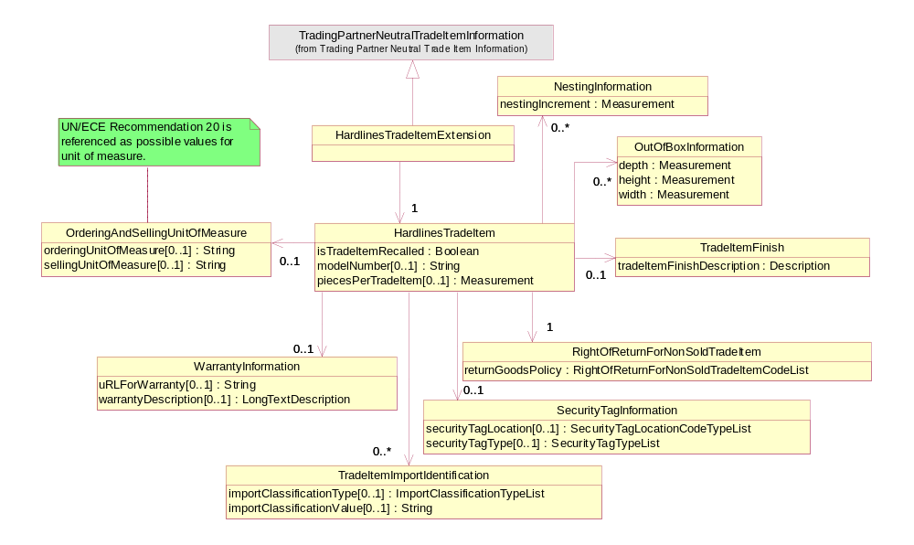

Class Diagram Enumeration Classes for Hardlines Trade Item Extension
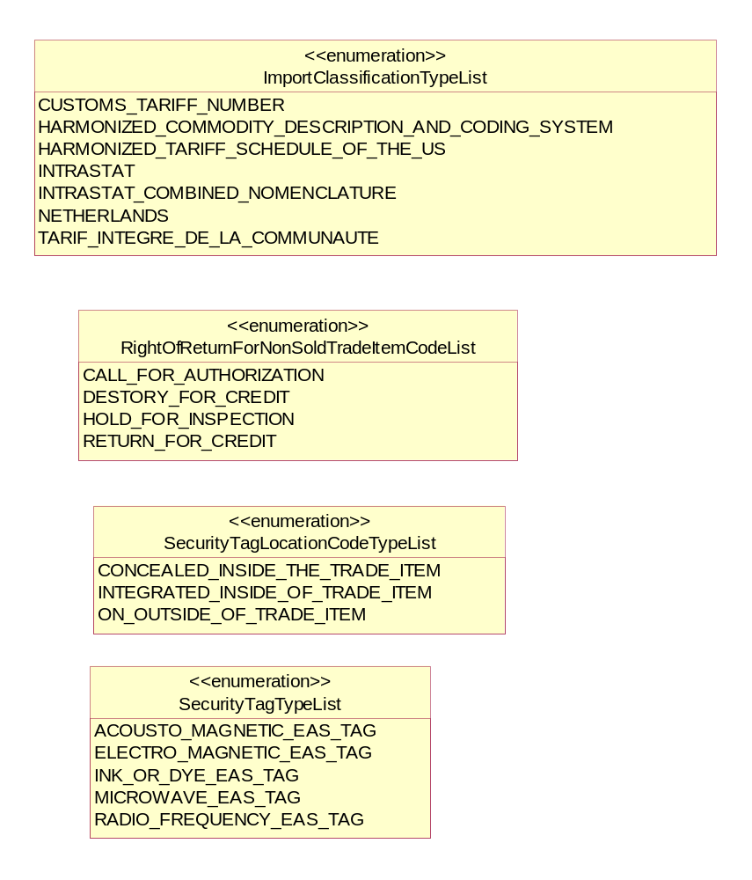

Examples
A sample Hardlines Item message is listed below for illustration.

Trading Partner Neutral Trade Item Information
Ordering And Selling Unit of Measure
Ordering Unit of Measure: ‘BAG’
Selling Unit of Measure: ‘BAG’

Security Tag Information
Security Tag Location: ‘ON_OUTISDE_OF_TRADE_ITEM’
Security Tag Type: ‘ACOUSTO_MAGNETIC_EAS_TAG’

Trade Item Import Identification
Import Classification Type: ‘CUSTOMS_TARIFF_NUMBER’
Import Classification Value: ‘94052060102’

Hardlines Trade Item Extension
Hardlines Trade Item
Is Trade Item Recalled: ‘False’
Model Number: ‘123’
Pieces Per Trade Item: ‘10’ UoM ‘CASE’

Right of Return For Non Sold Trade Item
Return Good Policy: ‘CALL_FOR_AUTHORIZATION’

Nesting Information
Nesting Increment ‘5.2’ UoM ‘IN’

Out of Box Information
Depth: ‘40’ UoM ‘centimeter’
Height: ‘150’ UoM ‘centimeter’
Width: ‘40’ UoM ‘centimeter’

Warranty Information
uRL For Warranty: ‘http://www.MyProductsWarranty.com’

Appendices

Implementation Considerations

Relationship with the EAN.UCC General Business Model (GBM)

The following diagram illustrates the position of the BRD Hardlines Item within the GBM:



