Department or Program Name
[System/Application Name]

Business Requirements Document

Business Requirements Document
Template Guideline
To aid in the creation of a successfully completed Business Requirements Definition (BRD) document, please adhere to the following guidelines. For additional instructions and information, please refer to the Enterprise Project Methodology (EPM) Guidebook. Remove these guidelines from the completed document.

Purpose | A requirement is a documented condition or capability to which the product, service, or system must conform in meeting project objectives. Requirements management is a systematic approach to eliciting, organizing, and documenting the requirements of the product, service, or system. The Business Requirements Definition document serves as the project baseline that explains, in business terms, what is to be accomplished during the Project Design Stage.  Because requirements are dynamic, the BRD is a progressive document in that the objective is to record what is known at the time and then build on it as the project progresses. It is from this document that the more specific design documentation can be produced based on the needs of the project and any unique and/or complementary methodology.
Ownership | The Business Analysis and Project Leads work with the Business Sponsor and any necessary Business or Technical Project Leads to document the business requirements within the BRD. The BRD must be approved before the project can proceed.
When  Process Phase: Execute  SDLC Phase: Analyze | The Business Requirements Definition document is started during the initial stages of the Execute Phase prior to the Project Design Stage within the project management process lifecycle.  Defining business requirements is a required deliverable on all projects.
Template Completion  Note: Text within < > brackets need to be replaced with project-specific information. | Collecting requirements is not as straightforward as it may first appear. It can become challenging because requirements:  - aren’t always obvious  - can come from many and varied sources  - need to be managed by cross-functional groups of people  - can be hard to express clearly in words  - can be expressed at different levels of detail  For a project that is an enhancement to an existing product, service, or system, the project team reviews existing documentation; therefore, the BRD tends to be briefer. However, a project that is developing a new product, service, or system would tend to generate a longer and more detailed document.  - Do not include the Template Guidelines in your final document. Enter the project information in the page header and footer, title page, and document contributors and version control.  - Complete the document utilizing suggested text where applicable and entering text/fields where shown within <blue text> brackets. Note that the blue text is NOT to be included in your final document. Its purpose is to either provide guidance for completing the document, or to show where text/fields should be entered.  - For smaller projects, you may opt to combine all Requirements sections within one table. If so, add a new column for “Requirement Type” and list those applicable requirements within the one table in a condensed format.  - If a requirement shown does not pertain to the project at hand, do NOT delete it, but rather mark it as “Non-applicable” and provide a brief explanation as to why it does not apply to the project.  - If a needed requirement is not showing due to the unique qualities of the project at hand, the Project Manager is empowered to ADD the requirement in Section 5 and create an appropriate table for help in identifying, defining, and tracking the requirements. Note that if such a new requirement is identified AFTER the BRD is approved, then this new requirement would be added under §10.1 – Addendums (New Requirements).  - Once changes are made to your document and you’re ready to finalize, ensure that you update your Table of Contents (TOC) section.  - Route the document for review and approval to those individuals previously identified.  - Because the BRD is a dynamic document, once the Project Manager obtains approval, the BRD is to be retained and modified as necessary in Section 10 to record any additional, changed, or cancelled requirements.  - If changes are to be made, update the Revision History information accordingly.  - The Business Requirements Definition document is to be retained with other project-related documentation and maintained in accordance with the business line’s records retention policy.
Empowerment & Scalability | This template is provided as a guideline to follow in producing the minimum basic information needed to successfully complete a Business Requirements Definition document. Project Managers are empowered to use this template as needed to address any specific requirements of the proposed project at hand. The amount of detail included in the template will depend on the size and complexity of the project. Depending on project or business line needs, requirements can be added, but cannot be deleted.
Important Notices | This template may change without advanced notice. It is highly recommended that you access a blank template from the U Services PMO website at:  www.uservices.umn.edu/pmo
Document Information and Approvals
UTORS

Version History
Version # | Date |  | Revised By | Reason for change
1.0 | 9/17/09 |  | Aaron Demenge | PMO Review

This document has been approved as the official Business Requirements Document for <project name>, and accurately reflects the current understanding of business requirements. Following approval of this document, requirement changes will be governed by the project’s change management process, including impact analysis, appropriate reviews and approvals.

Document Approvals
Approver Name | Project Role |  | Signature/Electronic Approval | Date

Table of Contents
1. Document Purpose 1
2. Document Resources 1
3. Glossary of Terms 1
4. Project Overview 1
4.1 Project Overview and Background 1
4.2 Project Dependencies 1
4.3 Stakeholders 2
5. Key Assumptions and Constraints 2
5.1 Key Assumptions and Constraints 2
6. Use Cases 2
6.1 Use Case Diagram 2
6.2 Use Case Narrative 3
7. Business Requirements 4
8. Appendixes 6
8.1 Appendix A – Business Process Flows 6
8.1.1 As Is Diagrams 7
8.2.2 To Be Diagrams 8
8.2 Appendix B – Business Rules Catalog 9
8.3 Appendix C- Models 9
8.4 Traceability Matrix 9
8.5 Use Case Narrative Instructions 10

1. Document Purpose

This document defines the high level requirements of <enter name of business line, internal organization, stakeholders> for this project. It will be used as the basis for the following activities:

- Creating solution designs
- Developing test plans, test scripts, and test cases
- Determining project completion>
- Assessing project success
2. Document Resources

Name | Business Unit | Role
<Identify all stakeholders and resources involved in gathering requirements>

3. Glossary of Terms

Term/Acronym | Definition
<Identify any terms and acronyms used within this document>

4. Project Overview

4.1 Project Overview and Background
<This information can be taken from the Project Charter. This is a brief description of what the project is about. It includes the current situation, the problem and the objectives. This section serves as the vision statement for the requirements. Each requirement should bring the project closer to the vision.>

4.2 Project Dependencies
<List any related known projects that relate in whole or in part, or has a dependency on this project.>

4.3 Stakeholders
The following comprises the internal and external stakeholders whose requirements are represented by this document:

Stakeholders
1.
2.

3.

5. Key Assumptions and Constraints

5.1 Key Assumptions and Constraints

# | Assumptions
 | List any assumptions the requirements are based on
# | Constraints
 | List any constraints the requirements are based on
6. Use Cases
< The primary purpose of the Use Case is to capture the required system behavior from the perspective of the end-user in achieving one or more desired goals. A Use Case contains a description of the flow of events describing the interaction between actors and the system. The use case may also be represented visually in UML in order to show relationships with other the use cases and actors>.

6.1 Use Case Diagram

6.2 Use Case Narrative

<Each Use Case should be documented using this template. Refer to the Appendix for Use Case Narrative instructions>

Use Case ID:
Use Case Name:
Created By: |  | Last Updated By:
Date Created: |  | Date Last Updated:

Actors:
Description:
Preconditions:
Postconditions:
Normal Course:
Alternative Courses:
Exceptions:
Includes:
Priority:
Frequency of Use:
Business Rules
Special Requirements:
Assumptions:
Notes and Issues:
Use Case Graphic

Example of a completed use case:

Use Case ID: | 1
Use Case Name: | View Interactive Campus Map
Created By: | Dan Sward | Last Updated By:
Date Created: | 4/19/09 | Date Last Updated:

Actors: | User
Description: | This use case describes the main way this interactive campus map will be used – as a web browser accessed application. The user accesses the appropriate URL and interacts with the functionality made available.
Preconditions: | Web browser opened, and interactive campus map URL accessed.
Postconditions: | User navigates from interactive campus map web site.
Normal Course: | - Open browser  - Navigate to campus map URL  - Interact with the campus map using available functionality
Alternative Courses: | None
Exceptions: | None
Includes:
Priority: | High
Frequency of Use: | Once per visit.
Business Rules | TBD…
Special Requirements: | - 24/7 access  - Response times comparable to common web mapping solutions (e.g. Google Maps)  - U of M accessibility requirements  - U of M eCommunications requirements
Assumptions:
Notes and Issues:
Use Case Graphic | 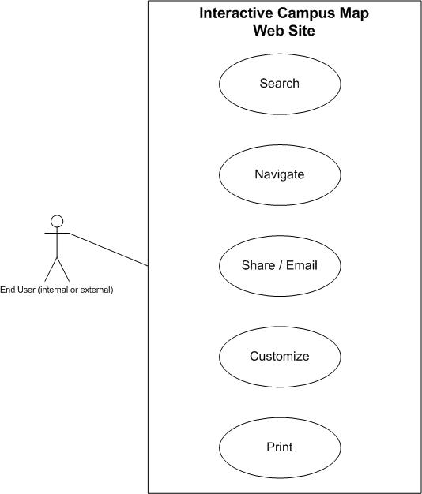

7. Business Requirements
The following sections document the various business requirements of this project.

Requirement Type | ID – Prefix ?? | ID – Number | Function – Feature - Requirement | Use Case Reference | Required | ?? | ?? | ?? | Comments
 | Business User Requirements
 | f | 0001
 | f | 0002
 | f | 0003
 | f | 0004
 | F | 0005
 | F | 0007
 | f | 0007
 | f | 0008
 | Reporting Requirements
 | f | 0001
 | f | 0002
 | f | 0003
 | f | 0004
 | F | 0005
 | F | 0007
 | f | 0007
 | f | 0008
 | User Access/Security Requirements
 | f | 0001
 | f | 0002
 | f | 0003
 | f | 0004
 | F | 0005
 | F | 0007
 | f | 0007
 | f | 0008
 | Service Level/Performance Requirements
 | f | 0001
 | f | 0002
 | f | 0003
 | f | 0004
 | F | 0005
 | F | 0007
 | f | 0007
 | f | 0008
 | Scalability Requirements
 | f | 0001
 | f | 0002
 | f | 0003
 | f | 0004
 | F | 0005
 | F | 0007
 | f | 0007
 | f | 0008
 | Support and Maintenance Requirements
 | f | 0001
 | f | 0002
 | f | 0003
 | f | 0004
 | F | 0005
 | F | 0007
 | f | 0007
 | f | 0008

8. Appendixes

8.1 Appendix A – Business Process Flows
<Describe the current existing process workflow using flow diagrams (i.e. Visio Flowcharts) and/or a detailed narrative.>
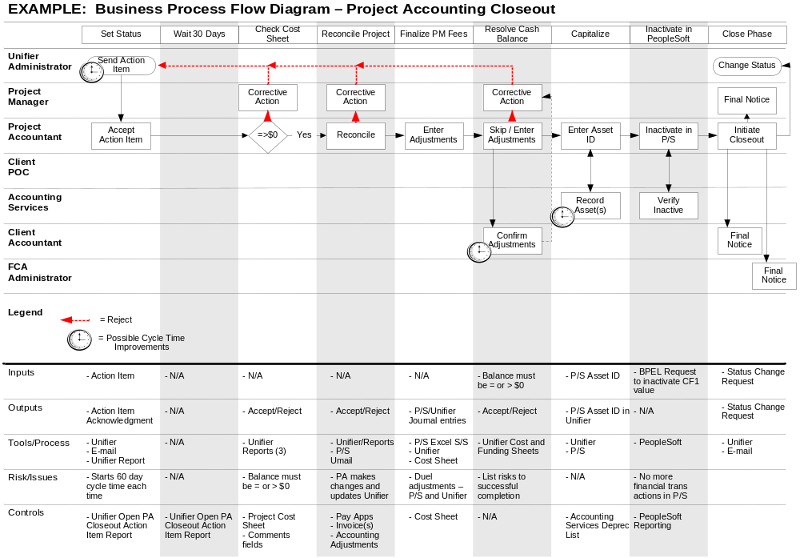

8.1.1 As Is Diagrams
<Insert As Is Diagrams here (if applicable)>

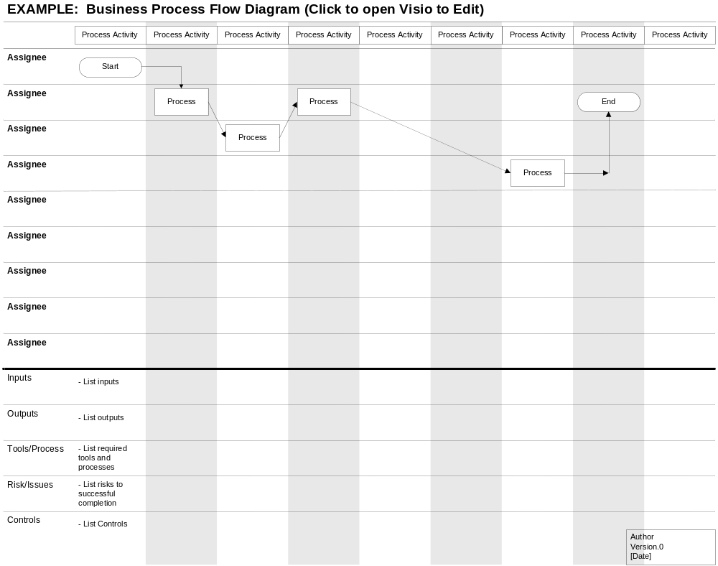
8.2.2 To Be Diagrams
<Insert To Be Diagrams here (if applicable)>

8.2 Appendix B – Business Rules Catalog
<Instructions: Use the following template for each business rule. >

Business Rule Name: | <The name should give you a good idea about the topic of the business rule.>
Identifier | <Defines unique identifier.> EXAMPLE: BR1
Description | <Defines the rule in detail.> EXAMPLE: “All employee labor is tracked, reported and billed in 15 minute increments.”
Example | <(Optional) An example of the rule>
Source | <Source of the rule. E.g. stakeholder>
Related Rules | <List of related rules, to support traceability>

8.3 Appendix C- Models
<Insert models here>

8.4 Traceability Matrix
<Insert traceability matrix here>

8.5 Use Case Narrative Instructions
<Instructions for completing the Use Case Narrative are included here. Remove these instructions from the completed Business Requirements Document>.

Use Case Field Name | Definition
Use Case ID | Give each use case a unique numeric identifier, in hierarchical form: X.Y. Related use cases can be grouped in the hierarchy. Functional requirements can be traced back to a labeled Use Case.
Use Case Name | State a concise, results-oriented name for the use case. These reflect the tasks the user needs to be able to accomplish using the system. Include an action verb and a noun. Some examples:  - View part number information.  - Manually mark hypertext source and establish link to target.  - Place an order for a CD with the updated software version
Created By | Include the name of the person who initially documented this Use Case.
Date Created | Enter the date on which the use case was initially documented
Date Last Updated | Enter the date on which the use case was most recently updated
Last Updated By | Include the name of the person who performed the most recent update to the use case description.
Actor | Enter the person or other entity external to the software system being specified who interacts with the system and performs use cases to accomplish tasks. Different actors often correspond to different user classes, or roles, identified from the customer community that will use the product. Name the actor(s) that will be performing this Use Case.
Description | Provide a brief description of the reason for and outcome of this use case, or a high-level description of the sequence of actions and the outcome of executing the Use Case.
Preconditions | List any activities that must take place, or any conditions that must be true, before the Use Case can be started. Number each precondition. Examples:  - User’s identity has been authenticated.  - User’s computer has sufficient free memory available to launch task
Post conditions | Describe the state of the system at the conclusion of the use case execution. Number each post condition. Examples:  - Document contains only valid SGML tags.  - Price of item in database has been updated with new value
Normal Course | Provide a detailed description of the user actions and system responses that will take place during execution of the use case under normal, expected conditions. This dialog sequence will ultimately lead to accomplishing the goal stated in the use case name and description. This description may be written as an answer to the hypothetical question, “How do I <accomplish the task stated in the use case name>?” This is best done as a numbered list of actions performed by the actor, alternating with responses provided by the system.
Alternative Courses | Document other, legitimate usage scenarios that can take place within this use case separately in this section. State the alternative course, and describe any differences in the sequence of steps that take place. Number each alternative course using the Use Case ID as a prefix, followed by “AC” to indicate “Alternative Course”. Example: X.Y.AC.1
Exceptions | Describe any anticipated error conditions that could occur during execution of the use case, and define how the system is to respond to those conditions. Also, describe how the system is to respond if the use case execution fails for some unanticipated reason. Number each exception using the Use Case ID as a prefix, followed by “EX” to indicate “Exception”. Example: X.Y.EX.1
Includes | List any other use cases that are included (“called”) by this use case. Common functionality that appears in multiple use cases can be split out into a separate use case that is included by the ones that need that common functionality.
Priority | Indicate the relative priority of implementing the functionality required to allow this use case to be executed. The priority scheme used must be the same as that used in the software requirements specification.
Frequency of Use | Estimate the number of times this Use Case will be performed by the actors per some appropriate unit of time.
Business Rules | List any business rules that influence this Use Case.
Special Requirements | Identify any additional requirements, such as nonfunctional requirements, for the use case that may need to be addressed during design or implementation. These may include performance requirements or other quality attributes.
Assumptions | List any assumptions that were made in the analysis that led to accepting this use case into the product description and writing the use case description.
Notes and Issues | List any additional comments about this use case or any remaining open issues or TBDs (To Be Determined) that must be resolved. Identify who will resolve each issue, the due date, and what the resolution ultimately is.

