Supplier Name:
Supplier Number:
Part Description:
Part Number:
Drawing Number: |  | Revision:
Purchase Order #:
Quantity:
Serial Number(s): |  | (if applicable)
Lot/Heat Number: |  | (if applicable)

All technical requirements of the contract are satisfied. Quality and performance are in accordance with the contract, the specifications, and all references and associated contractual drawings and documents.

I, as a supplier to Oshkosh Defense, acknowledge and certify the material covered under this document is produced in accordance with the following:

All Contractual “Flow Down” Requirements
Supplier Standards Guide
Global Supplier Quality Manual
Product Conformance
Free of Counterfeit Material
(Acknowledge by marking the boxes)

Signature |  | Title |  | Completion Date

This certifies the parts/items/materials identified above conform to all applicable drawings and/or specifications as evidenced by reports or other documentation on file and all other purchase order and quality requirements have been met.

Example: Certificate of Conformance

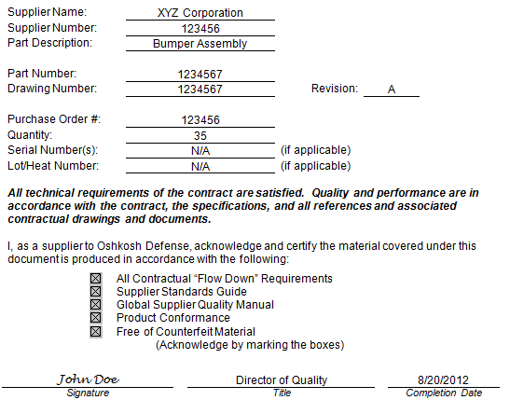
1
2
3
4
5
6
7
8
9
10
11
12
13
14

Required Fields

1 | Supplier Name
2 | Oshkosh Supplier Number
3 | Part description as noted on the drawing
4 | Part number as noted on the drawing
5 | Drawing number as noted on the drawing
6 | Current revision of the drawing that the parts are produced
7 | Purchase order associated with related shipment
8 | Quantity shipped on the associated release
9 | List of serial numbers (if serial action is required by the drawing or other applicable requirements)
10 | List of lot numbers (if lot traceability is required by the drawing or other applicable requirements
11 | All 5 requirements must be verified and all 5 boxes must be checked to be considered a conforming shipment and a validated CoC
12 | Document date the form was completed
13 | Typed or handwritten signature of supplier designee that validates conformance of said shipment
14 | Title of signature designee

This form shall be completed for each release of material shipped to Oshkosh Defense and must be stored at the supplier location. Records shall be maintained for 5 years. At the end of 5 years, the supplier shall provide Oshkosh Defense with the option of having the records forwarded to Oshkosh Defense for further retention, as required by contract, or authorizing disposal of the records and documents at the supplier’s location. Disposition shall be done in a timely and appropriate manner. Oshkosh Defense shall be notified when disposition has taken place.

