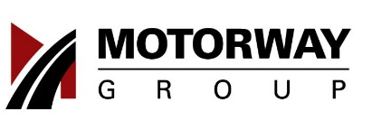
Consignment Agreement

Date: ______________

Part I. Original Car Owner’s Information

 | a. ❏ Mr | ❏ Ms |  | ❏ Mrs |  | ❏ Mdm | ❏ Dr
 | Member’s Name (underline surname): ______________________________________
 | b. NRIC/FIN No.:
 | c. Address:
 | d. Postal Code:
 | e. Contact No.:
 | f. Email:
 | Part II. Request for Update of Vehicle Details
 | 1. Registered Consignment Vehicle Details to be Updated:
 | ❏ Mileage |  |  | ❏ Model |  | ❏ Year of Manufacture |  |  |  | ❏ Color Exterior |  | ❏ Color Interior
 | ❏ COE |  |  | ❏ OMV |  | ❏ Road Tax Renewal Date |  |  |  | ❏ No. of Transfer |  | ❏ Accessories (if any)
 | 2. Asking Price: S$
 | ❏ S$200 + GST |  |  |  |  |  |  | Please submit the following documents for our processing:
 | ❏ For Cheque Payment to “Motorway Trading” |  |  |  |  |  |  | 1. |  | Signed application form.
 |  |  |  |  |  |  |  | 2. |  | A photocopy, front & back, of your NRIC(for local) of
 |  |  |  |  |  |  |  |  |  | FIN(foreigner)
 |  |  |  |  |  |  |  | 3. |  | (Consignment valid for 30days. Please indicate your IC number
 |  |  |  |  |  |  |  |  |  | & Mobile Tel No. at the back of your cheque.)

Part III. Declaration

By signing below I hereby agree to give Motorway Trading, through appointed Sales Consultant/ Consultants to market the said vehicle to third party at prevailing price agreed by both buyer and seller at Motorway Office. I accept all the SPECIFIC TERMS AND CONDITIONS OF MOTORWAY TRADING SERVICE AGREEMENT as attached with this form. Success fee payable to Motorway Trading is 2% of the transacted sale price.

Part IV. Signature

Signature: | Sales Consultant:
 | Acknowledgement
Date (DD/MM/YYYY):

Part V. Internal Use Only

Received Date: _________________ | Processed Date: ____________________
Received by: _________________ | Processed By: ____________________
 | Remarks: ____________________

Please fax or mail your duly signed form to:

1094 Lower Delta Road Motorway Building
Singapore 169205
Customer Service Hotline: 61006003 Fax No.: 62735535

Page 1 of 6

Consignment Agreement

Non Disclosure Agreement
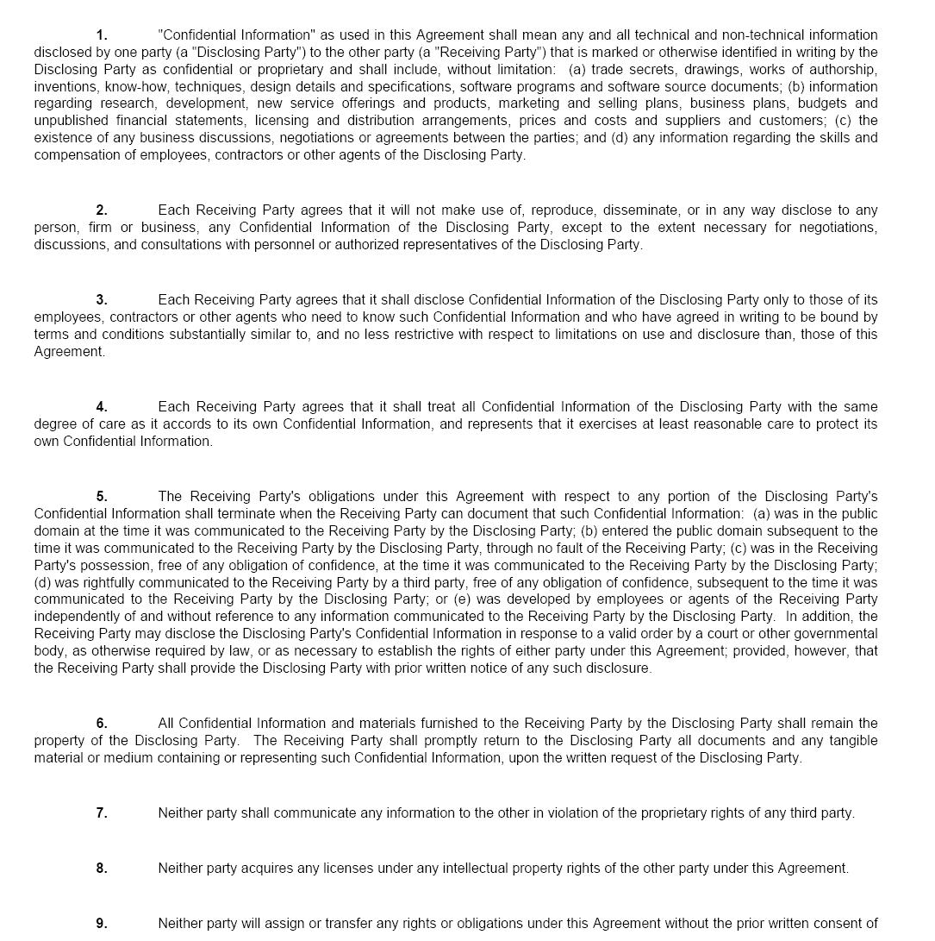

Page 2 of 6

Consignment Agreement
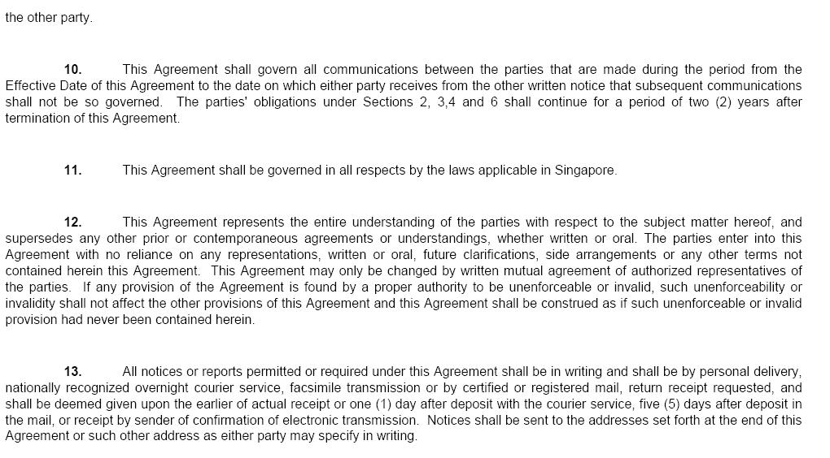

IMPORTANT : PLEASE READ THESE TERMS AND CONDITIONS OF USE CAREFULLY

1. GENERAL

1.1 The User agrees that the access to this Site, use of the services contained in this Site and/or Service are governed by these Terms and Conditions.

1.2 The User agrees and acknowledges that

1.2.1 these Terms and Conditions may be revised by Motor-Way Trading in such manner and at such times as Motor-Way Trading shall in its sole discretion deem fit. Such revisions shall take effect immediately upon publication on this Site, or by notification to the User via e-mail, facsimile or post;

1.2.2 by continuing to use the Motor-Way Trading Service, the User is conclusively deemed to accept the revisions; and

1.2.3 the description of the Motor-Way Trading Service and such other service available in this Site shall be read subject to Terms and Conditions.

1.3 The User further agrees and acknowledges that the respective terms and conditions of the Motor-Way Trading Service Agreement selected by the User for the use of the Motor-Way Trading Service are binding on an applicable to the User, and the User undertakes to abide by the said terms and conditions.

2. DEFINITIONS

2.1 The User agrees that the following words and expressions shall have the meanings set forth below:-

"Fees" | Means the fees and charges for the use of and access to the Motor-Way Trading
 | Service as may be charged by Motor-Way Trading from time to time including (i)
 | any registration fee and (ii) any other fees, taxes, tariffs and charges as may be
 | imposed by the relevant authorities from time to time.
"Registration | Means the registration form in the Site which the User may submit electronically
Form" | through the internet, through mail or facsimile, in connection with his application to
 | use the Motor-Way Trading Service.
"Site" | Means the web site at which Users access the Motor-Way Trading Service.
"Terms and | Means the terms and conditions of use contained herein and any subsequent
Conditions of | modification, addition or alteration thereto.
 | Page 3 of 6

Consignment Agreement

Use"

- Motor-wayMeans Motor-way Trading, deal making arrangement, facilitator and authorized

Trading "consignee herein by consignor etc

- Motor-way Means an e-commerce solution which will empower business and customers to Trading Service" register and choose freely and easily through the Site to arrange car viewing at
pre-defined day and time schedule. In this instance, Sat / Sunday 2pm to 4pm by appointment only arranged by assigned authorized Officer in charge.

"User" | Means the person who access, use the services in this Site and/ or the Motor-way
 | Trading Service.

2.2 The User further agrees that unless the context otherwise requires, the singular include the plural and vice versa; and words importing any gender include every gender and references to persons include bodies corporate and unincorporate.

2.3 The headings if any are inserted for convenience only and shall not affect the construction and interpretation of this Terms and Conditions.

3. Registration

3.1 In submitting the Registration Form, the User warrants and represents that
3.1.1 In the case of an individual user, he or she is of sufficient legal age, not a bankrupt and is capable of being bound by the obligations arising from the use of this Site and/ or the Motor-way Trading Service; 3.1.2 The information provided in the Registration Form is accurate, complete and up to date.

3.2 Upon submission of the Registration Form, Motor-way Trading, shall make available to the User the Motor-way Trading Service, PROVIDED ALWAYS THAT Motor-way Trading MAY IN ITS SOLE DISCRETION

- impose such limitations and restrictions on the Motor-Way Trading until such time as Motor-Way Trading deems fit or has had the opportunity of obtaining further information and documentation from the User;
- refuse to avail the Motor-Way Trading Service to the User altogether.

4. Motor-Way Trading ‘s Obligations

4.1 Subject to the User complying with these Terms and Conditions and paying the Fees as they fall due, Motor-way Trading will use its reasonable endeavours to provide, maintain and avail the Motor-Way Trading Service to the User.
4.2 Motor-Way Trading shall
4.2.1 publish user’s car asking rates on the site;
4.3 Save as aforesaid, the User agrees and acknowledges that
4.3.1 Motor-Way Trading shall maintain and availble the Motor-Way Trading Services on an "as is" basis without any express or implied warranties;

4.3.2 Web details are determined by the respective Motor-Way Trading’s supplier / third party provider and may be revised from time to time by the Motor-Way Trading without prior notice;
4.3.3 Motor-Way Trading is not responsible for the accuracy of the rates published herein; and
4.3.4 Motor- Way Trading cannot and does not guarantee nor warrant the service quality or performance of any sold vehicle and performance status.

5. User's Obligations

5.1 The User agrees and undertakes to
5.1.2 be responsible for the payment of all Fees arising from the transactions
5.1.3 inform Motor-way Trading immediately of any changes or updates to the information provided in the Registration Form;

5.1.5 to pay all Fees in accordance with the manner provided below;
5.1.6 to comply with these Terms and Conditions and the requirements of the Authority on the use of Motor-Way Trading Service;

5.1.7 to comply with the Act and all applicable laws in Singapore and any other relevant jurisdiction relating to the use of Motor-Way Trading Service or any Third Party Services;

6. Use of Motor-Way Trading Service

6.1 The User acknowledges that Motor-way Trading may, in its sole discretion and with or without notice:-
6.1.1 vary, add, subtract from the services available on the Motor-Way Trading Service;
6.1.3 temporarily discontinue the Motor-Way Trading third party provider Service or any part thereof.

7. Fees and Payments

7.1 The User agrees as follows:-
7.1.1 to pay Motor-Way Trading the Fees in the manner selected by the User on the Registration Form as and when they become due and payable without set-off or deduction.

Page 4 of 6

Consignment Agreement

7.1.2 that the records of Motor-Way Trading shall be final and conclusive in respect to the calculation of Fees, and except for any manifest errors.
7.1.3 to pay the Fees within the time period stipulated on Motor-Way Trading ‘s invoice failing which Motor-Way Trading may

- immediately suspend, restrict or terminate the User's access to and use of the Motor-Way Trading Service; and
- charge interest at the rate of 1.5% per month on the outstanding amount until payment has been made in full.

7.1.4 to pay administrative charge of S$ 5.00 for each invoice requested to be printed and mailed to the User at the User's address.
7.1.5 to pay Motor-Way Trading success fee of 2.5% of the selling transacted price.

8. Disclaimer and Limitation of Liability

8.1 The User agrees that Motor-Way Trading is entitled to disclaim
8.1.1 all and any representation, warranty or responsibility
a. in relation to the operational quality or performance of the Motor-Way Trading Service; b. that the Motor-Way Trading Service will be uninterrupted or error free;

c. on the services, operational quality or performance which may be offered by any Telecommunication Brand; and

d. on the fitness for a purpose, merchantability or standard or quality of the Motor-way Trading Service, Telecommunication Brand and any content, goods or services contained in this Site.
8.1.2 all liability for any loss or damage arising out of the access to this Site, use of the Services on this Site, the Motor-way Trading Service and/ or any Telecommunication Brand, including a. any damage to or loss of data suffered by the User;

b. any claim based in contract, tort or otherwise for loss of revenue, profits or consequential loss whether of an economic nature or not;

c. any disruption or suspension of this Site, Motor-Way Trading Service or part thereof, or the Telecommunication Brand;

d. any error, inaccuracy, or computer virus introduced into the User's computer system;
e. any claim relating to content, goods or services supplied, provided, sold or made available in this Site or by Motor-Way Trading, and

f. all and any loss and damage attributable to an event or circumstance beyond Motor-Way Trading control, including but without limitation, acts of God, war, flood, fire explosion, civil disobedience, governmental action, legislation not in force at the of the time of these Terms and Conditions of Use, restraints imposed by governments or any other regulatory authorities, labour disputes, trade disputes or delays of parties.

8.2 The User agrees that in the event Motor-Way Trading is found to be liable to the User for any loss or damage howsoever caused as a result of the use of the Motor-Way Trading Service, the Telecommunication Brand and such other services or facilities found on this Site, Motor-Way Trading’s liability shall in any event not exceed the total fees paid by the User to Motor-way Trading immediately preceding the event giving rise to the right to claim

9. Personal Data and Cookies

9.1 All personal data held by Motor-Way Trading will be kept confidential and in accordance with the Motor-Way Trading Privacy Statement, and the User agrees Motor-Way Trading may disclose or provide such data to the following parties :-

9.1.1 subsidiaries, holding companies, associated companies or affiliates or companies controlled by or under common control with Motor-Way Trading;

9.1.2 any other person who is under a duty of confidentiality to Motor-Way Trading who has undertaken to keep such information confidential;
9.1.3 any financial institutions, charge or credit card issuing companies, credit information or reference, or collection agencies necessary to establish and support the payment of any services being requested; and

9.2 During the User's use of the Site, Motor -Way Trading may issue to and request from your computer blocks of data known as "cookies." The User must not alter any cookies sent to the User's computer from the Site and the User must ensure that the User's computer sends correct and accurate cookies in response to any relevant request from the Site. Cookies enhance the Site's performance by providing a secure method for user identification and improving Site navigation. User privacy and security are not compromised when a User accepts a cookie from the Site.

9. Termination

Either the User or Motor-way Trading may without assigning any reason terminate the use of the Motor-Way Trading Service by prior written notice of one day, provided always that the User remains responsible for the payment of all outstanding Fees and fulfillment of obligations provided in the Terms and Conditions herein.

10. Assignment

Page 5 of 6

Consignment Agreement

11.1 This agreement may be assigned by Motor-Way Trading at any time without the consent of the User.

11.2 The User shall not assign, transfer, convey, license or otherwise dispose of its rights and obligations under the Terms and Conditions of Use to any other party without the prior written consent of Motor-Way Trading.

11. Notices

12.1 All notices required to be given in writing may be given by either party via facsimile or post, and the time of receipt of the notice shall be deemed as follows:-
12.1.1 if by facsimile: upon the successful transmission by the transmitting party; and
12.1.2 if by post: at the expiry of two days from the date of posting.
12.1.3 if by electronic mail, the electronic mail shall be deemed received by
i. the User upon Motor-Way Trading ‘s despatch of the electronic mail in the manner as defined in section 15(1) of the Electronic Transactions Act;

12. Applicable Law

These Terms and Conditions are governed by the laws of Singapore and the parties hereby submit to the non-exclusive jurisdiction of the courts of Singapore.

Page 6 of 6

