Event Plan Outline

Overall Goal(s) for the Event:

Specific Objectives for the Event:

Target Audience:

Topics for Sessions:

When:

Date:

Time:

Where:

Location:

6

Selecting a Planning Committee

Criteria for Selecting Committee Members

Main Function of the Committee

Task(s) Assigned and Deadline(s)

Budget

Future Meeting Dates and Times
Committee Chair Contact Information
Committee Members
Name | Committee Position
Task(s)
Email | Phone Number | Cell Number
Name | Committee Position
Task(s)
Email | Phone Number | Cell Number

7

Establishing a Timeline
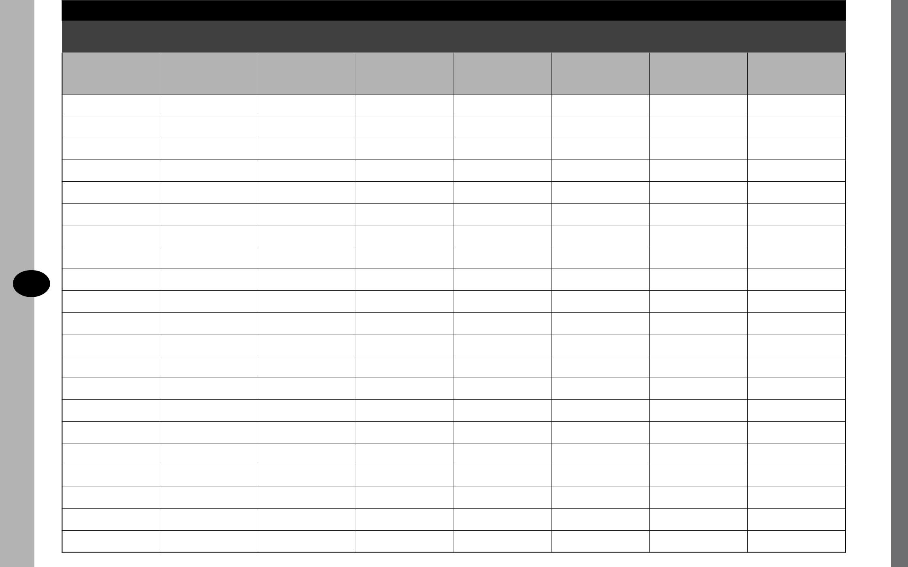

One year | Eight months | Four months | One month | Two weeks | One week | One day before | After event
before | before | before | before | before | before
Select an | Plan the sessions | Plan the ad | Make up an | Pick up any | Reconfirm | Set up equipment | Evaluate the
advisory |  | campaign | equipment list | specialty items | speakers’ | and arrange | event
committee |  |  |  |  | attendance | rooms

8

Planning a Program

Date:
9:00 a.m. - | Registration
9:30 a.m. | Registration
9:30 a.m. - | Opening Address
10:00 a.m. | Chairperson:
10:15 a.m. - | Refreshments
10:30 a.m. | Refreshments
10:30 a.m. - | Select-a-sessions
12:00 p.m. | Select-a-sessions

12:00 p.m. - | Lunch
1:00 p.m. | Lunch
1:00 p.m. - | Select-a-sessions
3:00 p.m. | Select-a-sessions

3:00 p.m. - | Refreshments
3:15 p.m. | Refreshments
3:15 p.m. - | Group Session/Keynote Speaker
4:00 p.m. | Speaker:
4:00 p.m. - | Closing Address
4:30 p.m. | Speaker:

9

Planning a Session

Title

Topic

Description of Presentation

Goal of the Event

Speaker(s)

Committee Member Responsible

Audio Visual Needs
(refer to the master equipment checklist)

Room Set-up

Fees/Expenses/Contracts

Payment Schedule

Thank You

Prepare a page for each session

10

Budgeting for an Event
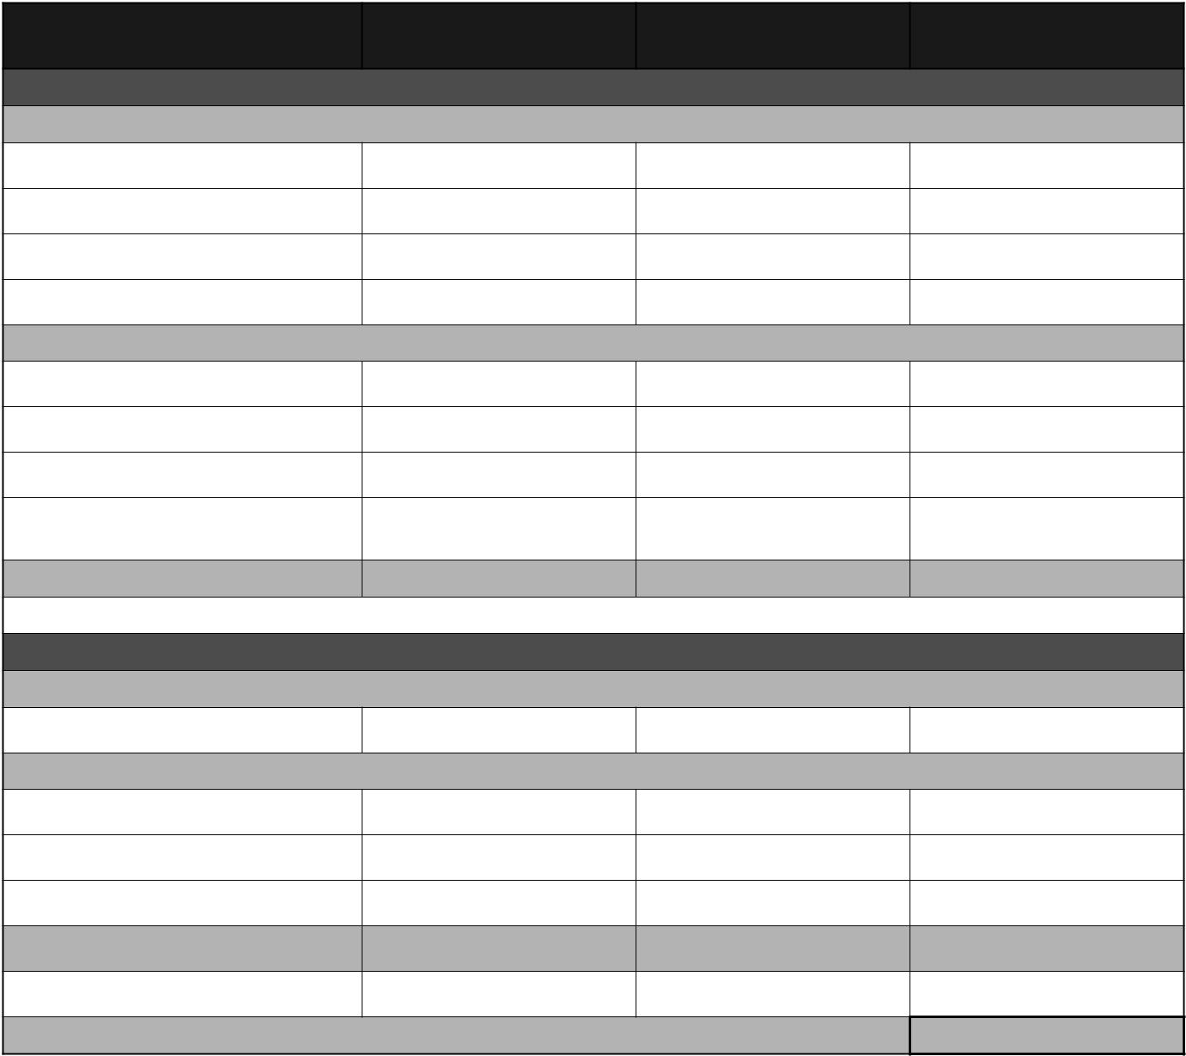

Actual cost of | Projected | Actual
last event | Projected | Actual

Expenses

Fixed Expenses

Facility

Speaker Fees

Refreshments

Advertising

Variable Expenses

Name Tags

Handout Materials

Door Prizes

Miscellaneous (phone, mileage,
photocopying)

Total Expenses

Revenue

Variable Revenue

Registration Fees

Fixed Revenue

Donations

Exhibitors’

Sponsorship

Total Revenue

Profit/Loss

(Total Revenue - Total Expenses = Projected Profit/Loss)

11

Arranging for a Speaker

Name of Session______________________________________________________
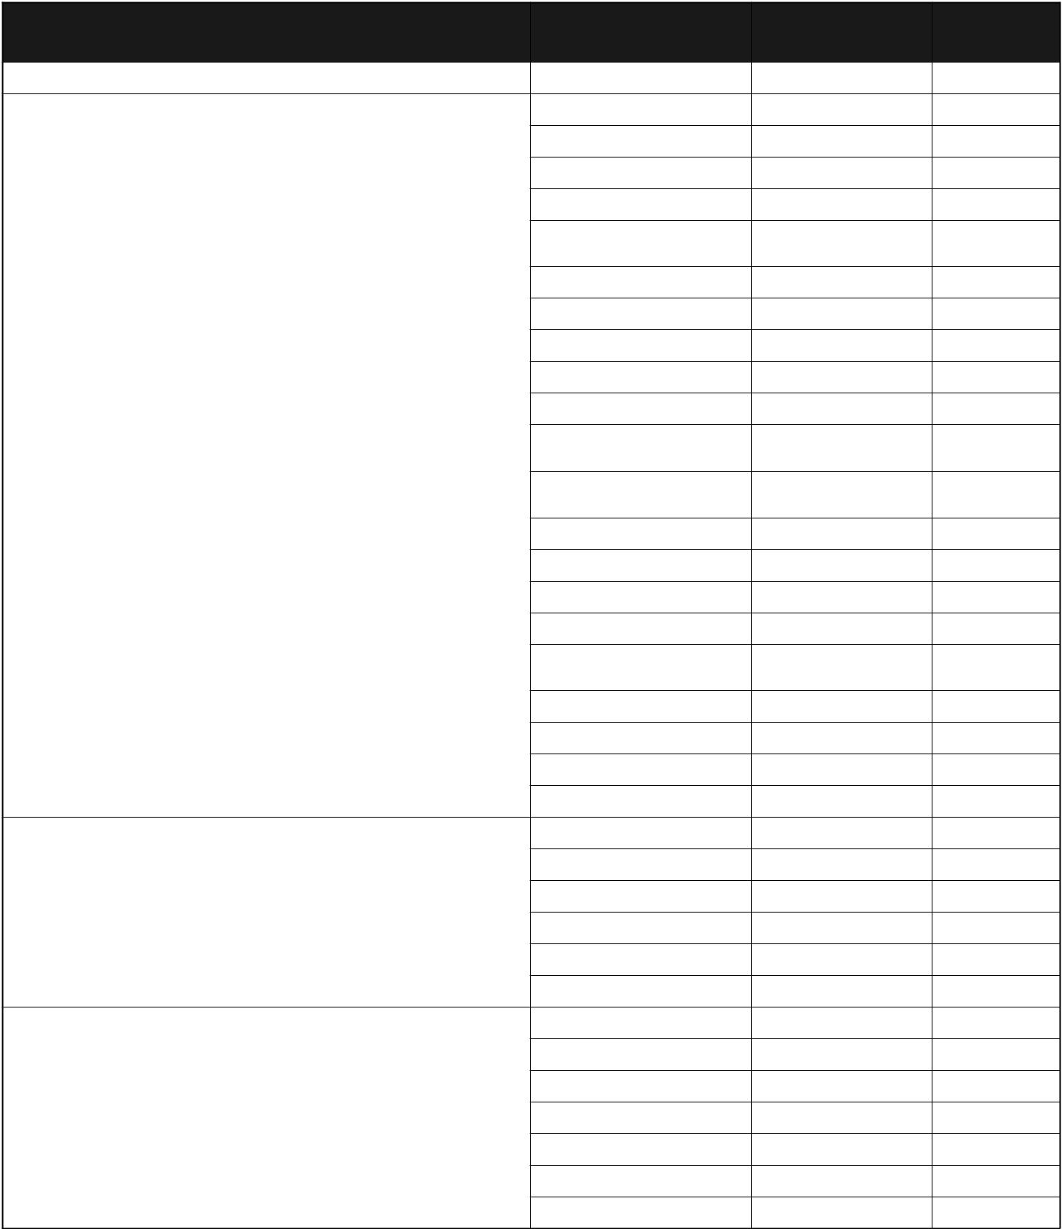

Checklist | Person | Deadline | Done
Checklist | Responsible | Deadline | Done

Determine who the speaker is

Contact the speaker

Outline the following:

- program agenda

- session content

- additional information (website, blog, facebook or twitter page)
- contract – informal/formal

- salary and expenses

- travel arrangements

- accommodations

- meal arrangements

- location of the event (include a map and promotional material)
- contact person who will be be meeting him/her at the event and their contact information
- conference chairperson’s name

Request details concerning:

- information for the person’s introduction

- how the person would like to be introduced

- do they require any special equipment (adapters, special cords, lapel microphones/head set)
- any hand signals/cues the person will be using

- any presentation tools needed (flip charts, etc.)

- room layout

- handouts/photocopying

Assist the speaker

- greet the person

- show the person to the room

- check that all the equipment is there and operating

- load the presentation prior to start of session

- introduce the person

Don’t forget to:

- thank the person and present a gift

- have the person sign payment form

- pay the speaker

- prepare the cheque

- mail the cheque

- complete the form for payment

12

Speaker Profile

Name:

Address:

Website:

Phone number:

Cell number:

Email address:

Educational background:

Personal experience:

How they would like to be introduced:

Meals/travel/accommocations:

Payment arrangements:

13

Booking the Facility and Coordinating Set Up

Name of the facility:_ ____________________________________________________

Address:_______________________________________________________________

Contact person:_________________________________________________________


Checklist | Person | Deadline | Done
Checklist | Responsible | Deadline | Done

Book the facility

- determine what is needed – banquet room, breakout rooms, trade show/display space

- send a letter of confirmation

- state date of use, price, cleanliness, what is included in the price, security access prior to event, set-up and take down times

- determine if there is in-house catering or not

- ask about a deposit and payment schedule

Provide facility manager with a set-up schedule and
agenda

- ask for day-of-event management contact information

Arrange the floor plan for sessions and tradeshow
displays

Plan the table arrangement

- tables for speakers and late comers

- water on speaker’s table

- resource and registration tables

Set up the signs

- directional, breakout rooms, welcome, registration, and sponsors

- no smoking

Miscellaneous

- registration table

- coat rack

- tablecloths

- podium/lectern

- microphones (numbers and type)

- washrooms

- decorations

- room temperature

14

Arranging the Food Service

Caterer:

Type of meal:

Menu:

Special requirements:

Head count:
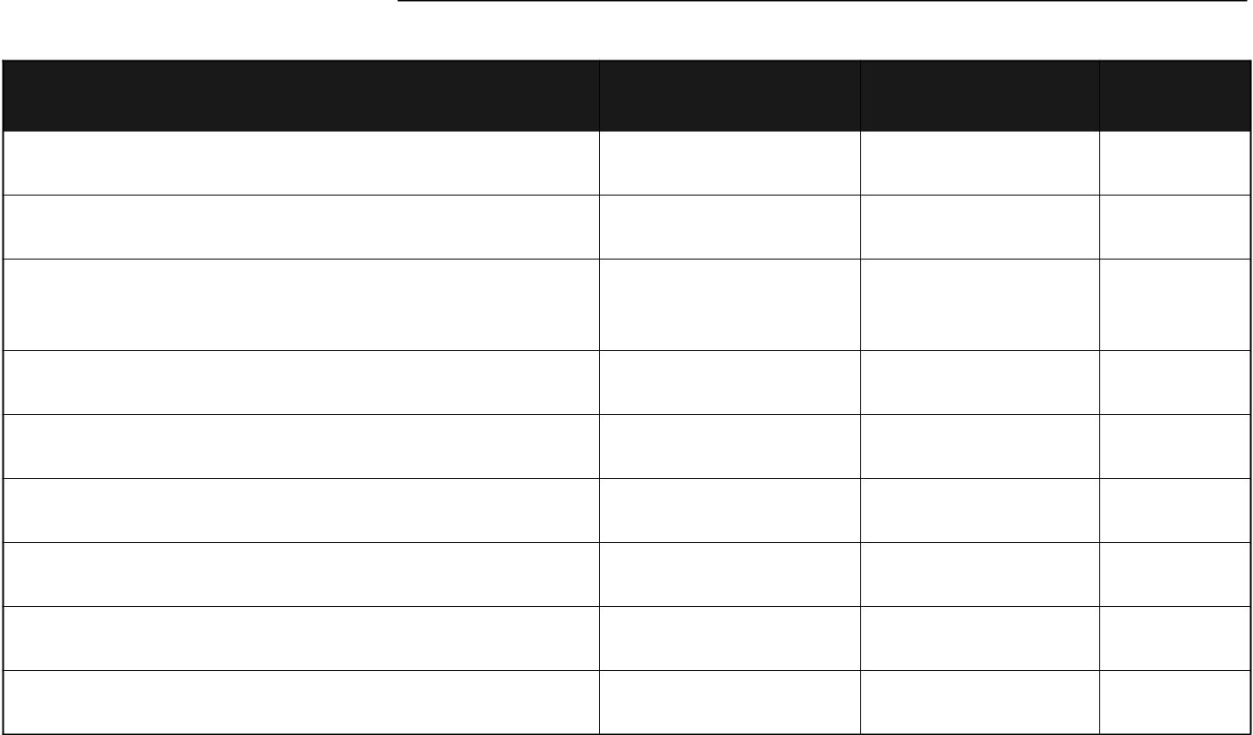

Checklist | Person | Deadline | Done
Checklist | Responsible | Deadline | Done
Contact caterer

Arrange meals - ask about special dietary concerns

Decide on refreshments
- time
- location

Line up entertainment/music for meals

Arrange for grace/O Canada/or similar opening

Order specialty items (i.e. centerpieces, linens)

Provide final head count for meals

Settle final payment

Thank the caterer

15

Planning an Ad Campaign
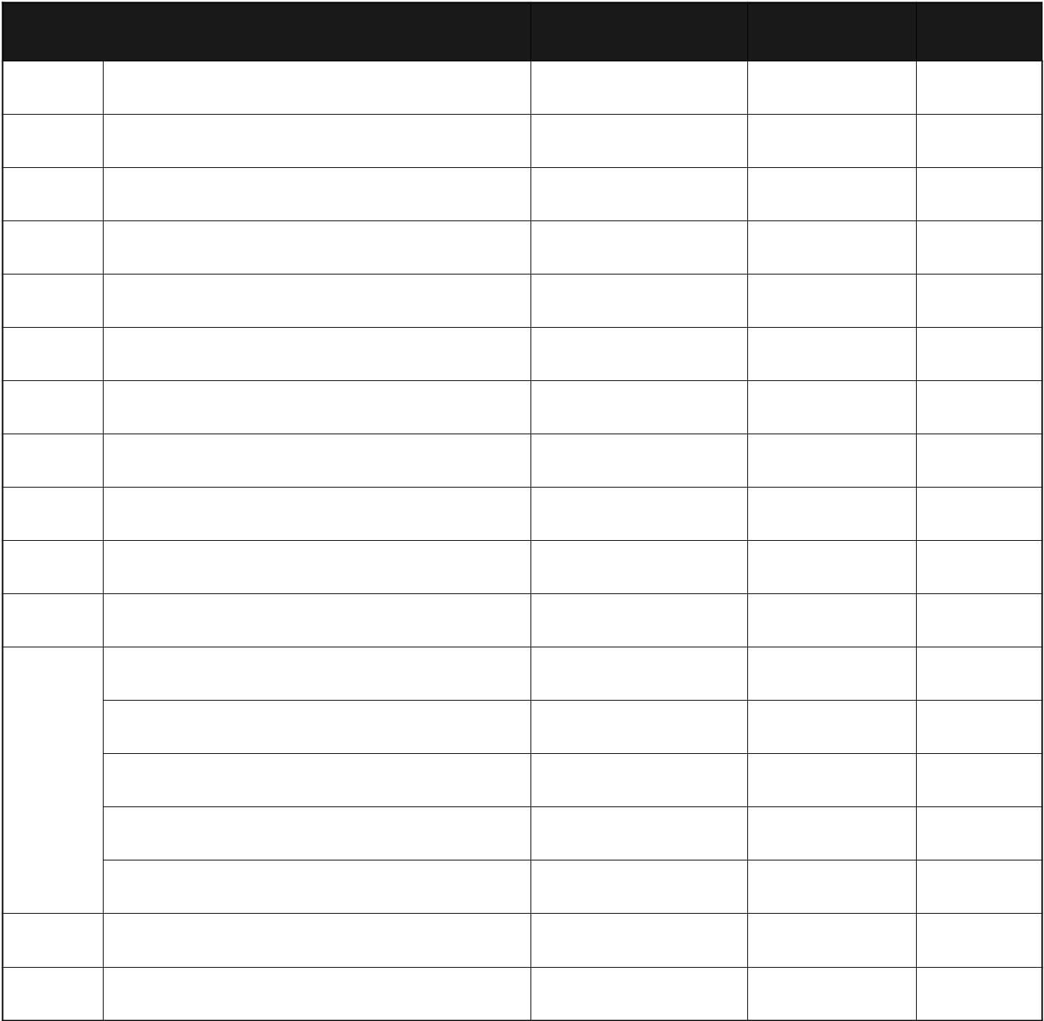

Checklist | Person | Placement | Done
Checklist | Responsible | Deadline | Done

- Community organizations

- Invitations

- Media and press (before and after the event)

- Newsletter

- Newspapers

- Posters

- Notify Public Library

- Contact radio/public service announcements

- Contact local T.V. stations

- Update website/blog

- Create Twitter page

- Create Facebook

- Send mailouts

14 | Contact community organizations

- Send invites/event reminders

- Contact media/press before and after event

Create advertisements for newsletter/
- newspapers

- Design posters

16

Managing Registration
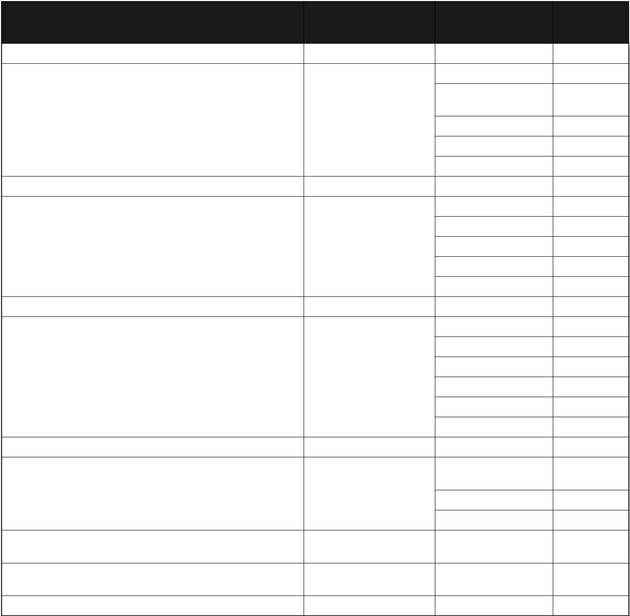

Checklist | Person | Deadline | Done
Checklist | Responsible | Deadline | Done

- Prepare registration forms

  - design

  - include procedures for submissions of form and registration fee

  - include submission deadlines

  - make a final participant count

  - prepare select-a-session participants lists

- Provide name tags

  - select a type

  - order them

  - number them

  - code them for sessions

  - write the names

- Prepare registration materials for participants

  - folders

  - program outline

  - inserts

  - pens/pencils

  - evaluation

  - other

- Arrange on-site registration

  - determine number of people needed to carry out registration

  - provide them with a schedule of the event

  - outline their responsibilities

- Assemble materials needed at the registration desk

  - tape, felt pens, pins, scrap paper, extra name tags, scissors, stapler, etc.

- Handle walk-in registrants

17

Inviting a Special Guest (VIP)


Checklist | Person | Deadline | Done
Checklist | Responsible | Deadline | Done

- Determine whether to invite a VIP

- Determine which VIP to invite

- Identify the person’s role, if any, at the event

- Send letter of confirmation

- Decide where to seat the person

- Greet the person at the event

- Introduce him/her

- Arrange for gifts if needed

- Send a thank you note

- Other

18

Master Equipment Checklist

Person responsible for equipment:

Equipment |  | Sessions | Equipment | Pick Up
(fill in total number needed) |  | Needed For | Source | Date
________ | Flipcharts, tape, markers
________ | Extension cords
________ | Microphones/cords
________ | Podium/lecterns/cords
________ | Screens
________ | DVD player
________ | T.V.’s
________ | Camera for taping session
________ | Camera for pictures
________ | Lighting
________ | Computers and projectors
________ | Internet access
________ | Computer cables
________ | Other

19

Setting up a Display Area
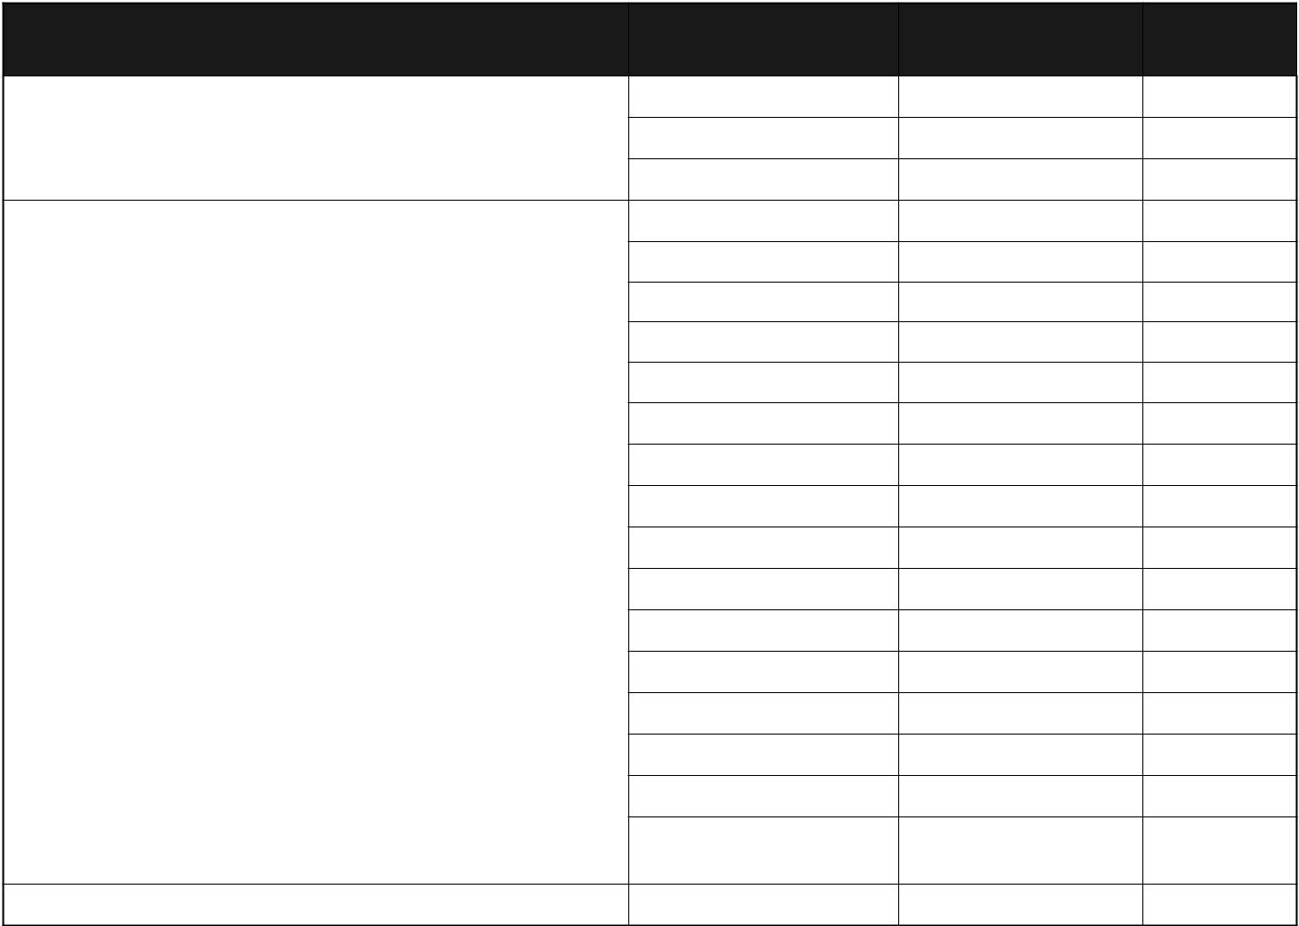

Checklist | Person | Deadline | Done
Checklist | Responsible | Deadline | Done

Determine display area

- number of displays

- type/purchase

Contact exhibitors regarding:

- set-up/tear-down times

- power needs

- internet access

- the floor plan

- availability of tables/backdrops

- any special needs, e.g. lighting

- tradeshow hours

- sponsorship opportunities

- taking in sessions/lunch

- letter of confirmation

- security

- donating a door prize

- fees, charges, if any

- issue of selling for profit

- Send letter of confirmation including a final version of the floor plan outlining the display area

Send a thank you letter

Exhibitors
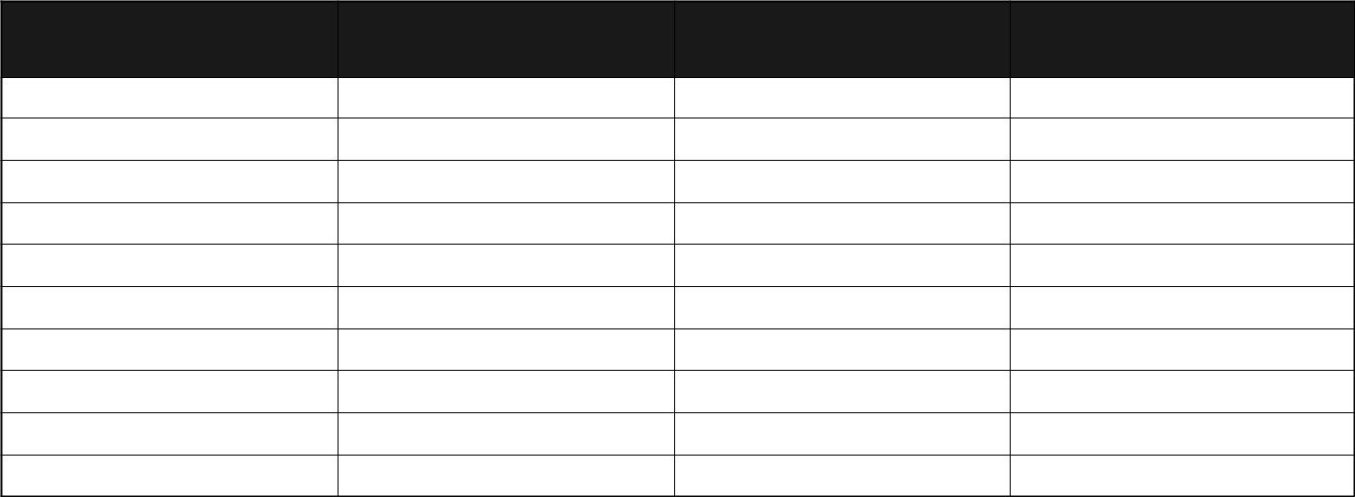

Name (business or | Address | Phone Number | Website and Email
organization) | Address | Phone Number | Website and Email

20

Assembling Registration/ Information Packages
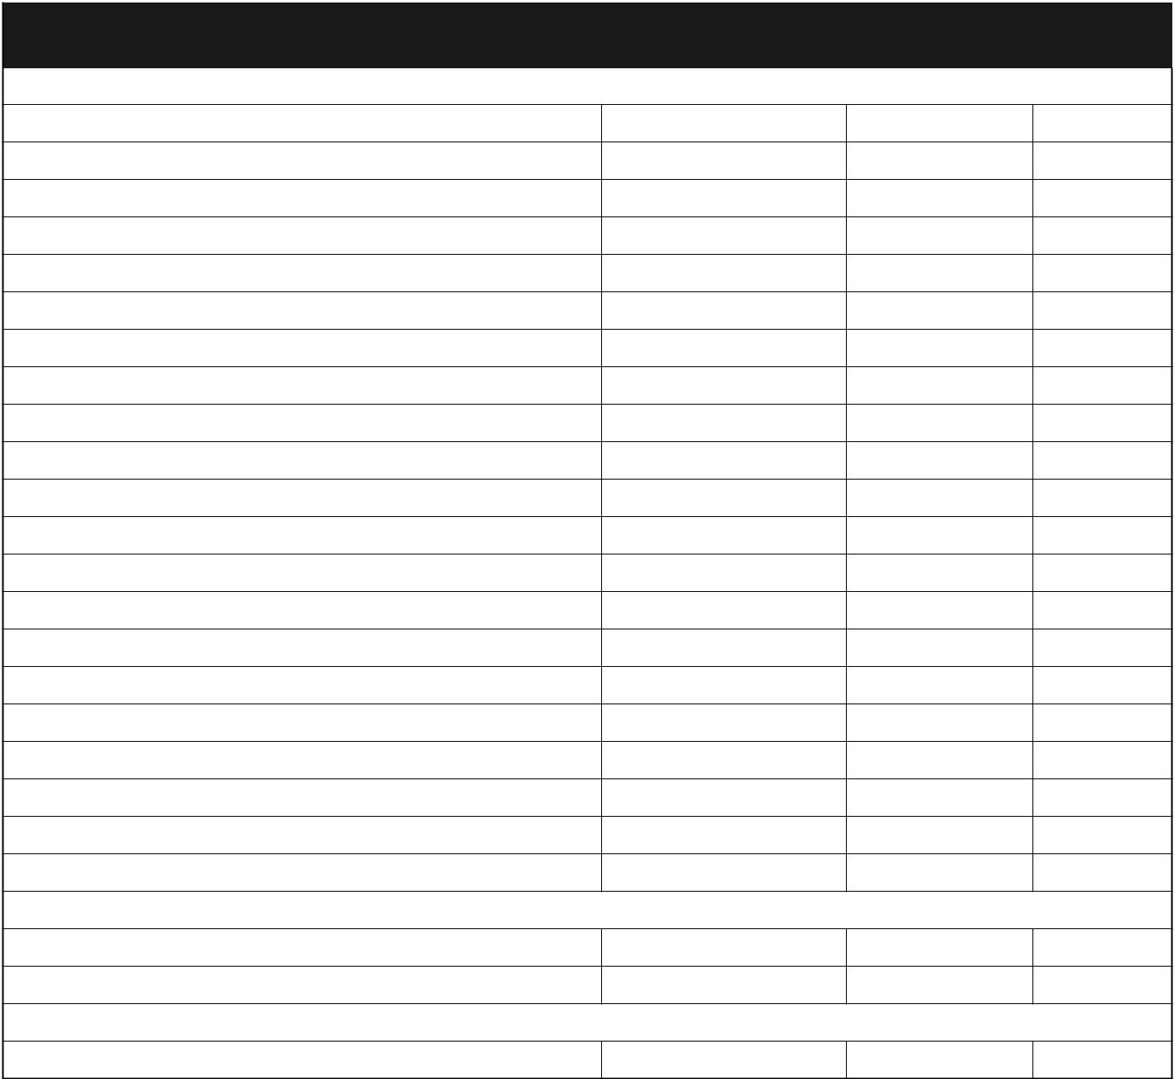

Checklist | Person | Deadline | Done
Checklist | Responsible | Deadline | Done

Develop/design registration/information packages

For participants

Contents:

For speaker(s)

Contents:

For committee members

Contents:

Assemble the package

Location:

Final count: ___________________ Plus 10

Deliver packages to the event

How:

21

Planning an Event Summary Sheet

Name:
Date: |  |  |  |  | Time:
Location: |  |  | Caterer: |  |  |  |  | Phone
Goal:
The Planning Committee |  |  | Phone No. |  |  | Cell No. |  |  |  | Email
Chairperson:
Managing Registration |  |  | Phone No. |  |  | Cell No. |  |  |  | Email
Person(s) responsible
No. of registrants: ______________________
Sessions |  | Speakers |  | Phone No. |  |  | Cell No. |  |  | Email
1.
2.
3.
4.
5.
6.
VIP Guests |  |  |  | Phone No. |  |  | Cell No. |  |  | Email
Equipment For Sessions |  |  |  | Phone No. |  |  | Cell No. |  |  | Email
Person responsible:
Setting Up The Display Area |  |  |  | Phone No. |  |  | Cell No. |  |  | Email
Person responsible:
Other Details



22

Evaluating an Event


Checklist | Person Responsible | Deadline | Done
Design evaluation form
(refer to the sample evaluation included in this booklet)

Set out a container to collect completed evaluation forms
(possibly email survey evaluation)

Compile evaluation results

Distribute evaluation results

Discuss results with advisory committee members

Prepare a final report with recommendations

23

Appendix 1 – Sample Contract Form

This is a contract agreed to on the |  | day of | 20
Between |  |  | (name of organization)
 |  |  | (address)
 |  |  | (phone/cell number)
 |  |  | (email)
and |  |  | (name of speaker)
 |  |  | (address)
 |  |  | (social insurance number)
 |  |  | (phone/cell number)
 |  |  | (email)
The speaker will provide the organization with the following:
For the |  |  | (session title)
At the |  |  | (location)

The contract must be fulfilled by |  | (date).
The cost to the organization will be:
a fixed fee of:
or
Total Hours per Session: |  | x Hourly Fee =
Expenses: | Travel
 | Accommodation
 | Other (itemize) | =
 |  | Total
Payable in accordance with the following terms and conditions:
Authorization Signature |  | Speaker’s Signature
Witness |  | Witness

24

Appendix 2 – Sample Evaluation Form

Name of the event:

Goal:

Objectives:

To what extent were each of the objectives met?

Objective #1 | hardly met | partially met | fully met
Objective #2 | hardly met | partially met | fully met
Objective #3 | hardly met | partially met | fully met

What did you like about the event?

What did you not like about the event?

How did you hear about the event?

Internet/email

Newspaper

Newsletter

Word of Mouth

Friend

Radio

Other

Did you attend the event last year? | yes | no

What would you suggest to the committee responsible for planning a similar event next year?

Additional comments and suggestions.

25

Appendix 3 – Sample Report

Information to include in a final report summarizing an event:

- Name of the event

- Date

- Number of participants

- A review of the goals and objectives of the event

- A description of the people attending the event. Collect information that is useful, for example, the age group, number of men and women, the number attending for the first time and so on.

- How people heard about the event

- A financial statement

- Recommendations for the next event

- A copy of the program

- Date to start organizing next planning committee

26

