Activity #4—Create A Debt Payoff Plan
Now that you have tracked your expenses, started to create a budget and reallocated some of your money to meet your priorities, you’ll want to focus on paying off your debt systematically with our Debt Payoff Plan Worksheet.

Although you may have already created debt pay-off goals in Activity #1, you may end up changing your goals as you review your debt. You now have the added benefit of knowing that you are able to re-allocate some mon- ey to debt payments from your reduction in other spending categories.

We recommend paying off the smallest balance debt first. You can then use this money to make larger debt payments in the future.

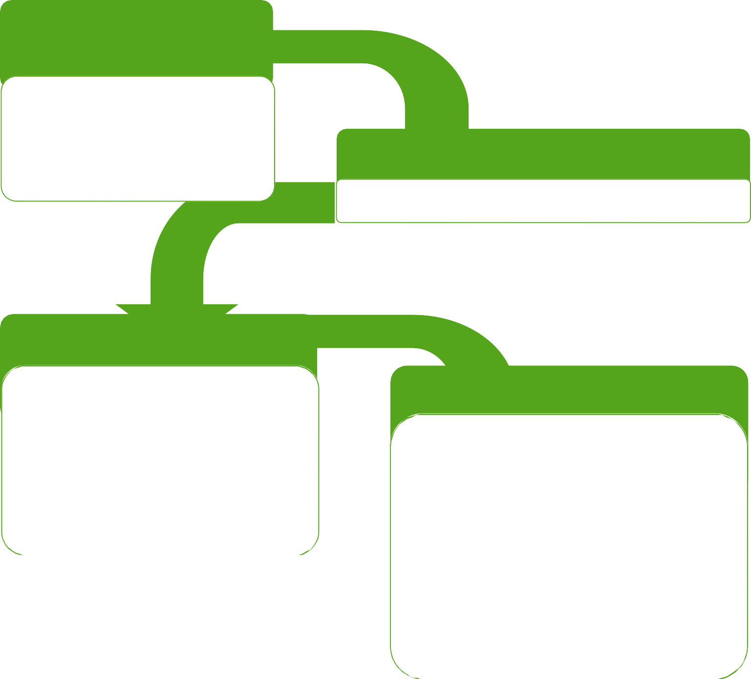
Step 1: Know How Much You Owe
- Write down all of your debts, including the balance, interest rates, minimum monthly payment, credit union and note the payment due dates.

Step 2: Prioritize Debt Payoff
- Prioritize your debt by the smallest to largest balance.

Step 3: Reallocate Money
- Based on the spending changes you’ve made, reallocate some of the money to the lowest balance debt payment.
- Set-up automatic payments to pay this loan off. When you divide your loan payment in half and make a payment each time you get paid, you reduce the amount of interest charged over the life of the loan.

Step 4: Create a Payoff plan
A debt payoff plan targets one debt at a time and systematically pays off your debts over time. When you pay off one debt, you re-allocate and add that money to the minimum balance of the next smallest debt—increasing your payments and paying the loans off faster.

Create a plan using the Payoff Debt example from page 7. You’ll be able to plan when you will pay off the first debt, then the second, third, etc. This will give you peace of mind that you are moving towards paying off your debts faster and on a specific timeline.

Know What You Owe - Credit Cards & Consumer Loans
Know What You Owe - Student Loans
Many people have a sense or urgency to pay off their student loans. We recommend that before additional money be put towards student loans, that you have a plan to continually save to build wealth, and you have paid off your credit cards. Our Project Money participant Katie worked for 7 months to pay off her home improvement credit cards so that she could take the money that she was paying and apply it to her student loans. Katie worked hard to prioritize spending, determine what she needed versus what she wanted, and set specific debt payoff goals as a motivation to not spend on extras. She created savings accounts to save each paycheck for fun and car repairs. Katie is now actively saving, not using her credit cards and putting more than $700 per month to her student loans, reducing the interest and the amount of time she will be paying from 16 to 6 years.
- Access your student loan servicer’s website and research your student loans. Fill in the information below as it relates to your student loan now. Be sure to do additional research into potential payment, consolidation, deferment, forbearance, forgiveness and cancellation options.

Debt Type, Who You Owe, Pay Date | Balance | Interest Rate | Minimum  Monthly Payment | Credit Limit

Servicer & Website | Balance | Interest  Rate | Monthly Payment | Loan Status | Repayment Plan
Federal Loans
Private Loans

My Debt Pay-off Plan
Debt Payoff Plan Example
Here’s how to Create Your Debt Payoff Plan
- Take the extra money you've found in Activity Step #3 and add it to the minimum payment of your small balance debt.
- Once you have paid off the smallest debt, shift the entire payment to the next debt, adding it onto your minimum payment. By rolling one payment into the other, you are creating a larger payment and paying down a bigger part of the debt each time.
- Enter the new payment information into the Budget Worksheet “Future” column.

Use the rest of this worksheet to establish goals and create your debt payoff plan!
Debt to Pay Off Amount | Minimum Payment | New Payment | Goal Date
Store Card  $350 | $25 | $25+ $65 Extra = $90 | 4 months
Store Card #2  $800 | $25 | $25 | 32 months
4 Months Later….
Store Card $350 | $25 | $90 | 4 months
Store Card #2  $800 | $25 | $25 + 90 = $115 | 6 Months

Debt to Pay Oﬀ  Amount | Minimum Payment | New Payment | Goal Date

