[](https://templatelab.com/)

[**© TemplateLab.com**](https://templatelab.com/)

**NAIL SALON**

900-350-1235

kelly.pink@nailsalon.com

4306 Abner Road, Gordon, Wisconsin

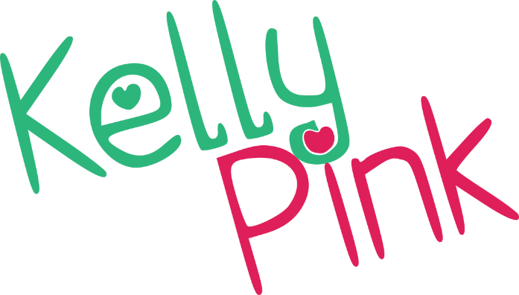

Acrylic Full Set $25

Acrylic Fill $15

Gel Nails Full Set $35

Pink & White Full Set $40

Lorem Ipsum $25

Lorem Ipsum $30

Lorem Ipsum $40

**NAILS CARE**

Nail Design (from) $20

Take Off Acrylic & Colour $25

Gel On Top $10

Nail Repair $10

Nail Ring $10

Lorem Ipsum $50

Lorem Ipsum $70

**NAIL ART DESIGN**

Manicure $25

Pedicure $30

Manicure & Pedicure $50

Manicure Spa $40

Pedicure Spa $45

French or American Manicure $30

Lorem Ipsum $40

**MANICURE & PEDICURE**