[](https://templatelab.com/)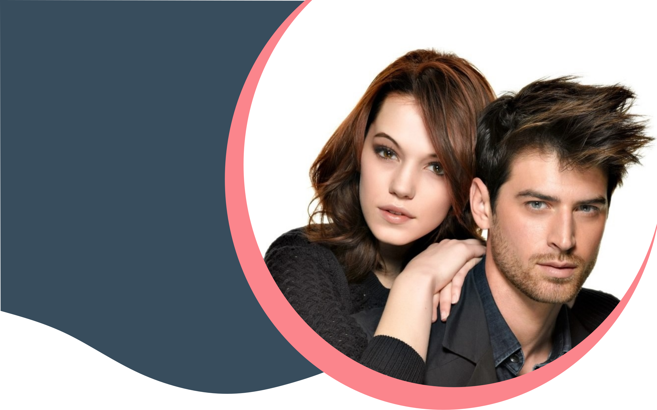

[**© TemplateLab.com**](https://templatelab.com/)

**MEN**

Men’s Haircut $40

Hair Styling $60

Shampoo, Blow & Dry $50

Eyebrow Shave $30

Beard Shave $20

After Shave Soothing Mask $30

Grooming Hands $40

Grooming Feet $30

Lorem Ipsum $50

Lorem Ipsum $20

501 Windfall Avenue, Twin Falls, Washington

**W & M HAIR STUDIO**

385.256.2588 www.wmhairstudio.com

**WOMEN**

Women’s Haircut $50

Blow & Dry Short Hair $40

Blow & Dry Long Hair $50

Shampoo, Blow & Dry Short Hair $60

Shampoo, Blow & Dry Long Hair $70

Bang Trim $50

Hair Styling $80

Make Up $30

Deluxe Manicure $40

Deluxe Pedicure $50

Lorem Ipsum $20

Lorem Ipsum $30

Lorem Ipsum $70

**HAIR**

**SALON**

**PRICE LIST**

PRO Hair Service