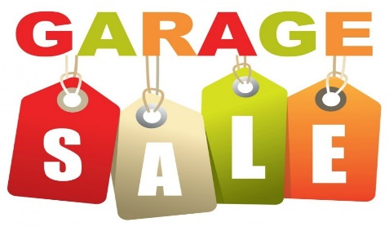 | 743 Riverstone St.  Palm Village, California  202-555-0126  everythingmustgo@domain.com
 |  | Date: <mm/dd/yyyy
 |  | Time: <HH am - HH am>

CLOTHES |  | HOME DÉCOR |  | FURNITURES |  | LAWN CARE
Baby | $0.25 - $1.00 | Lamps | $5.00 - $10.00 | Full Size Bed | $50.00 - $75.00 | Lawnmower (Push) | $30.00 - $75.00
Kids | $0.50 - $3.00 | Throw Pillows | $1.00 - $3.00 | Queen Size Bed | $50.00 - $75.00 | Riding Mower | $200.00 - 500.00
Juniors | $1.00 - $3.00 | Wall Décor | $1.00 - $3.00 | King Size Bed | $50.00 - $75.00 | Weed Eater (Elec) | $5.00 - $10.00
Adult | $1.00 - $3.00 | Mirrors | $20.00 - $40.00 | Night Stand | $20.00 - $30.00 | Weed Eater (Gas) | $15.00 - $30.00
Jackets | $3.00 - $5.00 | Throw Rags | $2.00 - $5.00 | Desk | $20.00 - $50.00 | Edger (Elec) | $5.00 - $10.00
Winter Coats | $05.00 - $10.00 | Area Rugs | $20.00 - $25.00 |  |  | Edger (Gas) | $15.00 - $20.00
Kids Shoes | $0.25 - $1.00 | Baskets | $0.50 - $2.00 | PARTY SUPPLIES |  | Hand Tools | $0.50 - $3.00
Adult Shoes | $0.25 - $1.00 | Curtains (Pair) | $2.00 - $5.00 | Wrapping Paper | $0.50 - $1.00 | Power Tools | $10.00 - $20.00
 |  | Candles | $0.50 - $2.00 | Gift Bags | $0.25 - $0.50
ACCESSORIES |  | Picture Frames (S) | $0.50 - $2.00 | Paper Plates (Set) | $0.50 - $1.00 | OUTDOOR
Hair | $0.50 - $1.00 | Picture Frames (L) | $5.00 - $20.00 |  |  | Patio Table Set | $50.00 - $100.00
Costume Jewelry | $0.50 - $3.00 |  |  | BEAUTY |  | Flower Pots (S) | $0.50 - $1.00
Sunglasses | $0.50 - $5.00 | KITCHEN |  | Shampoo | $1.00 - $2.00 | Flower Pots (L) | $5.00 - $10.00
Bag Packs | $1.00 - $5.00 | Dishes | $0.50 - $1.00 | Conditioner | $1.00 - $2.00 | Garden Bench | $25.00 - $40.00
 |  | Utensils | $0.50 - $2.00 | Body Lotion | $1.00 - $2.00
 |  | Flatware | $0.50 | Nail Polish | $1.00 - $2.00
 |  | Pots and Pans | $3.00 - $10.00
 |  | Appliances (Small) | $5.00 - $10.00
 |  | Drinking Glasses | $0.50 - $1.00
NOTE:
Prices are each unless otherwise noted.

