 |  | ELECTRICAL
 |  | Price List
 |  | 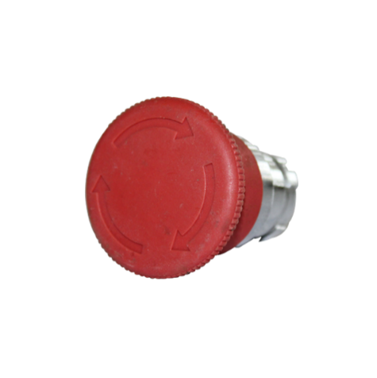
 |  |  |  | PRODUCT NAME #1 |  | Code: | 99900002525
 |  |  |  |  |  | Category: | Electrical 1
 |  |  |  | Compact and easy to use with just one hand. Featuring automatic AC/DC voltage selection, and comes with an integrated kick-stand for complete hands-free use as standard.
 |  |  |  | Supplied with: |  |  | $ 59.99
 |  |  |  | > 9V battery, User manual, Test leads
 |  | 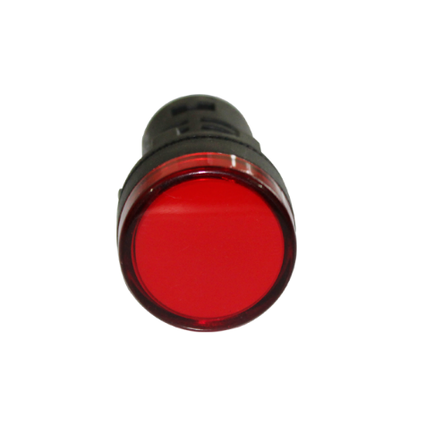
 |  |  |  | PRODUCT NAME #2 |  | Code: | 99900002517
 |  |  |  |  |  | Category: | Electrical 1
 |  |  |  | Lorem ipsum dolor sit amet, consectetuer adipiscing elit. Maecenas porttitor congue massa. Fusce posuere, magna sed pulvinar ultricies, purus lectus malesuada libero, sit amet commodo magna eros quis urna.
 |  |  |  | Supplied with: |  |  | $ 249.99
 |  |  |  | > 9V battery, User manual, Test leads
 |  | 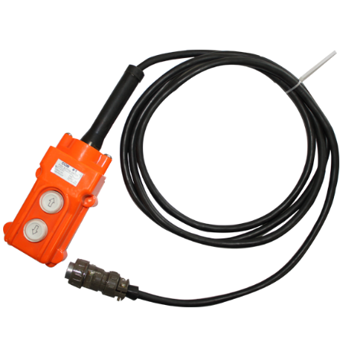
 |  |  |  | PRODUCT NAME 3 |  | Code: | 99900004529
 |  |  |  |  |  | Category: | Electrical 1
 |  |  |  | Lorem ipsum dolor sit amet, consectetuer adipiscing elit. Maecenas porttitor congue massa. Fusce posuere, magna sed pulvinar ultricies, purus lectus malesuada libero, sit amet commodo magna eros quis urna.
 |  |  |  | Supplied with: |  |  | $ 99.99
 |  |  |  | > 9V battery, User manual, Test leads
 |  | 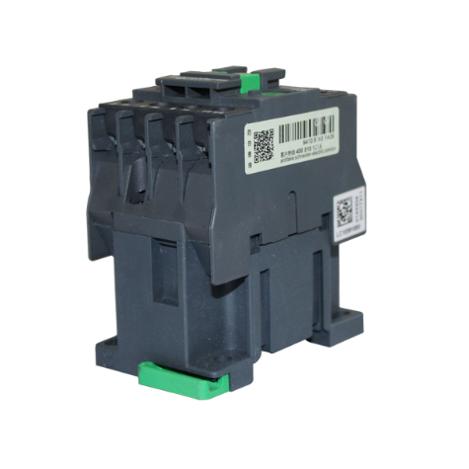
 |  |  |  | PRODUCT NAME #4 |  | Code: | 99900008456
 |  |  |  |  |  | Category: | Electrical 1
 |  |  |  | Lorem ipsum dolor sit amet, consectetuer adipiscing elit. Maecenas porttitor congue massa. Fusce posuere, magna sed pulvinar ultricies, purus lectus malesuada libero, sit amet commodo magna eros quis urna.
 |  |  |  | Supplied with: |  |  | $ 109.99
 |  |  |  | > 9V battery, User manual, Test leads
 |  | © TemplateLab.com |  | Category: ELECTRICAL 1

