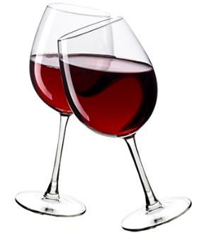 | <Company Name>  2450 Courage St, STE 108  Brownsville, TX 78521  +1 (956) 750 -8000  username@domain.com | BAR PRICE LIST TEMPLATE

Name | Origin | Packaging | Price
Don Jukio 1942 | USA | Bottle (700ml) | $11,600.00
Johnnie Walker Black | USA | Bottle (1 liter) | $1,199.00
2019 Dune Grls de Gris Rose | France | Bottle (750ml) | $477.79
2018 Paul Jaboulet Aine Cotes de Rhone Parallele | France | Bottle (750ml) | $449.38
2018 Le Triporteur | France | Bottle (750ml) | $426.95
Buttercream Chardonnay | USA | Bottle (750ml) | $398.89
Radius Cabernet Sauvignon | USA | Bottle (750ml) | $398.89
Cloud Break Wines Barrel Fermented Chardonnay | USA | Bottle (750ml) | $348.91
2019 Chateau Rose Sainte - Croix | France | Bottle (750ml) | $332.92
Flor de Raim Brut Cava | Spain | Bottle (750ml) | $309.60
Bodegas Nodus "Chaval" Bona | Spain | Bottle (750ml) | $306.79
2015 Red Diamond Winery Chardonnay | USA | Bottle (750ml) | $299.42
Canti Millesimato Prosecco | Italy | Bottle (200ml) | $225.75
Nightshade "Hackiarta" Huckleberry Margarita | Mexico | Bottle (750ml) | $149.46

