[](https://templatelab.com/)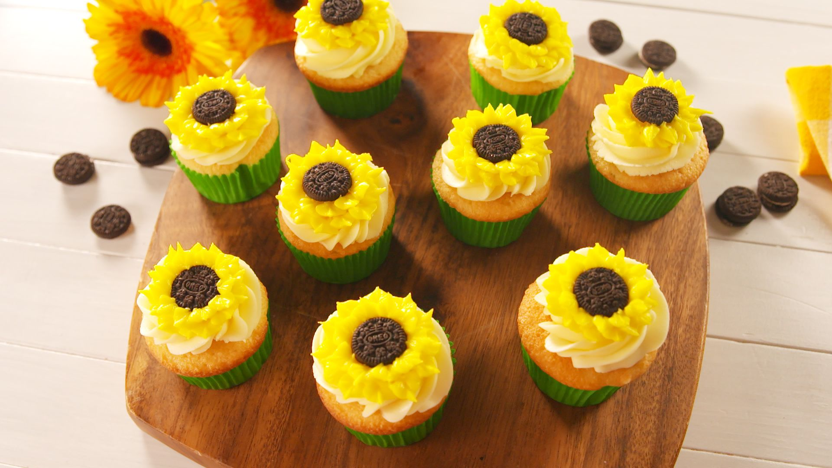

[**© TemplateLab.com**](https://templatelab.com/)

926 Baker Street, Sylvania, Ohio • 585 125 5689

WWW.BAKESALECOMPANY.COM

BAKE SALE



COOKIES $2

BROWNIES $3

MUFFINS $3

CUPCAKES $4

CAKE SLICE $5

WHOLE CAKES $5

PIES $4

ICE CREAM $6

DONUTS $3

LOREM IPSUM $8

LOREM IPSUM $7

OPEN

DAILY

07-19