F r a m e W o r x Arts & Gallery  231 Valley Farms Street  Santa Monica, CA 90403  frameworx@yahoo.com |  | Art Price List Template
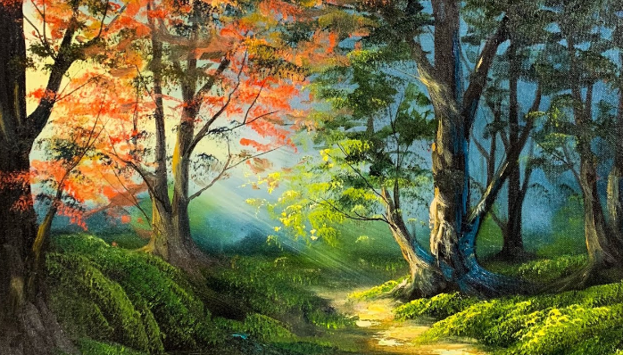 | Ref. No. | 8517512 |  |  | Ref. No. | 8517600
 | Art Title | Way to the Forest |  |  | Art Title | Quite Moment
 | Artist Name | Larry Hamilton |  |  | Artist Name | Leonid Afremov
 | Type | Oil |  |  | Type | Oil on Canvas
 | Size | 32in x 22in |  |  | Size | 34in x 24in
 | Price | $5,000 |  |  | Price | $8,000
 | Ref. No. | 8517512 |  |  | Ref. No. | 8517600
 | Art Title | Way to the Forest |  |  | Art Title | Quite Moment
 | Artist Name | Larry Hamilton |  |  | Artist Name | Leonid Afremov
 | Type | Oil |  |  | Type | Oil on Canvas
 | Size | 32in x 22in |  |  | Size | 34in x 24in
 | Price | $5,000 |  |  | Price | $8,000
 | Ref. No. |  |  |  | Ref. No.
 | Art Title |  |  |  | Art Title
 | Artist Name |  |  |  | Artist Name
 | Type |  |  |  | Type
 | Size |  |  |  | Size
 | Price |  |  |  | Price
 | Ref. No. |  |  |  | Ref. No.
 | Art Title |  |  |  | Art Title
 | Artist Name |  |  |  | Artist Name
 | Type |  |  |  | Type
 | Size |  |  |  | Size
 | Price |  |  |  | Price
 | Ref. No. |  |  |  | Ref. No.
 | Art Title |  |  |  | Art Title
 | Artist Name |  |  |  | Artist Name
 | Type |  |  |  | Type
 | Size |  |  |  | Size
 | Price |  |  |  | Price
 | Ref. No. |  |  |  | Ref. No.
 | Art Title |  |  |  | Art Title
 | Artist Name |  |  |  | Artist Name
 | Type |  |  |  | Type
 | Size |  |  |  | Size
 | Price |  |  |  | Price
 | Ref. No. |  |  |  | Ref. No.
 | Art Title |  |  |  | Art Title
 | Artist Name |  |  |  | Artist Name
 | Type |  |  |  | Type
 | Size |  |  |  | Size
 | Price |  |  |  | Price

