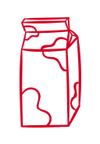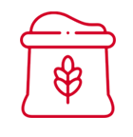

v

v

v

v

v

v

v

v



Other

Home Supplies

Toiletries

v

v

v

v

v

v

v

v

v

v

v

v

v

v

v

v

v

v

v

v

v

v

v

v

v

v

v

v

v

v

v

v

v

v

v

v

v

v

v

v

v

v

v

v

v

v

v

v

v

v

v

v

v

v

v

v

v

v

v

v

v

v

v

v

v

v

v

v

v

v

v

v

v

v

v

v

v

v

v

v

v

v

v

v

v

v

v

v

Beverages

Baked Goods

Snacks

Baking Supplies

Canned Goods

Condiments & Sauces

Grains

Meat / Poultry

Fruits / Vegetables