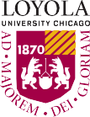
LOYOLA UNIVERSITY CHICAGO SCHOOL of L AW

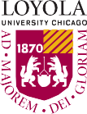
LOYOLA UNIVERSITY CHICAGO SCHOOL of L AW

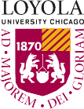
LOYOLA UNIVERSITY CHICAGO SCHOOL of L AW
LOYOLA UNIVERSITY CHICAGO SCHOOL of L AW

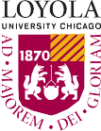
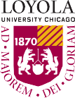
LOYOLA UNIVERSITY CHICAGO SCHOOL of L AW

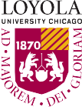
LOYOLA UNIVERSITY CHICAGO SCHOOL of L AW

