LAWN CARE QUOTE TEMPLATE
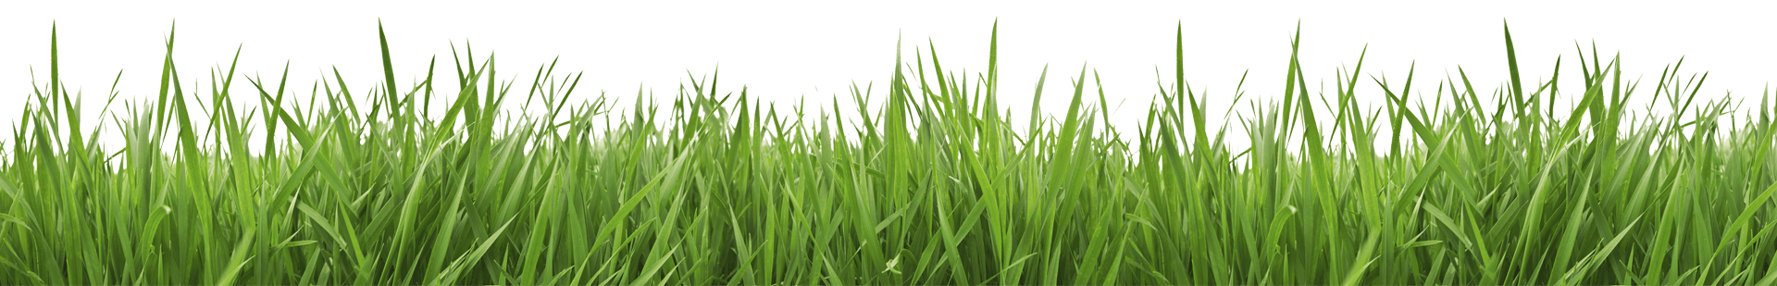
John Smith |  |  |  |  | 8279494 |  |  | mm/dd/yyyy
CUSTOMER |  |  |  |  | QUOTE ID |  |  | DATE
Residence of John Smith at Palm Beach, Florida
LOCATION
 | Services | Cost |  |  | WORK DESCRIPTION
 | Mow | $2,000.00 |  |  | This quote includes the following:  - Mowing (100 sq. meter @ $30/sq. meter)  - Trimming (10 trees @ $50/tree)  - Removal of debris
 | Plant Trim
 | Fertilize
 | Water
 | Weed treatment
 | Patio/Drive/Sidewalk Edging
 | Clearing of area
 | Removal/Hauling of leaves | $250.00
 | Removal/Hauling of branches | $400.00
 | Aerate
 | Thatch
 | Tree Trimming | $500.00
 | Others:
 |  |  |  |  | SCHEDULE
Mobilization will be 5 days upon acceptance of this quote.
Total duration of the project is estimated at 15 working days.
 | Materials | Cost
 | Fertilizer
 | Garbage Dumpster |  |  |  | PAYMENT TERMS (%)
 | Garbage Bin (Large) | $100.00 |  |  | 20 | Acceptance | $650.00
 | Garbage Bin (Medium) |  |  |  | 30 | Mobilization | $975.00
 | Garbage Bin (Small) |  |  |  | 40 | Completion | $1,300.00
 | Others: |  |  |  | 10 | Warranty | $325.00
 |  |  |  |  | COST SUMMARY (US$)
 |  |  |  |  | Labor |  | $3,150.00
 |  |  |  |  | Materials |  | $100.00
 |  |  |  |  | Total |  | $3,250.00
 |  |  |  |  | Total amount is subject to 10% VAT.

