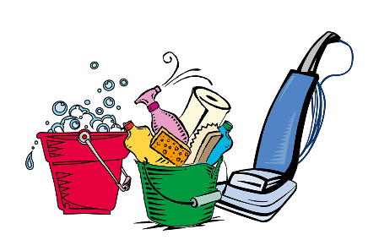
Weekly House Cleaning Checklist

☑ | MONDAY | ☑ | TUESDAY | ☑ | WEDNESDAY
□ | Clean toilets | □ | Wipe kitchen counters | □ | Change bed sheets
□ | Clean bathroom sinks | □ | Clean kitchen sink | □ | Dust bedroom surfaces
□ | Wipe down shower / tub | □ | Clean stove top | □ | Organize bedrooms
□ | Wipe bathroom mirrors | □ | Sweep / Mop kitchen floors | □ | Vacuum bedrooms
□ | Wipe bathroom counters | □ | Wipe down a[[;appliances | □ | Dust blinds / curtains
□ | Mop bathroom floors | □ | Clean or replace sponge | □ | Disinfect bedroom door
□ | Disinfect door knobs | □ | Clean microwave | □ | Disinfect light switches
□ | Disinfect light switches | □ | Take out trashes | □ | Iron clothes
□ | Take our trashes | □ | Toss expired food items | □ | Launder sheets
□ | Launder towels & rugs | □ | Launder rags & dishtowels | □
□ |  | □ | Wipe bathroom walls | □
□ |  | □ |  | □
□ |  | □ |  | □
□ |  | □ |  | □
□ |  | □ |  | □
□ |  | □ |  | □
□ |  | □ |  | □
□ |  | □ |  | □
□ |  | □ |  | □
☑ | THURSDAY | ☑ | FRIDAY | ☑ | WEEKEND
□ | Pickup around the house | □ | Launder dark colors | □ | Clean out/vacuum car(s)
□ | Vacuum living spaces | □ | Clean medicine cabinet | □ | Wash car(s)
□ | Dust shelves & wall arts | □ | Disinfect garbage cans | □ | Mow lawn
□ | Dust blinds & curtains | □ | Clean inside of fridge | □ | Pull weeds
□ | Launder light colors | □ |  | □ | Sweep porch/driveway
□ | Disinfect light switches | □ |  | □ | Water plants
□ | Disinfect door knobs | □ |  | □ | Straighten garage
□ |  | □ |  | □
□ |  | □ |  | □
□ |  | □ |  | □
□ |  | □ |  | □
□ |  | □ |  | □
□ |  | □ |  | □
□ |  | □ |  | □
□ |  | □ |  | □
□ |  | □ |  | □
□ |  | □ |  | □
□ |  | □ |  | □
□ |  | □ |  | □
□ |  | □ |  | □
□ |  | □ |  | □

