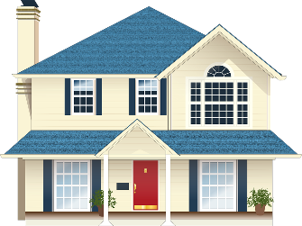 | 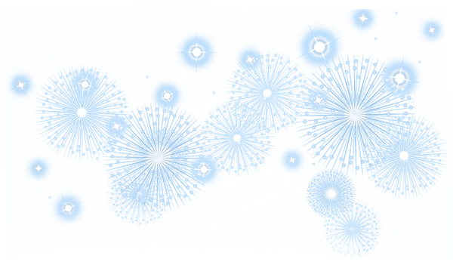  Deep Cleaning House Checklist
☑ | KITCHEN | ☑ | BATHROOMS | ☑ | LAUNDRY ROOM
□ | Wash and put away dishes | □ | Scrub shower walls & fixtures | □ | Empty trash
□ | Wipe down cabinets | □ | Scrub bathtub & faucet | □ | Run cleaning cycle in machine
□ | Organize cabinets | □ | Clean / wash shower curtain | □ | Clean out dryer vents & duct
□ | Throw out expired food | □ | Empty trash | □ | Wipe exterior of washer & dryer
□ | Clean & disinfect fridges | □ | Wash out trash can | □ | Replenish laundry supplies
□ | Organize pantry items | □ | Wipe down mirrors | □
□ | Empty trash | □ | Scrub countertops & sink faucet | □
□ | Scrub inside of microwave | □ | Scrub toilet | ☑ | GARAGE
□ | Wipe down backsplash | □ | Wash rugs | □ | Sweep out floor
□ | Wipe down countertops | □ | Clean out / organize cabinets | □ | Clean up any oil spills
□ | Deep clean oven & stovetop | □ | Clean out / organize drawers | □ | Clean out vehicles
□ | Wipe down appliances | □ | Wipe down cabinets | □ | Take trash
□ | Dust tops of cabinets | □ |  | □ | Put away / organize tools
□ | Scrub & disinfect sink | □ |  | □ | Organize sporting equipment
□ | Clean garbage disposal | □ |  | □
□ | Wash out garbage can | ☑ | BEDROOMS | □
□ |  | □ | Dust tops of dressers/headboard | ☑ | THROUGHOUT THE HOUSE
□ |  | □ | Vacuum drapes | □ | Change air filters
□ |  | □ | Pick up clothes | □ | Change batteries in smoke detectors
□ |  | □ | Wash pillows | □ | Polish wood floors
□ |  | □ | Wash bedding | □ | Steam clean carpets
☑ | LIVING ROOM | □ | Flip and rotate mattress | □ | Change burned out light bulbs
□ | Dust mantel/shelves/frames | □ |  | □ | Dust light fixture
□ | Dust tabletops | □ |  | □ | Dust ceiling / corners of room
□ | Dust electronics | ☑ | CLOSETS | □ | Dust shelves / picture frames
□ | Organize media cabinet | □ | Sort clothes | □ | Dust decorative accents
□ | Stream clean sofas | □ | Take dry cleaning | □ | Dust blinds & window sills
□ | Wash throw pillow covers | □ | Organize items in closets | □ | Dust baseboards
□ | Vacuum drapes | □ | Dust shelves | □ | Dust doors & doorframes
□ |  | □ |  | □ | Sweep / mop / vacuum floors & rugs
□ |  | □ |  | □ | Wash windows
□ |  | □ |  | □
□ |  | ☑ | OFFICE | □
□ |  | □ | File documents | □
□ |  | □ | Backup files on computer | □
☑ | DINNING ROOM | □ | Organize cabinets / drawers | ☑ | OTHERS
□ | Dust top of cabinets / table | □ | Refill office supplies | □
□ | Organize miscellaneous items | □ | Dust desk top & furniture | □
□ | Wipe down table | □ | Dust electronics | □
□ | Polish silver items | □ |  | □
□ |  | □ |  | □
□ |  | ☑ | ENTERWAY | □
□ |  | □ | Dust furniture | □
□ |  | □ | Clean rug / welcome mat | □
□ |  | □ | Organize shoes / coats | □
□ |  | □ |  | □
□ |  | □ |  | □

