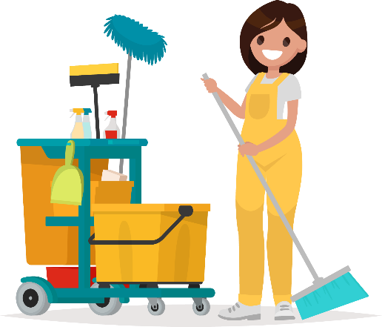 |  | Daily House Cleaning Checklist
Bathrooms |  |  |  | Living Area
□ | Wipe toilet seat |  |  | □ | Vacuum / sweep if needed
□ | Clean mirror & countertop |  |  | □ | Declutter
□ | Wipe off shower / bathtub |  |  | □ | Fold throw blankets
□ | Replace dirty towels |  |  | □ | Straighten throw pillows
□ |  |  |  | □ | Straighten up desks
□ |  |  |  | □ | Put away old papers & notes
□ |  |  |  | □
□ |  |  |  | □
□ |  |  |  | □
□ |  |  |  | □
□ |  |  |  | □
Bedrooms |  |  |  | Miscellaneous
□ | Make beds |  |  | □ | Check mail & get packages
□ | Declutter |  |  | □ | Do one load of laundry
□ | Fold & put away clothes |  |  | □ | Sweep porch
□ |  |  |  | □
□ |  |  |  | □
□ |  |  |  | □
□ |  |  |  | □
□ |  |  |  | □
□ |  |  |  | □
Kitchen |  |  |  | □
□ | Sweep floors |  |  | □
□ | Wash dishes |  |  | □
□ | Clean sink |  |  | □
□ | Wipe down countertops & tables |  |  | □
□ | Take out trash |  |  | □
□ | Replace hand towel (if needed) |  |  | □
□ |  |  |  | □
□ |  |  |  | □
□ |  |  |  | □

