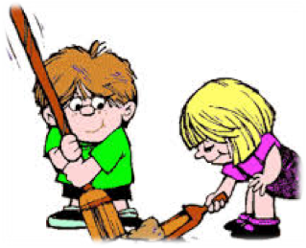Wolf Elective Adventure
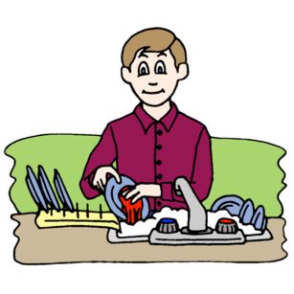Germs Alive – Requirement 6 – Chore Chart

Chore Chart
Chore List | Monday | Tuesday | Wednesday | Thursday | Friday | Saturday | Sunday
Make your bed
Empty trash can
Clean up your toys
Put away your clothes

August 2015

