Preschool Chore Chart

These chore charts were designed to go along with our workbox system, but mainly to help us keep better track of the chores that we have our kids do on a daily basis: some that are ex- pected and some that are paid.

The chart is divided into three parts daily: 3 morning chores, 3 afternoon chores and 3 paid chores. In our house, the morning and afternoon chores must be completed in order for the paid chores to receive compensation.

Our chore charts are laminated and we use a Sharpie to check off the chores that are completed {the Sharpie can be removed with nail polish remover} and we have ‘payday’ once a week.

If you are interested, you can read a more detailed explanation about our chore charts on my blog by following the link below:

http://homeschoolcreations.blogspot.com/search/label/chores

Please feel free to print this pdf file for your own personal use. They were created for private and non-profit use. Please do not sell or host these files anywhere else.

Created by Jolanthe @ http://homeschoolcreations.blogspot.com

Chores Today
Morning
Afternoon
To Earn

Chores Today
Morning
Afternoon
To Earn

Morning
Afternoon
To Earn
Chores Today

Morning
Afternoon
To Earn
Chores Today

Morning
Afternoon
To Earn
Chores Today

Laundry | Laundry | 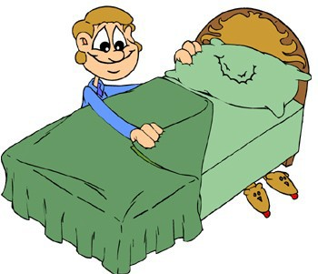  Make Bed | 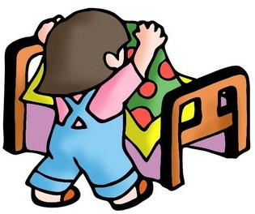  Make Bed
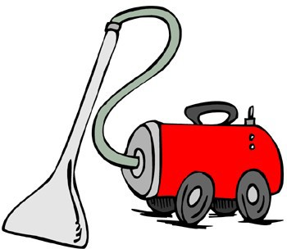  Vacuum | Wash Dishes | Water plants | 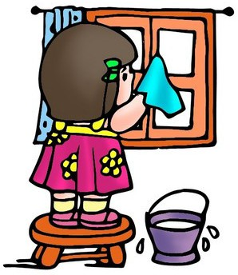  Windows
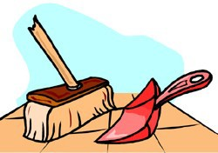  Sweep | Dust | Dishwasher | Devotions
Wash table | 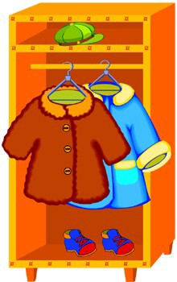  Jackets | 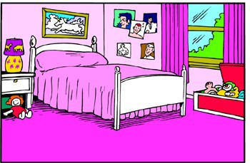  Clean Room | 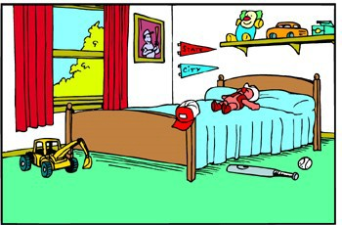  Clean Room
Trash | Trash | 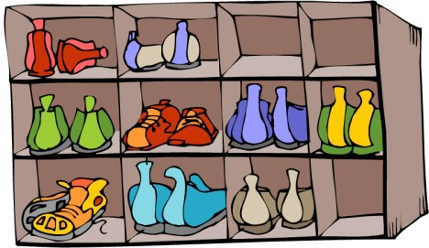  Shoes | 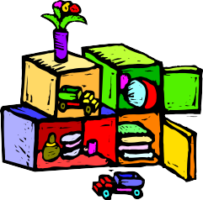  Clean up

Brush teeth | Brush teeth | 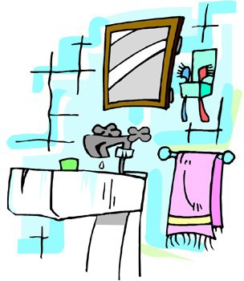  Clean sink | 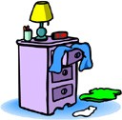  Pick up clothes
Feed pet | Feed pet | Set table | 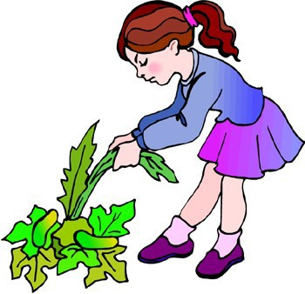  Weed garden
Brush Hair | No Fighting

