Guidelines- Creating Rubrics

Basic Rubric Format: Rubrics should be submitted in table form. When submitting your rubric, please use the attached rubric template, which can be found on MyPGCC or in S: Assessment- Academic Affairs Assessment Materials.

Parts of a Rubric: Each of the components of a Tk20 rubric is identified in the figure below. More comprehensive definitions and necessary information about each part are discussed below the figure.

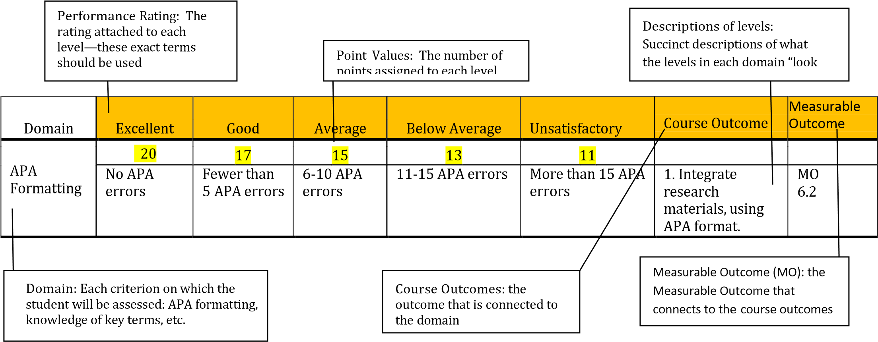
Performance Ratings: Each rubric should have five columns with the following performance ratings (in this order—from left to right):
- Excellent o Good o Average o Below Average
- Unsatisfactory

Point Values: Although the names of the performance ratings are prescribed, you are able to decide the point value for each domain’s level. You do not have to use the same point scale in every domain. For example, your first domain may have a 10- point scale and your second domain may have a 20-point scale.

When using five performance ratings, “excellent” generally equates to an A, “good” equates to a B, “average” equates to a C, etc., so you want to distribute the points across the performance ratings accordingly. For example, for a 20-point domain, the score for “excellent” can range from 19-20 (20 out of 20 equals 100%, 19 out of
20 equals 95%), the score for good can range from 17-16 (17 out of 20 equals 85%, 16 out of 20 equals 80%), and so on. In other words, if a student were to receive a “good” rating for all domains, he or she should earn an overall numeric

OPAIR – verFall2014 – Guidelines – Creating Rubrics Page 1

Guidelines- Creating Rubrics
score that equates to a B (80-89 on a 100-pt. scale).

You have two options when assigning the point values of each cell in a particular domain:

- Option 1: Select a single number for each cell.

Domain | Excellent | Good |  |  | Average |  |  | Below Average |  |  | Unsatisfactory |  |  | Course Outcome | Measurable Outcome
APA  Formatting | 20
 |  |  | 17 |  |  | 15 |  |  | 13 |  |  | 11
 | No APA errors | Fewer than 5 APA errors |  |  | 6-10 APA errors |  |  | 11-15 APA errors |  |  | More than 15 APA errors |  |  | 1. Integrate research materials, using APA format. | MO  6.2

- Option 2: Select two to three numbers per cell, one of which will be selected by the instructor during grading. For example, if the maximum score for the row is 20, in the cell under “excellent,” the instructor could choose a 20, 19, or 18; under “good,” he or she could select 17 or 16, etc. Although the system will accept more than three numbers per cell, the online format becomes difficult to grade if more than three numbers are used; therefore, it is strongly recommended that individual cells don’t exceed three numerical options.

Domain | Excellent |  |  | Good |  |  | Average |  |  | Below Average |  |  | Unsatisfactory |  |  | Course Outcome | Measureable Outcome
APA  Formatting |  | 20, 19, 18 |  |  | 17, 16 |  |  | 15, 14 |  |  | 13, 12 |  |  | 11, 5, 0
 | No APA errors |  |  | Fewer than 5 APA  errors |  |  | 6-10 APA errors |  |  | 11-15 APA errors |  |  | More than 15 APA errors |  |  | 1. Integrate research materials, using APA format | MO 6.2

Description of Levels:

Important things to remember when writing the description of each level:
- Avoid all vague quantities/amounts like some, many, often, and several. One person’s some is another person’s several. It is better to try to quantify these
- with percentages or hard numbers. Instead of “several spelling errors” the suggestion is “four or more spelling errors.”
- Avoid adjectives and adverbs whenever possible. Some of the more common ones used in rubrics are appropriate, appropriately, correctly, clear, clearly, somewhat. One person’s “appropriate” is another person’s

OPAIR – verFall2014 – Guidelines – Creating Rubrics Page 2

Guidelines- Creating Rubrics
“inappropriate.” Instead of “provides an appropriate description” use “provides a description containing …” It is better to fully or partially define the elements of an “appropriate description” and/or provide an example.
- Each level should have distinctly different description. There needs to be a difference between the description of “excellent,” “good,” etc.

OPAIR – verFall2014 – Guidelines – Creating Rubrics Page 3

Domain: For each row, there must be a name identifying what the row/domain is about (e.g., thesis statement, APA formatting, some aspect of content, background, etc.). Distinctly different skills should get their own domain. The skills should be separated so that they can be assessed independently of one another. How many domains a rubric should have depends on the tasks students have to complete, but generally rubrics have between 3 and 7 domains. The combined domains should represent the total performance, i.e. content, presentation, and mechanics.

Course Outcomes, Measureable Outcomes, and Program Outcomes:
- Before creating your rubric, you should check the master course syllabus to ensure that the alignments between course outcomes, program outcomes, and MOs are accurate and are applicable to the assessment being created. If alignments need to be changed, they should be approved by your dean and sent to the Director of Outcomes Assessment and Institutional Effectiveness and the Senior Academic Administrator to the Vice President for Academic Affairs.
- Course outcomes and the corresponding Measureable Outcomes (MOs) should be included on the rubric template. Not all of the MO connections from the master course syllabus should be entered on the rubric template; only those MOs relevant to the rubric domain. For instance, if a particular domain only seeks to measure students’ writing skills, only the MO on writing (1.1) should be connected, even if that course outcome connects to both the MOs for writing (MO 1.1) and speaking (MO1.2) on the Master Course Syllabus.
- For the assessment of General Education courses, in which specific skills that are not necessarily reflected in the course outcomes that must be assessed, MOs can be directly connected to the rubric without a corresponding course outcome. For example, if you are assessing writing skills as a separate domain in your rubric, a domain that isn’t linked to any course content, you could only connect the domain to the writing MO.
- We assess program outcomes through their alignment to course outcomes, as demonstrated by the course map on the master course syllabus. Therefore, course outcomes, as opposed to program outcomes, are primarily tied to rubrics. However, the relevant programs and program outcomes should be listed at the top of the rubric (see template).
- Each domain of the rubric does not have to be tied to a course outcome; however, all course outcomes must be covered in the rubric(s) being used to assess the course.
- In order to get clear data, do not connect a domain to more than two outcomes. One outcome per domain/row is ideal.
- When creating your rubric, include both the number and the text of each course outcome.

Saving and Naming Files: To maintain consistency, all rubrics and assignments should be saved in separate files. Please use the following file name template for rubrics:

Course_Name of Assessment_Type of Document_Draft/Final_Semester & Year

First, list the course name and number, followed by the name of the assessment. Next, indicate the type of document being submitted as “Rubric.” Indicate if the file is a draft or the finalized version. Finally, for the date, include the semester and year that the course is assessed, as opposed to the current semester and year.

Examples:

EGL1010_ResearchEssay_Rubric_Draft_FA14

EGL1010_ResearchEssay_Rubric_Final_FA14

Web Resources for Sample Rubrics:
- Tk20: in the library under “Assessment Tools,” you can see what rubrics other departments at PGCC have used.
- http://rubistar.4teachers.org/--You will need to create an account for this site, but it does not ask for an email address, so you won’t get emails from them. Many of these rubrics are for K-12 and some do not follow best practices, but it is still a good source to get some ideas.
- www.teach-nology.com/
- The University of Alabama’s rubric archive:
http://www.assessment.ua.edu/Rubrics/index.html

Recommended Books about Assignment and Rubric Writing:
- Effective Grading, 2nd edition (2010). Barbara Walvoord and Virginia Anderson
- Introduction to Rubrics (2005). Dannelle Stevens and Antonia Levi

Is this a new assessment or reassessment? new assessment reassessment
If a reassessment, have changes been made to the rubric since the initial assessment? Yes or No
Name of person submitting rubric:
Department:
Course: *If the course number has changed, include the old course number in parentheses after the name and number.
Course Outcomes: *Enter both the number and the text for all outcomes here and in the chart below
Program or Certificate:
Program or Certificate Outcomes: * If this course is being used to assess more than one program, please make sure that a course map has been completed for each program.

 | Excellent | Good | Average | Below Average | Unsatisfactory | Course Outcomes | Measurable Outcomes
Domain
 | Points: | Points: | Points: | Points: | Points:
 | Points: | Points: | Points: | Points: | Points:
 | Points: | Points: | Points: | Points: | Points:
 | Points: | Points: | Points: | Points: | Points:
 | Points: | Points: | Points: | Points: | Points:
 | Points: | Points: | Points: | Points: | Points:
 | Points: | Points: | Points: | Points: | Points:
 | Points: | Points: | Points: | Points: | Points:
 | Points: | Points: | Points: | Points: | Points:
 | Points: | Points: | Points: | Points: | Points:

OPAIR – verFall2014 – Guidelines – Creating Rubrics

Assessing Multiple Programs with a Single Assessment.
If you are assessing multiple programs with a single course, please make sure that you have filled out a course map (see below) for each program and submit these forms with your rubric.

Department:
Course:
Course  Outcome (Number and Outcome) | Program  Name: | Program  Name: | Program  Name: | Program  Name: | MOs
 | Program  Outcomes (Number and  Outcome) | Program  Outcomes (Number and  Outcome) | Program  Outcomes (Number and  Outcome) | Program  Outcomes (Number and  Outcome)
1.
2.
3.
4.
5.
6.
7.
8.

OPAIR – verFall2014 – Guidelines – Creating Rubrics

Template for Rubrics

OPAIR – verFall2013- Template – Rubrics Page 9

Template for Rubrics

OPAIR – verFall2013- Template – Rubrics Page 10

OPAIR – verFall2013- Template – Rubrics Page 11

