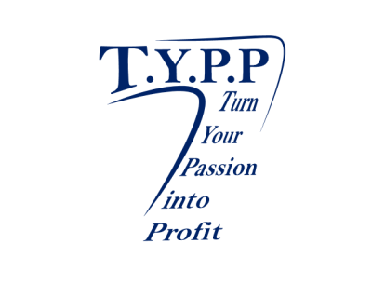
Turn Your Passion into Profit

Scholarship Program 2015

- DEADLINE for scholarship applications is Friday May 15, 2015 by 5:00 p.m. (no exceptions).
- Refer to criteria below for eligibility requirements.
- Refer to application process below for a list of the supporting documents needed (i.e., evidence of GPA.) Incomplete applications will not be considered.
- Submissions should be e-mailed to typp12@sbcglobal.net or mailed to PO Box 2430 Manteca, CA 95336.
- All submissions should be typed.
- The selections will be announced on Senior Night at Delta Charter High school and Lathrop High school. The recipients will be notified prior.
- If you have any questions about the application, please e-mail (Mary Kennedy) typp12@sbcglobal.net.

NOTE: Scholarship funds will be awarded to the student’s institution, upon evidence of registration in classes. This includes student identification number and correct address of school’s Registrar's Office.

Award Components: One(1) $250 scholarships will be awarded to One(1) students selected by Turn Your Passion into Profit..

Criteria:
- Applicant must be graduating from Delta Charter High School /Lathrop High School’s Senior Class in 2015.
- Applicant must demonstrate a positive impact consistent with capacity and circumstances. We will look at employment and involvement in the community and at school.

Components of Application
A. The following items must be attached to this application in order for the application to qualify to be reviewed by the scholarship committee.
Circle “YES” or “NO” to be sure you have attached each item as required.
 | YES | NO | Letter of recommendation.
 | YES | NO | Proof of college acceptance or current student enrollment must be produced, if selected as recipient. Scholarship will go directly to institution to be applied to tuition costs.
 | YES | NO | Most recent high school transcript.
 | YES | NO | Personal Essay. How do you have a positive impact in your community, school, family, etc.?

STATEMENT OF ACCURACY

I hereby affirm that all the above stated information provided by me is true and correct to the best of my knowledge. I also consent that my picture may be taken and used for any purpose deemed necessary to promote the Turn Your Passion into Profit scholarship program.

I hereby understand that if chosen as a scholarship winner, I must provide evidence of enrollment/registration at the post-secondary institution of my choice before scholarship funds can be awarded. They will be presented directly to institution. The scholarship will be mailed directly to the college of your admission.

Signature of scholarship applicant: _________________________________ Date: _______________________

REMEMBER

The Deadline is Friday, May 15th, 2015 at 5:00pm. Applications sent after 5:00pm will not be considered.

1 | What are your educational and professional goals?

2 | List your academic honors, awards and membership activities while in high school:

3 | List your community service activities, hobbies, outside interests, and extracurricular activities:

4 | Personal Essay  Turn Your Passion into Profit corporate purpose is, in part, to have a positive impact on all who come in contact with Turn Your Passion into Profit. How have you had a positive impact on those you come in contact with, and how do you plan to continue to positively influence people?

Thank you for your interest and we look forward to working with you.

Sincerely,

Mary Kennedy-Bracken Turn Your Passion Into Profit CEO/Founder www.themarykennedy.com

