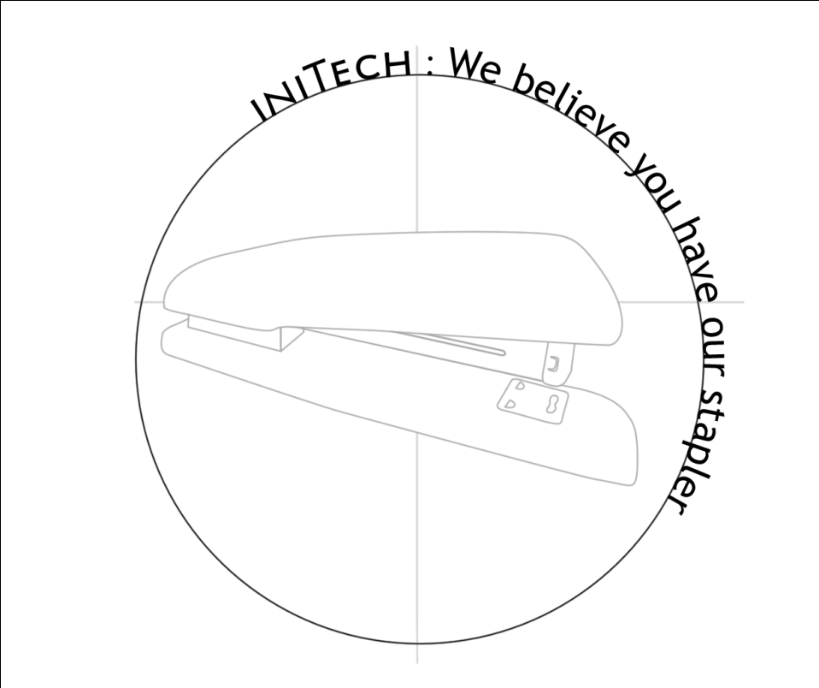

Technical

MANUAL

HOPE System

iNiTech

November 2010

Revision Sheet

Release No. | Date | Revision Description
Rev. 0 | 10/01/2010 | User’s Manual Template and Checklist
Rev. 1 | 10/10/2010 | Initial Work
Rev. 2 | 10/20/2010 | Revision 1: To Reflect Prototype 1.0
Rev. 3 | 11/10/2010

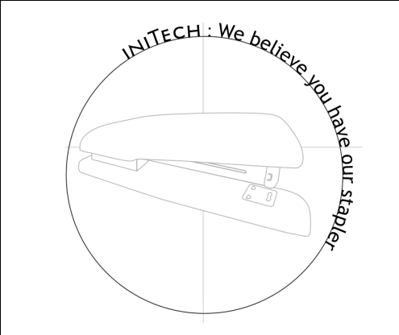

User’s Manual
Authorization Memorandum

I have carefully assessed the User’s Manual for iNiTech’s Hope System. This document has been completed in accordance with the requirements of System Development Methodology.

MANAGEMENT CERTIFICATION - Please check the appropriate statement.

______ The document is accepted.

______ The document is accepted pending the changes noted.

______ The document is not accepted.

We fully accept the changes as needed improvements and authorize initiation of work to proceed. Based on our authority and judgment, the continued operation of this system is authorized.

_______________________________ _____________________
NAME DATE
Project Leader

_______________________________ _____________________
NAME DATE
Operations Division Director

_______________________________ _____________________
NAME DATE
Program Area/Sponsor Representative

_______________________________ _____________________
NAME DATE
Program Area/Sponsor Director

USER'S MANUAL

TABLE OF CONTENTS

Page #

A. GENERAL INFORMATION A-1
1.1 System Overview A-1
1.2 Project References A-2
1.3 Authorized Use Permission A-2
1.4 Points of Contact A-2
1.4.1 Information A-2
1.4.2 Coordination A-2
1.4.3 Help Desk A-2
1.5 Organization of the Manual A-2
1.6 Acronyms and Abbreviations A-3
B. SYSTEM SUMMARY B-1
2.1 System Configuration B-1
2.2 Data Flows B-1
2.3 User Access Levels B-1
C. GETTING STARTED C-1
3.1 Logging On C-1
3.2 System Menu C-1
3.2.x [System Function Name] C-1
3.3 Changing User ID and Password C-1
3.4 Exit System C-1
D. USING the SYSTEM (ONline) D-1
4.x [System Function Name] D-1
4.x.y [System Sub-Function Name] D-1
4.2 Special Instructions for Error Correction D-1
4.3 Caveats and Exceptions D-1
A. Appendix D-1
B. Appendix D-2

1.0 GENERAL INFORMATION

NOTE TO AUTHOR: highlighted, italicized text throughout this template is provided solely as background information to assist you in creating this document. Please delete all such text, as well as the instructions in each section, prior to submitting this document. ONLY YOUR PROJECT-SPECIFIC INFORMATION SHOULD APPEAR IN THE FINAL VERSION OF THIS DOCUMENT.

The User’s Manual provides the information necessary for the user to effectively use the automated information system.

GENERAL INFORMATION

1.1 System Overview

An intelligent aid for impaired individuals:

- A software system based on the Windows 7 SmartPhone Platform.
- Graphical Scheduler system for notification
- User Medical Referencing System
- GPS / Electronic Compass Location
- System name or title: HOPE
- System code: WP7
- System category:
- Major application: performs clearly defined functions for which there is a readily identifiable security consideration and need
- General support system: provides general ADP or network support for a variety of users and applications
- Operational status:
- Partially Operational
- Under development

1.2 Project References

References that were used in preparation of this document in order of importance to the end user.

http://msdn05.e-academy.com/utd_cs
http://create.msdn.com/en-us/home/getting_started
http://windowsteamblog.com/windows_phone
http://www.microsoft.com/windowsphone/en-us/howto/wp7/default.aspx
http://social.msdn.microsoft.com/Forums/en-US/windowsphone7series
http://channel9.msdn.com/Learn/Courses/WP7TrainingKit/WP7GettingStarted
http://en.wikipedia.org/wiki/WP7

1.3 Authorized Use Permission

iNiTech provides you with access to a variety of resources on this website (“Web Site”), including documentation and other product information (collectively the “Documentation”), download areas, communication forums, and other services (collectively "Services"), software, including developer tools and sample code (collectively “Software”), and Application Program Interface information (“APIs”). The Documentation, Services, Software, and APIs (including any updates, enhancements, new features, and/or the addition of any new Web properties to the Web Site), are subject to the following Terms of Use ("TOU"), unless we have provided those items to you under more specific terms, in which case, those more specific terms will apply to the relevant item. Microsoft reserves the right to update the TOU at any time without notice to you. The most current version of the TOU can be reviewed by clicking on the "Terms of Use" hypertext link located at the bottom of our Web pages.

1.4 Points of Contact

1.4.1 Information

The points of organizational contact (POCs) that may be needed by the document user for informational and troubleshooting purposes are currently not available.

1.4.2 Coordination

The list of organizations that require coordination between the project and its specific support function (e.g., installation coordination, security, etc.) are currently not available.

1.4.3 Help Desk

Help desk information including responsible personnel phone numbers for emergency assistance is currently not available.

1.5 Organization of the Manual

User’s Manual v0.01.

1.6 Acronyms and Abbreviations

Provide a list of the acronyms and abbreviations used in this document and the meaning of each.

App: Application
MS: Microsoft
MSDN: Microsoft Developer Network
Wiki: Wikipedia
WP7: Windows 7 SmartPhone Platform

2.0 SYSTEM SUMMARY

SYSTEM SUMMARY

This section provides a general overview of the system written in non-technical terminology. The summary should outline the uses of the system in supporting the activities of the user and staff.

2.1 System Configuration

Windows Phone features a new user interface, based upon Microsoft's Windows Phone 7 design system, codenamed Metro. The home screen, called the "Start screen", is made up of "Tiles". Tiles are links to applications, features, functions and individual items (such as contacts, web pages, applications or media items). Users can add, rearrange, or remove Tiles. Tiles are dynamic and update in real time - for example, the tile for an email account would display the number of unread messages or a Tile could display a live update of the weather.

2.2 Data Flows

Users input text by using an on-screen virtual keyboard, which has a dedicated key for inserting emoticons. Spell checking and word prediction are supported, and users may change a word after it has been typed by tapping the word; similar words that may have been the word the user was trying to type will then be suggested as alternatives.

2.3 User Access Levels

The Primary user and family member and authorized user may be able to add and modify data and information.

3.0 GETTING STARTED

GETTING STARTED

This section provides a general walkthrough of the system from initiation through exit. The logical arrangement of the information shall enable the functional personnel to understand the sequence and flow of the system. Use screen prints to depict examples of text under each heading.

3.1 Logging On

A user ID and password is required to log onto web interface.

3.2 System Menu

This section describes in general terms the system menu first encountered by the user, as well as the navigation paths to functions noted on the screen. Each system function should be under a separate section header, 3.2.1 - 3.2.x.

3.2.x [System Function Name]

Provide a system function name and identifier here for reference in the remainder of the subsection. Describe the function and pathway of the menu item. Provide an average response time to use the function.

3.3 Changing User ID and Password

Sign in to the Web Interface.
Click Settings at the top of the main page, and open the Accounts and Import tab.
Click on Account settings.
In the new window, click Change password under the Personal information option.
Enter your current password and your new password.

3.4 Exit System

Click on Exit.

4.0 USING THE SYSTEM (ONLINE)

This section provides a detailed description of the online system from initiation through exit, explaining in detail the characteristics of the required input and system-produced output. THIS SECTION IS ONLY TO BE USED FOR ONLINE SYSTEMS. IF YOU ARE DEVELOPING A BATCH SYSTEM, USE SECTION 5.0 AND OMIT THIS SECTION ENTIRELY.

USING the SYSTEM (ONline)

This section provides a detailed description of system functions. Each function should be under a separate section header, 4.1 - 4.x, and should correspond sequentially to the system functions (menu items) listed in subsections 3.2.1 - 3.2.x.

4.x [System Function Name]

Provide a system function name and identifier here for reference in the remainder of the subsection. Describe the function in detail and depict graphically. Include screen captures and descriptive narrative.

4.x.y [System Sub-Function Name]

This subsection provides a detailed description of system sub-functions. Each sub-function should be under a separate section header, 4.1.1. - 4.x.y . Where applicable, for each sub-function referenced within a section in 4.x, describe in detail and depict graphically the sub-function name(s) referenced. Include screen captures and descriptive narrative.

The numbering of the following two sections will depend on how many system functions there are from 4.1 through 4.x. They are numbered here as 4.2 and 4.3 only for the sake of convenience. For example, if system functions run from sections 4.1 through 4.17, then the following two sections would be numbered 4.18 and 4.19.

4.2 Special Instructions for Error Correction

As a condition of your use of the Services, you will not use the Services for any purpose that is unlawful or prohibited by these terms, conditions, and notices. You may not use the Services in any manner that could damage, disable, overburden, or impair any Microsoft server, or the network(s) connected to any Microsoft server, or interfere with any other party use and enjoyment of any Services. You may not attempt to gain unauthorized access to any Services, other accounts, computer systems or networks connected to any Microsoft server or to any of the Services, through hacking, password mining or any other means. You may not obtain or attempt to obtain any materials or information through any means not intentionally made available through the Services.

4.3 Caveats and Exceptions

The services that iNiTech provides to you are subject to the following Terms of Use ("TOU"). iNiTech reserves the right to update the TOU at any time without notice to you. The most current version of the TOU can be reviewed by clicking on the "Terms of Use" hypertext link located at the bottom of Microsoft Connect Web pages

10.0 APPENDIX

Appendix

This section describes and depicts all addition information about the system. Use screen prints as needed to depict examples of text under each heading.

Menu Flow:

Appendix

Screen Shots:

Location Top Menu Main Menu Screen Favorite Menu
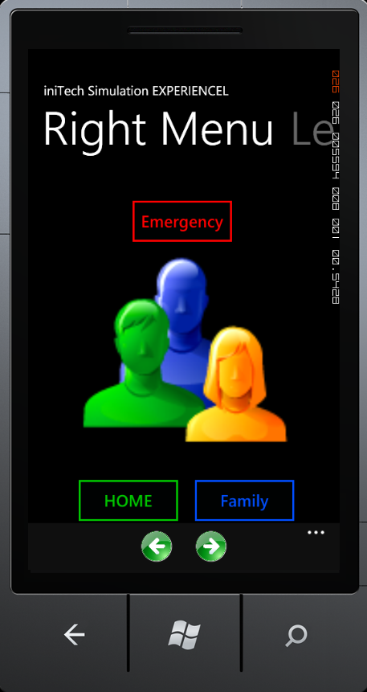
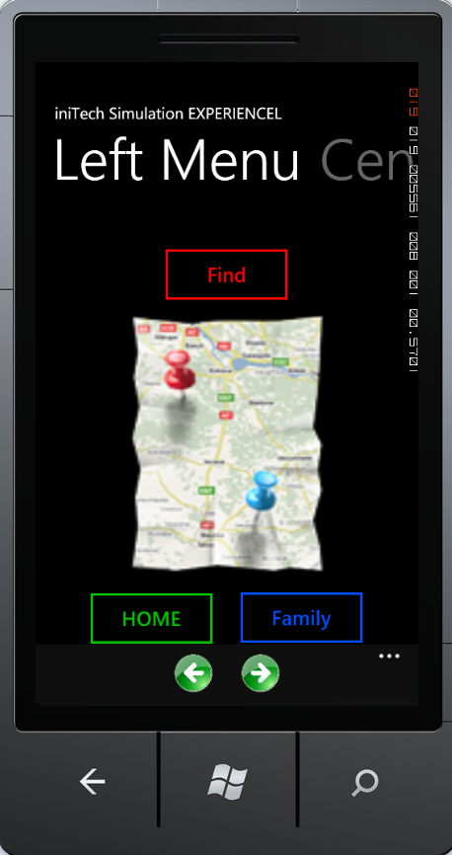
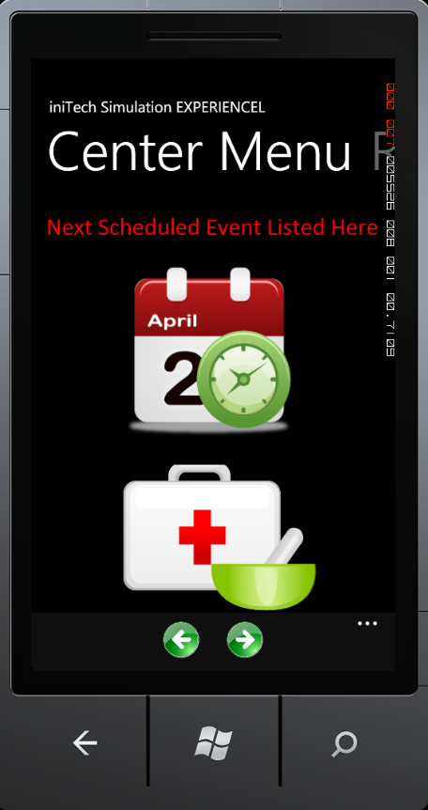

Top Menu Hierarchy:

Screen Shots:

Medical History Medication Tracker Medication Instruction
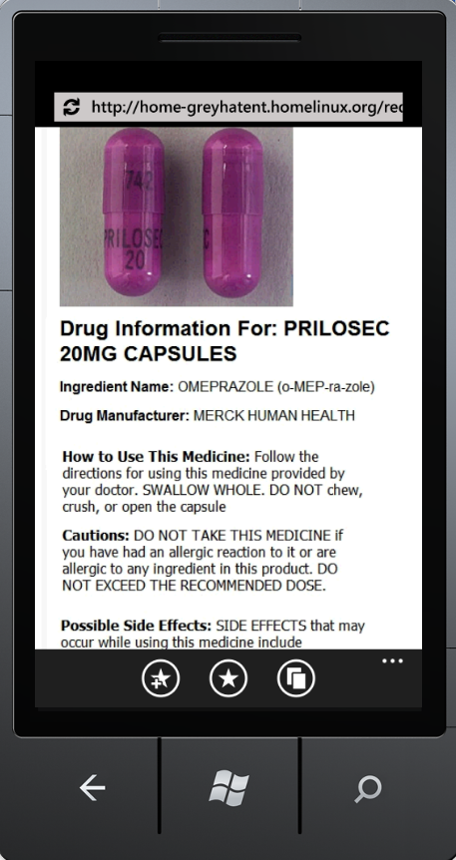
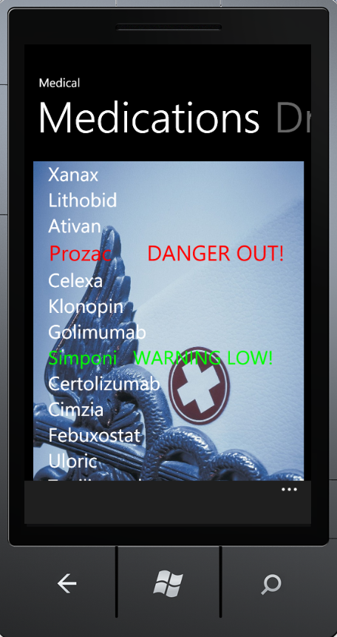
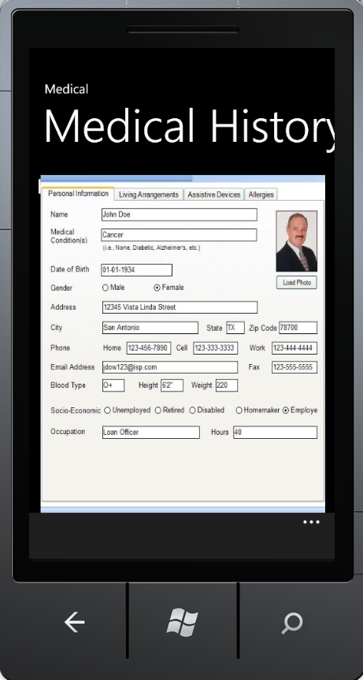

Medical Sub-Systems:

Screen Shots:

Location Screen Shot Voice Command Interface Scheduler

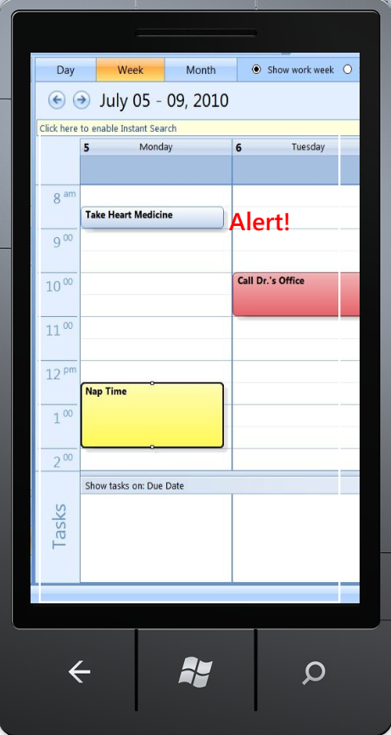
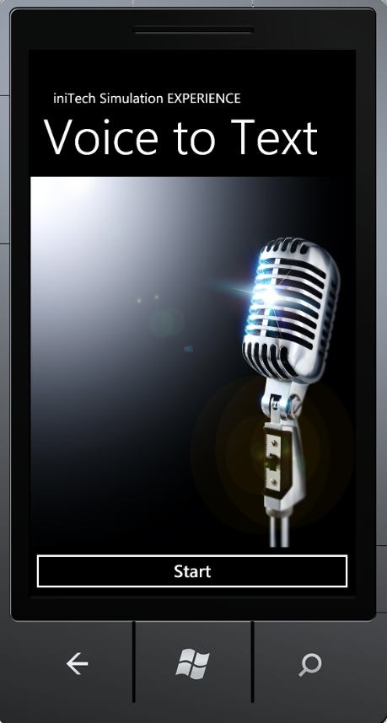
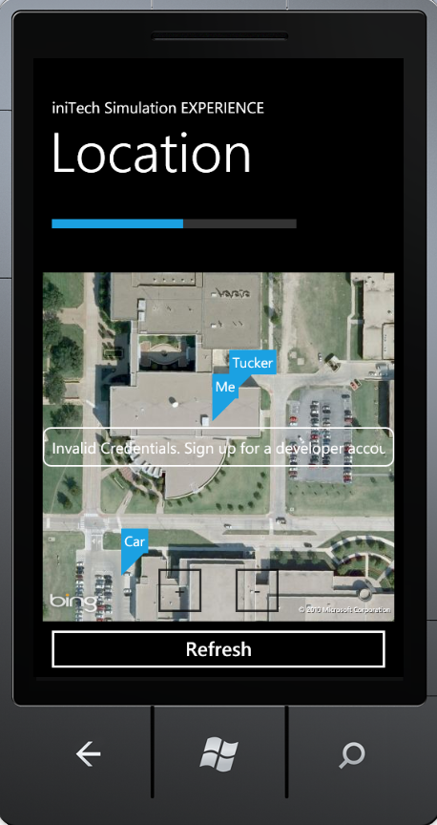

Secondary Systems:

