SDAP 1.2
Organize and display single-variable data in appropriate graphs
and representations (e.g., histogram, circle graphs) and explain
which types of graphs are appropriate for various data sets.
U
NDERLYING
S
KILLS AND
C
ONCEPTS
:
make graphs;
interpret graphs
Interpret Double Bar Graphs
A double bar graph shows how different groups of people answered the same survey question.
x
m
l
A double graph has a key to show what each bar in a pair means.
You can add the values of the bars in each category to find out how many people voted for each choice.

E a p E
What do the graphs show?

Favorite Sport Favorite Sport
E – © CSL Associates, Inc. All rights reserved.
Number of Votes
Hockey
Basketball
Gymnastics
Soccer
2
3
4
5
6
7
8
9
10
11
12
0
1
girls
boys
girls
boys
boys
girls
boys
Number of Votes
Hockey
Basketball
Gymnastics
Soccer
2
3
4
5
6
7
8
9
10
11
12
0
1
Sport Sport
Both graphs show which sport students prefer.
How is the double bar graph different from the single bar graph? It shows which sport girls and boys prefer.
Which sport do more girls than boys prefer?
Compare the bars for each choice. More girls prefer gymnastics.
page 236 Chapter 20 – Lesson 4

Name
P
R
A
C
T
I
C
E
Use the double graph to answer the questions.
1. Which subject got the most votes? Favorite Subjects
E – © CSL Associates, Inc. All rights reserved.
math
2.
Which subject do more girls like than boys?
none of them
3.
How many students voted in all?
students
32
Number of Votes
History
Science
Gym
Math
2
3
4
5
6
7
8
0
1
girls
boys
girls
boys
boys
girls
boys
girls
- Which insect got the most votes? Favorite Insect butterflies and spiders
Number of Votes
Spider
Ladybug
Butterfly
2
3
4
5
6
7
8
0
1
girls
boys
girls
boys
boys
girls
- Which insect do more boys like than girls? spiders
- How many students voted in all?
25
Misleading Graphs
MR 2.3
Reasoning
Math
- Explain the difference between a single bar graph and a double graph.
Possible answer: A single bar has one bar for each category and a

double bar graph has two bars.

Chapter 20 – Lesson 4 page 237

Name
P
R
A
C
T
I
C
E
…at home!
Use the double graph to answer the questions.
1. Which subject got the fewest votes? Favorite Subjects
history
2.
Which subjects do the same number of girls and
boys like?
science and history
3.
How many girls voted in all?
girls
13
Number of Votes
History
Science
Gym
Math
2
3
4
5
6
7
8
0
1
girls
boys
girls
boys
boys
girls
boys
girls

Favorite Insect
E – © CSL Associates, Inc. All rights reserved.
- Which insect got the most votes from boys? spiders
Number of Votes
Spider
Ladybug
Butterfly
2
3
4
5
6
7
8
0
1
girls
boys
girls
boys
boys
girls
- Which insects do more girls like than boys? butterflies and ladybugs
- How many boys voted in all?
12
Interpreting Graphs
MR 2.3
Reasoning
Math
- When would you use a double bar rather than a single bar graph?
Possible answer: When you have two categories of data you want to

compare.

page 160 Home Resource and Homework Chapter 20 Lesson 4

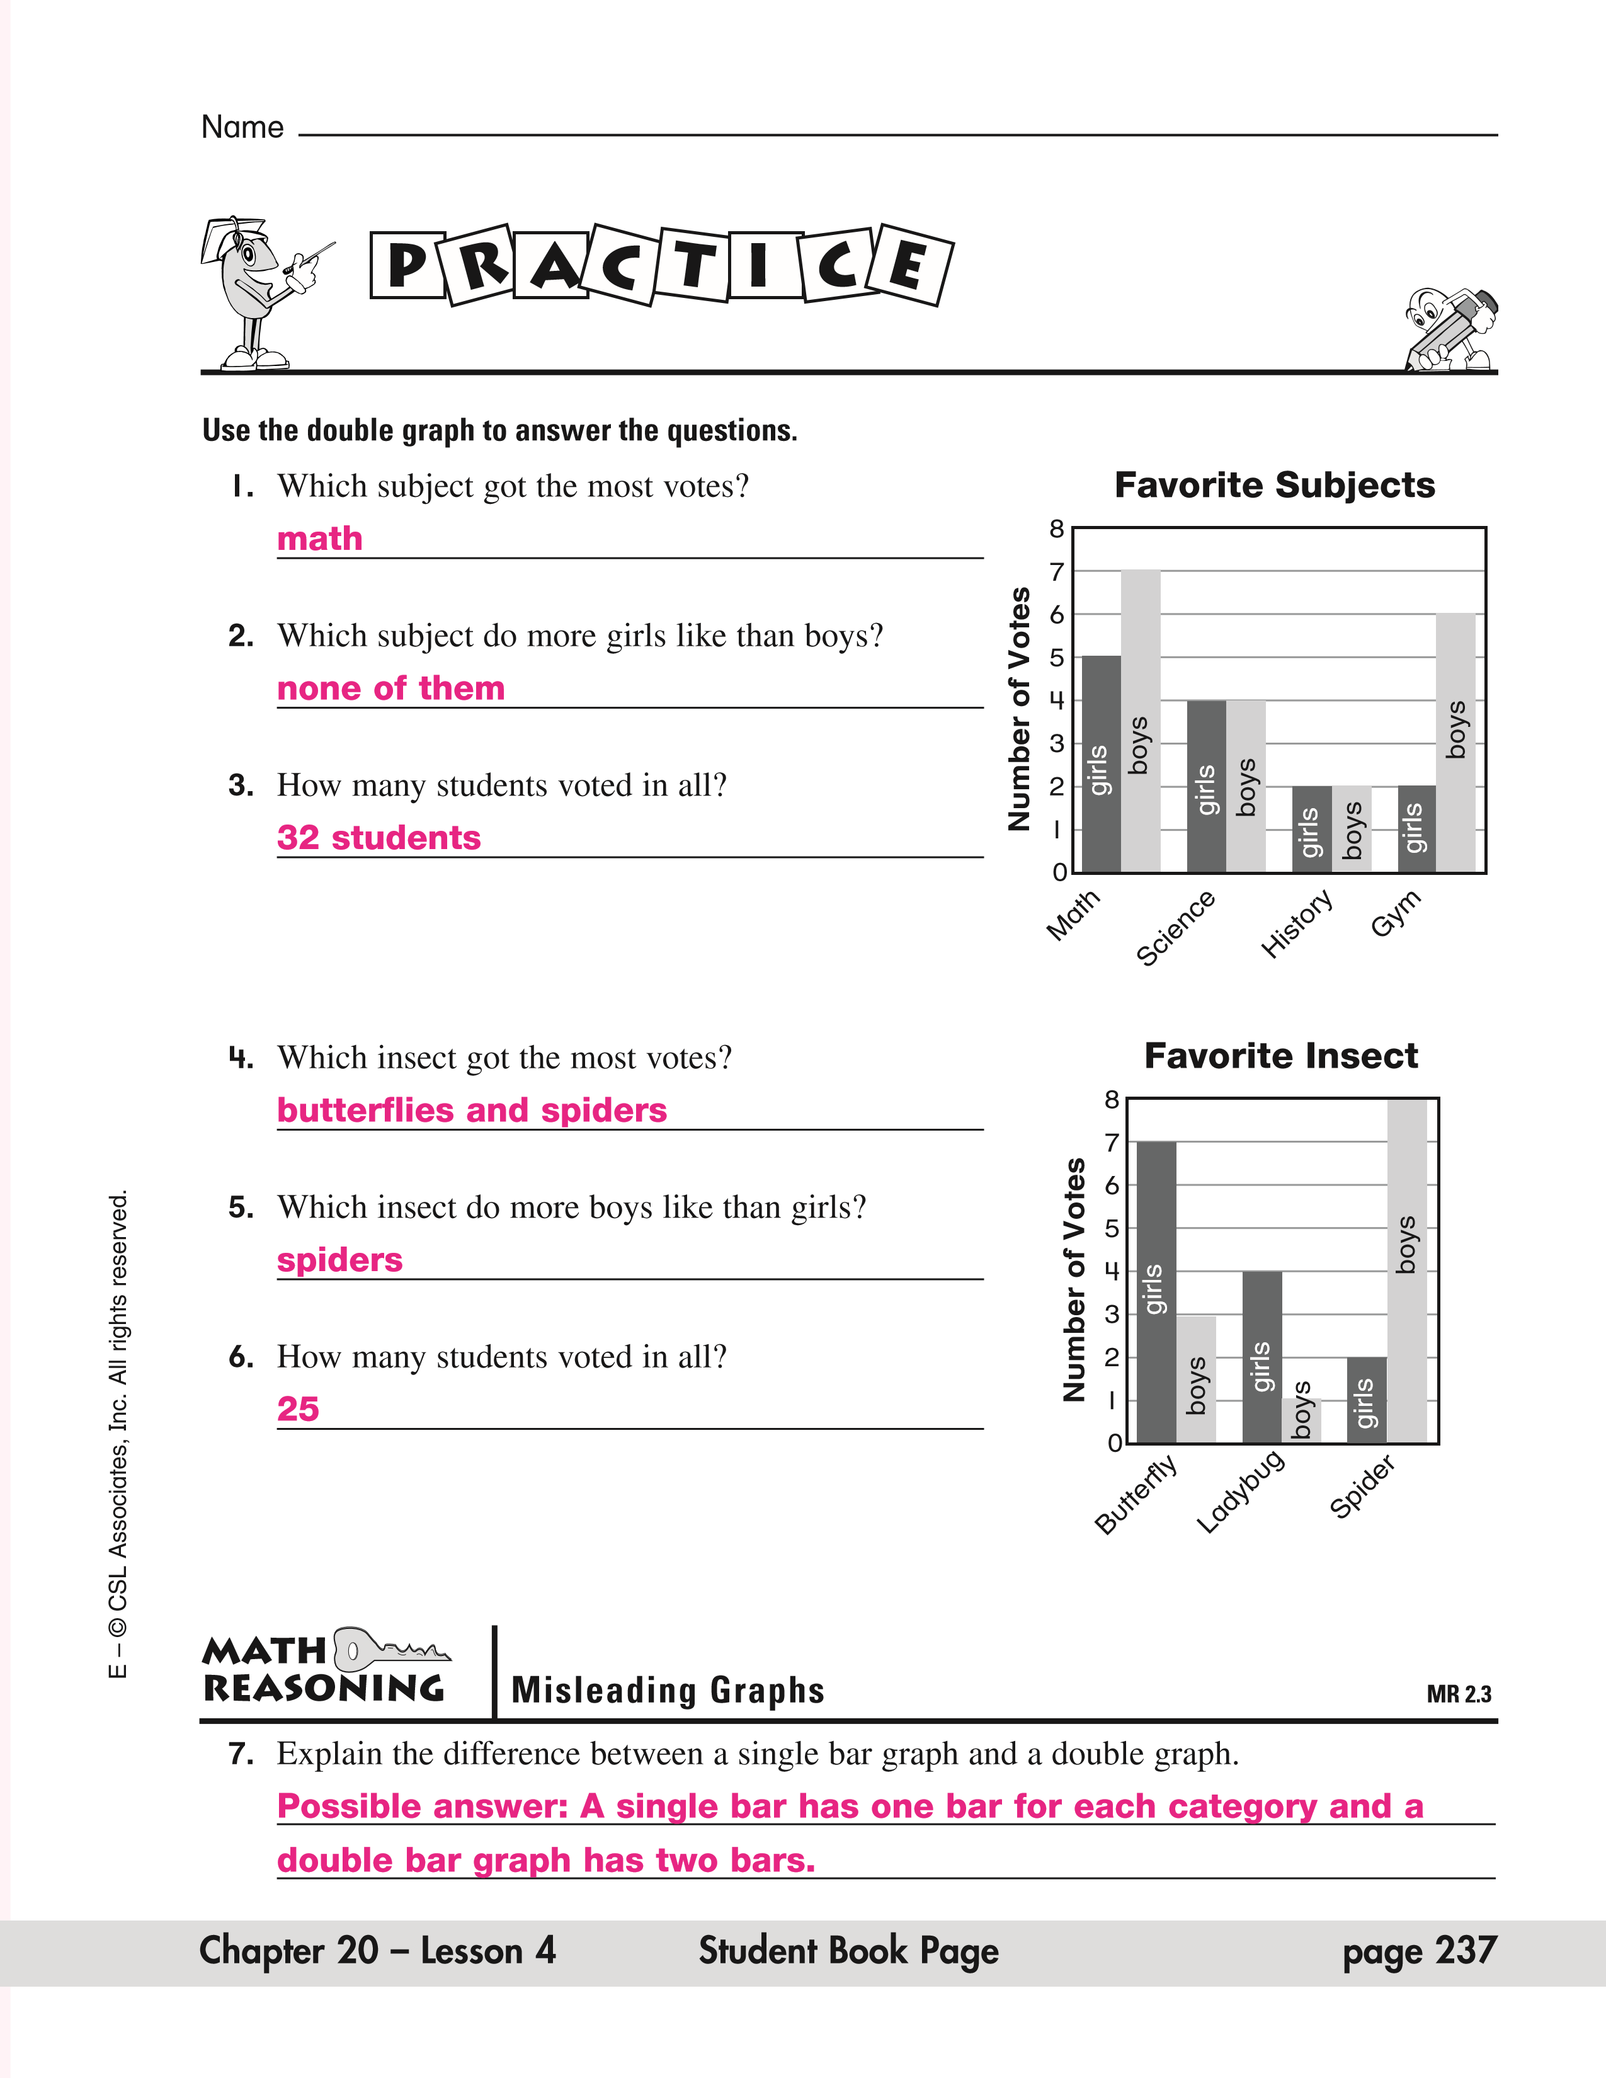

Name
P
R
A
C
T
I
C
E
…at home!
Use the double graph to answer the questions.
1. Which subject got the fewest votes? Favorite Subjects
history
2.
Which subjects do the same number of girls and
boys like?
science and history
3.
How many girls voted in all?
girls
13
Number of Votes
History
Science
Gym
Math
2
3
4
5
6
7
8
0
1
girls
boys
girls
boys
boys
girls
boys
girls

Favorite Insect
E – © CSL Associates, Inc. All rights reserved.
- Which insect got the most votes from boys? spiders
Number of Votes
Spider
Ladybug
Butterfly
2
3
4
5
6
7
8
0
1
girls
boys
girls
boys
boys
girls
- Which insects do more girls like than boys? butterflies and ladybugs
- How many boys voted in all?
12
Interpreting Graphs
MR 2.3
Reasoning
Math
- When would you use a double bar rather than a single bar graph?
Possible answer: When you have two categories of data you want to

compare.

page 160 Home Resource and Homework Chapter 20 Lesson 4

