Name Date
Bar Graph Blank

Teach your students about grids and bar graphs with this printable. This printable is customizable. Tailor the PDF to your teaching needs by typing in the highlighted fields before printing.

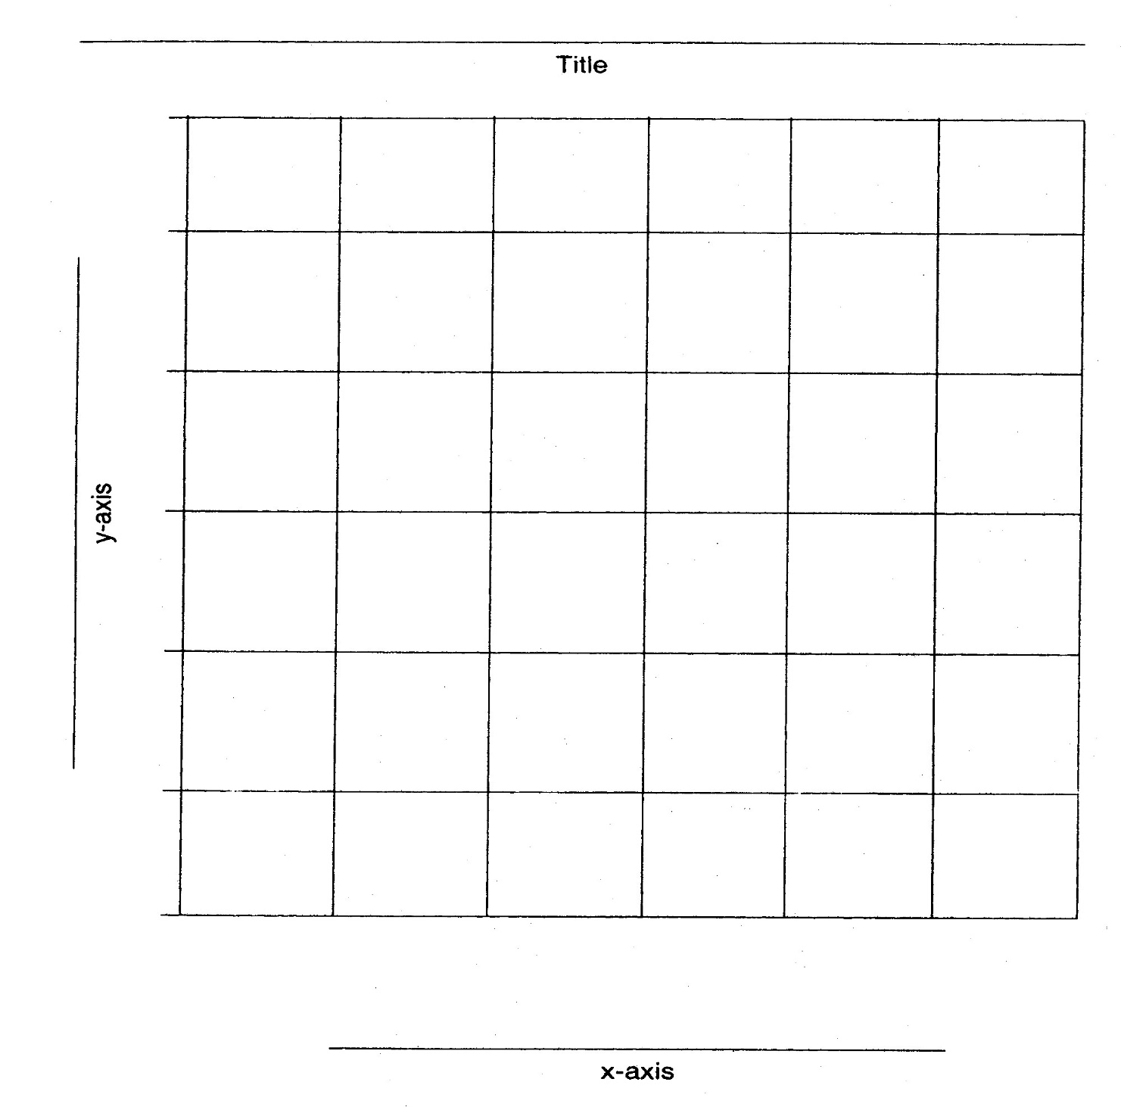
Grade Levels: 1 - 12

__________

__________

__________

__________

__________

__________

__________

__________

__________

