## Describing a character: mind map

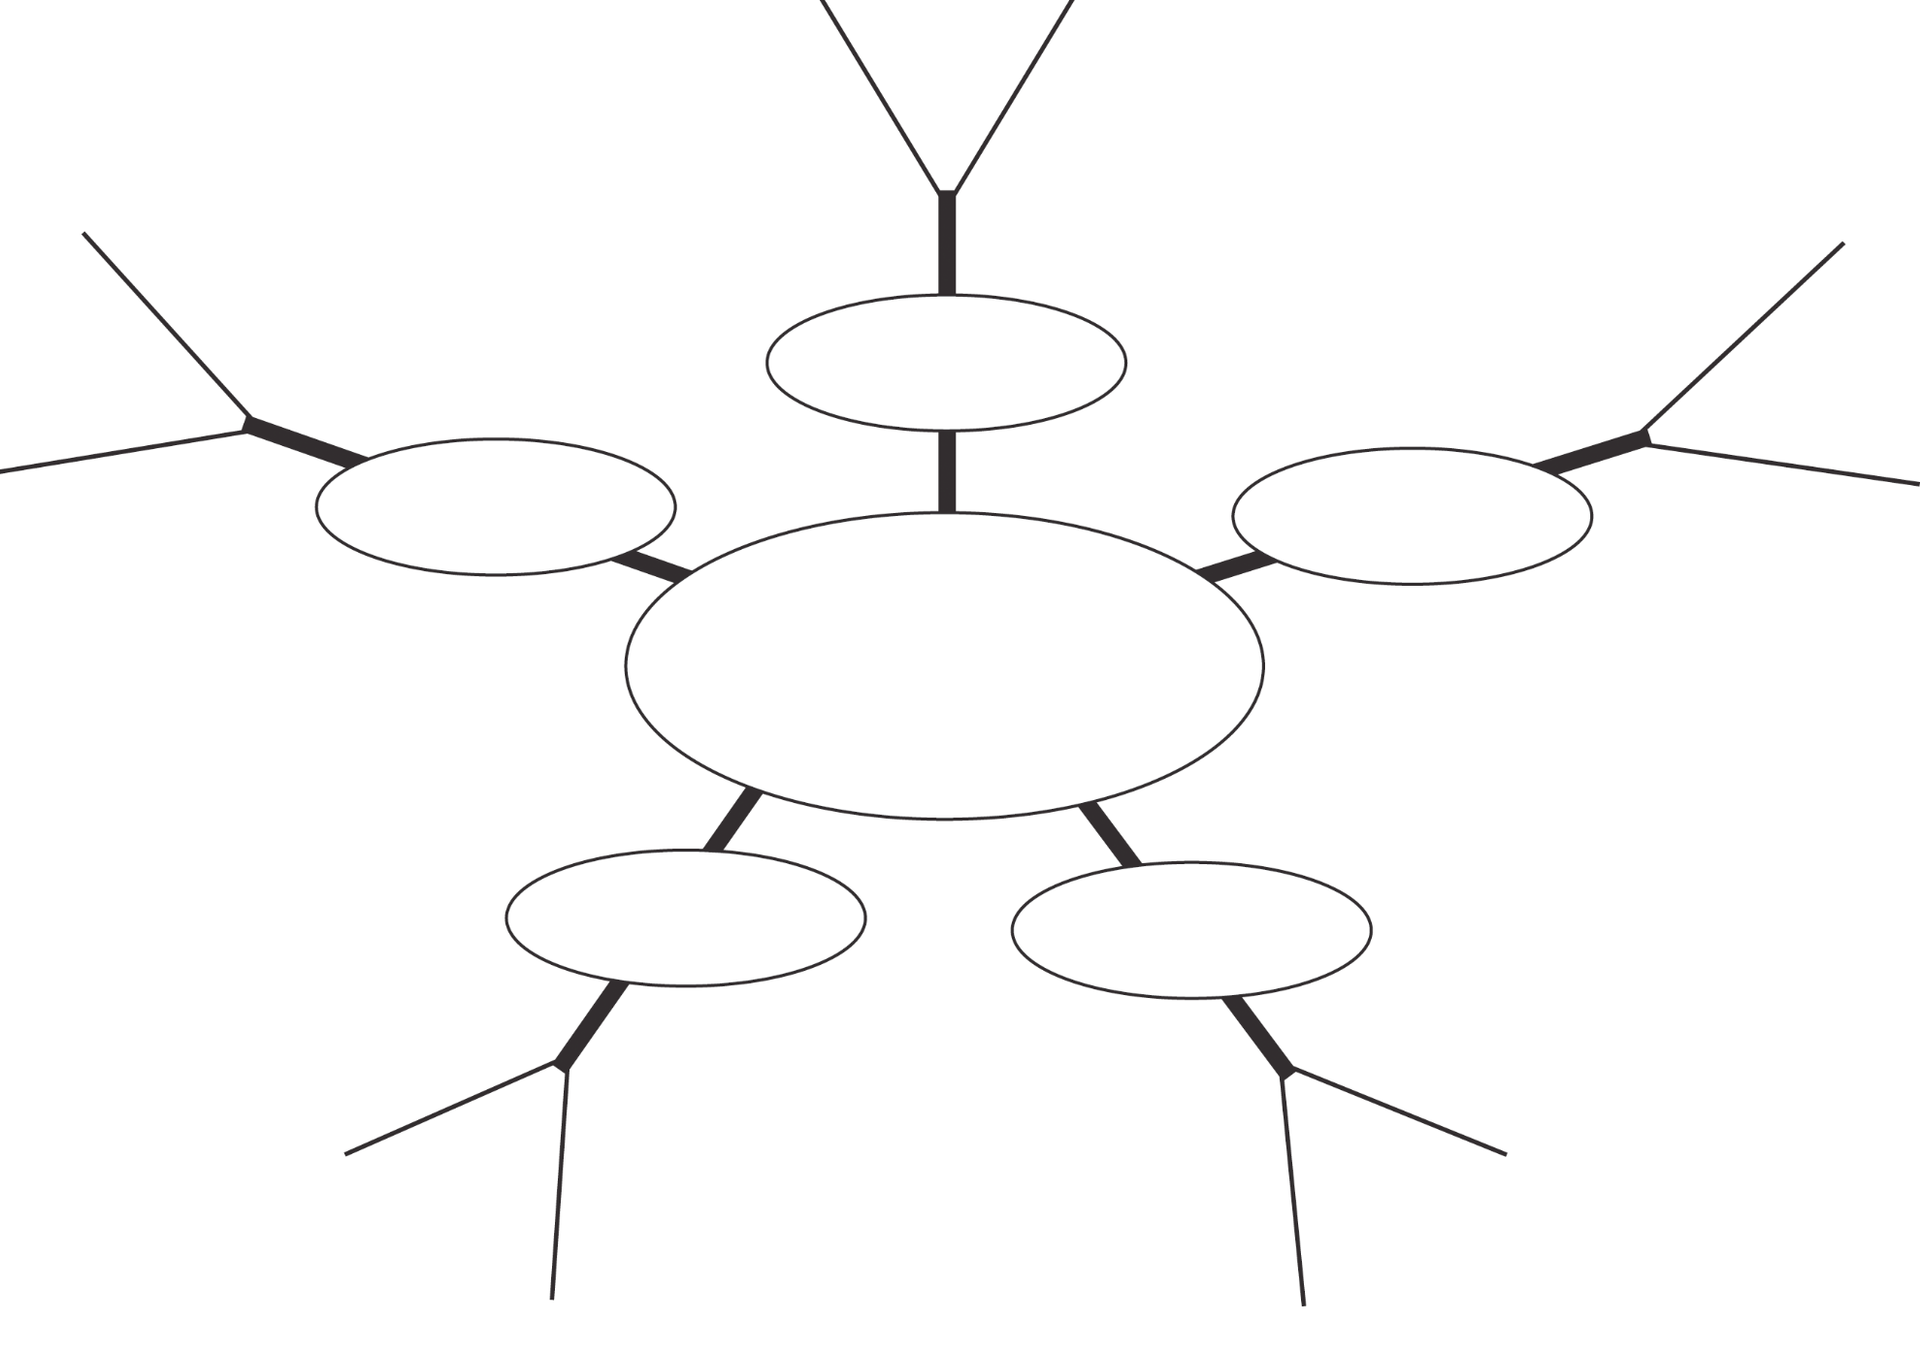

**How they look**

**Story setting**

**Opinions**

**Background**

**Events**

**Character’s name**