CFA Member Savings Program
Below is your personal printable Member Savings Program Privilege Card

CFA’s Member Savings Program (MSP) is designed to help you save time and money on your everyday business needs. Full details about MSP deals, including how to access individual savings offers, are available online.

Print your MSP card for quick reference and start saving today!

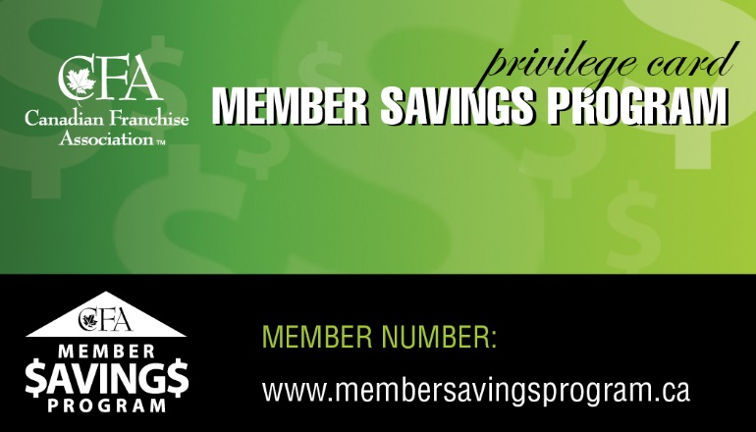
HES447

Name

Your MSP Privilege Card provides you with savings on every day business items such as:
Gas
- Accounting Services
- Payment Processing
- Car Rental
- Travel
- Events & Tickets
- … And more!

Should you have questions about how to access the Members Savings Program, please contact Lina Lepone at llepone@cfa.ca.

For information about how to register your franchisees for the Members Savings Program please contact Meredith Lowry at mlowry@cfa.ca.

www.membersavingsprogam.ca

