Fundraising and Development

Membership Card Template
Membership cards allow your constituents to get the most from membership. The card below allows you to understand how memberships can work for you.
Information to include with the card when it is distributed:
When visiting us, please make sure you have your card to get free admission or the 10-percent store discount. You must have your card.
Membership benefits are only extended to the person whose name appears on the card. Family membership includes adult parents/guardians and minor children. Membership is nontransferable.
Membership cards with expired dates will not be honored. Please make sure your membership is kept up to date. Thank you!
Organizational mission.
The Membership Card should include:
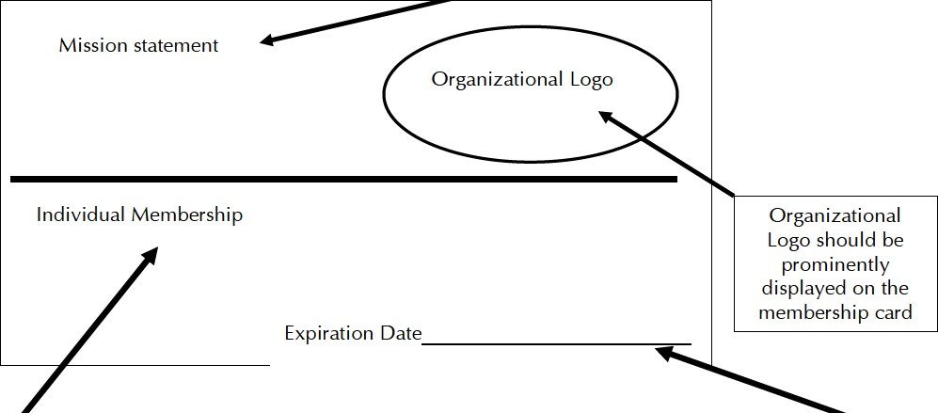
Membership type. Can indicate membership type by color:  For example:  1x1  Purple: Individual Members | The card becomes void on this date. Send notice to members who have expiring membership and request that they renew.
TCA Tool-kit 44

