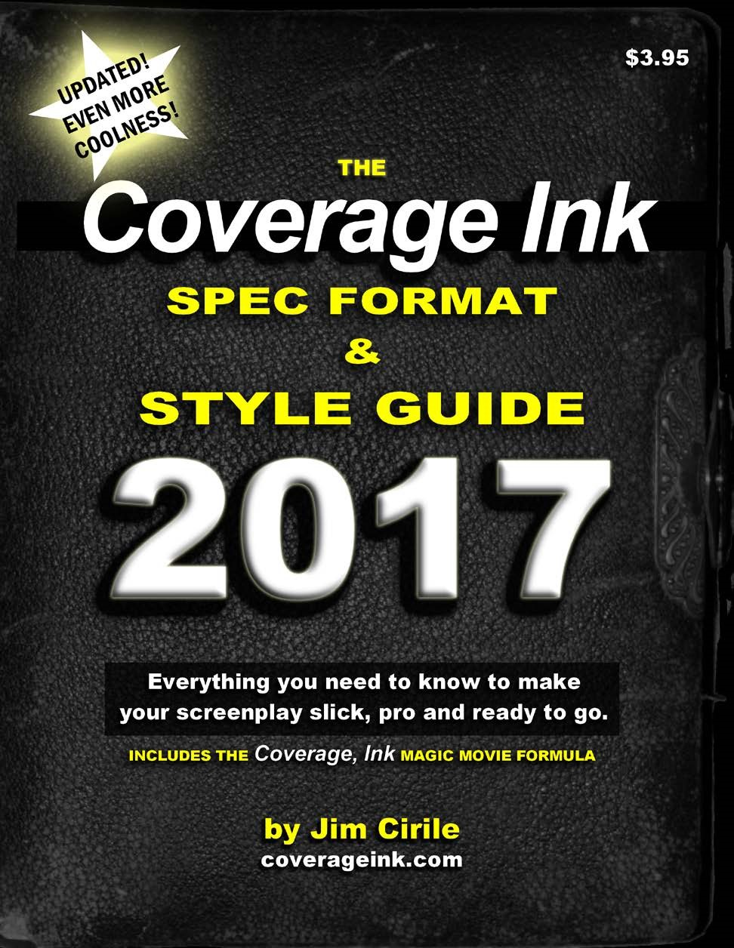

The Coverage Ink Spec Format & Style Guide
2017, All Rights Reserved.
WELCOME.

If you’re considering writing a screenplay, or perhaps you’ve written a few screenplays but are still unsure as to exactly what they are supposed to look like, or even if you’ve written a whole big pile of screenplays and think you know everything -- you’ve come to the right place.

Screenplay format is a deceptively difficult thing to master. It looks so easy, even perhaps intuitive, as you read a script, doesn’t it? Sure, the guy talking is in the middle, and then the other stuff is over at the left side… piece o’ cake.

But as you sit down to write one yourself, that’s when the headache begins. Where exactly does the dialogue go? Is it centered? Am I supposed to tell the camera what to do? (Hint: the word “CAMERA” should never, ever appear in your screenplay.) What words get CAPITALIZED? How do I tell the audience that this line is supposed to be sarcastic and said with a wink? And on and on.

Well, fear not! We’re here to help you master screenplay format. And we’re going to do it in a breezy, accessible style, because learning this stuff should be fun, not an exercise in tedium. Relieved? We certainly hope so.

One more thing: while there are rules and industry standards to be sure, there is no one true and correct way to format a screenplay, as you will see. Plenty of writers do things differently. All well and good. The main thing is: just tell the story.

Just remember, we at CI are here to help. Feel free to e-mail us with any question at info@coverageink.com.

Onward!

Jim Cirile
Founder, CoverageInk.com

INDEX

p. 5 GETTING STARTED

The part we all dread! As Douglas Adams once said, “I don’t enjoy writing nearly as much as having written.” This section will cover:

p. 5 Seriously, Do I Need to Use Correct Screenplay Format?
p. 7 Where to Find Scripts (and Why You Should Read Them)
p. 9 Paper Is Dead (AKA: Plagiarism and You)
p. 11 Screenplay Format Terminology
p. 11 INT/EXT
p. 11 FADE IN/OUT
p. 12 SHOT CALLS, CAMERA CALLS & MUSIC CALLS
p. 14 O.S. vs. V.O. (and O.C.)
p. 14 Parenthetical
p. 17 Direction, AKA Scene Description
p. 17 Transitions
p. 18 Match Cuts and Dissolves
p. 19 Slug Lines
p. 24 Intercut
p. 26 Act Breaks
p. 26 Software

p. 29 WRITE IT!

The meat in this two-fisted burrito. Ready to get writin’? Wait—don’t you have to procrastinate a little longer first—check your e-mail for the 90th time, scrub out the toilet?

p. 29 Margins, Spacing and Font
p. 33 White on the Page
p. 37 Title Page
p. 39 Locations, Establishing Shots
p. 40 Location Shorthand
p. 41 Continuous & Later
p. 43 Scene Description (Again)
p. 44 Character Introductions
p. 46 Shooting Script Versus Spec Script
p. 47 Dialogue (and Dual Dialogue)
p. 50 CAPITALIZATION, Bold, Italics and Underlining
p. 53 Ellipsis (…) and Dashes (--) and Periods, Oh, My!
p. 56 Subtitles
p. 57 Montage Vs. Series of Shots
p. 59 Flashbacks & Dream/Fantasy Sequences
p. 59 Pauses (Beats)
p. 60 Supers & Title Cards
p. 61 Writing Down the Page
p. 62 Slang and Patois
p. 63 Scene Headings: Bold or Not?
p. 63 Length
p. 65 TV Format
p. 65 Cold Open/Teaser
p. 67 Act Breaks
p. 68 Half-Hours
p. 68 TV Length

p. 70 ADVANCED STUFF – READ AT YOUR OWN PERIL!

Just kidding. But here are a tips and techniques you can employ to make sure your script rocks the proverbial house.

p. 70 Proofing, Editing and Spell-Checking
p. 75 Super Nitpicky Grammatical (and other) Mistakes
p. 80 Widows & Orphans
p. 81 Show, Don’t Tell
p. 82 Titles of Works, Legal Cases and Ships
p. 84 Character Counts
p. 85 Character Name Consistency
p. 86 Final Draft & MMS Tricks
p. 87 Where’s the @%!(&%$&!! Final Draft Title Page?
p. 88 How to Make a PDF in Movie Magic Screenwriter
p. 88 Inserts, Enclosures and Diagrams
p. 89 The Coverage, Ink Magic Movie Formula

p. 92 EXERCISES

Once you have your sea legs, we’re going to let you take a couple practice runs. We’ll give you some text. Your job will be to put that text in proper screenplay format.

p. 94 Resources
p. 97 Sample Screenplay Opening

***

Ready to take the plunge and learn all about screenplay format and style? Fasten your seatbelts, strap yourselves in, hold on tight (and any other hyperbolic clichés you might want to use here -- just DON’T USE ‘EM in your script) and let’s go.

Again: none of this is absolute. People break these ‘rules’ all the time. Ultimately it’s all about, what’s the best way to get your story across? If you ever get stuck or can’t figure out how to write something, don’t be afraid to shoot an e-mail over to info@coverageink.com and ask us anything! We’ve been empowering writers since 2002 and we are here to help.

GETTING STARTED

SERIOUSLY, DO I NEED TO USE CORRECT SCREENPLAY FORMAT?

Oh, so you think this is a trick question, huh? The answer is yes… and no.

It’s all about who you are and what you bring to the table. There are writers out there who have careers precisely because they eschewed all the rules of screenplay format. Take Larry Ferguson (The Presidio, The Hunt for Red October) for example:

“If I don’t want to write this INT./EXT, can I invent my own form?,” Ferguson recalls thinking. “Because I thought that when I read the INT./EXT., PULL BACK TO REVEAL, etc., I thought that was telling me a lot more about the writer’s familiarity with the medium than it was about the story. I want to just close my eyes and say, ‘What do you see on the screen?’ So I started writing that way. I didn’t put locations into my shots. I just jumped from one visual image to another. There weren’t a lot of people writing that way, and I was doing myself a service without knowing it.”

So Ferguson pioneered his own style, and his career took off like a rocket. Of course, he had terrific storytelling skills to boot, and the chutzpah to barge into top literary agent Ben Benjamin’s office and demand Benjamin read his screenplay. “Two and a half weeks later, he called me and told me he liked my work,” laughs Ferguson. “He wasn’t sure if he liked me very much, and his actual words were that I had ‘balls that clank.’”

But now let’s look at you and me and reality. For most of us the answer is YES, you do need to know how to format your screenplay. Because even if you’re the most amazing storyteller on the planet, if your script doesn’t look like a script, overworked creative execs will open your script and groan, “Amateur hour.” And just like that, you’re dead in the water. For every 25 people who might read your screenplay, there might be one who is an intrepid, forest-for-the-trees type who won’t simply scoff at your improperly formatted script and then line his cat box with it. Maybe. Creative execs, managers, agents, etc., are all crazy-busy, and they are looking for any excuse to STOP reading. Don’t give them one.

So bear in mind the next time you read a script by a big-shot writer and you notice things like, “Jeez, this thing has 12 typos on page one,” or “This guy never used ANY punctuation in the entire script--it’s all just one big run-on sentence!” (and believe me, those guys are out there, and they’re making big bucks.) Sure, that’s them, but YOU, you should probably adhere to all of these persnickety guidelines we’re about to lay on you. It will be up to you to decide how much, if at all, you want to push the envelope. But know this well: no one ever passed on a script because it was well-formatted. Just like this amazing example:

INT.

BARNEY:

MIKE I was wondering how much is that can of cheez whiz that yore selling (Mikle walks passed Banny picks up the Chee wiz)

(Camera zooms around THE room raking in the faces of the shocked mimes and basketball players who are in town for the mime and basketball convention next door_)

BARNEY: (CONT’D) (MORE) (CONT’D)

AND ALSO I SOLD YOURE CHIMP SPORKLE INTO SLAVIRY

Mik: WELLL Barnee that cheese Wiz IS five dollar and as for Sporkl well I don’t have ANY CHIMP NAMED SPORKLE BUT I do have this lovely bushel of rootabagas

THE CAMERA ZOOOOMS IN ON MILK’S FACE AS HE SPRAYS THE CHEZ
WHIZ INTO HIS GAPING FACE AS BANNERY LOOKS ON IN AW

BARENY:

Dood that was sick YOU CAN HAVE IT FOR FREE Barney does a nice dance and bows like a dancer who have FINISHED his danse and the audience applauds.
CUT TWO:

(CONT’D) MIKE SMILES AND TRIES TO DO
SOME MIME STUFF Smoke on the water plays on the radio while

MEANWHILE (CONT’D) (MORE) (V.O.) Int. Across town at HILDA’S PLACE Sprokle washes dishes and wissles a happy ditty

SROKLE: I am SO HAPPY THAT I AM FINALLY FREE OF MIKE!!!!

Carma zooms IN on Sporkl;e’s eyes and suddenly it’s 1863.

Yup, Nailed it!

WHERE TO FIND SCRIPTS
(AND WHY YOU SHOULD READ THEM)

So you’ve got an idea you think would make a cool movie or TV pilot. That’s great! Now how do you actually get it down on the page? And what do movie and TV scripts even look like?

Before you do anything else, you need to read some scripts.

Now stop, go back and reread that last sentence again. Got it? Bueno.

You wouldn’t try to design an airliner without ever having flown in one, right? Same thing with a movie script. You can’t learn screenplay format without ever having seen a screenplay. And yet some writers do exactly that. They assume that because they wrote a great thesis or got an “A” in creative writing in college that they know how to write a script.

Nope.

There are plenty of places to get scripts. One good place you should look is Drew’s Script-O-Rama (www.script-o-rama.com.) This site offers a bajillion scripts FREE to download. Now you can’t beat that deal. Most of these are in their original formats. Chances are good they have your favorite movie scripts there—and often multiple drafts! Read them and pay careful attention to how they look, how they flow on the page. However, do bear in mind many of these are SHOOTING SCRIPTS (we’ll talk about this in a moment) and thus they have scene numbers. Your scripts should not.

However, their TV script selection is not so great, and many of them are transcripts, not scripts, which you should avoid as they are useless for formatting purposes.

Otherwise, just use your favorite search engine and look around. Obviously, beware of spam downloads or anyone selling you anything.

There are other websites that offer scripts for download, but since they are not free, we are not going to plug them here.

If you live in Los Angeles, you will find tons of scripts available at the WGA and MPAA libraries and reading rooms. Additionally, most colleges with film or screenwriting programs have scripts. The UCLA library is excellent.

One place you do not want to look for scripts, however, is your local bookstore. Screenplay format usually gets butchered when a script is published in book form. If you try emulating the screenplay format from, say, your “Four
Screenplays by Woody Allen” paperback, you’ll be shooting yourself in the foot.

Lastly, if you have any industry friends, chances are good they’ll be able to get you scripts. These do not have to be scripts from produced movies—any screenplay written by a writer currently working in the business should be a worthwhile read.

Once you’ve read a few of these, you’ll start to get the feel of it. What do they all have in common? And what do they do differently? In the world of screenplay format, there is no one standard paradigm—a Quentin Tarantino script looks completely different from a Susannah Grant script. Yet they all (more or less) follow the same basic rules.

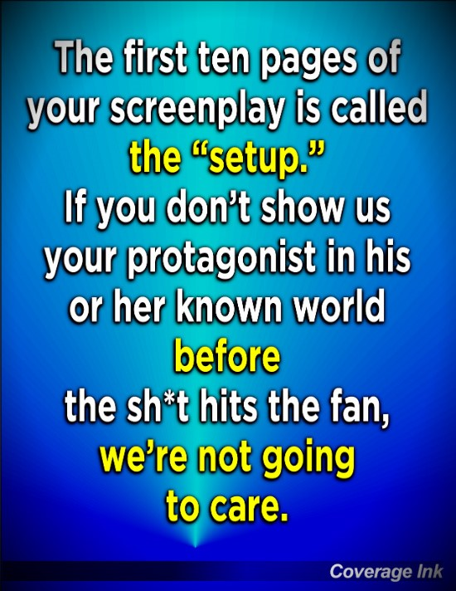

PAPER IS DEAD (AKA: PLAGIARISM AND YOU)

Spec screenplays are seldom printed out these days. They are sent around mostly as PDFs via e-mail. If the writer is working on the script with producers or other writers, then the document might be sent in its native form -- generally Final Draft or MovieMagic Screenwriter. But otherwise, it’s always PDFs. If you don’t know what a PDF is, read this:

http://www.adobe.com/products/acrobat/adobepdf.html

The only time screenplays get printed out anymore is for table reads or production. If you even offer to send a hard copy to someone, they are going to assume you’re (gasp!) old. Don’t do that! Whichever screenwriting software you use, make sure you can output as a PDF. And if you *must* use MS Word (and you really shouldn’t… we’ll cover that shortly,) there are even free Word to PDF online converters (such as pdfonline.com.)

In the early days of e-mail, some writers refused to submit files electronically, fearing the scripts could easily be ripped off. But with the advent of PDF, those security concerns are not quite as concerning. Since a PDF is a snapshot of each page, the data on it cannot easily be manipulated or cut and pasted into another script file. Well, that’s the theory, at least. Problem is the plethora of free PDF to Word converters you can find in a quick web search. These converters can transform your PDF into an imperfectly formatted Word document that can be input into any screenwriting software. It’s a bear to reformat, but it’s easier than retyping the whole thing. Slightly.

So what this means is: you are going to have to get used to the idea of putting your neck out there a little bit when you send out a script. Yes, the chance of plagiarism is real. But it’s also actually kinda small. Pretty much every real producer knows it’s a lot more economical to option a script (or more likely, to convince you to develop it with them for free) than to rip it off and have to worry about an eventual lawsuit. In other words: you need to be okay with sending your script out electronically, via PDF.

Here’s what you really need to know about plagiarism: sure, it happens, but not in the way you may think. Here’s how it really happens: you send your script along to a prodco, and it’s read by some reader there (who of course passes.) At some point down the line, maybe they’re developing a new script, and an idea from your script pops into the reader or exec’s head as the perfect solution to a problem. So now your idea(s) or character(s) wind up in that movie. Or say you have a pitch meeting for a writing assignment. That exec is meeting with a bunch of writers, and ultimately hires Not You. But now this exec has a head full of ideas from all the pitches he’s heard. And again, somewhere down the line, a situation pops up where an idea is called for, and the exec thinks of something brilliant. Except it was YOUR idea. The exec thinks he thought of it. He’d likely never even remember where the idea came from. This exact scenario has happened to me a half dozen times over the years.

So while I strongly recommend copyrighting your scripts (WGA registration has little legal status -- always copyright!) and keeping written documentation of who you submit to and when, beyond that, again, you have to learn to be okay with sending out your scripts electronically and rolling the dice.

One last comment on the subject of plagiarism: did you know that there are plagiarism lawsuits filed against just about every successful movie? This is mainly because there are only so many ideas, and at any given time, with approximately 250,000 emerging screenwriters in Los Angeles alone, there are bound to be a couple dozen scripts floating around with your exact same “unique” idea. Imagine my shock when, two decades ago, I discovered that my thriller about cloning Jesus from the blood stains on the Shroud of Turin was one of several to hit the market that year (and there have probably been hundreds since then.) So the studios are used to the folks who come out of the woodwork when X movie hits it big. These cases, meritorious or not, are generally settled out of court with “go-away” money.

If you do ever feel you’ve been ripped off for real, consider carefully whether or not to file a lawsuit. Because it could have serious, deleterious effects on your writing career. I chose to let something go some years ago, and I probably had a pretty good case. I had a firm copyright and submission record, and the exec whom I submitted it to was the executive in charge of the movie that came out two years later that used several of my script’s very specific ideas. But since yeah, I do want to actually work in this town again, suing that particular studio was clearly not the move. It wasn’t easy, but I let it go… and even took my kid to the movie, and we both enjoyed it. Grumble.

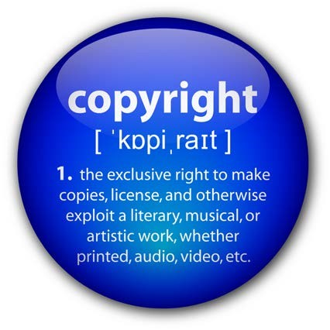

SCREENPLAY FORMAT TERMINOLOGY

This is the part where many newbies find themselves lost. There are a lot of terms in screenplays that many folks will be unfamiliar with. So we are going to break ‘em down for you right here.

INT. and EXT.

Short for INTERIOR and EXTERIOR. Used in location slug lines. (See Slug Lines, below.) This tells the reader whether the scene takes place inside or outside. Example:

INT. JONAH’S TRAILER – NIGHT

EXT. CENTRAL PARK ZOO - DAY

Now some locations are not so obvious. Suppose you’re in a moving car? We’re inside the car -- but the car is outside, right? Or maybe you’re underwater -- but you’re IN the ocean. Yikes! Sometimes (and you’ll find this sort of thing coming up from time to time in screenwriting) you’re just going to have to do what feels logical. In this case, well, the car is an INT.; underwater is an EXT.

Sometimes location slugs are bolded, especially (but not always) in TV scripts. There’s no real reason to do this, nor any real or no perceived benefit. So we say skip ‘em -- unless you’re writing a spec for a TV show that uses this technique.

Sometimes you’ll have action that moves into and out of a location, such as a car. In that case, you could do:

INT./EXT. - BONGO’S MERCEDES

Otherwise, you could just identify the location as INT. BONGO’S MERCEDES and then when Bongo exits the vehicle, EXT. BONGO’S MERCEDES. Save the INT./EXT. for times when characters are moving back and forth quickly, for example, unloading a moving van.

FADE IN and FADE OUT

Used at the beginning and the end of the screenplay (often regardless of whether or not there really is a fade in or fade out.) It’s sort of a shorthand to tell people the script is beginning (duh) and the script is now over (duh again.) Can also be used in the body of the script for emotional moments or to show a passage of time. I also like to use it for act breaks.

Word of warning: don’t NOT use these simply because you do not think you need them, or you don’t see your movie starting with a fade in. That’s one of those idiotic things you get snap-judged on. So unless it’s very important that you start on a certain image or over black, make sure to use FADE IN: at the beginning of your screenplay and FADE OUT at the end. Because, that’s why!

SHOT CALLS, CAMERA CALLS, MUSIC CALLS

RED ALERT
Never, ever use shot calls, camera calls or music calls. These things are the director’s purview—not yours.

A shot call, or camera call, is when someone tells the camera, or the director, what to do in the script, such as:

CLOSE UP on Peter, unscrewing the bottle of soda.

In virtually ALL cases, these are to be avoided like the plague. Why? Because it is not the writer’s job to tell the director where to place the camera. Directors consider this an insult, and worse, if you use camera calls in your script, industry types who read it will think—you guessed it—“amateur.”

In most cases, you can simply write the action without the camera calls, and the director will somehow figure out how to shoot it properly:

Peter unscrews the bottle of soda.

If for some reason it is absolutely necessary to direct the camera—for example, maybe Peter is critically injured, and we need to see his facial expression as he desperately tries to open the soda so as to cling to the last scraps of his fading humanity, you can indicate what the camera sees using a SLUG LINE:

PETER

Unscrews the bottle of soda.

Much more about slug lines below. For now, know this: they are your friend.

Now there are a few camera directions that are okay to use if employed sparingly: CLOSE ON (or TIGHT ON,) WIDE and PULL BACK TO REVEAL.

CLOSE ON is for the most part unnecessary, because instead of saying:

CLOSE ON PETER, nervously picking his fingernails and bouncing on his toes.

…We can use a slug line to do the same thing, like so:

PETER

Nervously picks his fingernails and bounces on his toes.

Pretty obvious we’re close on Peter, right?

And none other than William Goldman loves his PULL BACK TO REVEALS, because they are in fact a very effective way of telling the reader we weren’t seeing the whole picture at first, but now we are, and ha!, there’s a surprise there you didn’t expect. Feel free to use this, even though technically it is a camera direction. It’s a fun little trick.

MUSIC CALLS are much the same animal as camera calls -- to be avoided like the proverbial plague. The industry expects you to know to not include them in spec scripts (unless you’re already a successful writer. Then you can do whatever you want.)

For instance, let’s say you write:

VAN HALEN’S “JUMP” plays on the stereo as Brian drops his dentures into a glass.

Fine, but have you thought about the film’s BUDGET? What if Van Halen wants $1 million just to use a 10-second clip of “Jump” in the movie? Music licensing is notoriously expensive, particularly from well-known artists. There’s a reason “Stairway to Heaven” was not used in “Almost Famous.”

So don’t even think about putting Sinatra, Led Zeppelin, Green Day, whatever, on the radio in your script. Instead, refer to a Sinatra song like this:

On the radio, a crooner belts a TUNE in Rat Pack style.
Or to your Van Halen tune like this:

A jumpin’ classic ROCK SONG plays on the jukebox.

And let the music supervisor worry about plugging in the songs later. If the script gets produced, you can always tell the director, “Hey, I always envisioned Pink Floyd’s “Careful With That Axe, Eugene” would be playing throughout the murder scene. Any chance we can license it?”

O.S. VERSUS V.O. (and O.C.)
O.S. stands for OFF SCREEN. V.O. stands for VOICEOVER. O.C. stands for OFF-CAMERA and means the same as O.S.

When a character speaks, but we can’t see him in the shot, he is considered offscreen, or O.S. So you would indicate that like this:

BILL (O.S.)
Three-quarters dead, that dog just kept right on goin’.

Note that the O.S. (as well as V.O.) goes in parenthesis to the RIGHT of the speaker’s name (Bill.) It does not go UNDER the person’s name like this:

(WRONG)

BILL
(O.S.)
Three quarters dead, that dog just kept right on goin’.

The space under the speaker’s name is reserved for parentheticals, a.k.a. linereading direction (see below.)

- O., or VOICEOVER, is ONLY used when a character is narrating from off-screen—for example, Deckard’s much-reviled voiceover segments from “Blade Runner.” Like O.S., the V.O. designator goes to the right of the speaker’s name.

DECKARD (V.O.)
Boy, that replicant was a hottie! But I can’t let myself be distracted from my, uh, mission... whatever that was.

V.O. can also be used when a character is narrating a scene that he or she is in and commenting on it, such as in Dexter. To summarize: VO is only for voiceovers. OS is for anything you hear where the speaker is off-screen but NOT doing a voice-over.

PARENTHETICALS
“Parentheticals” means the line-reading cues which are placed under the speaker’s name and above the dialogue. It should be used to indicate to whom a character is speaking, if it’s not already obvious, OR occasionally to add a new dimension to the line reading not clear from the line itself. Example:

LEON
(to reporters)
I tried to make him fight my fight; but he made me fight his fight.

Leon abruptly keels over.

Note the placement. The speaker’s name is indented the most—just about center of the page (or five tabs over if, Odin forbid, you are still using MS Word.) The parenthetical is indented from the dialogue, but not as far over as the speaker. And then the dialogue margin is left of that. The SCENE DESCRIPTION (“Leon abruptly keels over,”) AKA “action description,” goes far left.

Now that all may sound confusing, but seriously, don’t worry about it -- that’s why we use software like MovieMagic Screenwriter or Final Draft to handle this stuff for us.

Parens can also be used mid-dialogue to indicate a pause (beat) or to clarify who the character is now addressing, e.g.:

FREUD
But, Ms. Finglebloon, I didn’t drink your spinach water!
(beat)
I have green all around my mouth, don’t I?

Don’t forget to indent and to ‘hard return’ (move to the next line) before and after using parentheticals! The parenthetical should be on its own line, nothing else on it. For example, this is incorrect:

MILDRED
But, Ma, all the kids in first grade have iPhones. (to Dad) First graders without iPhones suck!

…because the parenthetical is on the same line as the dialogue. It’s messy and hard to read. Put that parenthetical on its own line, and voila:

MILDRED
But, Ma, all the kids in first grade have iPhones. (to Dad)
First graders without iPhones suck!

