Creative Writing 1
Scriptwriting
An introduction to screenwriting
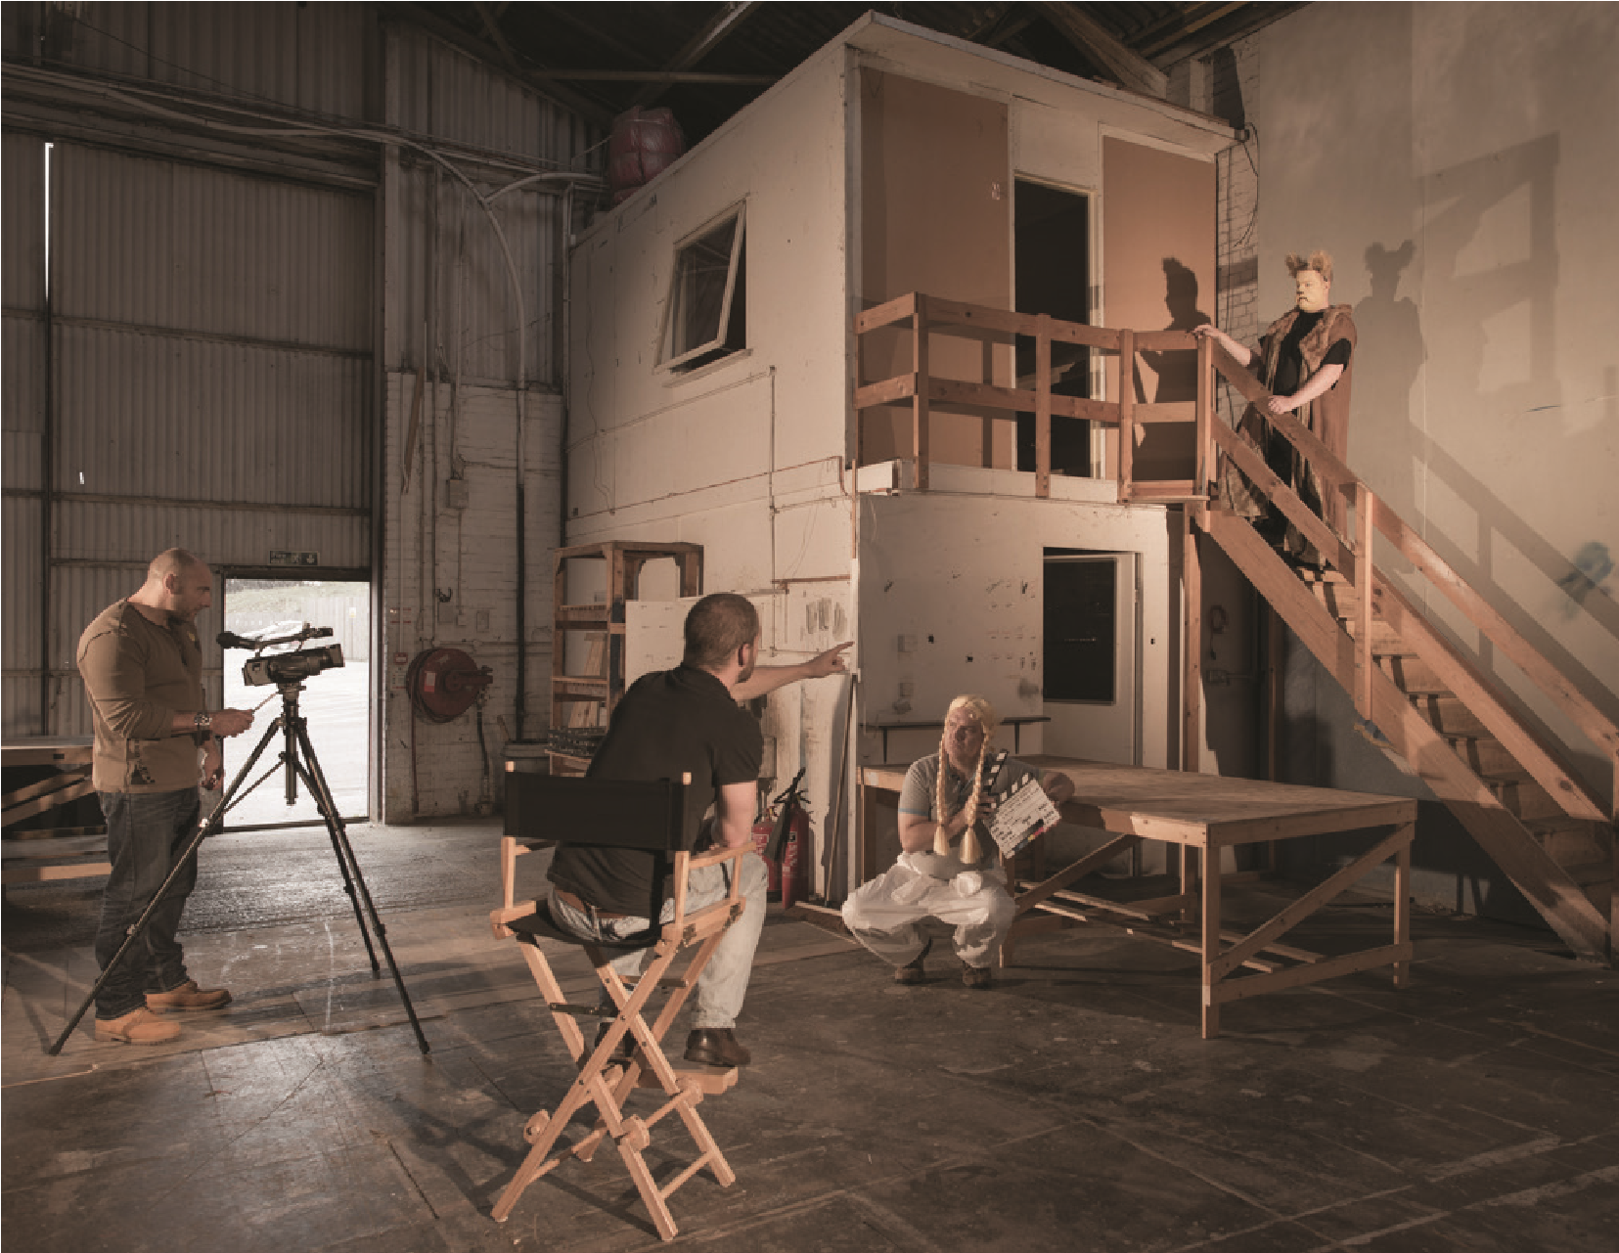
Level HE4 – 40 CATS

Copyright images courtesy of the Bridgeman Art Library and Wikimedia Commons
Other images from OCA tutors and students, unless stated otherwise
Every effort has been made to obtain permissions for the images used in this coursebook
This course has been written by Andrea McCartney.
Open College of the Arts
Redbrook Business Park
Wilthorpe Road
Barnsley S75 1JN
01226 730 495 enquiries@oca-uk.com
www.oca-uk.com
Registered charity number: 327446
OCA is a company limited by guarantee and registered in England under number 2125674
Copyright OCA 2013
Document control number: CW1SW151113
No part of this publication may be reproduced, stored in a retrieval system, or transmitted in any form or by any means – electronic, mechanical, photocopy, recording or otherwise – without prior permission of the publisher
Cover image by OCA photography student Jeremy Pelzer.

Contents

Before you start
Part one What is a screenplay?
Project 1 Thinking visually 13
Project 2 Writing a screenplay 18
Project 3 The screenwriter’s toolbox 26
Project 4 Finding ideas 34
Project 5 Writing a synopsis 37
Project 6 Genre 39
Assignment one 42

Part two Conflict and dialogue
Project 1 Conflict 47
Project 2 Protagonists and antagonists 53
Project 3 Dialogue 61
Project 4 Idiom and idiolect 66
Project 5 Conflict in dialogue 71
Assignment two 77
Part three Creating characters
Project 1 Connecting with characters 81
Project 2 The character lab 87
Project 3 Creating a character biography 89
Project 4 Revealing character 94
Project 5 Assembling a cast list 101
Project 6 Creating need and desire 111
Assignment three 112
Part four Picture the scene
Project 1 What is structure? | 115
Project 2 The scene | 121
Project 3 In the beginning… | 128
Project 4 The inciting incident | 134
Project 5 Writing the middle | 139
Assignment four  Part five Endings, edits and extras | 146
Project 1 All good things must come to an end… | 152
Project 2 Endings and genre | 157
Project 3 Film techniques: montage | 166
Project 4 Film techniques: the flashback | 173
Project 5 Re-drafting and editing | 178
Assignment five | 183

Before you start
Welcome to Scriptwriting: An Introduction to Screenwriting. Your Creative Writing Student Guide should be able to answer most questions about this and all other OCA creative writing courses, so keep it to hand as you work through the course.
Have you ever watched a film and said afterwards, ‘I’d like to have a go at writing a screenplay but where do I begin?’ This course will equip you with a writer’s toolbox filled with the basics: how to lay out a script professionally; how to structure your screenplay; the do’s and don’ts of writing compelling dialogue; and breathing life into your characters. You’ll pick up important film terms and techniques – and get to watch lots of films! By the end of the course you’ll not only have acquired the nuts and bolts of screenwriting but you’ll also have penned your own 15-minute screenplay.

Course aims and outcomes
Scriptwriting: An Introduction to Screenwriting aims to:
- enable you to understand screenwriting as a visual medium
- introduce you to the basic techniques of writing for screen
- develop your understanding of the building blocks of screenwriting: the scene, the dramatic arc, character and dialogue
- develop your ability to employ reflective skills, absorb constructive feedback and re-draft your work accordingly.
On successful completion of this course, you’ll be able to:
- analyse and put into practice the basics of screenwriting
- access a writer’s toolbox of techniques specifically related to writing for screen
- write, re-draft and complete a 15-minute screenplay
- critically appraise your own work in response to constructive feedback.
By the end of the course, you’ll have built up knowledge and experience of scriptwriting that you can carry forward into other media (radio, TV, stage), perhaps through progression to Creative Writing 2: Narrative and Dialogue.

Your tutor
Your tutor is your main point of contact with OCA. Before you start work, make sure that you’re clear about your tuition arrangements. The OCA tuition system is explained in some detail in your Student Handbook.
If you haven’t already done so, please write a paragraph or two about your experience to date. Add background information about anything that you think may be relevant for your tutor to know about you (your profile) – for example your experience of writing so far, your reasons for starting this course and what you hope or expect to achieve from it. Email or post your profile to your tutor as soon as possible. This will help him or her understand how best to support you during the course.
Arrange with your tutor how you’ll deal with any queries that arise between assignments. This will usually be by email or phone.
Make sure that you label any work that you send to your tutor with your name, student number and the assignment number. Your tutor will get back to you as soon as possible after receiving your assignment but this may take a little time. Continue with the course while you’re waiting.

Formal assessment
Read the section on assessment in your Creative Writing Student Guide at an early stage in the course. For assessment you’ll need to submit a cross-section of the work you’ve done on the course:
- Your three best re-drafted course assignments together with the original tutor-annotated versions. Please note these should be three distinct and separate pieces of work. If you submit assignments originating in your own ideas rather than the suggested exercises they should not all stem from the same screenplay.
- Your final reflective commentary on the course (1,500–2,000 words).
- Your tutor report forms.
Only work done during the course should be submitted to your tutor or for formal assessment.
Your final reflective commentary will count for 20% of your final mark should you decide to go for formal assessment.

Assessment criteria
The assessment criteria are central to the assessment process for this course, so if you’re going to have your work assessed to gain formal credits, please make sure you take note of these criteria and consider how each of the assignments you complete demonstrates evidence of each criterion. The criteria are evenly weighted, i.e. each represents 20% of your total mark. On completion of each assignment, and before you send your assignment to your tutor, test yourself against the criteria – in other words, do a self-assessment, and see how you think you would do. Note down your findings for each assignment you’ve completed in your writing diary, noting all your perceived strengths and weaknesses, taking into account the criteria every step of the way.
This will be helpful for your tutor to see, as well as helping you prepare for assessment.

Assessment criteria points
- Presentation and technical correctness – Grammatical accuracy, punctuation, layout, spelling, awareness of literary conventions, and the ability (where appropriate) to play with these conventions and fit them to your needs.
- Language – Its appropriateness to genre, subject matter, and characters. Avoidance of cliché, employment of a wide vocabulary, awareness of the rhythmic powers of language, and an ability to make appropriate use of imagery.
- Creativity – Imagination, experimentation, inventive exploration of subject matter, originality, and empathy.
- Contextual knowledge – Evidence of reading, research, critical thinking and reflection. Engagement with contemporary thinking and practice in the specific genre (i.e. scriptwriting).
- Craft of writing – Technical competence in your chosen genre (in scriptwriting, areas such as structure, dialogue, characterisation).

Your writing diary
Your writing diary is an integral part of this and every other OCA creative writing course. Your writing diary is where you work reflectively, recording your thoughts on your writing and how your thought processes relate to your growing battery of skills. When you’re generating creative writing texts, you may be learning on an intuitive level; the writing diary will help your understanding of how this learning process works for you. As you add to the diary, be it daily or sporadically, you’ll form a record of your writing journey. This record is for you alone; you won’t have to show it to anyone, so you can write from the heart about the highs and lows of becoming a writer. This can be online, as a blog, (which you can use the blog settings to keep private), or in a paper-based journal.

Plan ahead
This Level 1 course represents 400 hours of learning time. Allow around 20% of this time for reflection and keeping your writing diary. The course should take about a year to complete if you spend around 8 hours each week on it.
As with all OCA courses, these course materials are intended to be used flexibly but keep your tutor fully informed about your progress. You’ll need to allow extra time if you decide to have your work formally assessed.
Introduction to Screenwriting is divided into five parts, corresponding to the five course assignments. The first assignment will enable your tutor to get to know you, review your work so far and decide how best to help you in future. Your work for this assignment will not count towards your final mark if you decide to go for formal assessment.
Each part of the course addresses a different aspect of screenwriting and is separated into a series of projects designed to tackle the topic in bite-sized chunks. As well as information and advice, each project offers research, viewing and exercises to encourage writing. The exercises slowly build up into the assignments that you’ll send to your tutor.
Each assignment will ask you for a piece of scriptwriting or developmental work. You’ll also submit a short reflective commentary (around 500 words) with Assignments One to Four, describing the writing process and your experience of that part of the course. These are for your tutor only and will not be submitted for assessment. At the end of the course, you’ll write a longer reflective commentary (1,500–2,000 words) on the course as a whole and this will be submitted for assessment if you decide to go down this route.

Reading
A reading list for the course is available at the end of this course guide and on the OCA website. The reading list recommends key texts and gives suggestions for further reading. You should also seek out further reading independently of this list, perhaps in consultation with your tutor. The online reading list on the OCA website is updated regularly, so check this for recently published recommendations.

Referencing your reading
Whenever you read something that you might want to refer to in your projects and assignments, get into the habit of taking down the full reference to the book, article or website straight away. You must fully reference any other work that you draw on if you plan to go for formal assessment. To do this you should use the Harvard system of referencing – see the Harvard referencing system guide on the OCA website. Getting down the full reference at the time will save you the frustration of having to hunt for the details of a half-remembered reference long after the event. Referencing other people’s work accurately will also help you avoid unintentional plagiarism.

Watching films
This course guide references over 60 films and we certainly don’t expect you to have watched them all! However, you’ll definitely need a copy of the following three films for your work on Part Three:
- The Lord of the Rings trilogy (2001, 2002, 2003, dir. Peter Jackson, screenplays Fran Walsh, Philippa Boyens, Peter Jackson, Stephen Sinclair)
- The Truman Show (1998, dir. Peter Weir, screenplay Andrew Nicol) • Fargo (1996, dir. Ethan & Joel Coen, screenplay Ethan & Joel Coen)
And for Part Four:
- Brokeback Mountain (2005, dir. Ang Lee, screenplay Larry McMurty & Diana Ossana)
- Little Miss Sunshine (2006, dir. Jonathan Dayton & Valerie Faris, screenplay Michael Arndt)
- The Godfather (first part of the trilogy, 1972, dir. Francis Ford Coppola, screenplay Francis Ford Coppola & Mario Puzo)
- Notting Hill (1999, dir. Roger Michell, screenplay Richard Curtis)
You’ll also find it extremely useful to have copies of:
- American Beauty (1999, dir. Sam Mendes, screenplay Alan Ball)
- Django Unchained (2012, dir. Quentin Tarantino, screenplay Quentin Tarantino)
- Pulp Fiction (1994, dir. Quentin Tarantino, screenplay Quentin Tarantino)
- Sense and Sensibility (1995, dir. Ang Lee, screenplay Emma Thompson)
- Jaws (1975, dir. Stephen Spielberg, screenplay Peter Benchley, Carl Gottlieb)
- Thelma and Louise (1991, dir. Ridley Scott, screenplay Callie Khouri)
- Winter’s Bone (2010, dir. Debra Granik, screenplay Debra Granik & Anne Rosellini)

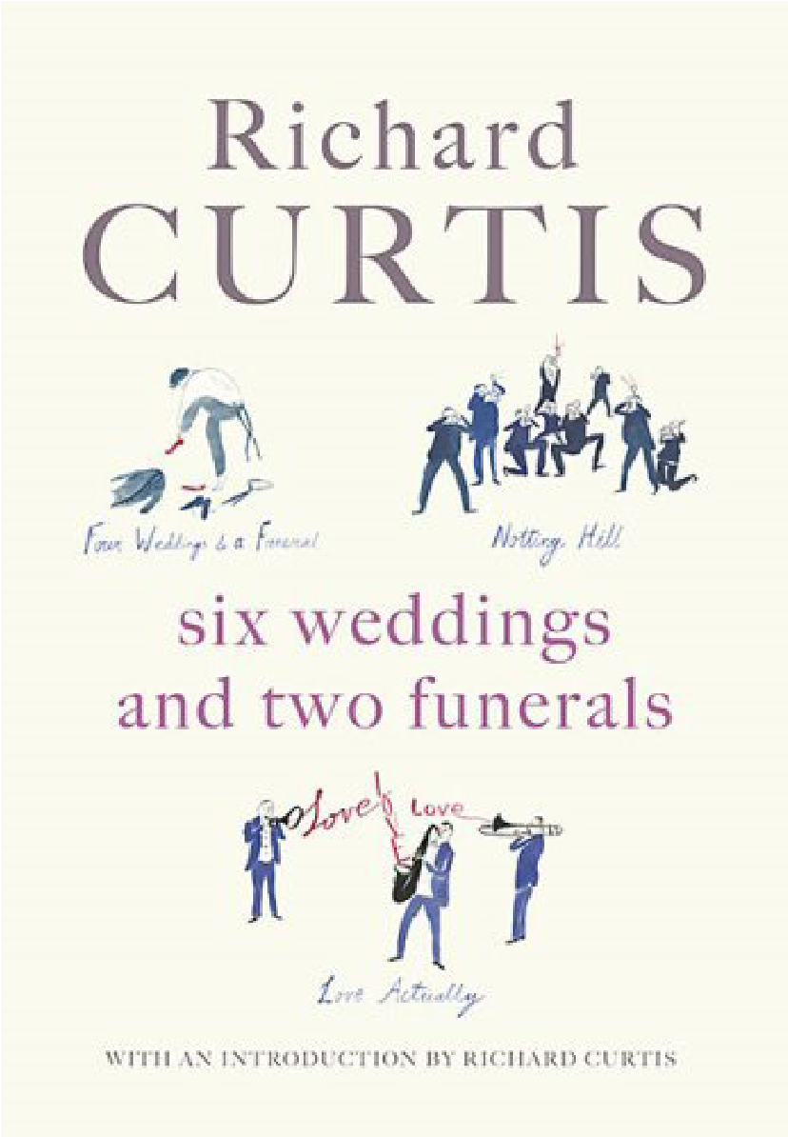
Six Weddings and Two Funerals: Three Screenplays by Richard Curtis (Michael Joseph, 2006). Cover reproduced with permission from Penguin Books.
If you can buy or borrow copies of The Hurt Locker, The Devil Wears Prada, The Bourne Identity or Bridesmaids, that would be helpful too – but not essential.
The best plan is to skim through the course guide quickly to see which films are referenced and then see how many you already own or can borrow from friends or family. The key thing is to watch as many films as you can – they don’t have to be mentioned in the course guide. Keep a record and brief notes on every film you watch in your writing diary so that you can mention them in your reflective commentaries.
Creative Writing 1
Part one
What is a screenplay?
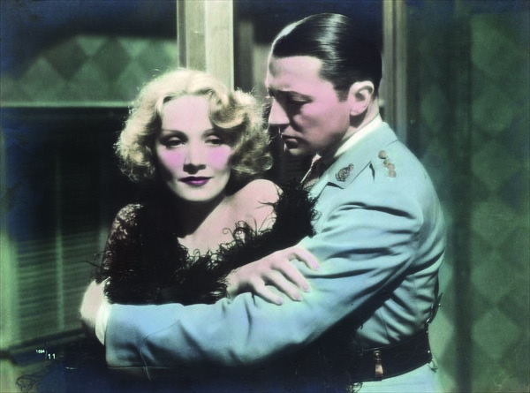
Still from the film Shanghai Express, Marlene Dietrich and Clive Brook, 1932
“You’ve got a screenplay, 120 pages, there’s a lot of white spaces, and it’s full of double-spacing. There’s no reason why you can’t write three pages a day; it’s not like writing three pages a day of a novel. Not many words, not many words.”
William Goldman, screenwriter – Butch Cassidy and the Sundance Kid, All the President’s Men, Misery (Frensham, 2008, p.13)
Part One is your introduction to visual storytelling. By the time you reach the end of this part of the course, you’ll have gained an understanding of script formatting, layout and genre and learned how to write a synopsis. Your first assignment will give you an opportunity to adapt a short scene for screen and to discuss your own ideas for a short film with your tutor.
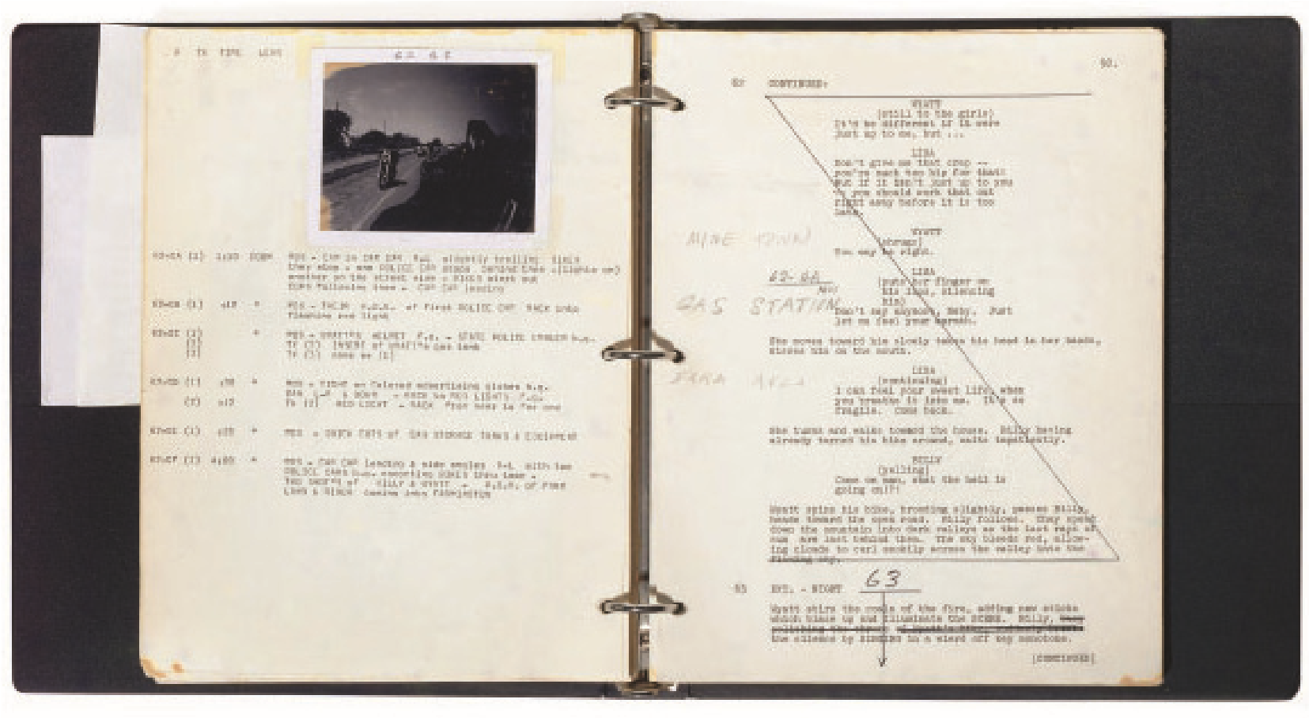
Pages from the original working script for Easy Rider, 1969

Project 1 Thinking visually
Think about your favourite films. What immediately springs to mind? Most likely you’ll conjure up an image or a scene. It may be the frog-like Gollum creeping behind Frodo in The Lord of the Rings, or Baby sprinting towards Johnny Castle in the climactic scene of Dirty Dancing, or Donald Sunderland as the bereaved father reaching towards the small, sinister red figure he thinks is his daughter in Don’t Look Now. If you do remember a line of dialogue, you probably won’t think of it in terms of words on a page; you’ll remember the way the words were spoken by the actor and the expression on their face as they delivered them.
You’ll remember the story in images because film is a visual art form. And yet all films begin with a script. Words on a page, certainly, but words with a purpose: to create pictures in the mind that will eventually (depending on the interest of a director, finance and luck!) end up on screen.
You may have come across the phrase ‘show don’t tell’ in relation to storytelling. In writing for screen it is arguably the single most important phrase to remember as you sit at your computer or notebook. While a novel or short story can take you inside the mind of a character, with the words revealing opinions, dreams, thoughts, psychological insights and feelings, a screenplay has to show what a character is thinking and feeling through images, action and dialogue.
Dialogue, perhaps surprisingly, is only one element of your screenplay. Dialogue can certainly help reveal what a character is thinking and feeling, whether it’s an exchange between two or more characters or a voiceover (a device used in American Beauty and Apocalypse Now, for example). Unless you are Quentin Tarantino, however, you risk losing your audience’s attention with a screenplay overloaded with hefty chunks of dialogue. When you’re writing visually you also need to decide what your character is doing within a given location – and describe the action in your script.
Consider these memorable scenes from well-known films…
The Shining (1980, dir. Stanley Kubrick, screenplay Stanley Kubrick)
A little boy, Danny Torrance, cycles down the corridors of the Overlook Hotel. He turns a corner and stops suddenly. Before him stand a pair of creepy twin girls who greet him and invite him to play.
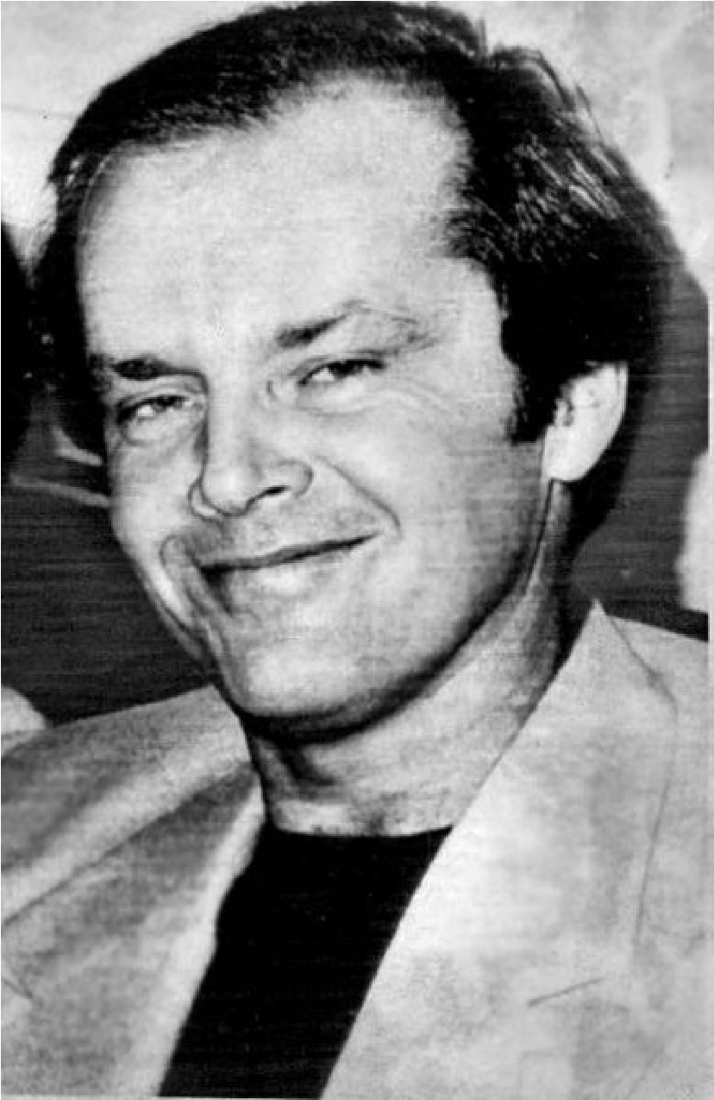
Press photo of Jack Nicholson after being nominated for an Academy Award for One Flew Over the Cuckoo's Nest, 1976 (AP Wire Photo). Nicholson played Jack Torrance in The Shining.
Psycho (1960, dir. Alfred Hitchcock, screenplay Joseph Stefano)
In a desolate hotel, runaway Marion Crane takes a shower. A shadowy figure enters the bathroom, the knife silhouetted through the shower curtain. There is no dialogue, only Marion’s screams.
American Beauty (1999, dir. Sam Mendes, screenplay Alan Ball)
Lester Burnham, in the throes of a mid-life crisis, dreams of his daughter’s best friend Angela. She lies in a bed of roses beckoning to him. Life and the dream world collide as the red petals drift over Lester’s smiling face.
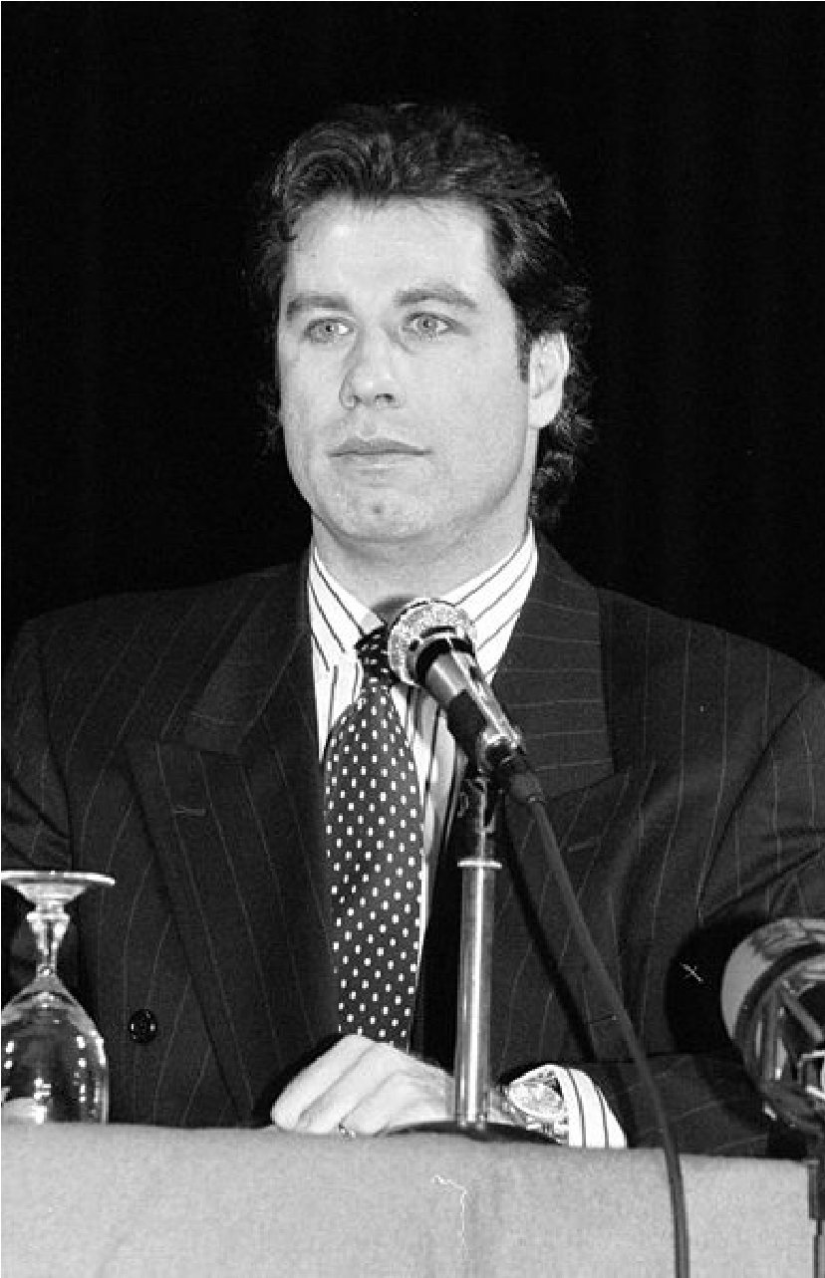
John Travolta at the American Film Festival of Deauville, 1991 (Roland Godefroy). Travolta played Vincent Vega in Pulp Fiction.
Pulp Fiction (1994, dir. Quentin Tarantino, screenplay Quentin Tarantino)
In Jackrabbit Slim’s diner, a retro joint where the servers are dressed as Marilyn Monroe, James Dean and Buddy Holly, hit man Vincent Vega turns 1950s-style dancer as he twists with his boss’s beautiful young wife.
Can you see these scenes in your mind’s eye? In each there is a balance of action, a smattering of dialogue (or no dialogue at all) and reaction (how a character ‘reacts’ to an event, another character or something that is said). Throughout this course you’ll train your mind to think visually. As you begin to craft your own screenplay, let the following advice become your mantra:
Screenwriters tell stories in images.
Screenwriters build stories through actions, reactions and dialogue.
Screenwriters should create pictures in your mind with their script.
This is what screenwriter and author Syd Field (2006, p.29) has to say about writing for film:
“Film is a visual medium that dramatizes a basic story line. It deals in pictures, images, bits and pieces of film: we see a clock ticking, ride inside a moving car, see and hear rain splattering against a windshield. We see a woman moving along a crowded street; a car slowly turning a corner, stopping in front of a large building; a man crossing the street; a woman entering an open doorway, an elevator door closing. These bits and pieces, these fragments of visual information joined together, allow us to grasp an incident or situation merely by looking at it.”

Exercise
To get you thinking about screenwriting as primarily a visual medium, consider the following scene from one of the most iconic films of all time, Jaws (1975), directed by Steven Spielberg,
screenplay by Peter Benchley and Carl Gottlieb. You can access it on YouTube www.youtube.com/watch?v=8gciFoEbOA8 or by renting the film.
Police Chief Martin Brody is reluctantly feeding bait into the water. We see him smoking a cigarette and shooting dirty looks at Quint, captain of the boat. Suddenly, an enormous Great White, its teeth bared, surges out of the ocean towards Brody. Brody jumps backwards. Still smoking, his eyes never leaving the water, he retreats slowly to the wheelhouse where he delivers the unforgettable line, “We’re going to need a bigger boat.”
How much of the scene is action? How much of the scene is reaction? How much of the scene is in dialogue? Jot down your thoughts in your writer’s notebook.
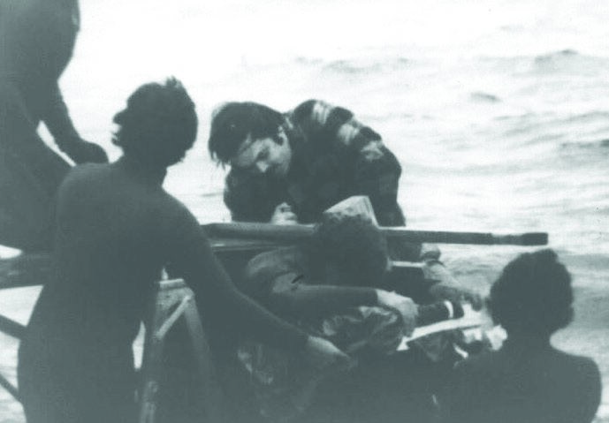
Jim Harrington climbing the pier while the camera rolls (Producer 48). Jim Harrington is an American radio personality of the 1960s, who featured as an extra in Jaws.

Research point
You can access hundreds of scripts online through sites such as www.simplyscripts.com, www. screenplays-online.de and www.script-o-rama.com. Throughout this course you should read as many scripts as possible. You may notice that there are sometimes discrepancies between the script and the film. This is perfectly normal. Once a script goes into production, the director may omit scenes, add scenes or improvise dialogue with the actors during filming.
We’ll end this short opening project with a reminder to use your writing diary to reflect on your progress through the course. Keeping a writing diary should be an ongoing task – not something you decide to catch up on every so often. At the end of each part of the course you’ll be asked to synthesise your writing diary entries into a short reflective commentary. If you’re unsure about how and when to use your writing diary, re-read the relevant section in the Creative Writing Student Guide before you go any further.

Project 2 Writing a screenplay
Screenplays can be adapted from novels, short stories, comic books, etc., or be wholly original, i.e. existing only as a screenplay.
Examples of original screenplays:
Little Miss Sunshine (2006, dir. Jonathan Dayton, Valerie Faris, screenplay Michael Arndt)
Secrets and Lies (1996, dir. Mike Leigh, writer Mike Leigh)
Pulp Fiction (1994, dir. Quentin Tarantino, screenplay Quentin Tarantino)
Examples of adapted screenplays:
Sense and Sensibility (1995, dir. Ang Lee, screenplay Emma Thompson) adapting Jane Austen’s novel Sense and Sensibility
Jaws (1975, dir. Stephen Spielberg, screenplay Peter Benchley, Carl Gottlieb) adapting Peter Benchley’s bestseller of the same name
Spider-Man (2002, dir. Sam Raimi, screenplay David Koepp) adapting the Marvel comic book by Stan Lee and Steve Ditko

Research point
Using a movie database such www.imdb.com, find three original and three adapted screenplays.
When a novel, short story or comic book is adapted for screen it undergoes a metamorphosis from one genre to another. The writer has to transform the prose into the more visual language of the screenplay. The writer must also ensure that the story works dramatically. As you’ve already discovered, the screenwriter can’t write what’s inside their character’s head so they have to dramatise it through actions, reactions and dialogue and by placing their characters in an appropriate location.
Adapting a scene within a novel for screen might involve adding or removing a character, expanding a scene to show more effectively the conflict between two characters, or shortening or omitting a scene that worked perfectly well in the book but doesn’t help tell the story visually.

Exercise
Comparing the prose version with the adapted screenplay is a great opportunity to examine some of the techniques a writer can use to make a story more visual and dramatic. Annie Proulx is an American writer who published Close Range: Wyoming Stories in 1999. The bestknown story in the collection is Brokeback Mountain, which screenwriters Larry McMurty and Diana Ossana adapted into a film of the same name.
Read the following extract from Annie Proulx’s short story (Proulx, McMurty & Ossana, 2005, pp.16–17) and compare and contrast it with Larry McMurty and Diana Ossana’s adaptation (pp.67–69). The scene takes place in the wake of a divorce between Alma and her husband Ennis. During a tense Thanksgiving supper she confronts him about his relationship with a fellow cattle hand called Jack Twist.
Her resentment opened out a little every year: the embrace she had glimpsed, Ennis’s fishing trips once or twice a year with Jack Twist and never a vacation with her and the girls, his disinclination to step out and have any fun, his yearning for low-paid, longhoured ranch work, his propensity to roll to the wall and sleep as soon as he hit the bed, his failure to look for a decent permanent job with the county or the power company, put her in a long, slow dive and when Alma Jr. was nine and Francine seven she said, what am I doin hangin around with him, divorced Ennis and married the Riverton grocer.
Ennis went back to ranch work, hired on here and there, not getting much ahead but glad enough to be around stock again, free to drop things, quit if he had to, and go into the mountains at short notice. He had no serious hard feelings, just a vague sense of getting shortchanged, and showed it was all right by taking Thanksgiving dinner with Alma and her grocer and the kids, sitting between his girls and talking horses to them, telling jokes, trying not to be a sad daddy. After the pie Alma got him off in the kitchen, scraped the plates and said she worried about him and he ought to get married again.
He saw she was pregnant, about four, five months, he guessed.
‘Once burned,’ he said, leaning against the counter, feeling too big for the room.
‘You still go fishin with that Jack Twist?’
‘Some.’ He thought she’d take the pattern off the plate with the scraping.
‘You know,’ she said, and from her tone he knew something was coming, ‘I used to wonder how come you never brought any trouts home. Always said you caught plenty. So one time I got your creel case open the night before you went on one a your little trips – price tag still on it after five years – and I tied a note on the end of the line. It said, hello Ennis, bring some fish home, love, Alma. And then you come back and said you’d caught a bunch a browns and ate them up. Remember? I looked in the case when I got a chance

and there was my note still tied there and that line hadn’t touched water in its life.’ As though the word ‘water’ had called out its domestic cousin she twisted the facet, sluiced the plates.
‘That don’t mean nothin.’
‘Don’t lie, don’t try to fool me, Ennis. I know what it means. Jack Twist? Jack Nasty.
You and him –‘
She’d overstepped his line. He seized her wrist; tears sprang and rolled, a dish clattered. ‘Shut up,’ he said. ‘Mind your own business. You don’t know nothin about it.’ ‘I’m a going a yell for Bill.’
INT: RIVERTON, WYOMING: MONROE HOUSEHOLD: THANKSGIVING NIGHT: DINING ROOM: 1977:
ENNIS sits next to JENNY. MONROE sits at the head of the table. ALMA across from MONROE. ALMA JR. sits across from her daddy. The girls are about 13 and 11, respectively. ENNIS dressed in a clean Levi’s jacket and a bolo tie, his shirt collar threadbare.
MONROE, at the head of the table, carves a large turkey. ALMA is visibly pregnant.
ENNIS tries to be cheerful for his girls, not wanting to be a sad daddy.
ALMA JR.
Daddy, tell about when you rode broncs in the rodeo.
ENNIS
Short story, honey. Only ‘bout three Seconds I was on that bronc, an’the next thing I knew I was flyin’ through the air. Only I wasn’t no angel like you and Jenny, and didn’t have no wings.

(smiles at her)
And that’s the story of my saddle bronc career.
His girls love him, their faces rapt when their daddy speaks.
MONROE is cheerful, and a bit smug: despite his unromantic appearance, he has ALMA.
INT. RIVERTON, WYOMING: MONROE HOUSEHOLD: THANKSGIVING NIGHT: KITCHEN: 1977:
ENNIS has gallantly brought a dinner plate or two into the kitchen, sets them on the counter.
Leans against the counter. ALMA is scraping food off the dinner plates.
ALMA
(trying to start conversation)
You ought to get married again, Ennis.
(pause)
Me and the girls worry ‘bout you bein’ alone so much.
ENNIS
(feeling too big for the room) Once burned…
ALMA
(scraping)
You still go fishin’ with Jack Twist?
ENNIS
Not often.
A beat.

ALMA
You know, I used to wonder how come you never brought any trouts home.
From her tone, ENNIS knows something is coming.
ALMA (CONT’D)
(trembling, but controlled) …Always said you caught plenty, and you know how me and the girls like fish.
(pause)
So one night I got your creel case open the night before you went on one a your little trips---price tag still on it after five years---and I tied a note on the end of the line. It said, ‘Hello Ennis, bring
some fish home, love, Alma’…
(pause)
…And then you come back lookin’ all perky and said you’d caught a bunch a browns and ate them up. Do you remember?
Looks over at ENNIS, stiff.
ALMA is scraping harder and faster, as if she means to take the pattern off the plates.
ALMA (CONT’D)
I looked in the case first chance
I got And there was my note still tied there.
ALMA turns on the water in the sink, sluices the plates.
ENNIS
That don’t mean nothin’, Alma.

ALMA
(turns on him)
Don’t try to fool me no more, Ennis, I know what it means. Jack Twist? Jack Nasty. You didn’t go up there to fish. You and him…
ENNIS grabs her wrist and twists it.
ENNIS
Now you listen to me, you don’t know nothin’ about it.
Tears spring to her eyes, she drops a dish.
ALMA
I’m goin’ to yell for Monroe.
Have you identified and taken note of some of the similarities and differences between how the scene appears in prose and how the scene appears in the screenplay?
Similarities:
You probably noticed that the content of the scene is more or less the same: Alma finally confronts Ennis about his relationship with Jack Twist.
McMurty and Ossana have retained the character names from the story with the exception of Monroe. The short story refers to him as ‘the grocer’ but, as he is present at the dinner table, the screenwriters have given him a name.
The time and location are the same.
Some lines of dialogue (and a couple of descriptions) remain the same in the screenplay. Make a note of these. Consider why the screenwriters have retained or added some lines of dialogue and action.
Differences:
Compare the layout of the short story version with the layout of the screenplay. In what ways do they look different on the page?
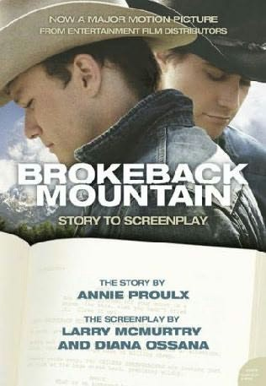
Look at the actions of each character in the screenplay. How do they help reveal what the
character is thinking and feeling?
In the short story the writer tells us in a few sentences that Alma is concerned and talks to
Ennis privately in the kitchen…
…sitting between his girls and talking horses to them, telling jokes, trying not to be a sad
daddy. After the pie Alma got him off in the kitchen, scraped the plates and said she worried
about him and he ought to get married again.
How have the screenwriters transformed this scene in the screenplay version? What does it
show us about the relationship between Alma and Ennis?
Book cover,
Brokeback Mountain.

Reprint by permission of Harper Collins Publishers Ltd © 1997
(
Larry McMurty and Diana Ossana
)
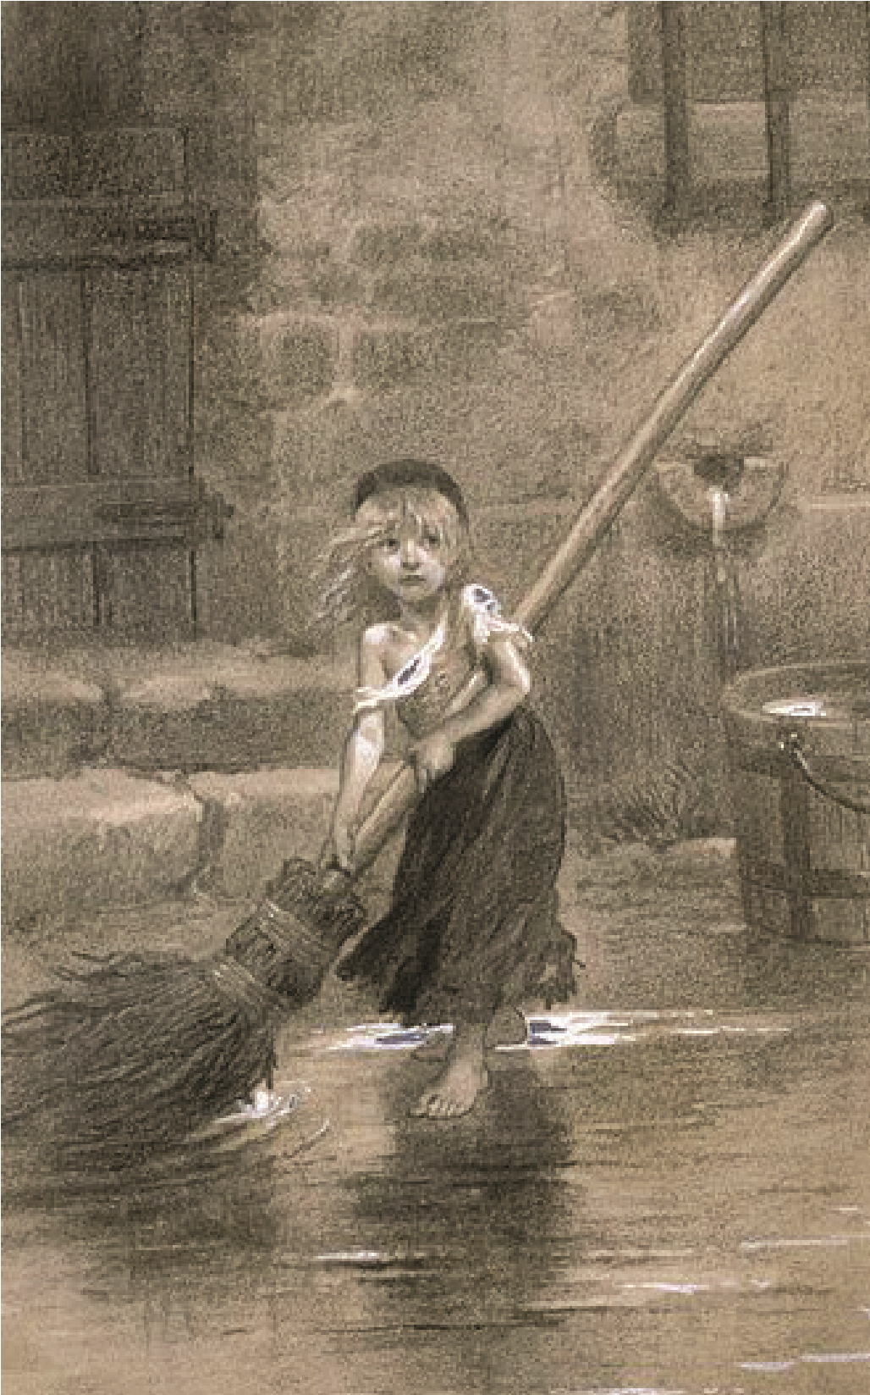
Émile Bayard, Young Cosette Sweeping, 1862. Drawing for Victor Hugo’s Les Misérables.

Research point
In your earlier research list of adapted screenplays you may have come across, for example, Baz Luhrmann’s The Great Gatsby (2013), Peter Jackson’s The Hobbit (2012), Tom Hooper’s Les Misérables (2012) or come up with a few of your own. Choose one book and its film adaptation to read and watch. Note down some of the similarities and differences between the prose and screen versions. What omissions and additions has the screenwriter made in order to make the story work visually?

Project 3 The screenwriter’s toolbox
“It is the writer’s screenplay, but the director’s film – get used to it.”
William Goldman (Frensham, 2008, p.6)
You’ll have noticed from the sample page of script from Brokeback Mountain that a screenplay has a unique format that is very distinct from a page of prose. The font, margins, spacing, dialogue, description and directions all follow a formula that is commonly understood and used across the film industry. Some writers call the screenplay a blueprint, others liken it to a set of instructions. This is because, unlike a novel or short story, the text does not end with the reader.
Screenwriting is a collaborative process. A successful script (i.e. one that is made into a film) is a working document that will pass through many hands: from the script reader or producer who first reads it, to the team of executives who will fund it, to the director who will make it, to the cinematographer who will film it, to the sound engineer, to the set and costume designer and to the actors who will inhabit the characters, to name but a few. The script is their guide and template for making the film. It is therefore essential that the script is clear, concise and correctly formatted.
Producers and directors receive hundreds of scripts so you’ll want yours to stand out from the crowd and make a good impression. If your script is incorrectly formatted, the script reader or producer will immediately think you’re unprofessional, even if you’ve written a compelling story.
Another reason to follow the guidelines is timing. The standardised margins and font size ensure that every page of script represents roughly the same time. In film, one page of script equals (more or less) one minute of screen time. A typical feature-length film script might be 105–120 pages long. Your final assignment will involve writing a 15-minute script which equates (if you use the correct formatting) to 15 typewritten pages.
Think of the formatting of a screenplay in terms of a toolbox. Your job as the writer is to assemble the tools and to understand when and how to use them.

Opening the toolbox
Every script has:
- Character names and dialogue.
- Description. Sometimes referred to as visual directions, this will include essential information about the location and characters and, most importantly, what the characters are doing in any given scene.
- Scenes. A screenplay is broken into scenes indicated by a change of location. They can vary greatly in length, from a couple of lines to two or three pages, and will influence the pace of your script.
- Page numbers.
- Set margins, font type and size.
Examine the following page of script from Little Miss Sunshine (2006, dir. Jonathan Dayton & Valerie Faris, screenplay Michael Arndt) (Arndt, 2007, p.10). Take note of the guidelines on formatting in the margins. It may seem a lot to remember but the more scripts you write, the easier it will become. When you access scripts online you may notice variations in formatting, for example between the US and the UK and between television and film scripts. Don’t worry about this. For the purposes of this course, follow the guidelines laid down here.
There is screenwriting software available, for example Final Draft. It’s not essential for you to have special software, but it will save you time formatting.
Each new scene should have a heading – known as a slugline – in capitals, telling us where and when the scene is set. Basic information in terms of location and time are sufficient. INT is used for interior scenes. EXT. is used for exterior scenes.
INT. DINING ROOM – DAY
DWAYNE sits in his chair, folds his arms, Use capitals for character names and – scowling – waits for everyone else to the first time they are mentioned arrive. FRANK tentatively follows. SHERYL in your visual directions. After that, use lower case. comes out and puts her salad on the table.
Always write your screenplay in the
SHERYL present tense.
Frank, you can sit here, next
Indent dialogue from left and right to Dwayne. Here’s the salad. margins. Character names should I’m gonna run get Sprite for be in CAPITALS above the dialogue. everyone. Use single-line spacing for dialogue
and directions.
She walks off, pausing to open the rec room door again.
SHERYL (cont’d) Olive! Come on! Dinner time!
OLIVE (O.S.) Off screen. Use this and other
directions such as V.O. (voice-over)
Coming!!! sparingly.
Description should run from margin to margin. | Sheryl disappears, leaving Dwayne and Frank alone. Frank sits. Dwayne scowls at the table in front of him.
Screenplays should be typed.  Always use 12 point Courier font. It helps ensure that a page of script equals one minute of screen time. | Incredible Hulk on it. He picks up the cup and examines it dispassionately. He puts it down.
Margins should be set either side at
3.5 cm and top and bottom at 5cmFrank looks at his place setting – a paper plate and a Big Gulp cup with the
Dwayne doesn’t move. Frank glances at Dwayne, not knowing what to do. He seems to have met someone who is at least as unhappy as he is. This intrigues him. He ventures:
FRANK
Got a girlfriend?
Dwayne looks at Frank, then shakes his head.
You can use (‘cont’d) if a character’s FRANK (cont’d)
speech is interrupted by directions. | Boyfriend?  Dwayne gives Frank a look.  FRANK (cont’d)
Indicates a pause in dialogue. Use Kidding. Kidding. I know. sparingly.
(beat)
So who do you hang out with?
Dwayne shakes his head.

Additional do’s and don’ts
Do:
- Place your title on a separate page. All you need is your title (in capitals) and your name (in lower case), for example:
LITTLE MISS SUNSHINE by
Michael Arndt
- Number your pages in the top right hand corner of every page except the title page.
- Follow the formula for scene headings :
INT (interior) or EXT (exterior) + LOCATION + TIME OF DAY For example: INT – CASINO – NIGHT
- Use parentheticals ( ) to show how a person says a line, for example:
ROBERT
(yelling)
But use sparingly. The action and dialogue should convey the intent of the character without you needing to over-emphasise it.
- After the title page you can open your script with FADE IN in the top left hand corner. You can place FADE OUT or FADE TO BLACK or CUT TO BLACK in the bottom right-hand corner of the last page of your script.
Don’t:
- Number your scenes. There is no need to number your scenes until your script goes into production. Then the production team will do it for you.
- Add camera angles. Occasionally you see these in a script (particularly where a writer also directs) but this is doing the director’s job for him/her. Your job is to describe the action and allow the director to decide how to shoot it.

Using description
“Description should always be simple, concise and to the point, with no superfluous text. It should be highly visual and deal only with what happens in the scene. It should not exceed four or five lines. Long passages should be broken up into shorter paragraphs or sentences. Producers and script readers dislike dense areas of text.”
(Nash, 2012, Chapter 8)
In Little Miss Sunshine, writer Michael Arndt is very adept at writing clear and concise directions that help the reader visualise the scene.
For example:
DWAYNE sits in his chair, folds his arms, and – scowling – waits for everyone else to arrive. FRANK tentatively follows. SHERYL comes out and puts her salad on the table.
Within three sentences, the writer has introduced Dwayne, Frank and Sheryl. The description ‘folds his arms’ and ‘scowling’ gives a telling yet economical introduction to Dwayne’s character. The use of the word ‘tentatively’ in relation to Frank also hints at this character’s feeling of displacement at the table. Sheryl is clearly a mother figure, in perpetual motion. Quickly we understand that this is a domestic scene with tense undercurrents.
Novice scriptwriters are often tempted to overdo the directions in their script. Read the example below.
ROGER walks across a farmyard. It is a typical rural scene. Hens root amongst the machinery strewn across the yard. Roger dodges the clutter – old tractor parts, wheels, engines. A dog is chained to the shed door. It rears up on its hind legs and snarls at Roger as he passes. He doesn’t blink. He continues walking towards the house which is bathed in early evening sunlight. The house has pink curtains and a blue half-door. The walls are pebble dashed, crumbling in places. Roger wrinkles his nose as the smell of boiling cabbage reaches him. The fields beyond the house are empty of cattle. Roger hesitates before entering, cups his hand around a cigarette in order to light it and waits for Bob in the yard.
This may (possibly!) work as a piece of prose but as a piece of direction for a screenplay it is grossly overwritten. We don’t need to know about the machinery or that the house has pink curtains and a blue half-door, nor that Roger smells boiling cabbage (how would the audience know it’s cabbage if they can’t see it?) and the pebble dashed walls could also be classified as non-essential information. Directions can be longer but it needs to be information essential to the story. Look at the opening of Jaws on www.script.com, for example. The directions are lengthy but absolutely essential in setting up the threat of the Great White.
A more economical way to write the directions in our fictional scene might be:
EXT – FARMYARD – EARLY EVENING
ROGER crosses a cluttered farmyard and hesitates at the door of the farmhouse. He lights a cigarette and decides to wait for BOB in the yard.
Let the set designer decide the look of the yard and farmhouse. Allow the actor to decide how to light his cigarette. ‘Hesitates’ is retained, though, as it suggests the character has reasons for waiting in the yard.

Exercise
Choose a film, one of your favourites. Check if the screenplay is available on www. simplyscripts.com but don’t read it yet! Watch the film and choose a scene with no dialogue. Write down the action as a direction. Compare what you’ve written with what is actually in the script. Have you used too many words or too few? What has the writer added/omitted in comparison to your version? Make some notes on how well you did with this exercise in your writing diary. If you found it hard, try repeating the exercise for a different scene.

Tip
www.bbc.co.uk/writersroom is a great resource which has advice on script layout and information on writing competitions as well as being home to a library of scripts.
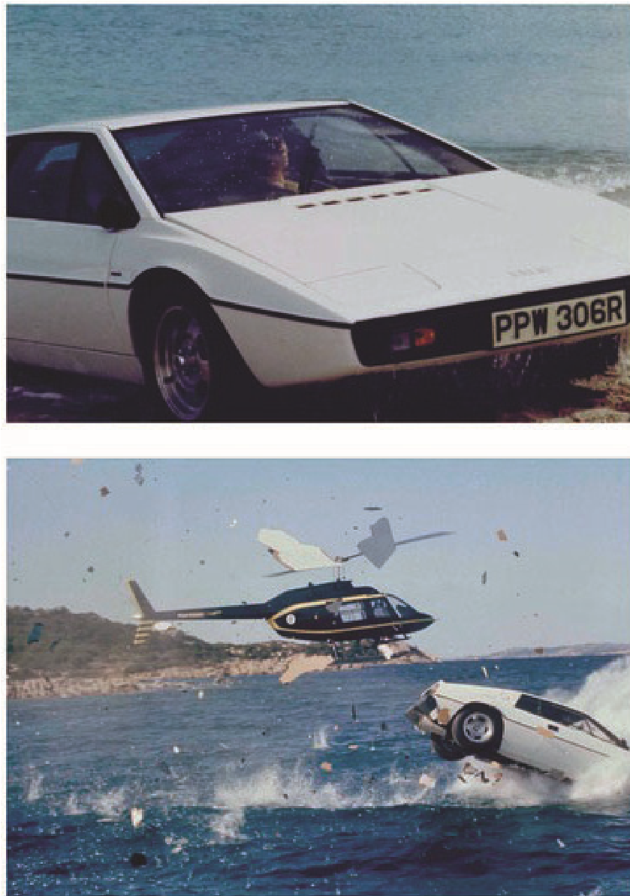
Film stills, The Spy Who Loved Me, 1977

Project 4 Finding ideas
“When I started writing full-time all I had to talk to was my word processor. I had to learn how to bounce ideas off myself.”
Andrew Davies, writer and adaptor – Pride and Prejudice, Bridget Jones’s Diary, House of Cards, Mr Selfridge (Frensham, 2008, p.33)
Every screenplay begins with an idea. But how do screenwriters come up with ideas?
Novelist Annie Proulx was inspired to write her short story Brokeback Mountain by an encounter in a rough local bar. Her subject matter is social and economic change in hard and isolated rural communities in Vermont, Newfoundland, Texas and Wyoming:
“Sometime in early 1997 the story took shape. One night in a bar upstate I had noticed an older ranch hand, maybe in his late sixties, obviously short on the world’s luxury goods. Although spruced up for Friday night his clothes were a little ragged, boots stained and worn. I had seen him around, working cows, helping with sheep, taking orders from a ranch manager. He was thin and lean, muscular in a stringy kind of way. He leaned against the back wall and his eyes were fastened not on the dozens of handsome and flashing women in the room but on the young cowboys playing pool. Maybe he was following the game, maybe he knew the players, maybe one was his son or nephew, but there was something in his expression, a kind of bitter longing, that made me wonder if he was country gay. Then I began to consider what it might have been like for him – not the real person against the wall, but for any ill-informed, confused, not-sure-of what-he-was-feeling youth growing up in homophobic rural Wyoming.”
(Proulx, McMurty & Ossana, 2005, pp.129–30)
This closely observed scene sparked a series of questions in Annie Proulx’s mind and the heart-breaking love story of Ennis and Jack, two cattle hands living in a deeply homophobic community, began to take shape. Screenwriters Diana Ossana and Larry McMurty read the short story and found it so compelling that they decided to turn it into a screenplay.
Alan Ball, writer of American Beauty, talks eloquently about the origins of his original screenplay. Lester Burnham lives in suburban America with his wife Carolyn and teenage daughter Jane. His wife is irritated by him, his daughter is embarrassed by him and his job is on the line. A crush on his daughter’s best friend inspires Lester to reshape his life, with fatal consequences. Alan Ball’s inspiration came from a widely reported scandal in 1990s America. Amy Fisher was a teenage girl known as the Long Island Lolita, who was convicted of the attempted murder of her lover’s wife. Alan Ball came across a comic-strip version of the story being sold by a local street vendor and the idea took root in his imagination.
“What had become fodder for jokes on late-night talk shows was, to those who had lived it, genuine tragedy – and, no doubt, a far more complicated and interesting story than any we would ever hear.”
(Ball, 2000, p.151)
Somewhere around the time the news story was playing on his mind, he was also haunted by the image of a plastic bag floating outside the World Trade Centre. This ordinary object was transformed by Ball’s imagination into the central image in the screenplay. Lester Burnham’s teenage neighbour Ricky films it and shows it to Jane, telling her that it is the most beautiful thing he has ever seen. The bag floating across an azure sky becomes an antidote for Ricky to the materialism and routine of the suburbs.
Use your writer’s notebook to build ideas for possible screenplays. Note down:
- observations of people who intrigue you – ask yourself questions about their lives
- personal experiences and/or images that you keep returning to
- other people’s experiences that you find compelling
- newspaper stories, documentaries, magazine features, etc., that capture your imagination
- your dreams.

Exercise
The writers of Brokeback Mountain and American Beauty encountered stories, people and images that lodged in their imaginations. The screenplays they would eventually write could be framed within the question What if…?
The following are What if…? scenarios from well-known films. Can you spot what they are?
- What if two cattle hands in a homophobic rural community fell in love?
- What if a man in a mid-life crisis decided to transform his life?
- What if a shark terrorised a small seaside town?
- What if a group of people were trapped on board a spaceship with an alien?
- What if a bookshop owner fell in love with a female film star who visited his shop?
- What if two young people from different backgrounds fell in love on board a ship on a fatal collision course?
Look through your writer’s notebook and commonplace book. Develop five What if…? scenarios based on your ideas and research. Log them in your notebook. You’ll return to these when you come to write your first assignment.
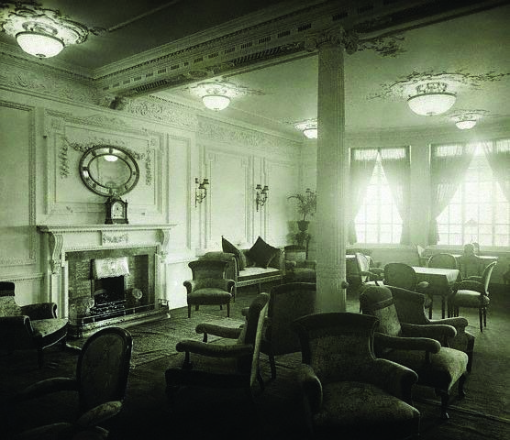
Reading and writing room on the A-Deck aboard Titanic, 1912

Project 5 Writing a synopsis
Writing a synopsis is another essential tool in the screenwriter’s box of tricks. So what is a synopsis? A synopsis is 100–500 words that sums up what your screenplay is about. Screenwriters use them in a number of ways:
- A synopsis is a marketing tool. Script readers or producers sometimes request a synopsis before reading a script in its entirety. If they like the idea in principle, they will commit to reading the screenplay.
- Films need funding. Providing a synopsis is usually part of the application process.
- More importantly, a synopsis is good creative practice. It helps you distil your idea into its essential components.
A good synopsis should:
- set out the main character and locations in your story
- be written in the present tense, to give the story immediacy and help captivate your reader
- include the conflict and challenges the main character faces and how they will overcome them. (The driving energy of any screenplay is conflict. There’s more about this in Part Two.)
A synopsis is an excellent way of working out your initial idea and it also helps identify any weak points in your characters or plot. As you develop your script you’ll find yourself refining your synopsis. This is all part of the creative process. As your story evolves and you begin to know it inside out, you’ll continue to fine tune your synopsis.
Here are two sample synopses. Note that each is just over 100 words. The Silence of the Lambs
The United States, the present. Young FBI agent Clarice Starling is assigned to help find a missing woman and save her from a serial killer named ‘Buffalo Bill’, who skins his victims. Clarice attempts to gain a better insight into the twisted mind of the killer by talking to an incarcerated psychopath, Dr Hannibal ‘the Cannibal’ Lecter, who prior to his capture was a respected psychiatrist. Starling’s mentor, FBI agent Jack Crawford, believes that Lecter might have the answers to questions that will help them locate the killer. Starling’s twisted relationship with Lecter not only forces her to confront her psychological demons, but also leads her to Buffalo Bill himself.
(Conroy Scott, 2005, p.1)
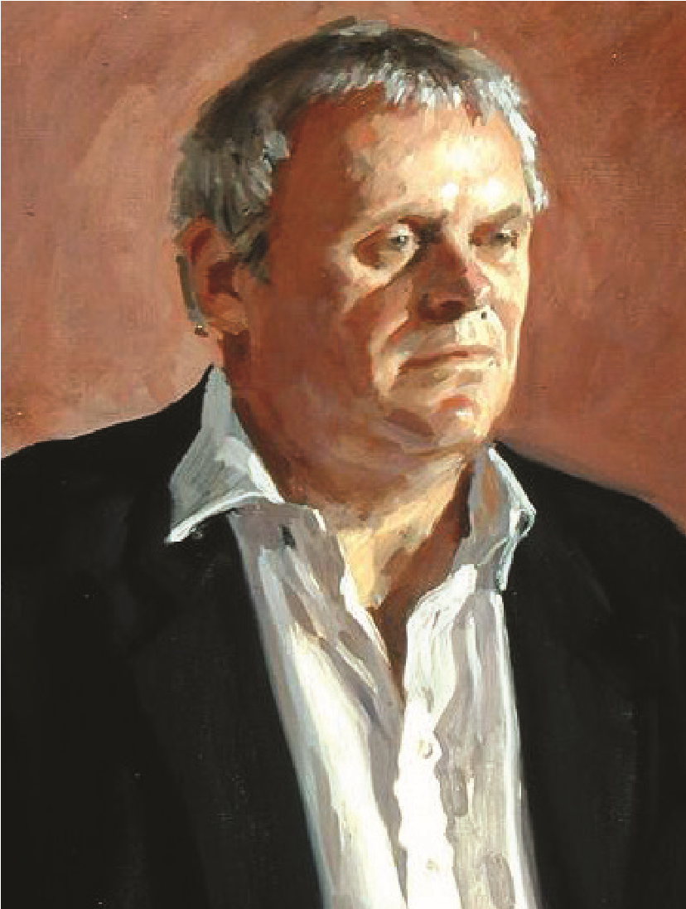
Richard Foster, Sir Anthony Hopkins, 1994. Hopkins plays
Hannibal Lecter in the 1991 film The Silence of the Lambs.

Rushmore
The United States, the present. Max Fischer is a scholarship student at Rushmore, a private school, where he has great success in organising clubs and dramatic productions but fails most of his academic classes. He befriends a rich industrialist, Blume, and falls for a recently widowed teacher at Rushmore, Ms Cross. His attempt to build an aquarium with Blume’s money in order to impress Ms Cross gets him expelled. Max then discovers Blume also loves Ms Cross and he seeks vengeance. Blume retaliates, war ensues, and Max’s troubles worsen. Rescue comes from unexpected places, including his simple but philosophical father, a barber.
(Conroy Scott, 2005, p.109)

Exercise
Choose a film from the TV listings or your DVD collection. Watch it closely and write a 100–120 word synopsis. Establish the location (e.g. the United States), the time frame (e.g. the present), the main character (e.g. Clarice Starling, Max Fischer) and the key events that form the beginning, middle and the end of the film.

Project 6 Genre
“I am a genre lover – everything from spaghetti western to the samurai movie.”
(en.wikiquote.org/wiki/Quentin_Tarantino)
The Oxford Dictionary, Thesaurus & Wordpower Guide defines ‘genre’ as ‘a style of art or literature’. All writing is divided into different types or genres. There are three overarching genres – drama, poetry and prose – but within each of these are numerous sub-genres. You only have to go into a bookstore or look at an online bookseller to see how novels, for example, are divided into genres such as romance, literary fiction, crime.
The same applies to film. An audience enters the cinema with certain expectations: there will be vampires in a vampire film, romance in a romantic comedy, horror in a horror film. You may gravitate towards a certain genre because of the expectations it creates. You know you’ll be scared in a horror film, will laugh (or should laugh!) at a comedy, and will feel uplifted by a romance.
Here are just some of the main film genres. You can probably think of many more.

Romantic comedy
British screenwriter Richard Curtis is renowned for his romantic comedies Four Weddings and a Funeral, Notting Hill, Love Actually and Bridget Jones: The Edge of Reason. What do they have in common? A central love story (or stories) in which the main characters face obstacles to win or keep the love of the other.

Horror
There has been an explosion in horror films in recent years. Titles include the Paranormal Activity trilogy, The Blair Witch Project, The Ring and Hostel. They are characterised by individuals or a group of people being terrorised, often violently, by a real or supernatural presence. Sci-fi and fantasy
Imaginary worlds, distant universes, non-human characters are all key to the sci-fi and fantasy genre. The Lord of the Rings, the Harry Potter series, The Hunger Games, Alien and Star Wars fall into this category. The plot is usually driven by a quest against great odds.
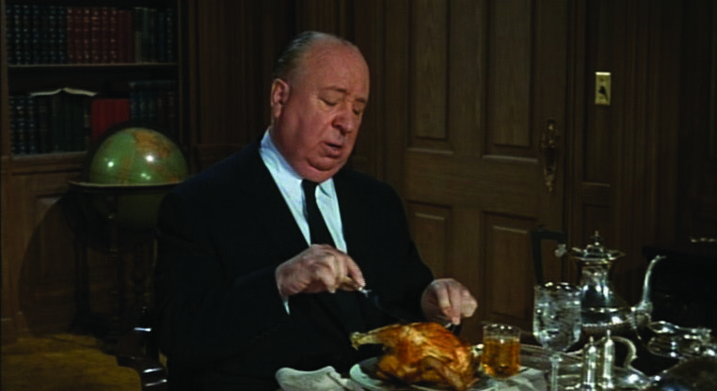
Alfred Hitchock, The Birds, trailer screenshot, 1963

Thrillers
Alfred Hitchcock is the master of suspense. Thrillers such as The Birds and Rear Window feature a mystery and central character(s) who face great personal danger as they uncover the truth. Modern thrillers add action to the mix, for example The Bourne Identity and Panic Room.
Other genres include martial arts, war, period drama, family sagas, animation, coming-of-age, westerns.
Quentin Tarantino is a fascinating study in terms of genre. He has talked about genre providing a road map for the scriptwriter and how he loves working within a recognisable, pre-existing structure then adding his own unique twist. For example, he engaged with the martial arts genre, made famous by Jackie Chan and Bruce Lee, in Kill Bill 1 and 2. In addition to the genrespecific acrobatic martial arts scenes, Tarantino introduces his own unique twist by turning the traditionally male main character into a woman known as ‘The Bride’.
Similarly, Tarantino has placed his own stamp on the vampire genre. In vampire movies, the main character is terrorised by vampires from the outset of the film. Look up Dracula, Fright Night and the Twilight series as examples of this genre. In From Dusk Till Dawn Tarantino plays with audience expectations. The film begins as a road movie with a family taken hostage by two criminal brothers but it soon morphs abruptly and unexpectedly into the vampire genre when the group visit a remote roadside bar.
When you’re developing your own ideas for screenplays, engage with genre. Ask yourself ‘What if the neighbour my main character is fighting with turns out to be a vampire?’ or ‘What if my main character lives in the American mid-west rather than inner-city London?’ Who knows? You may be inspired and find that by placing your idea within a particular genre you can give it a unique spin.

Exercise
Allow yourself five minutes for this exercise. In your writer’s notebook, write a list of films you love. Next, list them according to genre.
Do your chosen films cluster under one particular genre? If they do, take note – if you love watching this genre, you’ll love writing it.
Write the film you want to see!

Assignment one
This first assignment is about introducing yourself so that your tutor can get to know you, your ideas and your work better. It should take you between two and three hours of study time. This assignment is not submitted for formal assessment.
Before you attempt the two assignment tasks below, read through each project again, checking that you’ve understood them first time round.
- For example think about the genres you’re drawn towards. Your preference might be for horror or romances or thrillers.
Now re-read the five What if …? scenarios you came up with in Project 4. Does applying a genre to any of these scenarios provide inspiration?
Choose the three What if…? scenarios you like the best (or come up with some new ones) and develop each idea into a synopsis for a 15-minute script, 100–120 words each. Make sure you include the location, time, genre, the main character, the challenges they face, the beginning, middle and end. Refer to the sample synopses as a guide.
This is an opportunity to run your ideas past your tutor and to discuss their potential. You may end up using one of them for your final assignment but at this stage they don’t have to be perfect! There is plenty of time for you to develop them with the help of your tutor.
- For the second part of this assignment, you’ll adapt an extract into two short scenes from a screenplay. Re-read the prose to screenplay adaptation from Brokeback Mountain (Project 2). Recall your thoughts on what the screenwriters added in terms of visual directions and dialogue (and what they chose to omit). Apply similar techniques to your own adaptation. Lay out your adaptation according to the formatting guidelines in Part One (Project 3); your adaptation should run to approximately 3–4 pages.
The extract is from The Great Gatsby by F. Scott Fitzgerald. Set in the hedonistic 1920s, the scene takes place in the opulent home of Daisy and Tom Buchanan, who live just outside New York. Present at the lunch are Daisy, Tom, Nick Carraway (the narrator), Jordan (a glamorous female friend of Daisy’s) and Jay Gatsby, their enigmatic millionaire neighbour. Tensions are high. Gatsby is deeply in love with Daisy and they have recently begun an affair. Nick and Jordan already know about it but, in this scene, the penny drops with Tom. The first scene should take place inside the house, the second scene outside. Remember to use a slugline to indicate the scene change.

The Great Gatsby by F. Scott Fitzgerald (Chapter 7)
We had luncheon in the dining-room, darkened too against the heat, and drank down nervous gaiety with the cold ale.
“What’ll we do with ourselves this afternoon?” cried Daisy, “and the day after that, and the next thirty years?”
“Don’t be morbid,” Jordan said. “Life starts all over again when it gets crisp in the fall.”
“But it’s so hot,” insisted Daisy, on the verge of tears, “and everything’s so confused. Let’s all go to town!” Her voice struggled on through the heat, beating against it, molding its senselessness into forms.
“I’ve heard of making a garage out of a stable,” Tom was saying to Gatsby, “but I’m the first man who ever made a stable out of a garage.”
“Who wants to go to town?” demanded Daisy insistently. Gatsby’s eyes floated toward her. “Ah,” she cried, “you look so cool.”
Their eyes met, and they stared together at each other, alone in space. With an effort she glanced down at the table.
“You always look so cool,” she repeated.
She had told him that she loved him, and Tom Buchanan saw. He was astounded. His mouth opened a little, and he looked at Gatsby, and then back at Daisy as if he had just recognized her as some one he knew a long time ago.
“You resemble the advertisement of the man,” she went on innocently. “You know the advertisement of the man –” “All right,” broke in Tom quickly, “I’m perfectly willing to go to town. Come on – we’re all going to town.” He got up, his eyes still flashing between Gatsby and his wife. No one moved.
“Come on!” His temper cracked a little. “What’s the matter, anyhow? If we’re going to town, let’s start.”
His hand, trembling with his effort at self-control, bore to his lips the last of his glass of ale. Daisy’s voice got us to our feet and out on to the blazing gravel drive.
“Are we just going to go?” she objected. “Like this? Aren’t we going to let any one smoke a cigarette first?”
“Everybody smoked all through lunch.”
“Oh, let’s have fun,” she begged him. “It’s too hot to fuss.” He didn’t answer.
“Have it your own way,” she said. “Come on, Jordan.”
They went up-stairs to get ready while we three men stood there shuffling the hot pebbles with our feet. A silver curve of the moon hovered already in the western sky. Gatsby started to speak, changed his mind, but not before Tom wheeled and faced him expectantly.
“Pardon me?”
“Have you got your stables here?” asked Gatsby with an effort.
“About a quarter of a mile down the road.” “Oh.” A pause.
“I don’t see the idea of going to town,” broke out Tom savagely. “Women get these notions in their heads –” “Shall we take anything to drink?” called Daisy from an upper window.
“I’ll get some whiskey,” answered Tom. He went inside.
Gatsby turned to me rigidly: “I can’t say anything in his house, old sport.” “She’s got an indiscreet voice,” I remarked. “It’s full of –” I hesitated.
“Her voice is full of money,” he said suddenly.
That was it. I’d never understood before. It was full of money – that was the inexhaustible charm that rose and fell in it, the jingle of it, the cymbals’ song of it. . . . high in a white palace the king’s daughter, the golden girl.
(Fitzgerald, F. Scott, The Great Gatsby, Chapter 7, Oberon Books Ltd., Kindle edition)
Also send to your tutor a reflective commentary on your experience of this part of the course. This will be a synthesis of your writing diary so far. Write about 500 words for this first attempt.

Reflection
Don’t forget to review this assignment against the assessment criteria. Review how you think you have done against the criteria and make notes in your writing diary.
Make sure that all work is labelled with your name, student number and assignment number.
You don’t need to wait until you’ve heard from your tutor before continuing with the course.

