Grade 5 Unit 5 Week 1
Skill/Strategy: Plot/Prior Knowledge
Essential Questions: How can I identify the plot and the type of conflict?

Review:
A plot, or underlying story structure, is found only in fiction. A plot begins when a character has a problem or conflict. The problem builds up during the rising action, is met directly at the climax or turning point, and comes to an end, as the action winds down, during the resolution. Characters are people or animals in a story. Characters show what they are like by what they say and do and how they treat each other.
Good readers use what they already know to help them follow a story. Before you read, look at the title, illustrations, and author. Have you read stories by this author before? Remember that you will read about characters, a problem, and how that problem is resolved.
Reading Street, Grade 5, Unit 5, p. 262.
Part A: Introduce/Reteach Plot
Materials: copy the Plot Diagram on both sides of a paper for each student (used for part A and part B).
Create a diagram showing what a plot is. You can use the diagram below or go to the website below:
Interactive Plot Diagram:
http://www.readwritethink.org/classroom-resources/student-interactives/plot-diagram-30040.html?tab=4#tabs
There is an excellent, very short PowerPoint that introduces the graphic organizer. The PowerPoint can also be found under Resources at http://www.readwritethink.org/classroom-resources/lesson-plans/plot-structure-literary-elements-904.html

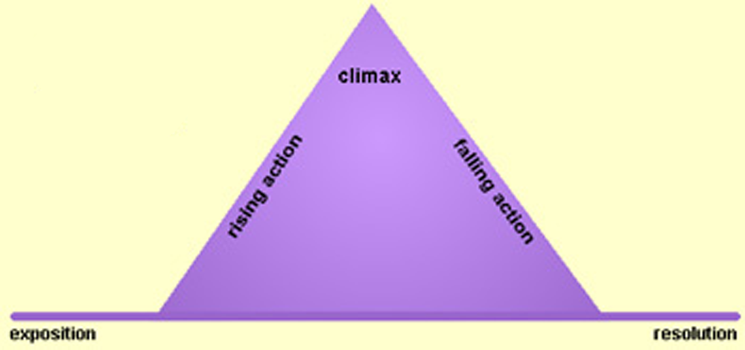

from readwritethink.org

Demonstrate identifying the elements of plot with a well-known tale such as the Three Little Pigs. (see sample plot diagram attached)
Three little pigs left home. Built houses, it was hard. Wolf goes to first pig’s home, blows it down, eats the pig. Wolf goes to 2nd pig’s home, blows it down, eats the pig. Wolf goes to 3rd little pig’s home, tries to blow it down, gives up and leaves. The pigs celebrate.
Part A2: Practice with plot
Materials: 1 sheet of back-to-back plot diagrams for each student, Reading Street textbooks
Draw one plot diagram on the white board to demonstrate the first short story, ask students to work with a partner on the second and third short stories. Share and discuss results. (conflict is shown in red, climax is underlined)

p. 19 Homework Help
Anna was rushing to get to school. Her mom exclaimed, “I see the bus!” Anna stuffed toast in her mouth and gathered up her homework from the table.
She darted outside and hopped onto the bus. Her history report was due today. She decided to examine it one last time. Anna searched her backpack, but there was no report. She groaned and thought, I can’t believe I forgot my report! What am I going to do?
Anna began to imagine how she could get that report. Her dog was always snorting around the table
looking for scraps from a meal. Maybe he would snatch her report, sprint to school, and slide it under
her locker door. Well, Max was smart, but not THAT smart.
Another idea came to Anna. Perhaps a hurricaneforce wind would blow through the kitchen window. It would carry her report to school and drop it on Mr. Mulligan’s desk. Hmm, that idea was unlikely too.
As Anna got off the bus, she realized that the only solution was to be honest and tell Mr. Mulligan what
happened. Suddenly, Anna heard a blaring horn. There was her mom, waving her report out their
car window. Anna dashed over to the car. “Thanks, Mom,” she sighed. “You’re the greatest!”

p. 263 Minnie Miller, Millionaire
Minnie Miller was a six-year-old with a grownup’s goal. She would make herself a millionaire. How
would Minnie reach this grand goal? It was August, and what did people crave when the air sweltered
and sizzled? Minnie Miller would make her million selling lemonade.
Building the stand was easy. Two sawhorses and a slab of plywood from the basement did the
trick. Then there was a quick trip to the QuickMart with Mom for lemons and sugar. Soon it was all
ready, but Minnie scrunched up her freckled face. “Boring,” she said. “My stand totally lacks pizazz. I must spice it up. But how?” “I got it!” Minnie cried. Minnie’s mom was an artist. Together, they got a huge sheet of paper and began painting. Soon they had a colossal collage of glistening lemons, sparkling ice, and a mammoth mouth with the tongue eagerly licking the lips. All day long people streamed in from all around for a cool, refreshing drink.
Did Minnie Miller make her million? Not quite. She still had $999,984.17 to go. Her next brilliant brainstorm? We’ll have to wait and see.

p. 205-206 The Lion and the Mouse
A lion was sleeping in his lair one hot afternoon when a mouse ran over his nose and woke him up. The lion snarled and was just about to crush the mouse with his huge paw when: “Oh spare me, my lord,” cried the mouse. “I am really not worth killing. I mean you no harm—and I don’t even taste nice.”
The lion snarled sleepily.
“Besides,” the mouse squeaked, “perhaps I can do something for you one day if you spare me now.”
The lion gave a great roar of laughter, but he lifted his paw, and the mouse skipped out of reach. Still laughing, the lion sank back to his dreams. Not long after, the lion was hunting in the woods when he fell
into a trap. Some hunters had stretched a trip rope across one of his favorite paths. They had suspended a huge net above the path and had fixed it so that when the lion fell over the rope, the net would
fall down and cover him, holding him prisoner until morning.
The lion twisted and turned and scratched and bit, but the more he struggled the more tightly he seemed to be held in the net. Soon he could not move at all. With no hope of escape, he began to roar, and his mighty voice echoed through every corner of the forest.
Now it happened that the mouse was also out hunting that night. Of course he quickly recognized the lion’s voice, and he ran as fast as he could to the spot. He saw at a glance what the situation was and pausing only to say “Don’t worry, sir, I’ll have you out in no time,” and “Keep still, sir, please,” he began to gnaw and nibble the thick cords of the net. In a very short time the lion’s front paws were free; then his head and mane; then his back legs and finally his tail.
The little mouse had done something for the great lion, just as he had promised. In fact, he had saved his life.

Part B: Characters
Materials: Character Webs (or draw these on a board or chart paper)

Use the stories from Part A to evaluate the characters.

p. 19 Homework Help
Character - Anna
What she says or thinks: | What she does: | How she treats others:
I can’t believe I forgot my report! What am I going to do?  Thanks, Mom. You’re the greatest! | Rushes to get ready for school  Looks for her homework on bus  Imagines different solutions | She is planning to be honest with Mr. Mulligan.  She thanked her mom.
What do you know about Anna? She cares about getting her homework done. She is creative in looking for solutions. She is honest and grateful.

p. 263 Minnie Miller, Millionaire
Character – Minnie, 6 years old
What she says or thinks: | What she does: | How she treats others:
Boring. My stand totally lacks pizazz. I must spice it up. But how? I got it! | Goes with mom to get lemons and sugar  Keeps going even if the job is difficult  Wants her idea to be the best it can be  Asks Mom to help make a sign. | Works with her mom  Serves lemonade
What do you know about Minnie? She is determined and creative. She knows to ask an adult for help. She will probably be a great business owner.

p. 205-206 The Lion and the Mouse
Character – Mouse
What he says or thinks: | What he does: | How he treats others:
Oh spare me. I mean you no harm—and I don’t even taste nice. Perhaps I can do something for you one day. | Pleads for his life, uses humor, gnaws the rope holding the lion | Honored his promise to the lion, even when he could have run away
What do you know about Mouse? Mouse is brave to stand up to a lion and he is trustworthy because he saved the lion even when he did not have to.

Part C: Types of Conflict
Materials: Types of conflict chart
Explain the common different types of conflict, using the pictures to help students remember. Discuss some real life conflicts and decide what the conflict is and what type of conflict that would be. Focus more on real-life examples and only one or two stories for each category. Explain that stories can often have more than one conflict, but there is usually one that is prominent. I just brainstormed a few examples for each category, and some of them are quite debatable. Feel free to change these or add more…
Types of Conflict:

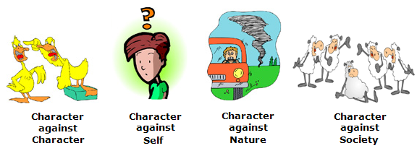

Types of Conflict
conflict – the problem or struggle between two forces in a narrative
Type of Conflict | Real-Life Examples | Story Examples
Character vs. Character – this includes groups as characters | Eagles vs. Steelers, two friends having a disagreement on the playground, two countries at war, police catching a crook | Three Little Pigs, Little Red Riding Hood, Star Wars, Home Alone, Sleeping Beauty
Character vs. Nature | Earthquake, tornado, flood, environmental issues, fisherman in a hurricane | Great Kapok Tree, The Stranger
Character vs. Society | Poverty, excluding people, slavery, being different, bullying | Abiyoyo, WALL-E, Romeo and Juliet, Avatar, Cinderella, Little Mermaid
Character vs. Self | Making a decision, growing up, learning how to make friends, working towards a goal | Lord of the Rings, Polar Express, Miss Rumphius, Rainbow Fish

Types of Conflict
conflict – the problem or struggle between two forces in a narrative
Type of Conflict | Real-Life Examples | Story Example
Character vs. Character

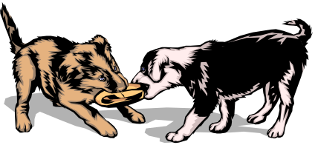

Character vs. Nature

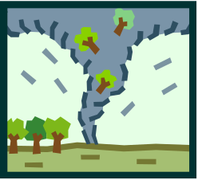

Character vs. Society

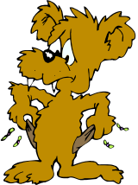
Character vs. Self

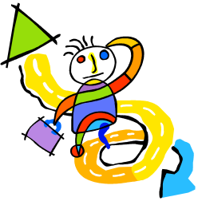

Name ______________________________________________ Date _______________________________________
Character Traits
p. 19 Homework Help

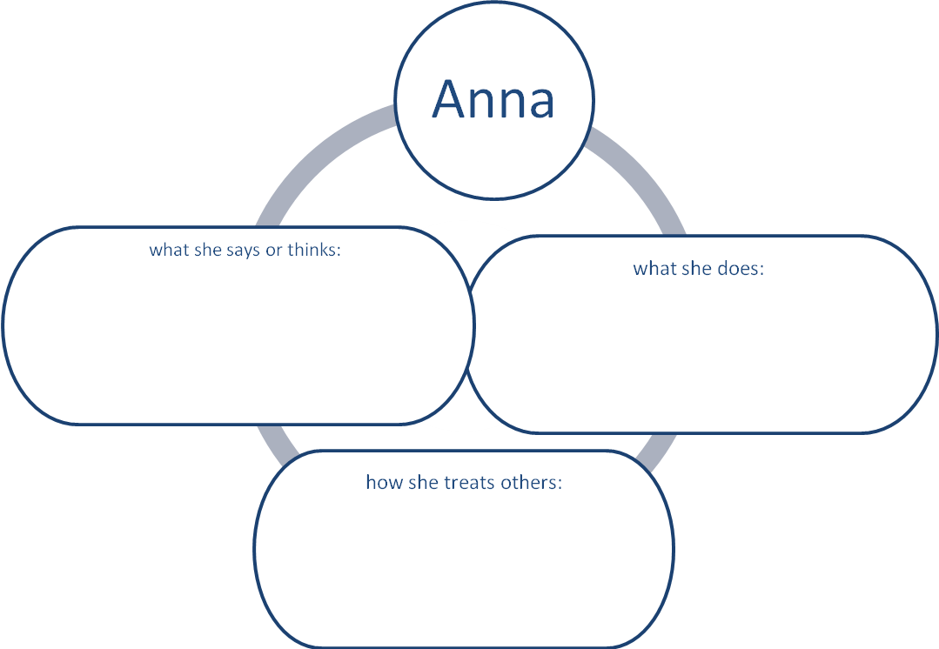

What do you know about Anna from thinking about what she says and does, and how she treats others?

Name ______________________________________________ Date _______________________________________
Character Traits
p. 263 Minnie Miller, Millionaire

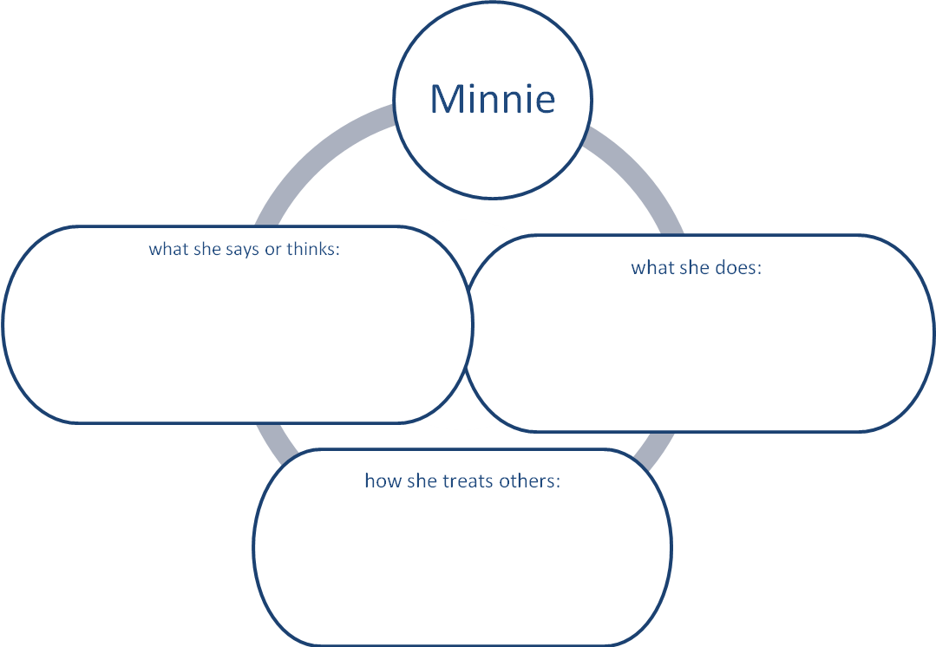

What do you know about Minnie from thinking about what she says and does, and how she treats others?

Name ______________________________________________ Date _______________________________________
Character Traits
p. 205-206 The Lion and the Mouse

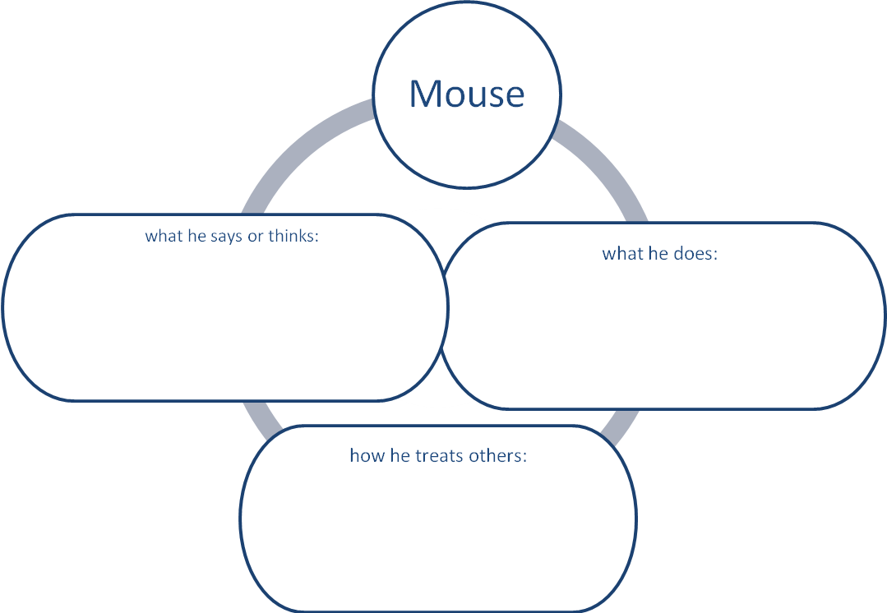

What do you know about Mouse from thinking about what she says and does, and how she treats others?

Name TEACHER Date _____________ Title: The Three Little Pigs .
PLOT DIAGRAM
Climax:
Climax: The wolf tried to blow down the 3rd little pig’s house!
Clima
Resolution:
The wolf is burned in the hot water and runs away, never to be seen again.
Beginning:
The three little pigs left their mother and set out on their own.
Rising Action:
The pigs built houses, but the wolf came by!
CONFLICT
He blew down the first two houses!
Falling Action:
He can’t blow the house down.
He climbs up to the roof.
He tries to come down the chimney.

Name _______________________________ Date _____________ Title: ______________________________________
PLOT DIAGRAM
Climax:

Resolution:
Beginning:
Rising Action:
Falling Action:

