



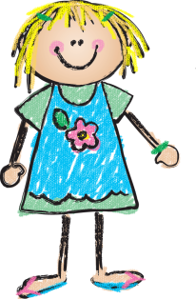

**with Mrs.Kazanjian August 17, 2016**



**Weekly News…**



**A Look at Next Week…**

**Our theme will be “All About Me and My Feelings”. We will discuss how we are unique and special in our very own way. In Phonics, we will learn how to identify the letter T and complete many fun activities to help us learn the shape and sound of this letter. In Math, we will begin sorting activities using math manipulatives. We will also practice counting to tell the number of objects. We will visit the Media Center for our orientation and meet with our Book Buddies.**

**Reminders**

* Thursday was the kick off for the Sally Foster fundraiser.
* Remember to send a snack in with your child.
* Remember to return the daily folder & sign the monthly behavior calendar.
* Remember tennis shoes on PE days.
* Students can check out one book from the library each visit.

Mrs. Kazanjian

**Star Student**

**Coming**

**Soon**

**Dates to Remember**

8/22: Chick-fil-a Biscuit Sale

8/23: Chick-fil-a Family Night

8/27: School Pictures



**Sight Words (for next week)**

**I**

**a**

Our first week in Kindergarten was a great success! The boys and girls have done a great job of adjusting to our daily routine. We continue to review classroom rules and procedures as well as center rules and proper indoor voice level. Thank you for all who were able to attend Open House on Tuesday. A power point was shared as well as a folder of information about classroom happenings. I will post the power point on my blog for those who were unable to attend. If you have any questions, please contact me. Thank you to all for sending in the items on the supply list and from our Wish List! Brady sent in sidewalk chalk and emergency snacks for kids who forget theirs! Thank you so much!! Have a wonderful weekend!