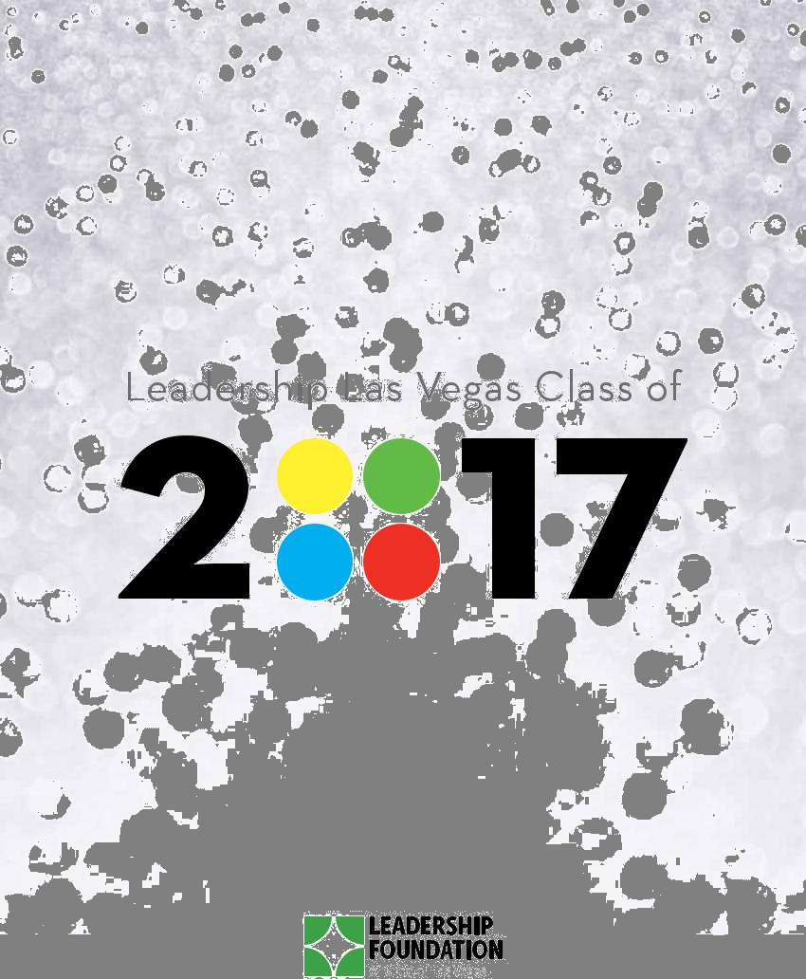

CONGRATULATIONS,

LEADERSHIP LAS VEGAS CLASS OF
Many thanks to the following supporters for their commitment to the community and the Leadership Las Vegas Class of 2017.
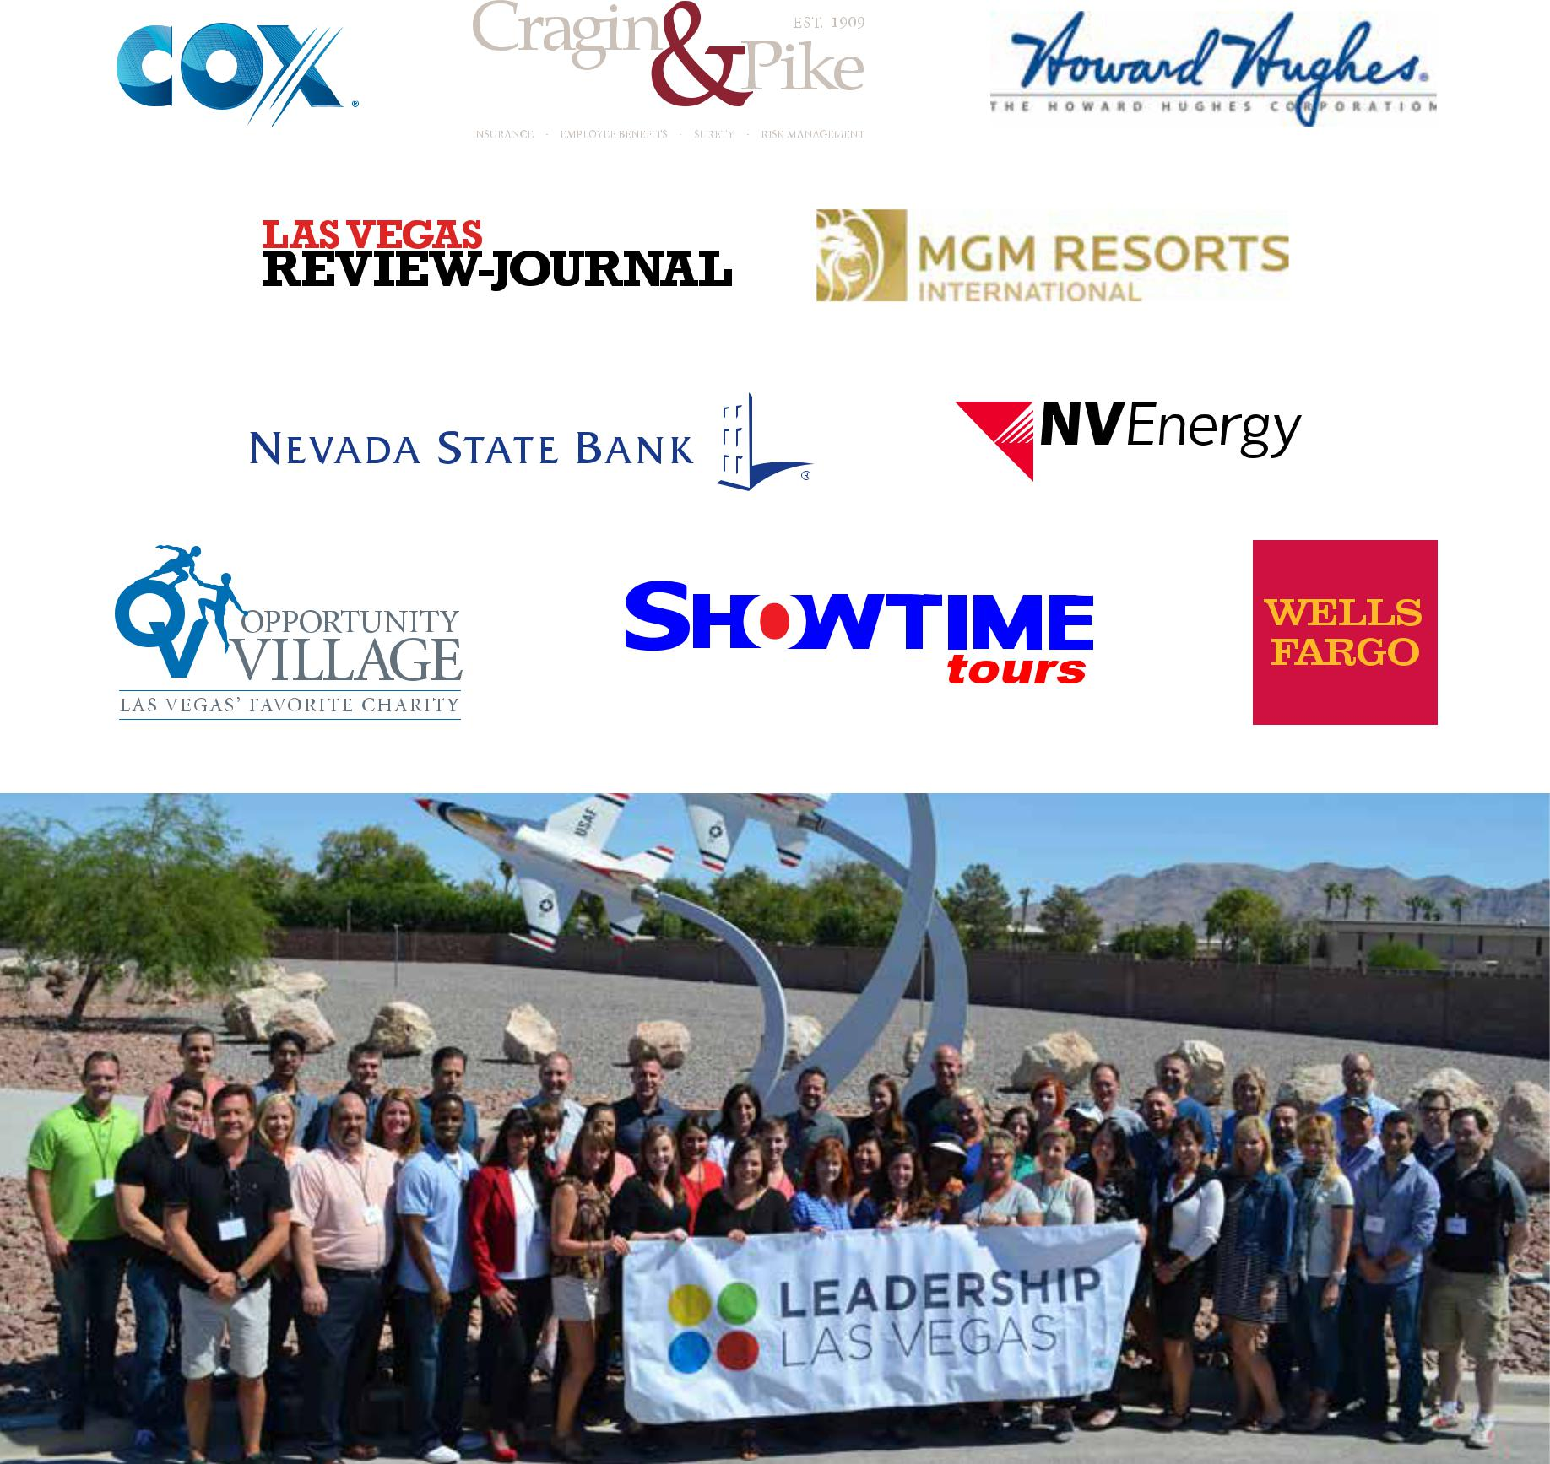

NELLIS AIR FORCE BASE – SEPTEMBER 15, 2016


2 CLASS OF 2017 LEADERSHIP LAS VEGAS

LEADERSHIP LAS VEGAS

Class of 2017

Graduation Ceremony June 23, 2017

EVENT PROGRAM

Welcome

Gordon Absher ‘09 Leadership Las Vegas Council Chair

Remarks

Cara Clarke ‘07

Leadership Foundation of Greater Las Vegas

Executive Director

Leadership Las Vegas

Hall of Fame Induction

Honoree: Kimberly Malloy ‘00 Presented by Alan Diskin ‘03 Incoming Council Chair

Class Observations

Andrew Magness ‘17

Presentation of Class & Diplomas

Jennifer Mayon ‘14

Curriculum Chair

Gordon Absher ‘09

Council Chair

Alan Diskin ‘03

Incoming Council Chair

Closing Comments

Gordon Absher ‘09

Council Chair

TABLE OF CONTENTS

Letters of Congratulations | 4
About the Program and
Leadership Foundation | 8
Leadership Las Vegas
Hall of Fame | 9
2017 Leadership Council | 11
2016-2017 Volunteers | 11
Leadership Las Vegas
Class of 2017 Graduates | 15
Leadership Las Vegas
Online Directory | 28

LEADERSHIP LAS VEGAS CLASS OF 2017 3

LETTER OF CONGRATULATIONS


Congratulations, Class of 2017!

President Harry S. Truman once said, “Progress occurs when courageous, skillful leaders seize the opportunity to change things for the better.”

We are living in transformative times – locally, nationally, and globally. We need talented, passionate, and informed individuals who will step up and have the courage to engage and work to positively shape the future.

As you graduate from the Leadership Las Vegas program, our community is counting on you to take the information you have learned over the past
10 months and use it to help make Southern Nevada an even better place.

There are many areas in which you can have a meaningful impact. Volunteer your time to help improve one individual’s life; join a non- profit that could benefit from your skills and expertise; be willing to serve on a public board or run for office to enact policies that will improve the quality of life in our region.

I look forward to seeing where the path of leadership takes you.


Kristin McMillan ’97

President & CEO

Las Vegas Metro

Chamber of Commerce

4 CLASS OF 2017 LEADERSHIP LAS VEGAS

LETTER OF CONGRATULATIONS


Dear Class of 2017:

Congratulations! Tonight is a celebration of the journey you have taken over the past 10 months of not only getting to know our community better, but also the life-long friendships you have made with each other.

Tonight, you join the network of more than 1,300 alumni who span 30 years of the program. We encourage you to continue to engage with the friends you made in your class, as well as with the alumni and program activities.

And as you seek opportunities to continue your development as a community leader, we encourage you to look to the Leadership Foundation for programs to help you achieve your goals and maximize your impact.

We wish you the best of luck in your leadership endeavors.



Lori Nelson ’99 |  | Cara Clarke ‘07
President of the Board |  | Executive Director
Leadership Foundation |  | Leadership Foundation
of Greater Las Vegas |  | of Greater Las Vegas

LEADERSHIP LAS VEGAS CLASS OF 2017 5

CURRICULUM CHAIR LETTER

Inspiration. Collaboration. Gratitude. These words were the foundation for our planning for the Leadership Las Vegas Class of 2017. The results were a culture of caring, community, and connection far surpassing our expectations. Our octopus mascot, appropriately named “Crud” by the LLV alumni, helped us navigate a successful 2017 class year with eight guiding principles:

1. | Show up | 5. | Connect and Collaborate
2. | Be Authentic | 6. | Inspire and Be Inspired
3. | Be Vulnerable | 7. | Be Happy and Have Fun
4. | Demonstrate Gumption | 8. | Express and Demonstrate Gratitude


Symbolized by the octopus hand signal, these principles have shaped the 2017 Leadership Las Vegas program for 49 leaders who are certainly more engaged in our community than they were 10 months ago. Their generous spirit and the intensity and consistency of their involvement are indeed an inspiration.

While this has been a year of enrichment for the class, it has also been a year of growth for the program. This year, we included “making connections” as a tenet of each session day. Mini leadership lessons and meaningful conversations occurred at the end of each day in order to tie the session days together. We also connected the different session day

chairs and co-chairs by creating new activities and opportunities to share their recipes for what makes a session day successful. Through formal meetings, social meet-ups, and group texting, it was our hope to develop and nurture collaboration by creating a space for the dedicated people who lead the session days in order to improve the session day experience for the class and the volunteers.

While there are many people who helped make this year transformative, it is with deep appreciation and gratitude that we recognize the hard work and leadership of the session day chairs and co- chairs. It is their passion and unwavering commitment to the Leadership Las Vegas program that created a fantastic experience for the Class of 2017. We want to thank the Leadership Foundation, the Las Vegas Metro Chamber of Commerce, and their hard-working staff for their ongoing support, and for trusting our vision. The Leadership Las Vegas Council embraced the year of the octopus with enormous enthusiasm and encouragement, and we are tremendously grateful. We also want to thank our families for their enduring love and support. We could not have done this without them.

As curriculum chair and co-chair, we are humbled to have been a part of this incredible adventure. It has been a labor of love and our privilege to be a part of your journey. As graduates, we encourage you to not only become active as Leadership Las Vegas alumni, but to also remain true to your goal to make an impact on this great community as individuals and as a class. Practice acts of kindness (AOKs) every day. Pebbles make ripples and we have no doubt that our Las Vegas community is in for a tidal wave.
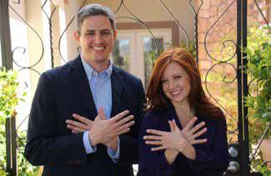

With gratitude,

Jennifer Mayon ‘14

Brian Rice ‘09

Curriculum Chair


Curriculum Co-Chair
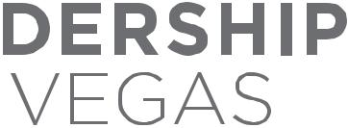

6 CLASS OF 2017 LEADERSHIP LAS VEGAS

HISTORY & THE ARTS
Seth Godin’s Linchpin: being a true artist at whatever you set your mind on doing.

COMMUNITY SAFETY NET
When Giving Is All We Have

by Albert Rios

GOVERNMENT, POLITICS, AND MEDIA
“There is a difference between truly listening and waiting for your turn to talk.”

– Ralph Waldo Emerson
EDUCATION–

“YOLO.” “Be curious, not judgmental.”

– Walt Whitman

“What do you want to teach the world?

Someone is learning from you.”

– Kid President

CRIMINAL JUSTICE
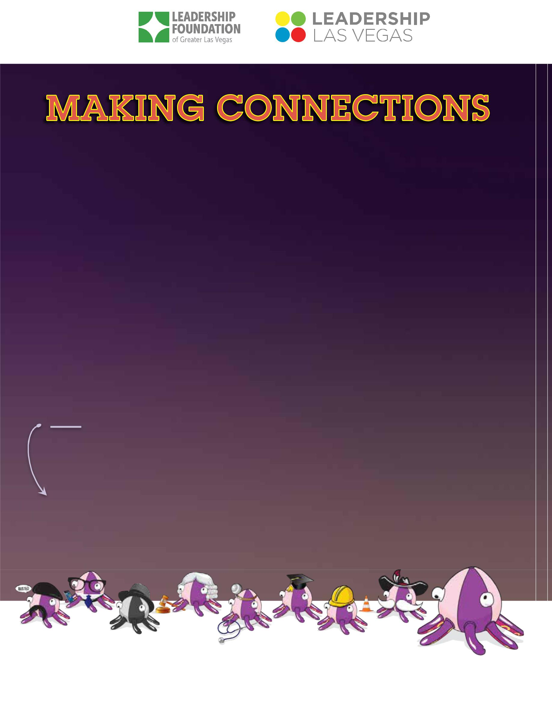
“Justice cannot be for one side

alone, but must be for both.”

– Eleanor Roosevelt

“The essence of human dignity.”

– Supreme Court Justice Kennedy

HEALTHCARE
“I will respect the hard -won scientific gains of those physicians in whose steps I walk, and gladly share such knowledge as is mine with those who are to follow.”

– Hippocratic Oath (Modern version as written by Louis Lasagna, Academic Dean of the School of Medicine at Tufts University, 1964)

BUSINESS
“Someone is sitting in the shade today because someone planted a tree a long time ago.”

– Warren Buffett

GAMING AND TOURISM
“If you dislike change, you’re going to dislike irrelevance even more.”

– General Eric Ken Shinseki

inspiration | collaboration | gratitude

LEADERSHIP LAS VEGAS MISSION STATEMENT

Leadership Las Vegas, part of the Leadership Foundation of Greater Las Vegas, is the premier community leadership building program in Southern Nevada. Through the 10-month program, class members develop a deeper understanding of the region, and its challenges and opportunities, in order to become more effective leaders and change agents.

PROGRAM GOALS

- Develop awareness of the community by examining the major systems which contribute to patterns of life in the city.
- Enhance leadership skills and qualities in participants, leading to creative and insightful community solutions.

- Ensure broad community future leadership by recruiting leaders with diverse social, economic and professional backgrounds.
- Motivate and encourage participants to assume leadership roles in community affairs.

At the end of the Leadership Las Vegas experience, graduates will have developed a network of relationships throughout the community to bring a fresh, broadened perspective to issues facing Las Vegas.

LEADERSHIP FOUNDATION OF GREATER LAS VEGAS

No matter the challenge, changing the world starts with cultivating great leaders who are informed, engaged, passionate, and interconnected. That is the mission of the Leadership Foundation of Greater Las Vegas – to develop and move leaders to action for the betterment of our community. As a 501(c)(3) charitable nonprofit in affiliation with the Las Vegas Metro Chamber, the Leadership Foundation is the only organization in Southern Nevada dedicated full time to preparing and engaging leaders at every level so they can positively address challenges and create a bright future for the region. Its programs included Leadership Las Vegas, Leadership Advance, Focus Las Vegas, Vegas Young Professionals, and the Public Policy Leadership Series.

The success of the Leadership Foundation and its programs depends largely on the financial generosity of our community’s corporate and philanthropic leaders who support a variety of programming, events, and scholarships. We are deeply appreciative for their ongoing support.

LEADERSHIP FOUNDATION OF GREATER LAS VEGAS BOARD OF DIRECTORS:

Lori Nelson, President | Gordon Absher | Kristin McMillan
Station Casinos, LLC | MGM Resorts International | Las Vegas Metro
Larry Singer, Secretary | DeAndre Esteen | Chamber of Commerce
Larry Singer, Secretary | DeAndre Esteen | Dulcinea Rongavilla
Newmark Grubb Knight Frank | Barclaycard US | Dulcinea Rongavilla
Brent Hathaway, Treasurer | Dawn LaBonte | Cragin & Pike Insurance
Brent Hathaway, Treasurer | Dawn LaBonte | Cara Clarke, Executive Director
UNLV, Lee Business School | Wells Fargo | Cara Clarke, Executive Director
 |  | Leadership Foundation of Greater
 |  | Las Vegas


8 CLASS OF 2017 LEADERSHIP LAS VEGAS

LEADERSHIP LAS VEGAS HALL OF FAME

“A leader is a motivator, mentor and visionary. A great leader celebrates

the success of those they have assisted but takes no credit.”

2017 Inductee Kimberly Malloy ‘00

Kimberly Malloy embodies the spirit of Leadership Las Vegas and has dedicated more than twelve years in giving back to the program. Kimberly graduated in 2000, and immediately engaged as an alumna by joining the Community Safety Net day committee. She then dug in a little deeper and became the Community Safety Net Co-Chair the following year.
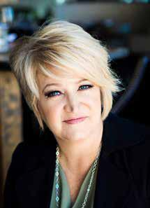

As part of seven years on the Leadership Las Vegas Council, Kimberly took a strong interest in the former Leadership Las Vegas Youth program geared for high school students and served as the Assistant Curriculum Chair followed by the Curriculum chair in that program. She followed that by immediately serving as the Assistant Curriculum Chair and then the Curriculum Chair for the Leadership Las Vegas program.

Recently, she was compelled to come back, and pick up where she started, by volunteering for Community Safety Net Day for the past two years.

In addition to her involvement in Leadership Las Vegas, Kimberly has had an exemplary career. Kimberly received her Master of Science in Counseling, specifically, Marriage, Family & Child Therapy and is a licensed therapist with the state of Nevada in private practice. She currently serves as the CIO (Chief Inspirational Officer) for the Relational Wellness Institute (RWI). The mission of RWI is to educate and develop others in relational thinking, so they can grow to

embrace the complexities of the soul, life and relationships. The therapy, workshops, corporate training and consultations are geared toward improving relationships at home, work and in the community by embracing emotional health. RWI is proud to provide many services to organizations such as Hope for Prisoners, Walter Hoving Home, various churches and individuals through marriage retreats, parenting classes and leadership development.

Kimberly draws from her prior experience owning, Train2Excel, from 1997 to 2011, a corporate training and consultation corporation. She loves being able to help others clarify their vision, see their value and help them grow personally and professionally. Her conferences on Emotionally Healthy Marriages & Families, Healthy Conflict and Interpersonal Communications have consistently received high marks from corporations and individuals alike. She is a licensed presenter for the Color Code Personality & Character Profile. She has consulted for a variety of arenas including military, legal, medical and banking fields.

In honor of her sister Starr, Kimberly co-founded Starr Ministry, a women’s ministry dedicated to bringing the message of hope and healing to women across the world. She has been a highly requested women’s retreat speaker both locally and nationally. Kimberly has also spoken internationally in Eastern Europe and Central America.

Kimberly founded and hosts a monthly luncheon, Businesswomen for Christ, where women from all over Las Vegas are invited to network, fellowship and share their passion and help support nonprofit charities in the community. She co-hosted a women’s talk show, A View From Above with Felicity Cunningham for almost three years. She previously served many years on the advisory board at her church, Cornerstone Christian Church. She credits any accomplishments to her Heavenly Father, her family, friends, church community and to Leadership Las Vegas.

What brings her the most joy is her husband of 35 years, Monty, their three wonderful daughters, two sons in love, two grandsons and two granddaughters.

LEADERSHIP LAS VEGAS CLASS OF 2017 9

LEADERSHIP LAS VEGAS HALL OF FAME HISTORY

Leadership Hall of Fame was created in 2004 to recognize outstanding Leadership Las Vegas graduates for their commitment to the Leadership Las Vegas program and contributions to the community.

HALL OF FAME INDUCTEES

2016 Hall of Fame Inductee Todd Palumbo ‘007

“Leadership is vision, confidence, motivation, and communication!”

2015 Hall of Fame Inductee Florence M.E. Rogers ‘04

“When people treat you as a leader when it’s not occurred to you to consider yourself a leader – you’re probably a much more effective leader than the people who anointed themselves leaders.”

2014 Hall of Fame Inductee Gina Gavan ‘06

“To recognize that at any moment we have the chance to create opportunities that will move us forward, if we’re willing to do the work and/or take the risk.”

2013 Hall of Fame Inductee Ronald Kline, M.D. ‘04

“Leaders lead by setting a good example. You cannot ask others to do what you yourself will not do. Respect the judgments of those on the front lines of any endeavor.”

2012 Hall of Fame Inductee Alan M. Diskin ‘03

“Leadership is action, not position and real leaders are ordinary people with extraordinary determination.”

2011 Hall of Fame Inductee Darcy K. Neighbors ‘03

“A true leader inspires others to be passionate about people, the foundation of all relationships, growth, life’s meaning, and ultimately, success and happiness.”

2010 Hall of Fame Inductee Shannon West ‘99

“Leadership is not something that you are in; it’s something that you do. A leader is someone who does the right things for the right reasons.”

2009 Hall of Fame Inductee Punam Mathur ’90

“Change, whether managed or not, is inevitable. Community leaders are those who possess a vision, spend the time to gain knowledge, and then rally the energy to manage and direct the course to desirable outcomes.”

2008 Hall of Fame Inductee Howard L. Skolnik ’95

“A leader is someone people follow without being asked. He/She has a vision which others willingly share regarding where the organization is going.”

2007 Hall of Fame Inductee Gina Polovina ’98

“Leadership is the ability to perceive common things in an uncommon way coupled with the capacity to inspire others to strive toward a desired goal.”

2006 Hall of Fame Inductee Valerie Wiener ’90

“It starts with one person, one idea, and the unswerving determination to put a plan into action. That’s leadership. When that person combines his or her talents and insight with other inventive, resourceful, committed individuals...
that’s Leadership Las Vegas.”

2005 Hall of Fame Inductee John Wilcox ’92

“A leader establishes a vision and motivates others to achieve it. They do so by demonstrating their personal commitment in every aspect of their life. A Leadership Las Vegas graduate is a teacher, a counselor, a motivator, a listener and a role model.”

2004 Hall of Fame Inductee Henry Hoogland ’89

“A man’s accomplishments in life are the cumulative effect of his attention to detail.”
- John Foster Dulles

10 CLASS OF 2017 LEADERSHIP LAS VEGAS

2017 LEADERSHIP LAS VEGAS COUNCIL

COUNCIL CHAIR

Gordon Absher ‘09

MGM Resorts International

IMMEDIATE PAST COUNCIL CHAIR

Dulcinea Rongavilla ‘10 Cragin & Pike

CURRICULUM CHAIR

Jennifer Mayon ‘14

Clark County School District

CO-CURRICULUM CHAIR

Brian Rice ‘09

Boys & Girls Clubs of Southern Nevada

SELECTION CHAIR / INCOMING COUNCIL CHAIR

Alan Diskin ‘03

College of Southern Nevada Foundation

CO-SELECTION CHAIR

Mark Hinueber ‘05

Law Offices of Mark A. Hinueber

CO-ALUMNI ACTIVITIES CHAIR

Nicole Wolf ‘11

Cleveland Clinic

CO-ALUMNI ACTIVITIES CHAIR

Tonya Carpenter ‘14

Caesars Entertainment Corporation

PUBLIC RELATIONS CHAIR

Kate Whiteley ‘13

Kirvin Doak Communications

CHAIRS AT LARGE

Justin Anderson ‘14

Confess Media

Audry “JB” Batiste ‘16 Precise Financial Planning

Alaina Cowley ‘12

UNLV

Mike Disbennett ‘14

The Glenn Group

Erin Keller ‘16

UNLV

Christina Nishiyama ‘15 Consultants to Management

PROGRAM MANAGER

Lisa Gough
2016-2017 VOLUNTEER PHOTOGRAPHERS

Justin Anderson ‘14

Confess Media

Luke Adamo ‘16

ROI Appraisal/Britton-Adamo Group

Julia Watson ‘13

Las Vegas Metropolitan Police

Department

GATEWAY
September 13-15, 2016

CURRICULUM CHAIR

Jennifer Mayon ‘14

Clark County School District

CO-CURRICULUM CHAIR

Brian Rice ‘09

Boys & Girls Clubs of Southern Nevada

FACILITATORS

Sheree Corniel ‘14

Real Talk Youth Impact Program

Alaina Cowley ‘12

UNLV

Edgar Carranza ‘10 Backus, Carranza & Burden

Mario Joyner ‘12

Bank of Nevada

Zane Marshall ‘15

Southern Nevada Water Authority

Todd Palumbo ‘07

Geotab

Dulcinea Rongavilla ‘10 Cragin & Pike

Kate Whiteley ‘13

Kirvin Doak Communications

Lezlie Young ‘14

Westin Las Vegas Resort and Spa

VOLUNTEERS

Gordon Absher ‘09

MGM Resorts International

Greta Beck-Seidman ‘11

Las Vegas Metro Chamber of Commerce

JD Daniels ‘12

National Security Technologies

Pete Flores ‘16

United States Air Force

Patrick Hughes ‘14 Fremont Street Experience

John Osborn ‘08

UNLV

Robin “VBERRY” Vanderberry ‘10 VBERRY Consulting

SESSION DAY
COMMITTEES

HISTORY & CULTURE
October 14, 2016

CHAIR

Ted Hartwell ‘11

Desert Research Institute

CO-CHAIR

Joy Rineer ‘14 Simpson Coulter Studio
COMMITTEE

Mark Achenbach ‘16

The Mob Museum

Wendy Anderson ‘16

BMM International

Tim Arndt ‘16

NV Energy

Erica Benson ‘16

Nevada State Bank

Maria Castillo ‘12

Luxor Hotel & Casino

Jan Craddock ‘91

BLVDS Las Vegas

Krista Darnold ‘05

Las Vegas Convention & Visitors Authority

Mary Ellen Heise ‘91

The Smith Center for the Performing Arts

Louise Helton ‘01

1 Sun Solar Companies

Rebecca Howell ‘07

Sidra Kain ‘97

ManagedPAY

EXECUTIVE DIRECTOR

Cara Clarke ‘07

LEADERSHIP LAS VEGAS CLASS OF 2017 11

Bill Marion ‘89 Andy Bischel ‘14

Purdue Marion Boys & Girls Clubs of Southern Nevada

Dawn Merritt ‘97 Donna Damron ‘15

Neon Museum Las Vegas Metro Chamber of Commerce

Lindsay Meyers ‘16 Kesha Dirkson ‘14

William Hill KDE Public Relations

Christina Nishyiyama ‘15 Michael Disbennett ‘14

Consultants to Management The Glenn Group

Bart Roberts ‘01 Melissa Fernandez ‘13

Bank of George NV Energy

Shannon Steiner ‘16 Ed Guthrie ‘98

Beacon Academy of Nevada Opportunity Village

Jennifer Taylor ‘10 James Harden ‘11

Clean Energy Project NV Cox Communications

Denyce Tuller ‘00 Ted Hartwell ‘11

Discovery Children’s Museum Desert Research Institute

Amy Wiles ‘11 Jodi Manzella ‘06

Las Vegas Philharmonic After School Allstars

Sydney Smith ‘15 Kimberly Malloy ‘00

RISE Center for Recovery Relational Wellness Institute

Kelli Vaz ‘16 Paul Phillips ‘15

Red Sky Cox Communications

COMMUNITY |  | GOVERNMENT,
SAFETY NET |  | POLITICS & MEDIA
November 4, 2016 |  | December 2, 2016
CHAIR |  | CHAIR
Scott Emerson ‘14 |  | Kami Dempsey-Goudie ‘02
American Red Cross |  | Accretive Consulting
CO-CHAIRS |  | CO-CHAIRS
Amelia Gulling ‘15 |  | Jason Gray ‘09
Desert Research Institute |  | MGM Resorts International
Jane Jensen Saint ‘07 |  | Jennifer Simich-Beristain ‘12
Safe Nest |  | Republic Services
Tim Mullin ‘10 |  | COUNCIL LIAISON
USO |  | Mark Hinueber ‘05
COUNCIL LIAISON |  | Law Offices of Mark A. Hinueber
 |  | COMMITTEE
Alan Diskin ‘03 |  | COMMITTEE
College of Southern Nevada Foundation |  | Gordon Absher ‘09
COMMITTEE |  | MGM Resorts International
 |  | Luke Adamo ’16
Luke Adamo ‘16 |  | Luke Adamo ’16
ROI Appraisal / Britton-Adamo Group |  | ROI Appraisal/Britton-Adamo Group
Tim Arndt ‘16 |  | Kesha Dirkson ‘14
NV Energy |  | KDE Public Relations

Sallie Doebler ‘14

Las Vegas Metro Chamber of Commerce

Stacey Escalante ‘15

Escalante Media Management, LLC

Tim Hacker ‘16

City of Las Vegas

Raymond Hess ‘16

Regional Transportation Commission of Southern Nevada

Ryann Juden ‘16

City of North Las Vegas

Zane Marshall ‘15

Southern Nevada Water Authority

Erin McMullen ‘14

Boyd Gaming

Lindsay Minor ‘02

LP Insurance Services

Paul Moradkhan ‘12

Las Vegas Metro Chamber of Commerce

Marina Nicola ‘15

Vox Solid Communications

Craig Rosen ‘16

Desert Research Institute

Jeffrey Rugg ‘12

Brownstein Hyatt Farber Schreck, LLP

Barbara Tapp ‘16 Make-A-Wish Southern Nevada

Jennifer Taylor ‘10 Clean Energy Project NV

EDUCATION
January 13, 2017

CHAIR

John Osborn ‘08

UNLV

CO-CHAIR

Jason Ginoza ‘15

Veterans Tribute Career & Technical Acadamy

COUNCIL LIAISON

Alaina Cowley ‘12

UNLV

COMMITTEE

Tera Anderson ‘16

Nexus 30 Properties

12 CLASS OF 2017 LEADERSHIP LAS VEGAS

Justin Cohen ‘15

IMI

Chanda Cook ‘11

Nevada Public Education Foundation

Steven Curtis ‘13

Kathleen DeVleming ‘00 Retired

Carmen Gigar ‘10

University of Phoenix

Ted Hartwell ‘11

Desert Research Institute

Ron Heezen ‘15

Las Vegas-Clark County Library District

Tamar Hoapili ‘14

Cox Communications

Rick Jost ‘12

The Mirage

Erin Keller ‘15

UNLV

Liberty Leavitt ‘15

Clark County School District

Elizabeth “Liz” Lowell ‘99 Pengilly Law Firm

Zane Marshall ‘15

Southern Nevada Water Authority

James McCoy ‘15

College of Southern Nevada

Joan McGee ‘10

College of Southern Nevada

Marilyn Ming ‘03

University of Nevada Cooperative

Extension

Marina Nicola ‘15

Vox Solid Communications

Bill Regenhardt ‘12

Regis 702 Consulting Group

Craig Rosen ‘16

Desert Research Institute

Debra Solt ‘12

Vegas PBS

Shannon Steiner ‘16
American Preparatory Academy
CRIMINAL JUSTICE

February 10, 2017

CHAIR

Brian Connett ‘09

Nevada Department of Corrections/Silver State Industries

CO-CHAIR

Linda Bell ‘08

Eighth Judical District Court

COUNCIL LIAISON

Sherri McKenzie ‘07

Retired

COMMITTEE

Mary Bacon ‘16

Fennemore Craig

Sheree Corniel ‘14

Real Talk Youth Impact Program

Donna Damron ‘15

Las Vegas Metro Chamber of Commerce

Tierra Jones ‘10

Eighth Judicial District Court

Andy Moore ’14

Danielle Pieper ‘15

Clark County District Attorney’s Office

Abby Quinn ‘16

HELP of Southern Nevada

Melissa Saragosa ‘08

Las Vegas Justice Court

Alma Spears ‘16

Boys & Girls Clubs of Southern Nevada

Kelli Vaz ‘16

Red Sky

Kristina Wildeveld ‘02

The Law Offices of Kristina Wildeveld & Associates

Michelle Wilson ‘08

Las Vegas Metropolitan Police Department

Shane Zeller ‘15

Clark County Public Defender’s Office

Ann Zimmerman ‘09

Las Vegas Justice Court
HEALTH

March 10, 2017

CHAIR

Lisa Santwer ‘13

Comprehensive Cancer Centers of Nevada

CO-CHAIR

Ross Seibel ‘13

Southwest Medical Associates

COUNCIL LIAISON

Dulcinea Rongavilla ‘10 Cragin & Pike

COMMITTEE

Anna Catlett ‘13

Southwest Medical Associates

Donna Damron ‘15

Las Vegas Metro Chamber of Commerce

Tony Greenway ‘07 American Medical Response

Debbie Makiri ‘13

Las Vegas Metro Chamber of Commerce

Loretta Moses ‘99

Clark County Medical Society

Rebecca Purdy ‘13

Renaissance Dental

John Socha ‘14

Culinary Health Fund

Vicky VanMeetren ‘02

Roseman University

BUSINESS
April 7, 2017

CHAIR

Gina Bongiovi ‘14 Bongiovi Law Firm, LLC

CO-CHAIRS

Kelli Ross ‘98

Southwest Gas

Chris Gaynor ‘98

Bank of Nevada

COUNCIL LIAISON

Justin Anderson ‘14

Confess Media

COMMITTEE

Luke Adamo ‘16

ROI Appraisal/Britton-Adamo Group

LEADERSHIP LAS VEGAS CLASS OF 2017 13

Mary Bacon ‘16

Fennemore Craig

Erica Benson ‘16

Nevada State Bank

Jim Chittenden ‘16 United States Air Force

Justin Cohen ‘15

IMI

Jan Craddock ‘91

BLVDS Las Vegas

Rachelle Crupi ‘16

Bank of Nevada

Krista Darnold ‘05

Las Vegas Convention & Visitors Authority

Kesha Dirkson ‘14

KDE Public Relations

Sallie Doebler ‘14

Las Vegas Metro Chamber of Commerce

Ken Heck ‘09

Heck Wealth Management

Patrick Hughes ‘14 Fremont Street Experience

Jean Sharon Jones ‘08

Better Homes and Gardens Realty

Soozie Jones Walker ‘01 Commercial Executives-Soozi Jones Walker

Liz Kugel ‘96

LucyVegas.com

Christina Mangino ‘13 Survest Wealth Management

Luis Maceira ‘16

Distinctive Insurance

Brad Margison ‘14

Merrill Lynch

Lindsay Meyers ‘16

4 Wall Entertainment

Tami Miramontes ‘08

Eide Bailly LLP

Craig Newby ‘16

McDonald Carano Wilson LLP

Patrick Sinnott ‘16

City of Las Vegas

Jennifer Taylor ‘10 Clean Energy Project NV

GAMING & TOURISM
May 12, 2017

CHAIR

Amy Rossetti ‘13 Rossetti Public Relations

CO-CHAIRS

Lezlie Young ‘14

Westin Las Vegas Resort & Spa

Jenn Michaels ‘13

MGM Resorts International

COUNCIL LIAISON

Kate Whiteley ‘13

Kirvan Doak Communications

COMMITTEE

Gordon Absher ‘09

MGM Resorts International

John Adams ‘16

Cragin & Pike

Wendy Anderson ‘16

BMM International

Dolores Campuzano-Pignatello ‘16 The Mirage

Maria Castillo ‘12

Luxor Hotel & Casino

Krista Clar ‘14

MGM Resorts International

Krista Darnold ‘05

Las Vegas Convention & Visitors Authority

Michael Disbennett ‘14

The Glenn Group

Ted Hartwell ‘11

Desert Research Institute

Patrick Hughes ‘14 Fremont Street Experience

Rachel Hunt ‘12

Stratosphere Casino, Hotel & Tower

Rick Jost ‘12

The Mirage
Liz Kugel ‘96

LucyVegas.com

Chris Moeslacher ‘15

Las Vegas Convention & Visitors Authority

Christina Nishiyama ‘15 Consultants to Management

Debra Nutton ‘10

Wynn Resorts

Sydney Smith ‘15

RISE Center For Recovery

London Swinney ‘11

MGM Grand Las Vegas

Josh Swissman ‘10

MGM Resorts International

Katarina Tesarova ‘12

Las Vegas Sands Corp

CLOSING SESSION
June 16, 2017

CHAIR

Rae Lathrop ‘17

Regional Transportation Commission of Southern Nevada

CO-CHAIRS

Clay Buck ‘17

The Smith Center for the Performing Arts

Shellie Keller, PhD ‘17 College of Southern Nevada

COMMITTEE

Vandana Bhalla ‘17 Signature Real Estate Group

Ulyanna Chung-Winterrowd ‘17 Chung Insurance Agency

Ron Bilodeau ‘17

NV Energy

Lance J. Kirk ‘17

LG Architects, Inc. (LGA)

Rebecca Miltenberger ‘17

Brownstein Hyatt Farber Schreck, LLP

Mary Beth Sewald ‘17

Nevada Broadcasters Association

14 CLASS OF 2017 LEADERSHIP LAS VEGAS

TOM ANDRULIS
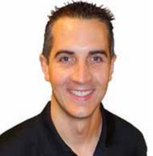

Chief Executive Officer

Intelligent Technical Solutions

DEFINITION OF LEADERSHIP

Leadership is organizing people that share the same values to reach an objective.

SHAN BATES-BUNDICK
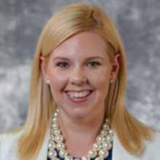

Strategic Marketing Consultant

Shan Bates, LLC

DEFINITION OF LEADERSHIP

Leadership is a characteristic that inspires others to follow, moving together in the same direction to reach a common goal.

MARK E. BENNETT
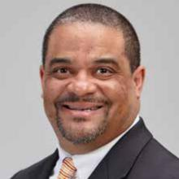

President & General Manager

Jumer’s Casino and Hotel - Delaware North Companies Inc.

DEFINITION OF LEADERSHIP

Leadership is about giving one’s self to help, inspire, teach and improve themselves and others in order to make every aspect of our society the best it can possibly be.

MICHAEL BENSHIMON
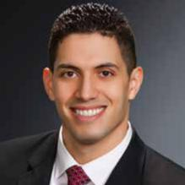

Vice President, Senior Wealth Manager

BNY Mellon Wealth Management

DEFINITION OF LEADERSHIP

Leaders help, inspire and motivate others to grow and become the best version of themselves.

LEADERSHIP LAS VEGAS CLASS OF 2017 15

VANDANA BHALLA
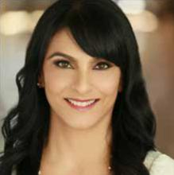

Corporate Broker / REALTOR

Signature Real Estate Group

DEFINITION OF LEADERSHIP

Leaders make a remarkable impact on people throughout their journeys. Leaders motivate to achieve big things by guiding, challenging and supporting others so as to build future leaders.

RON BILODEAU
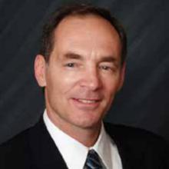

Manager, Delivery Projects

NV Energy

DEFINITION OF LEADERSHIP

Leaders are visionary individuals who understand objectives, create a strategy to accomplish those objectives and engage others to willingly work together to execute the strategy.

COLLEEN BIRCH


Senior Vice President, Revenue Optimization

The Cosmopolitan of Las Vegas

DEFINITION OF LEADERSHIP

Leaders do the right thing when no one is watching!

GINA D. BISHOP
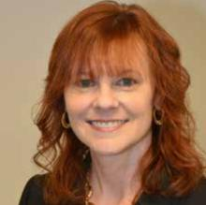

Franchise Analyst

City of Las Vegas

DEFINITION OF LEADERSHIP

Leadership is projecting yourself as one others will follow, by setting a good example, being authentic in your feelings, true to your cause, and never compromising your integrity.

16 CLASS OF 2017 LEADERSHIP LAS VEGAS

JAKE BODINE
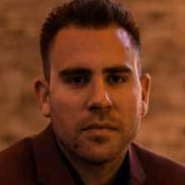

Founder & CEO

God Behind Bars Inc. & Castaways Resale Group

DEFINITION OF LEADERSHIP

To me leadership is inspiring incredible people, to do incredible things, in intentional ways, at intentional times.

GIAN (“JOHN”) BROWN
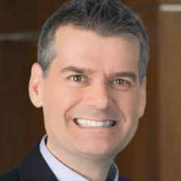

Partner

Holland & Hart, LLP

DEFINITION OF LEADERSHIP

For me, leadership starts with listening and observing, is informed by thinking and creativity, and results in taking action.

T. CLAY BUCK, CFRE
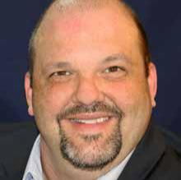

Director of Membership and Annual Giving

The Smith Center for the Performing Arts

DEFINITION OF LEADERSHIP

Leadership is turning vision into action, passion into purpose, problems into solutions.

DEREK CARDER
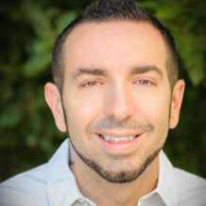

Director of Customer Experience

Geotab

DEFINITION OF LEADERSHIP

Leadership is positively inspiring and motivating other individuals toward the achievement of a shared goal.

LEADERSHIP LAS VEGAS CLASS OF 2017 17

GREG J. CHASE
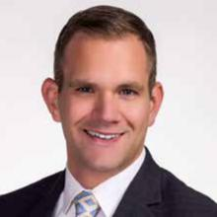

Executive Director of Guest Experience

MGM Resorts International

DEFINITION OF LEADERSHIP

To me, being a leader is about touching the hearts and minds of others, motivating others to achieve their potential

LORI CHITTENDEN
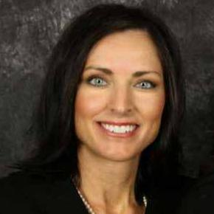

Portfolio Manager

Buckley Wealth Management

DEFINITION OF LEADERSHIP

Leadership is about inspiring and empowering others to reach higher than they thought possible.

ULYANNA CHUNG-WINTERROWD


Agent/Owner

Chung Insurance Agency

DEFINITION OF LEADERSHIP

Leadership is having a vision and motivating, managing, and mentoring others to achieve that vision.

WILLIAM CROZER
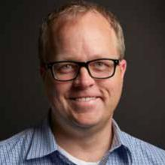

Director of Digital Strategy

The Glenn Group

DEFINITION OF LEADERSHIP

Being an open, authentic and positive force to help a team realize a goal.

18 CLASS OF 2017 LEADERSHIP LAS VEGAS

NICOLE CURFMAN
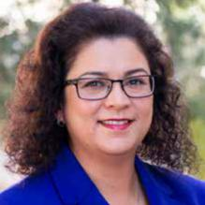

Vice President, Senior Operations Manager

Zions Bancorporation

DEFINITION OF LEADERSHIP

Leadership is about inspiring others to be their best self. A good leader will be vulnerable, listen, create trust and empower their team.

JASON DEMUTH
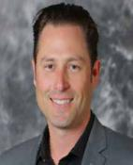

Division Director of Marketing

PulteGroup

DEFINITION OF LEADERSHIP

Leadership is driving progression, order and collaboration toward a common goal. It is taking the first step when others are uncertain.

JAMES DZURENDA
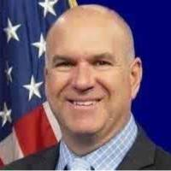

Director

Nevada Department of Corrections

DEFINITION OF LEADERSHIP

A leader is someone who has future vision, strong values, and a clear mission to drive an Agency forward, as well as, someone who not only commands respect, but also respects and values his/her employees.

LISA FELLER
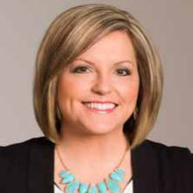

Manager

Immunize Nevada

DEFINITION OF LEADERSHIP

Leadership is earned mutual respect.

LEADERSHIP LAS VEGAS CLASS OF 2017 19

JEN GRANT
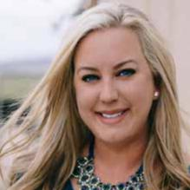

Senior Vice President of Sales and Marketing, Partner Elite Media, Inc.

DEFINITION OF LEADERSHIP

Leadership is having a vision, sharing it, and then inspiring others to support it, all the while encouraging them to use their own unique talents to create their own.

PRANAV JAMPANI
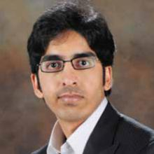

Director of Sustainability

The Venetian | The Palazzo | Sands Expo

DEFINITION OF LEADERSHIP

Leadership is creating a vision and inspiring others to take action and help that vision become reality. Leadership is to inspire others to do more and become more.

SHELLIE KELLER, PHD
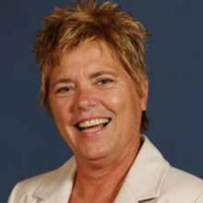

Associate Vice President, Academic Success College of Southern Nevada

DEFINITION OF LEADERSHIP

Leadership is opportunity to bring talented, diverse people together, inspire them, and ensure they have the necessary resources to reach their professional and organizational goals.

LANCE J. KIRK
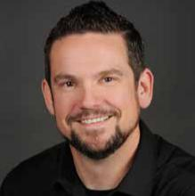

Partner & Project Architect

LG Architects, Inc. (LGA)

DEFINITION OF LEADERSHIP

Leadership is building a foundation which allows people to thrive and be their best.

20 CLASS OF 2017 LEADERSHIP LAS VEGAS

JAMES R. LARSEN
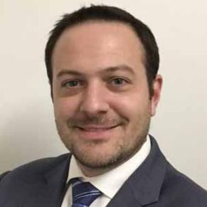

Vice President of Revenue Strategy

Caesars Entertainment

DEFINITION OF LEADERSHIP

Leadership is an ongoing commitment to build up the people around you.

RAE LATHROP
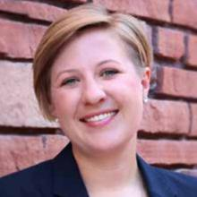

Regional Planning Manager

Regional Transportation Commission of Southern Nevada

DEFINITION OF LEADERSHIP

Leadership is honing your strengths, investing in others, and acting when its right.

CHAD WALLACE LEAVITT
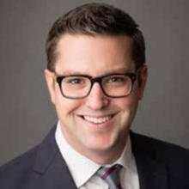

Chief Accounting Officer

Findlay Automotive Group

DEFINITION OF LEADERSHIP

Being a leader is being a servant to those you lead. When you show them you are genuine, and have the groups best interest at heart, they will follow.

SHAUNA LEMIEUX
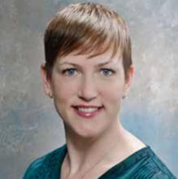

Director of Communications and Brand Management Vegas PBS

DEFINITION OF LEADERSHIP

Leadership is about inspiring and empowering others to realize their highest potential, while working to achieve a shared mission.

LEADERSHIP LAS VEGAS CLASS OF 2017 21

NIKKOLE LIESSE
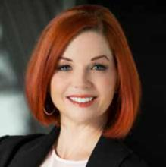

Director, Executive MBA

UNLV Lee Business School

DEFINITION OF LEADERSHIP

I believe in servant leadership. To be an effective leader is not to seek personal glory, title or reward, but to serve those around you, the organization and the mission.

EVA LITTMAN, M.D.
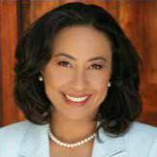

CEO

Red Rock Fertility Center/Sunset Surgery Center

DEFINITION OF LEADERSHIP

I take the road less traveled and believe wholeheartedly in leading by example and that has made all the difference.

ALAN L. LIVENGOOD
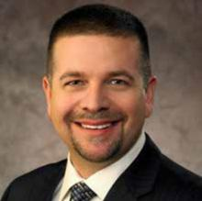

Director, Field Operations

Cox Communications

DEFINITION OF LEADERSHIP

Leadership is the art of influencing and inspiring others towards a common goal.

Effective leaders develop others to be future leaders.

MARY E. MADDEN
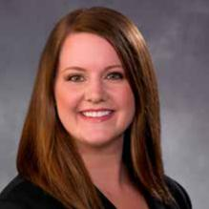

Director - Human Resources

Las Vegas Valley Water District

DEFINITION OF LEADERSHIP

A leader can gather unique people together for a stated purpose managing and synthesizing ideas and information created into action through collaboration, kindness and strength.

22 CLASS OF 2017 LEADERSHIP LAS VEGAS

ANDREW MAGNESS
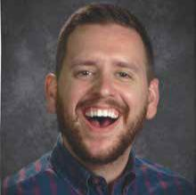

Educator

Clark County School District - Valley High School

DEFINITION OF LEADERSHIP

Leadership is a process of social influence which helps to maximize efforts of others towards the achievement of a goal. -Kevin Kruse

PAUL V. MANGUAL
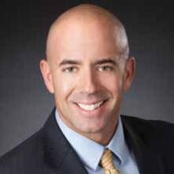

Vice President, Sales Manager- Clark County, Nevada First American Title Insurance Company

DEFINITION OF LEADERSHIP

Leadership is running with your team, not making them run for you. Share in the victories, but also share in the defeats.

LESLIE MAPLE


Manager, Communications and Corporate Affairs Barrick Gold Corporation

DEFINITION OF LEADERSHIP

Leadership is authentic being and doing that promotes trust, motivates and facilitates connection.

MARIA MARINCH
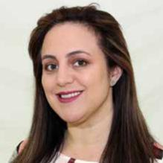

Executive Director of Community Relations, Diversity and Multicultural Affairs College of Southern Nevada

DEFINITION OF LEADERSHIP

Leadership requires long-term vision and true understanding of the impact of actions beyond our immediate sphere. Leaders ignite the commitment of individuals towards a common goal by connecting their internal motivators and communicating the shared goals

LEADERSHIP LAS VEGAS CLASS OF 2017 23

MELISSA MCKINLEY
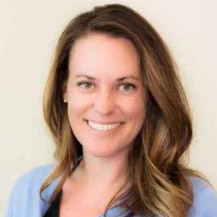

Corporate Work Study Program Coordinator

Cristo Rey St. Viator College Preparatory High School

DEFINITION OF LEADERSHIP:

“If your actions inspire others to dream more, learn more, do more and become more, you are a leader.” - John Quincy Adams

MATT MCNALLY
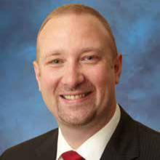

Community Engagement Director

Las Vegas-Clark County Library District

DEFINITION OF LEADERSHIP

Leadership is the ability to foster inspiration, create vision, guide execution, and mentor others while remaining morally principled to achieve a successful result.

REBECCA MILTENBERGER


Shareholder

Brownstein Hyatt Farber Schreck, LLP

DEFINITION OF LEADERSHIP

A strong leader is one who guides others with compassion, courage and integrity.

ELAINA MULÉ
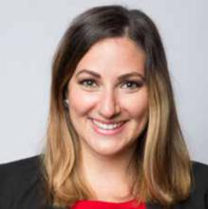

Vice President, Collective Impact and Social Innovation United Way of Southern Nevada

DEFINITION OF LEADERSHIP

Leadership is an opportunity to seek understanding and empathy, empower those around you, and promote collaboration.

24 CLASS OF 2017 LEADERSHIP LAS VEGAS

NICOLE NEAL
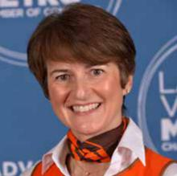

Director of Events

Las Vegas Metro Chamber of Commerce

DEFINITION OF LEADERSHIP

Inspirational, a leader maintains an effortless hold on those around them, drawing people in and bringing out the best in everyone they touch.

LAURA OVERTON
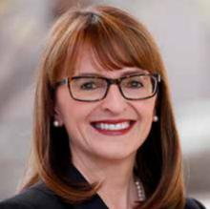

General Counsel and Vice President of Legal Affairs Allegiant Travel Company

DEFINITION OF LEADERSHIP

The best leaders are servants and they inspire and attract others to serve alongside them.

BILL PAREDES
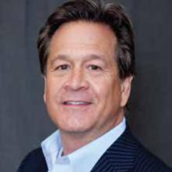

Executive Vice President - Corporate Banking Manager Bank of Nevada

DEFINITION OF LEADERSHIP

A leader motivates people to perform at a higher level than they otherwise would perform by being inspirational, instilling confidence and demanding accountability.

KARL O. RILEY, ESQ.
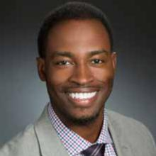

Senior Associate Attorney

Snell & Wilmer, LLP

DEFINITION OF LEADERSHIP

“Leadership is the capacity to influence others through inspiration motivated by passion, generated by vision, produced by a conviction, ignited by a purpose.” --Myles Munroe

LEADERSHIP LAS VEGAS CLASS OF 2017 25

MARY BETH SEWALD
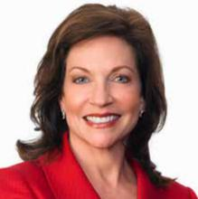

President & CEO

Nevada Broadcasters Association

DEFINITION OF LEADERSHIP

Leadership is about motivating and cultivating the best in others through integrity, character and a heart for serving.

DAN SHAPIRO
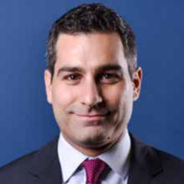

Vice President of Strategy & Business Development William Hill US

DEFINITION OF LEADERSHIP

Leadership is about consistency, integrity and the ability to inspire and motivate people.

TORI STAMM


Vice President of Finance

Baha Mar

DEFINITION OF LEADERSHIP

Leadership is not about leading people but about getting people to stand next to you conquer tasks and obstacles together.

LORI WILKINSON
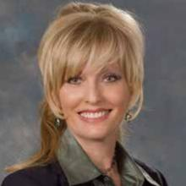

Vice President Employee Benefits

Brown & Brown Insurance of Nevada

DEFINITION OF LEADERSHIP

The best leaders are confident and strong, yet humble. They communicate the vision and collaborate with their team to accomplish their collective goals.

26 CLASS OF 2017 LEADERSHIP LAS VEGAS

JILL ZIMBELMAN


Executive Assistant for the Vice President of Research University of Nevada, Las Vegas

DEFINITION OF LEADERSHIP

Leadership is like kindness. It’s not an act. It’s a lifestyle.

THE SHANNON WEST REDWINE COMMUNITY WARRIOR AWARD

Shannon West Redwine served her community endlessly. A graduate of the Leadership Las Vegas Class of 1999, a former Session Day Chair and Curriculum Chair, she was a passionate supporter of the Leadership Las Vegas program. But she was a driving force in many other areas of our community.


By profession, she was the regional homeless services coordinator for Southern Nevada, but she was also instrumental in establishing a number of community programs and initiatives, including the Southern Nevada Community Gang Task Force, the Clark County Neighborhood Services Unit, Ready for Life Collaborative and Camp Any Town. In 2010, HELP of Southern Nevada honored Shannon by renaming its youth facility the Shannon West Homeless Youth Center in honor of her tireless efforts advocating for homeless youth. Shannon’s love for her community and passion for helping the disadvantaged was her life’s work and is her legacy.

Although her time with us was cut short in 2012, Shannon’s impact on those fortunate enough to know her was profound. To honor Shannon, the Leadership Las Vegas Council has established the Shannon West Redwine Community Warrior Award in her memory.

Unlike most, this award doesn’t come around just once a year. Like Shannon, it has lived with our class, month after month, constantly challenging us, reminding us there are those who need our help, and that we can do better. During its second year, the award was given to members of the current Leadership Las Vegas class who exemplified the qualities we loved, respected and appreciated most about Shannon – courage, compassion, commitment, advocacy, open-mindedness, willingness to be vulnerable, pushing beyond your comfort zone, and having an opinion, even when you don’t have all the answers.

The following members of the Class of 2017 were selected for demonstrating these and other important characteristics of community leadership:

November: Jen Grant

December: Lisa Feller

January: Matt McNally

February: Vandana Bhalla

March: Colleen Birch

April: Clay Buck

May: Alan Livengood

June: Gian “John” Brown

Each month the winner took home the award – a worn brass lantern containing a bright pink feather boa. The lantern reminds us that the light of leadership shines to guide us all. The pink boa makes us remember Shannon. Each month, the award was brought back to pass on, but not before the previous winner added a piece of themselves to the traveling trophy.

LEADERSHIP LAS VEGAS CLASS OF 2017 27

LEADERSHIP LAS VEGAS GRADUATE DIRECTORY

You can now update your own information at http://llvdirectory.com

Update your information!

Have you moved? Changed jobs? Been promoted? Your Leadership friends want to know. We need your help to keep this Directory accurate. Use the convenient search functions to find your personal listing and review your information. If any of your fields need to be updated, please click on the change button in the very first column next to your name. You will receive an email to the address we have on file with further instructions. If your email has changed and you no longer have access to the email on file, please contact Lisa Gough at lisa@leadership.vegas.

What’s Your Color?

We’ve added a new feature to this new directory. But we need your help. As you review and edit your information, take a moment to indicate your SimSoc color. It will display with the rest of your information in the directory. Once we see your SimSoc color code, others will know you’ve reviewed your entry and your information is current.

Use of this database

As with all previous versions of the Leadership Las Vegas Directory, the data included in this website is intended for the use of graduates of the Leadership Las Vegas program. This database is password protected. The password will be changed periodically. Please do not share the password outside of the alumni network.

This directory is not to be used for political or commercial gain or solicitation.

The Leadership Las Vegas logo is the property of the Leadership Foundation of Greater Las Vegas and may not be used without the written consent of the Foundation.
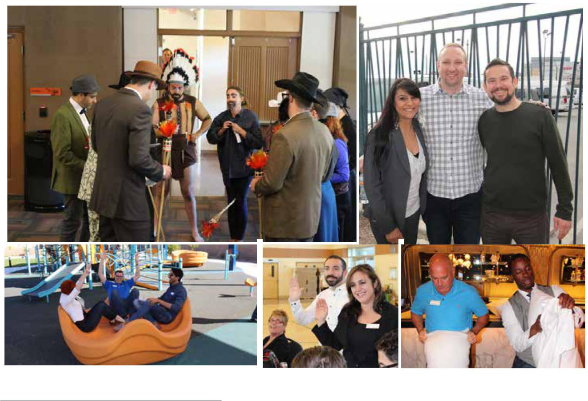

28 CLASS OF 2017 LEADERSHIP LAS VEGAS

PHOTO GALLERY
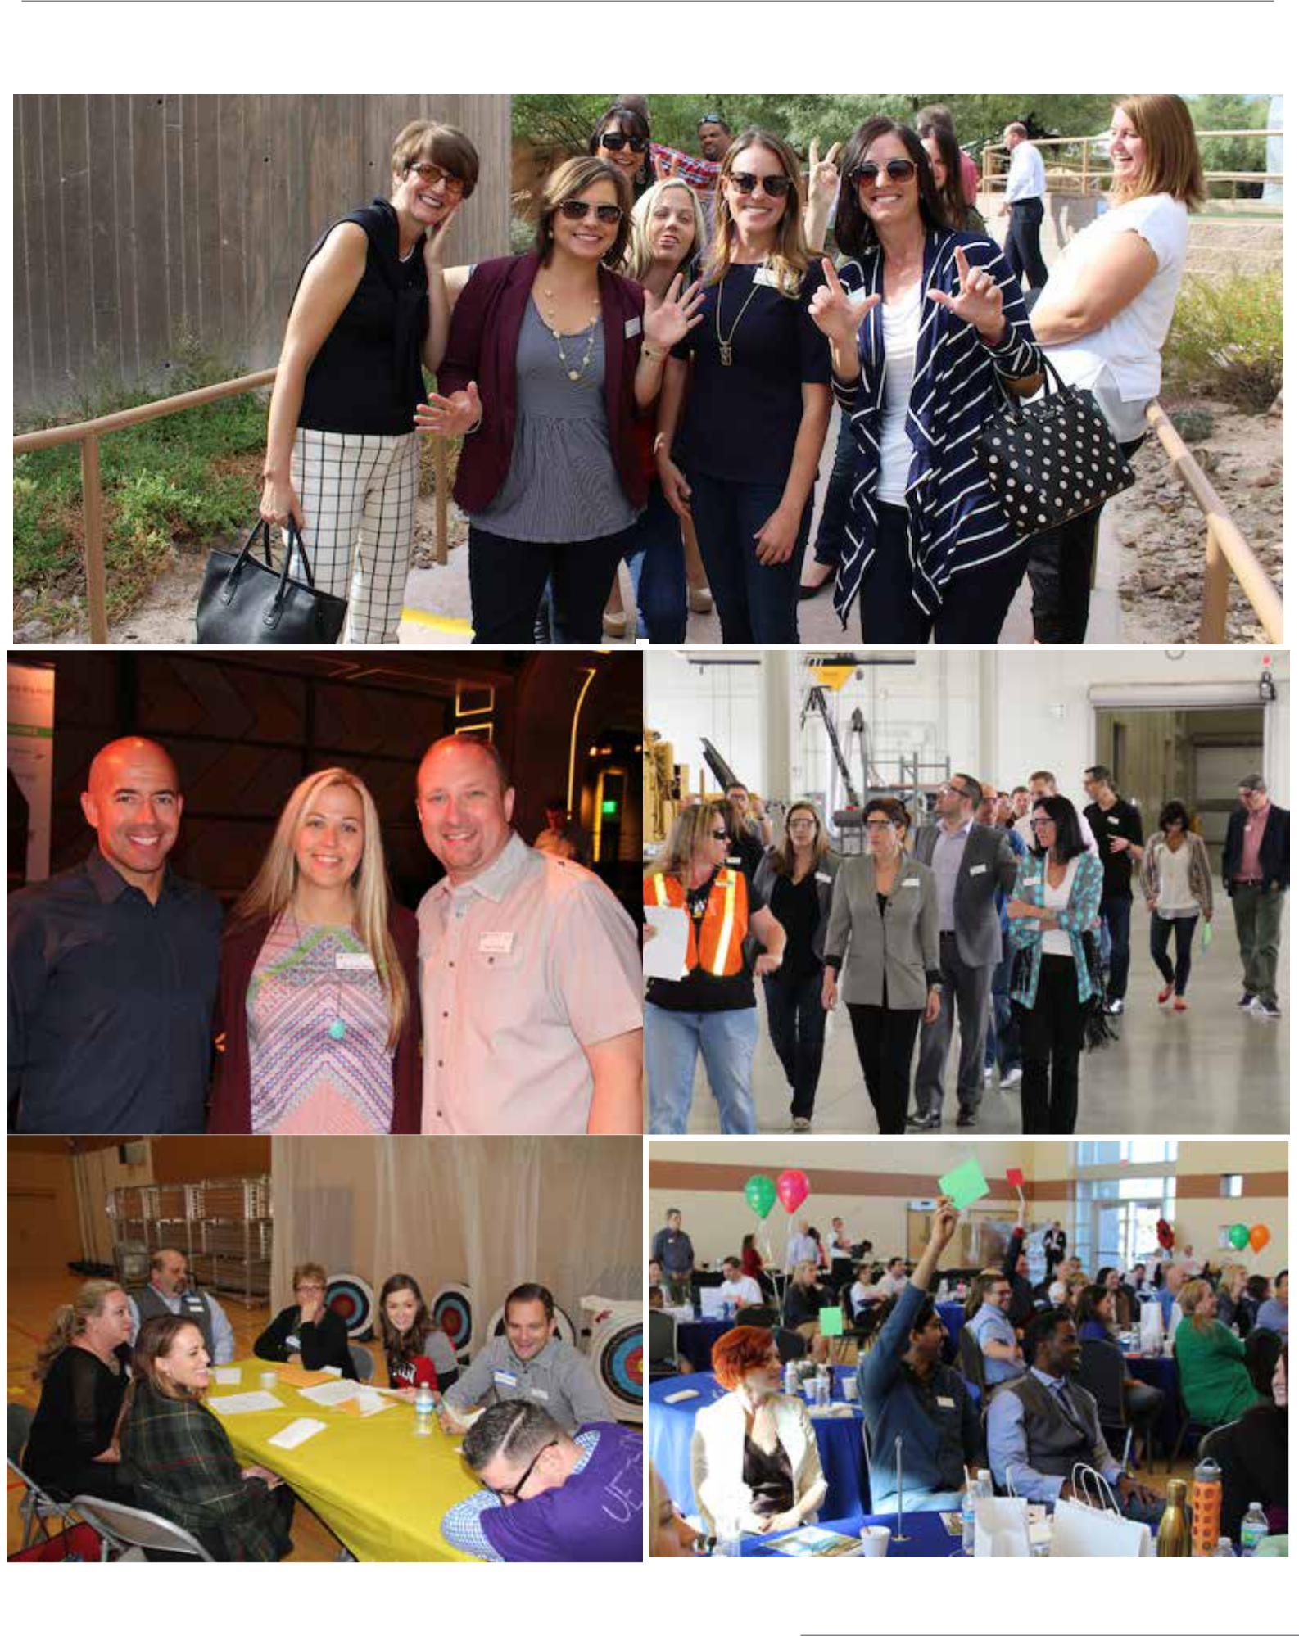

LEADERSHIP LAS VEGAS CLASS OF 2017 29

PHOTO GALLERY
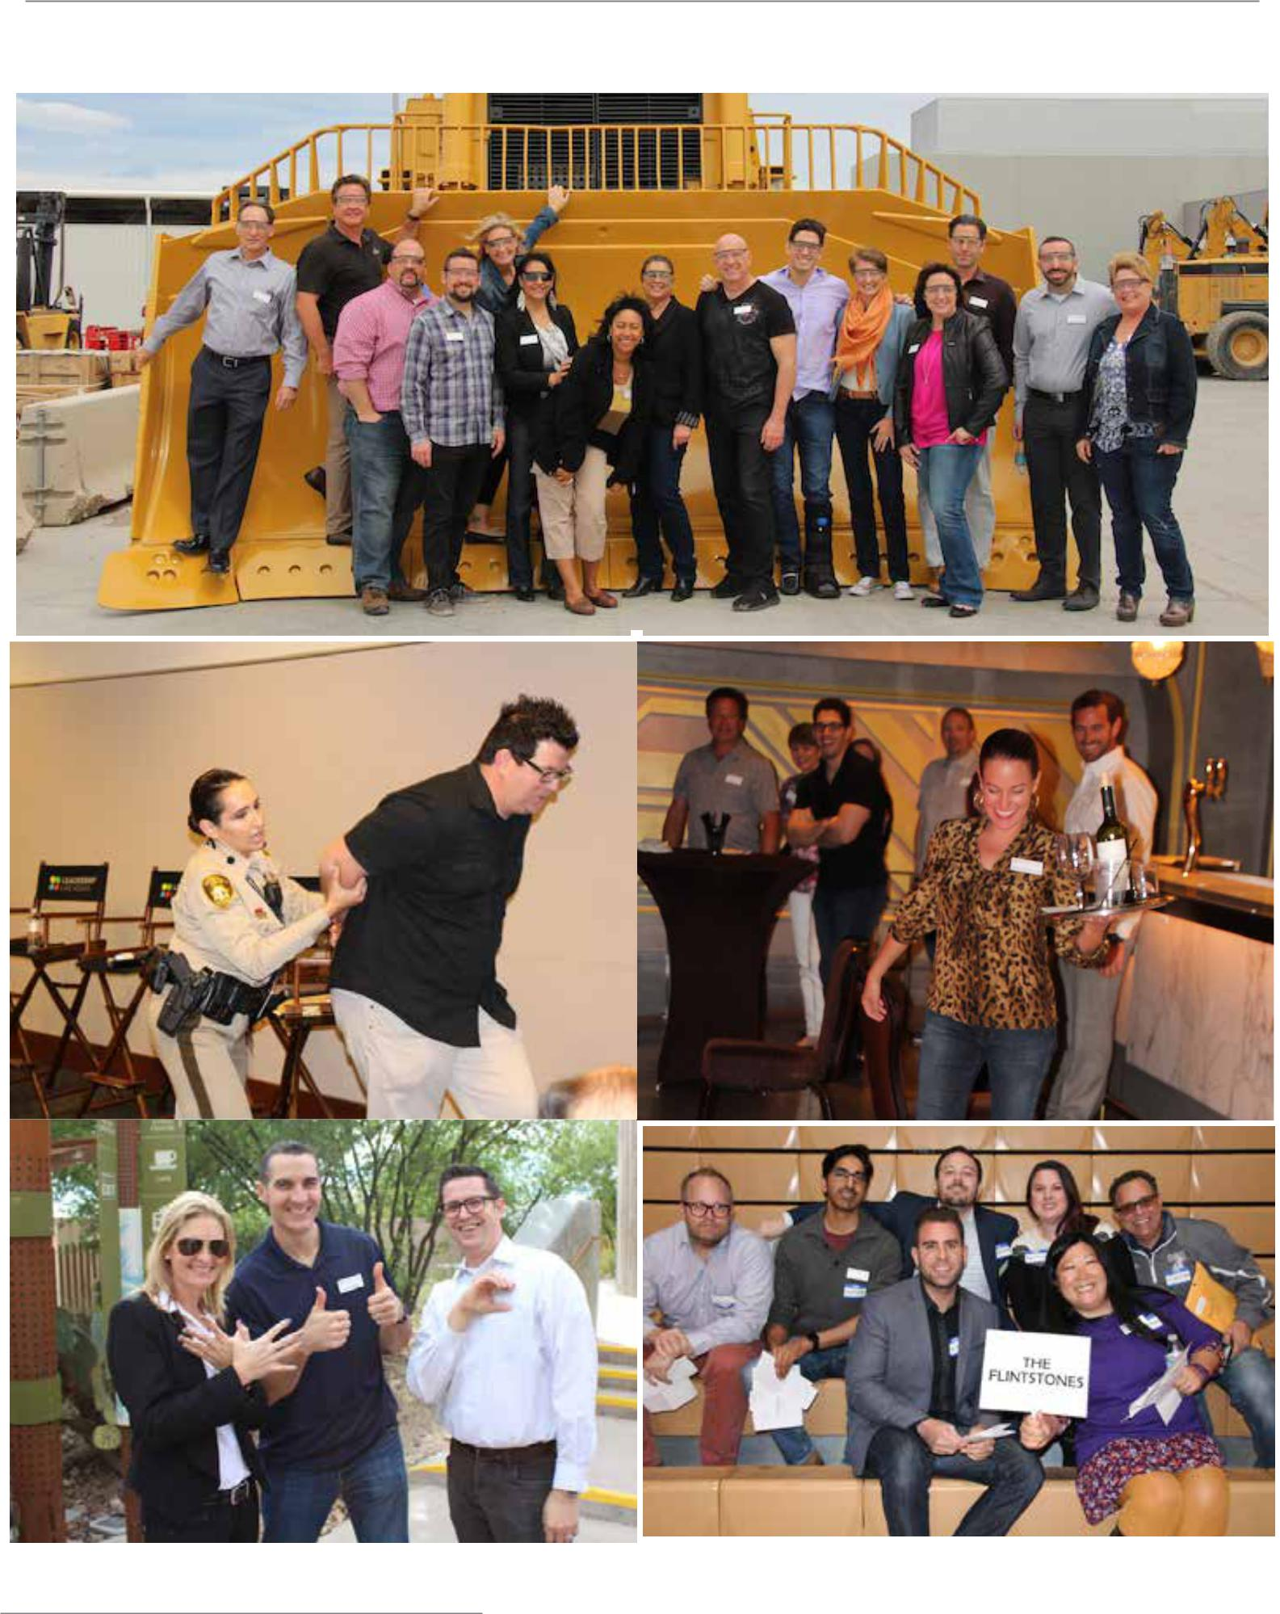

30 CLASS OF 2017 LEADERSHIP LAS VEGAS

PHOTO GALLERY
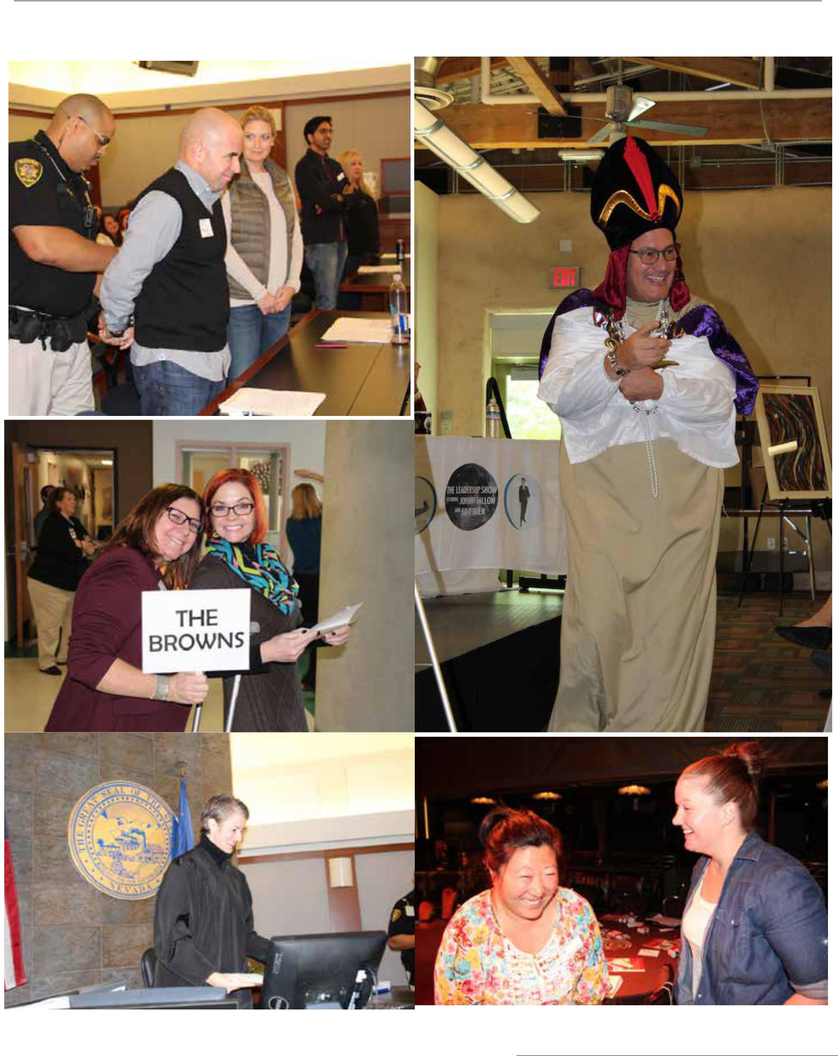

LEADERSHIP LAS VEGAS CLASS OF 2017 31

PHOTO GALLERY
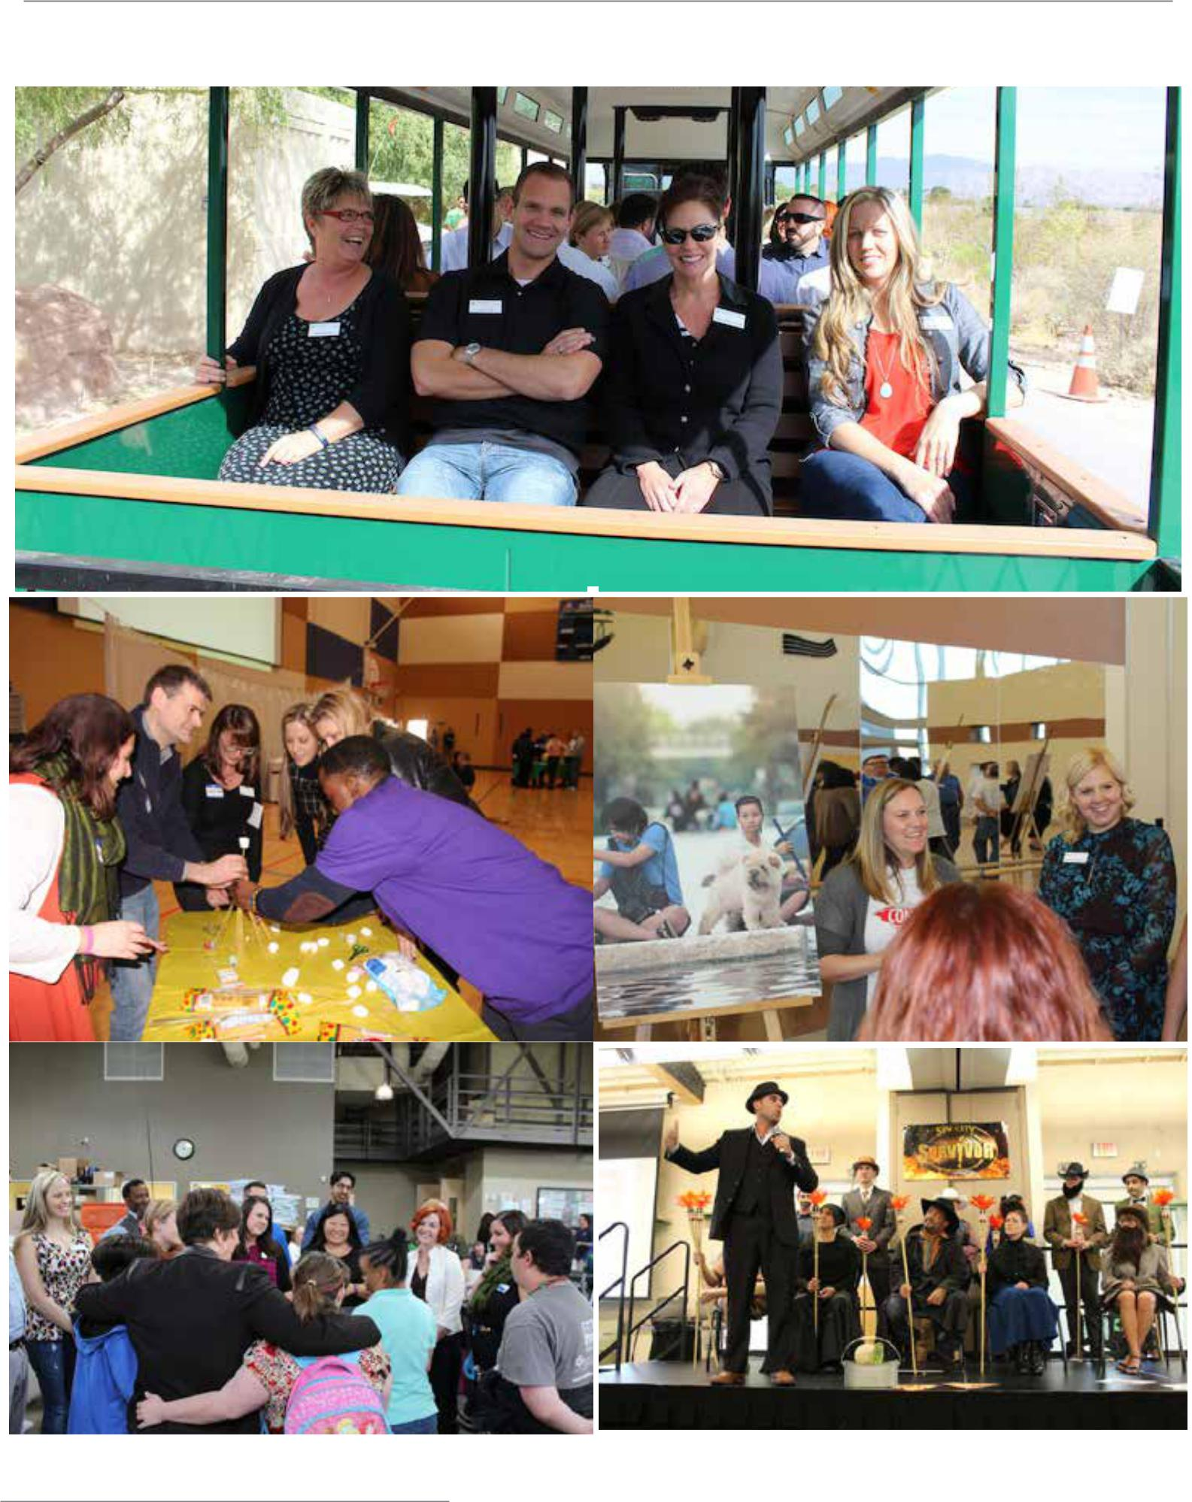

32 CLASS OF 2017 LEADERSHIP LAS VEGAS

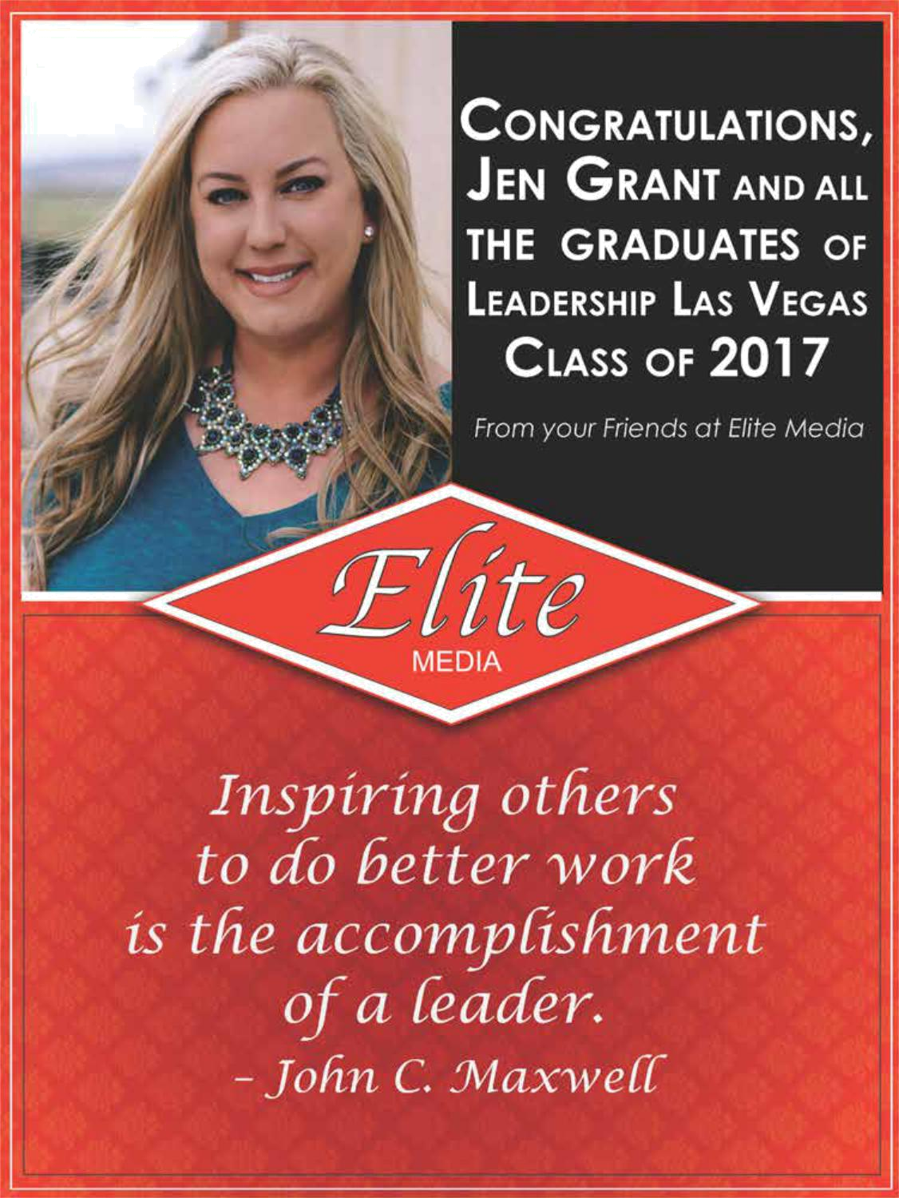
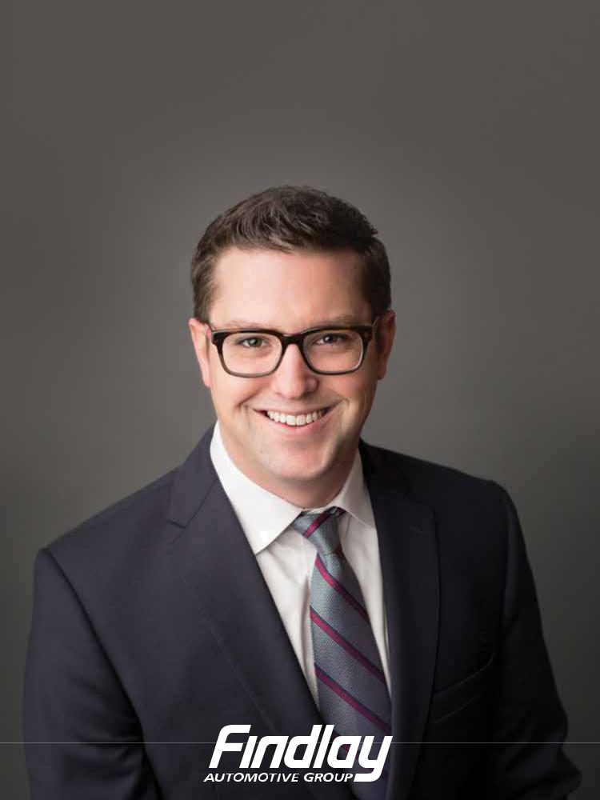
“Example is leadership.”

–Albert Schweitzer

Congratulations to the entire class of 2017, especially our man Chad Leavitt.

From your friends at Findlay Automotive Group


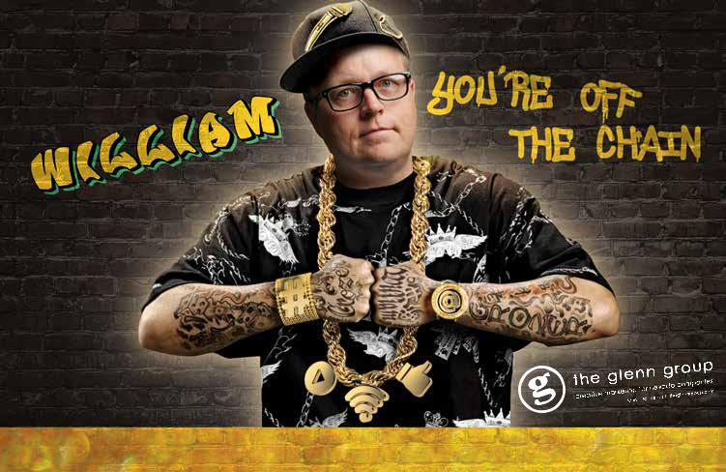

Props on graduating from Leadership Las Vegas. You prove that in Las Vegas, gangstas can still make s%*t happen.
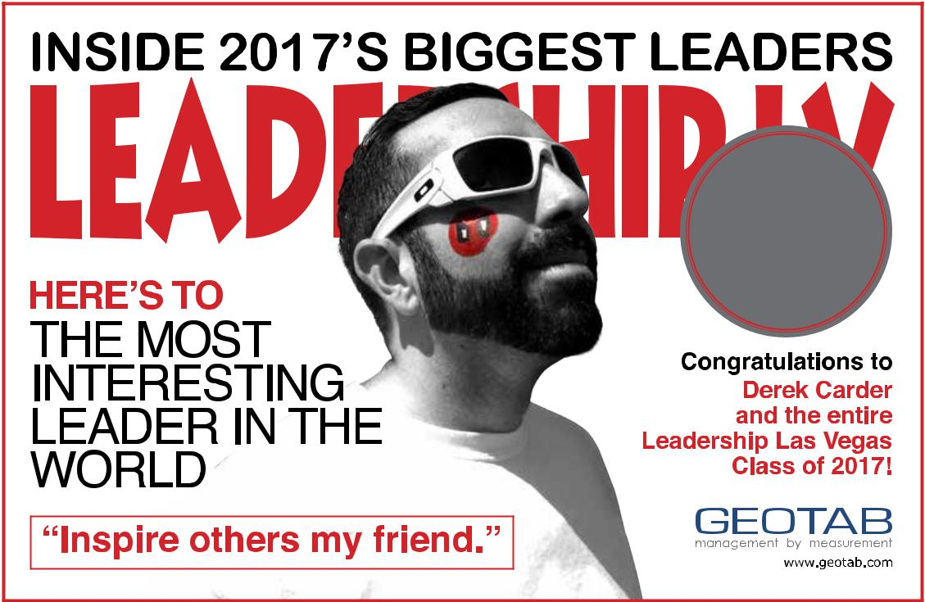

2017
LLV
GRAD!

Derek Carder
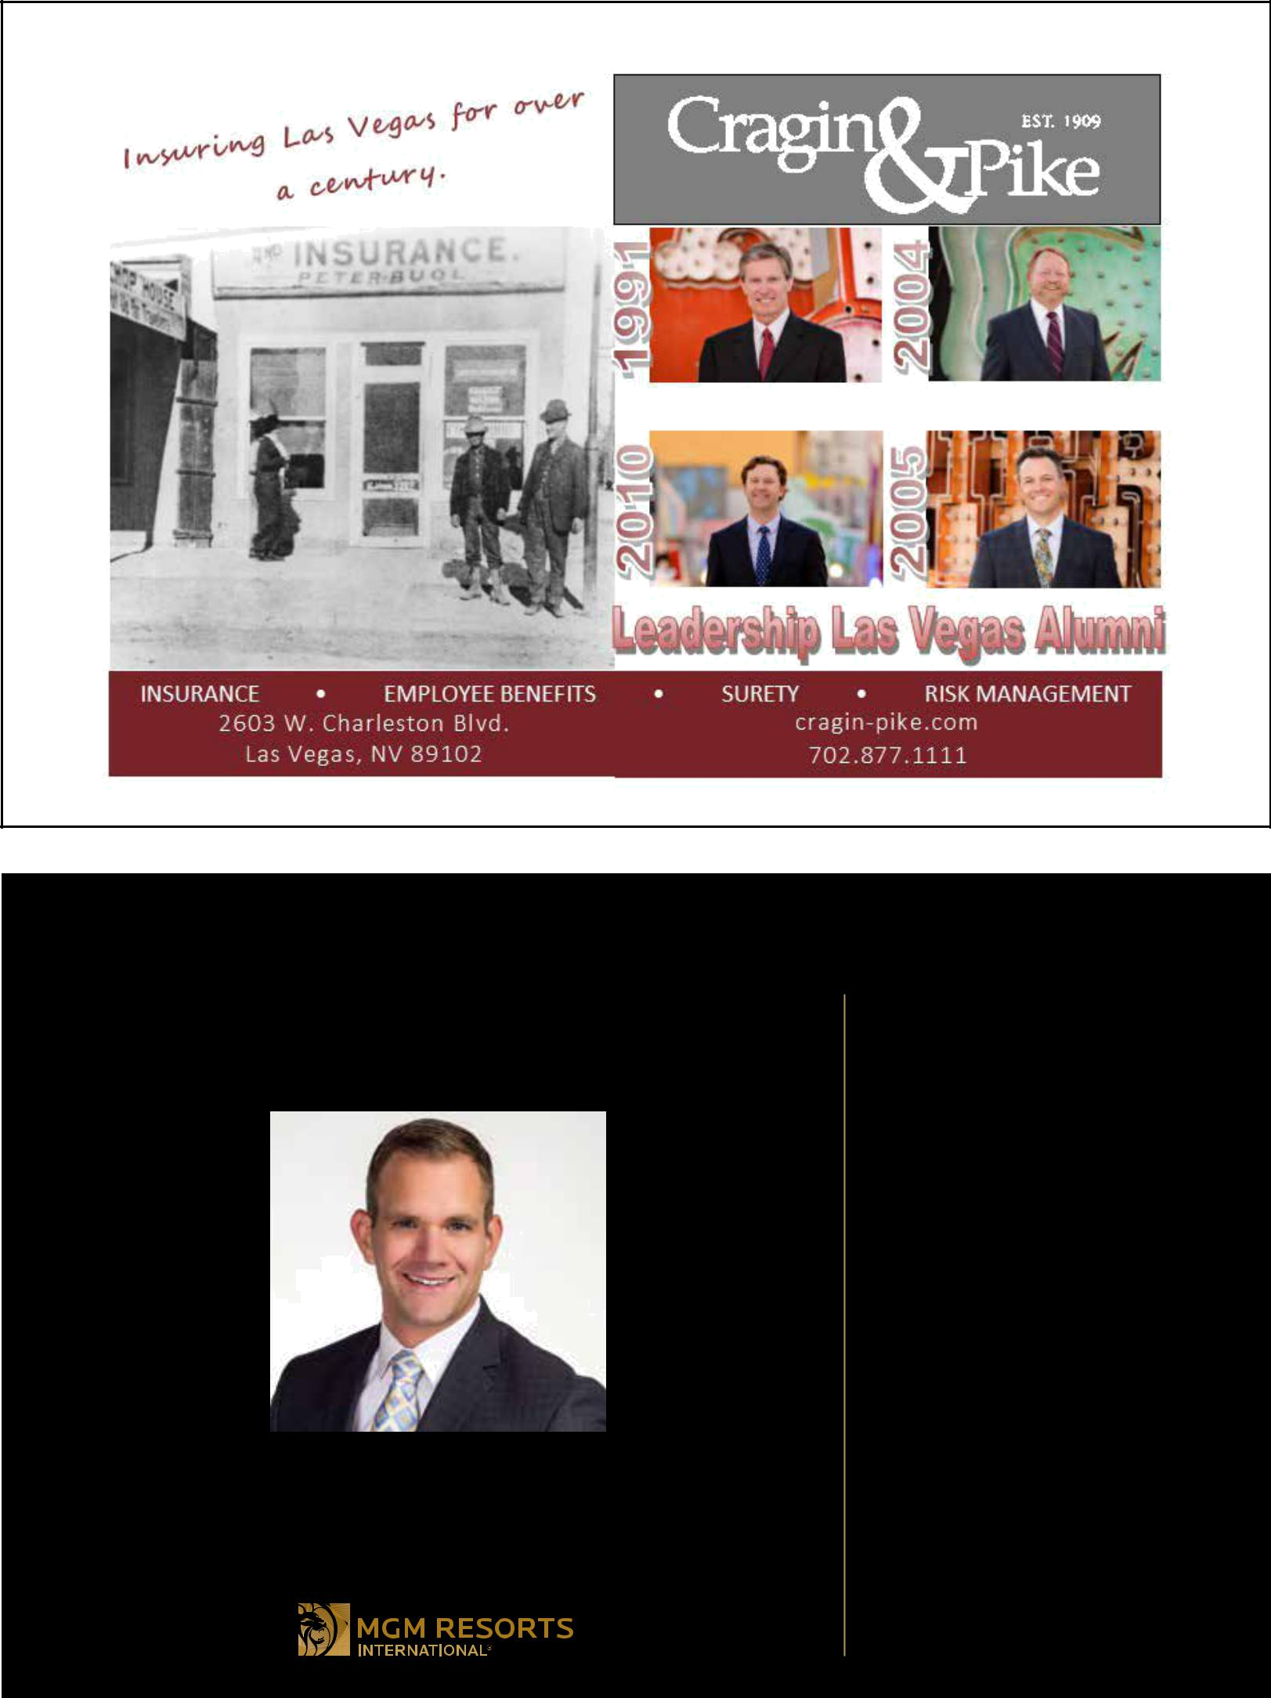

CONGRATULATIONS CLASS OF 2017!

OUR COMPANY’S GROWING FAMILY OF

LEADERSHIP LAS VEGAS GRADUATES IS PROUD TO

WELCOME A NEW LEADER TO OUR GROUP:

GREG CHASE

WE HOPE YOU HAVE BIG PLANS FOR

YOUR FUTURE. WE KNOW WE DO.

Bill Hornbuckle, LLV ’91

George Togliatti, LLV ’91

Tony Gladney, LLV ’92

Cynthia Kiser Murphey, LLV ’92

Stephen Koenig, LLV ’95

Gordon Absher, LLV ’09

Michelle DiTondo, LLV ’09

Jason Gray, LLV ’09

Ann C. Hoff, LLV ’10

Laura L. Lee, LLV ’10

Josh S. Swissman, LLV ’10

Mary Giuliano, LLV ’11

Franz Kallao, LLV ’11

London Swinney, LLV ’11

Anthony Williams, LLV ’11

Maria Castillo, LLV ’12

Rick Jost, LLV ’12

Kelley Tucky, LLV ’12

Jenn Michaels, LLV ’13

Randy Boynton, LLV ’14

Krista Clar, LLV ’14

Paul Garcia, LLV ’15

Yvette Harris, LLV ’15

Doug Sandoval, LLV ’15

Dolores Campuzano-Pignatello, LLV ’16

Dawn Christensen, LLV ’16

Amanda Voss, LLV ’16

Saul Wesley, LLV ’16


WE’RE PROUD TO WELCOME A NEW GROUP OF LEADERS TO THE FRONT OF THE PACK.

©2017 The Howard Hughes Corporation. All rights reserved.
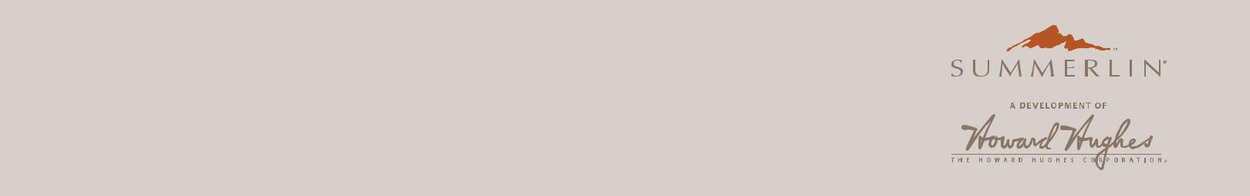

The Howard Hughes Corporation would like to congratulate the graduates of Leadership Las Vegas, Class of 2017. You inspire us all to lead the way in everything we do.

SUMMERLIN.COM
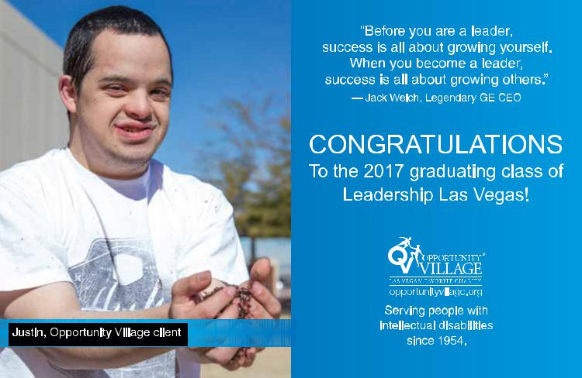

57

BANKING MEANS COMMUNITY

You care about the community you live in. So do we. In fact, we are proud to support this and so many other worthy organizations. When you surround yourself with inspiring people, they make life better. Like Nicole Curfman and the Leadership Las Vegas Class of 2017. It’s our pleasure to recognize their efforts to make our community shine.

BRING YOUR BANKING HOME.

nsbank.com | 855.822.DOOR

A division of ZB, N.A. Member FDIC


NV Energy congratulates

Ron Bilodeau

in honor of his

commitment to excellence
as a graduate of | Excellence
Leadership Las Vegas
Class of 2017.


Congratulations 
to the

LEADERSHIP LAS VEGAS CLASS OF 2017

“Leadership and learning are indispensable to each other.”

-John F. Kennedy
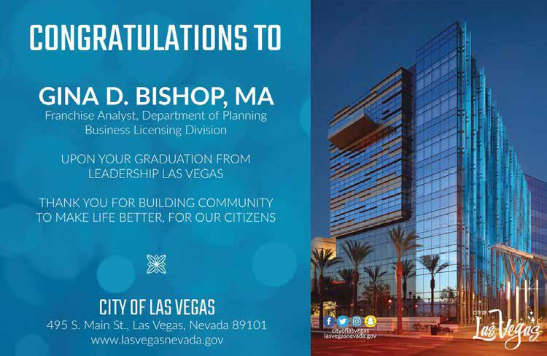


Making a path
for positive change.

In every community, there are leaders who set the course for positive change through their vision and guidance. Their work not only supports local needs, but inspires others to do the same.

Thank you graduating class of 2017 for your service to Southern Nevada.

wellsfargo.com/stories
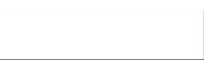


© 2017 Wells Fargo Bank, N.A. All rights reserved. (4203201_20404)
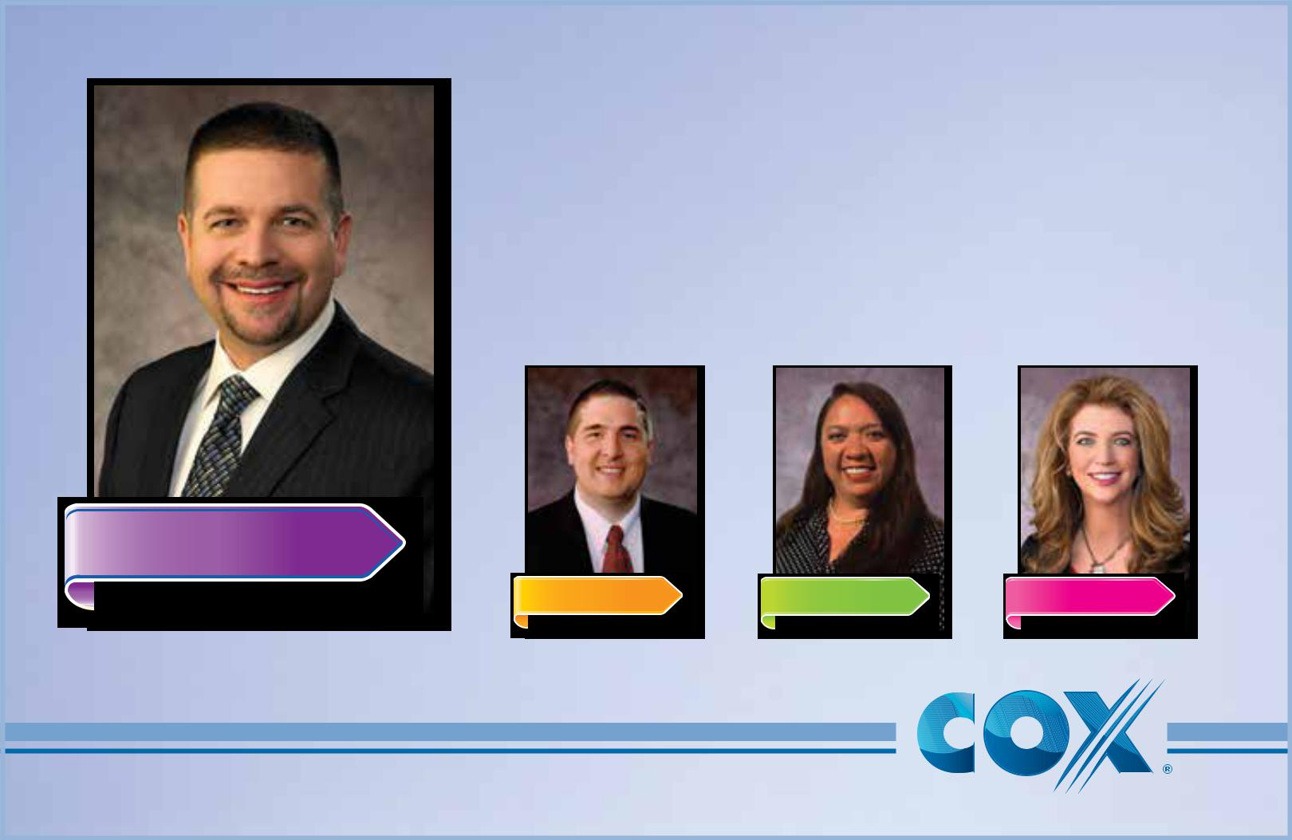

Congratulations to the
Leadership Las Vegas Class of 2017

from your friends (and LLV Alumni) at

Cox Communications, Las Vegas.

Class of 2017

Class of 2015 Class of 2014 Class of 1992

ALAN LIVENGOOD

PAUL PHILLIPS TAMAR HOAPILI STEPHANIE STALLWORTH

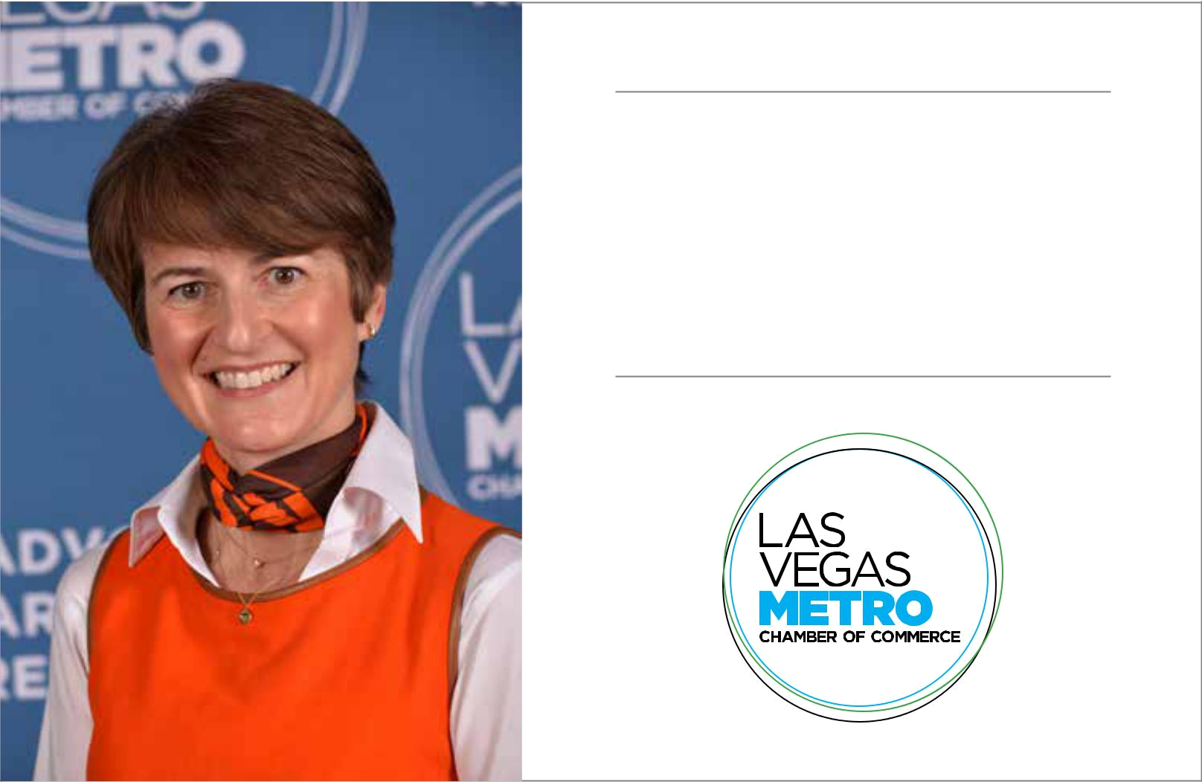

CONGRATULATIONS TO

NICOLE NEAL

AND THE CLASS OF 2017


Lance J. Kirk, AIA, LEED AP
LEADERSHIP LAS VEGAS
CLASS OF 2017

C O N G R A T U L A T I O N S

From your friends & colleagues at LGA

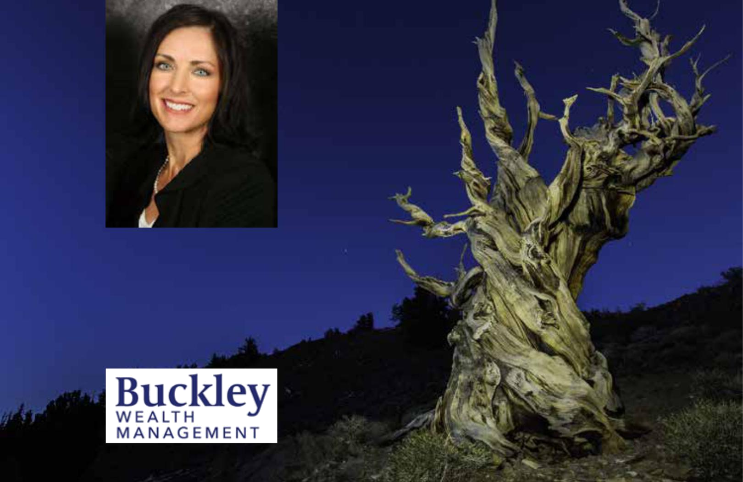

Congratulations Lori Chittenden

and and the entire Leadership

Las Vegas Class of 2017.

We are so proud of you!

www.buckleywealth.com
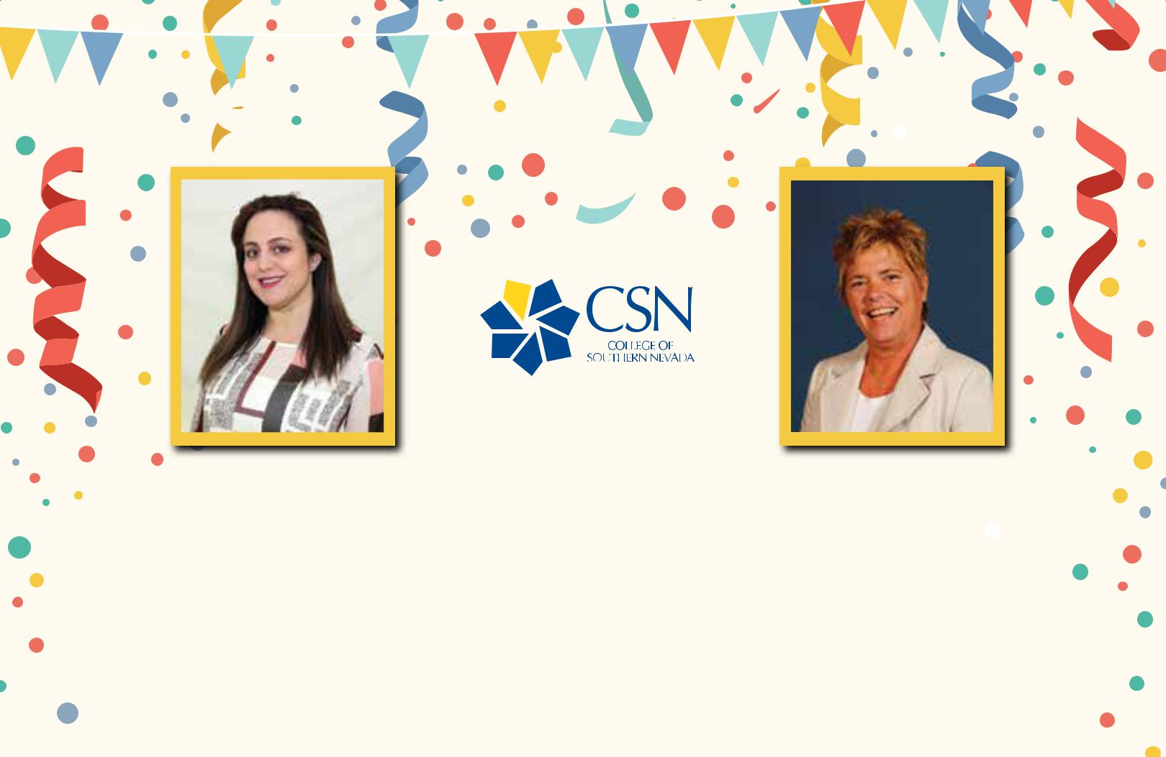

 Congratulations Maria &Shellie!

Maria Marinch | Shellie Keller
Executive Director, | Interim Associate Vice President,
Community Relations, Diversity & | Academic Affairs
Multicultural Affairs

The entire CSN family congratulates you on your graduation from Leadership Las Vegas. You have made us all proud!

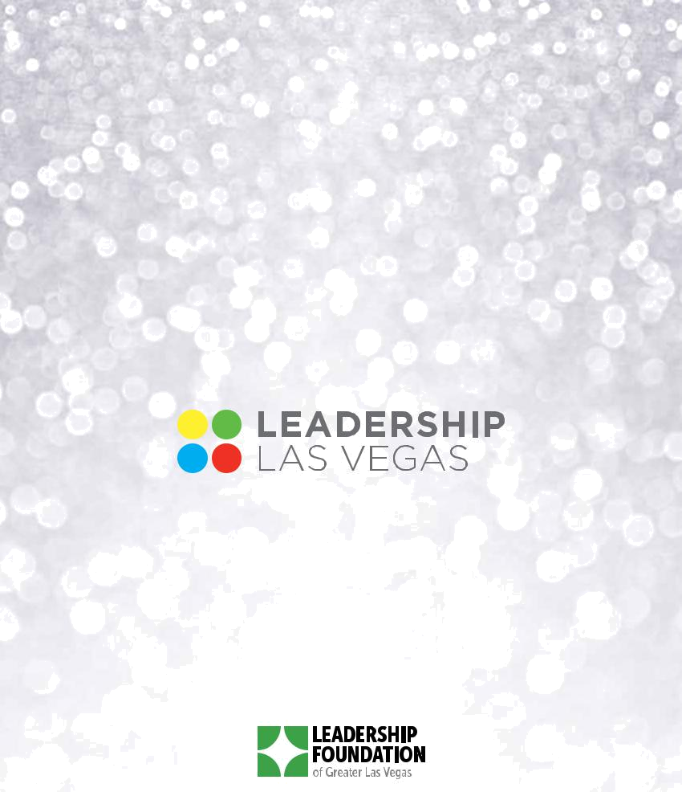

Leadership.Vegas

