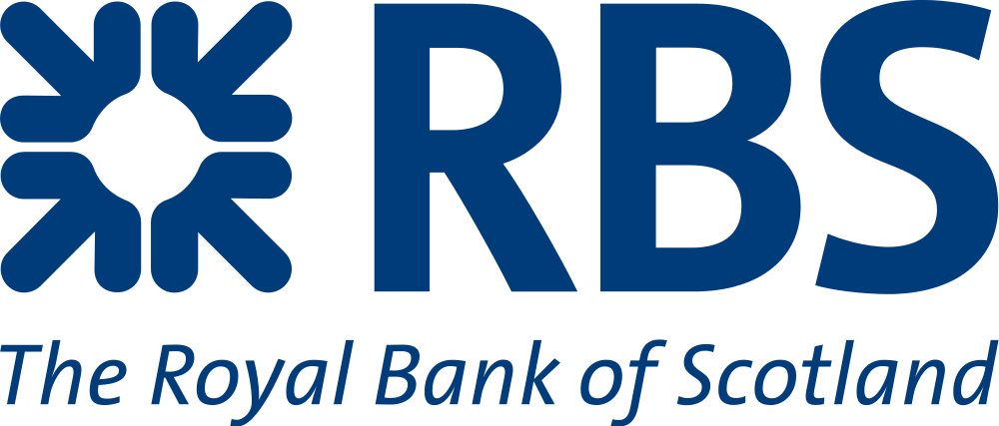 | Statement |  | Account Number: 1111111
 |  |  | Sort Code: 16-10-00
 |  |  | BIC: RBOSGB2L
 | SELECT ACCOUNT |  | IBAN: GB11RBOS 1610 0011 1111 11
MR TEST TESTER
CURRENT ACCOUNT
Branch Details | Your Details | Period | 22 Oct 2014 to 21 Dec 2014
ANY BRACH  ANY STREET  ANY TOWN | MR T TESTER  1 TEST STREET  TEST TOWN | Previous Balance |  | £1803.90
 |  | Paid Out |  | £2,684.10
AN1 TWN | TE5 7ER | Paid In |  | £2,180.40
 |  | New Balance |  | £300.20
Date | Type | Description | Paid In | Paid Out | Balance
BRIGHT FORWARD |  |  |  |  | 1803.90
22 Oct 2014 | AUTOMATED PAY IN | 650274051211-CHB |  | 190.40 | 1803.9
22 Oct 2014 | DIGITAL BANKING | CALL REF. NO. 3442, FROM A/C 22222222 |  | 140.00 | 1613.5
24 Oct 2014 | Faster Payment | Amazon |  | 132.30 | 1473.5
24 Oct 2014 | BACS | Tebay Trading Co. |  | 515.22 | 1341.2
25 Oct 2014 | Faster Payment | Morrisons Petrol |  | 80.00 | 825.98
25 Oct 2014 | BACS | Business Loan | 20,000.00 |  | 745.98
26 Oct 2014 | BACS | James White Media |  | 2,461.55 | 20745.98
27 Oct 2014 | Faster Payment | ATM High Street |  | 100.00 | 18284.43
01 Nov 2014 | BACS | Acorn Advertising Studies |  | 150.00 | 18184.43
01 Nov 2014 | BACS | Marriott Hotel |  | 177.00 | 18034.43
01 Nov 2014 | Faster Payment | Abellio Scotrail Ltd |  | 122.22 | 17857.43
01 Nov 2014 | CHQ | Cheque 0000234 |  | 1,200.00 | 17735.21
01 Dec 2014 | Int. Bank | Interest Paid | 9.33 |  | 16535.21
01 Dec 2014 | DD | OVO Energy |  | 2470.00 | 16544.54
21 Dec 2014 | BACS | Various Payment |  | 10,526.40 | 14074.54
21 Dec 2014 | BACS | HMRC |  | 1,000.00 | 3548.14
21 Dec 2014 | DD | DVLA |  | 280.00 | 2548.14
 |  | Balance Received Forward

Royal Bank of Scotland Plc. Registered Office, The Mound, Edinburgh EH1 1YZ. Registered in Scotland number SC327000
Authorized by the Prudential Regulation Authority and regulated by the Financial Conduct and the Prudential Regulation authority.

