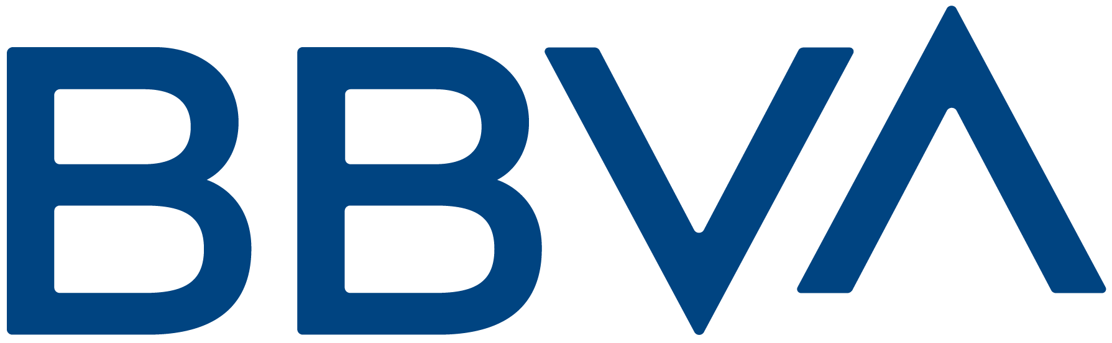 |  | October 01, 2019, through November 30, 2019
 |  | Account Number: | 254100541522695
BBVA USA (formerly BBVA Compass) is a bank headquartered in Birmingham, Alabama. |  | CUSTOMER SERVICE INFORMATION
 |  | Website: |  | www.bbva.com
 |  | Service Center: |  | 58212 / 5045111 / 4111 / 6211
 |  | Hearing Impaired: |  | 0810-222-0000
John Chosen  Called Parvenu, Edify, Tocome, Pisa 3,  Caracas, Venezuela |  | International Calls: |  | 0803-333-0540

CHECKING SUMMARY
 | INSTANCES | AMOUNT
Beginning Balance |  | $ 15,050.64
Deposits and additions | 2 | $ 130.00
Electronics withdrawals | 2 | $ 356.04
Ending Balance | 4 | $ 14,824.60
Your monthly service fee was waived because you maintained an average checking balance of $ 7,500 or minimum checking balance of $ 5,000.00 or more during the statement period.

DEPOSITIS AND ADDITIONS
DATE | DESCRIPTIONS | AMOUNT
10/12 | ATM Check Deposit | $ 125.00
10/16 | ATM Cash Deposit | $ 5.00
Total Deposits and Additions |  | $ 130.00

ELECTRONIC WITHDRAWALS
DATE |  | DESCRIPTIONS | AMOUNT
10/20 |  | Qwest 2514552154578 CCD ID: 5L854p4521 | $ 249.84
10/20 |  | Qwest 2514552154578 CCD ID: 5L854p4521 | $ 106.20
Total Electronic Withdrawals |  |  | $ 356.04

ENDING BALANCE
DATE | AMOUNT
10/12 | $ 15,154.12
10/20 | $ 14,824.60

