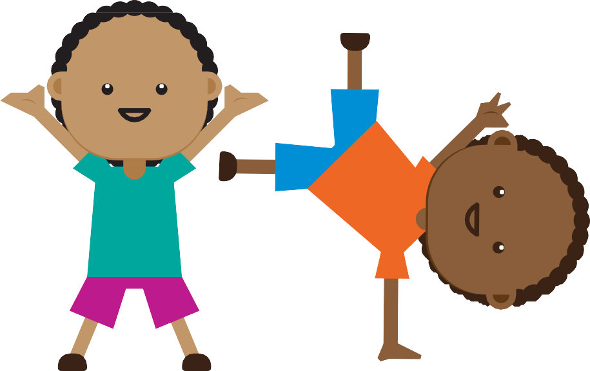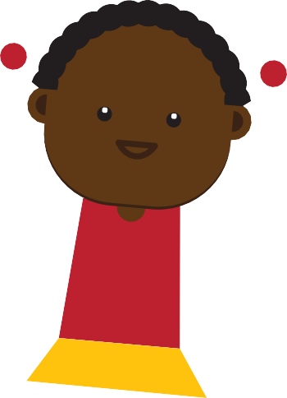

TIP: Before you write on this page, make a few photocopies to keep.

THIS CHART BELONGS TO:

TASK
Mon Tues Wed Thurs Fri Sat Sun

TOTAL

When I reach my goal of smiley faces,
my reward will be:

When I reach my goal of smiley faces,
my reward will be:

When I reach my goal of smiley faces,
my reward will be:

When I reach my goal of smiley faces,
my reward will be:

When I reach my goal of smiley faces,
my reward will be:

parents' guide to using a reward chart

'Young children do better with immediate rewards. For example, if you're taking them for ice cream as a reward, give them a coupon with "Out for ice cream"
written on it. ' Trudy Coetzee, teacher at Prestwich Primary,
Cape Town.
This is a parenting tool you can use to praise your kids and encourage them to do chores or homework without having to nag. Here's how to use it most effectively:
Involve your child before you start using a reward chart – s/he must want to do the task and understand how the chart is going to work.
List your child’s daily chores in the ‘Tasks’ column. You can use a reward chart to tackle everyday activities, from tidying up to doing homework. Make sure each task is simple, specific, measurable and achievable.
Draw stars or smiley faces or use stickers in the corresponding boxes to show when a task is complete. If it hasn't been done, draw a sad face ☹ or make a cross.
Rewards should be small treats – just think how excited kids get over the free toys found in some cereal
boxes, for example.
Stay positive and focus on praising success. Never take away stickers or rewards.

