# *Our Family Reward Chart*

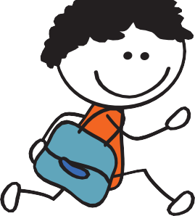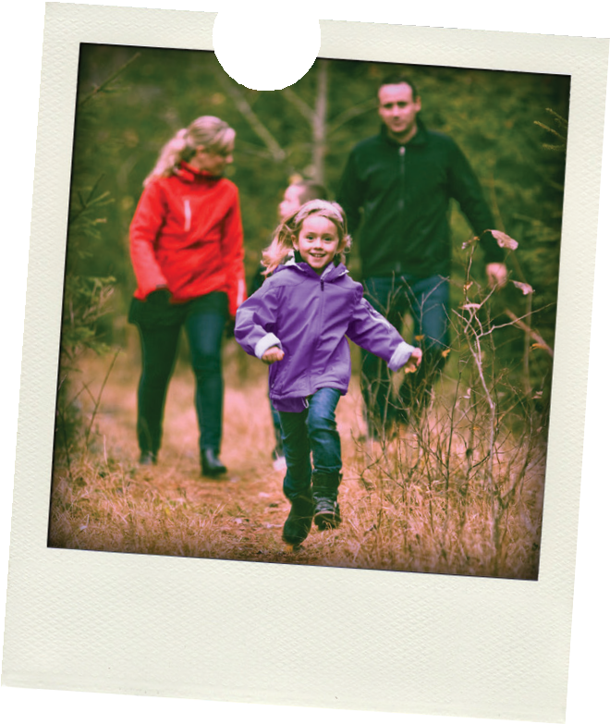

|  |  |  |  |  |  |  |  |
| --- | --- | --- | --- | --- | --- | --- | --- |
|  | **Monday** | **Tuesday** | **Wednesday** | **Thursday** | **Friday** | **Saturday** | **Sunday** |
| My name is | | | | | | | |
| My food goal is |  |  |  |  |  |  |  |
| My activity goal is |  |  |  |  |  |  |  |
| My name is | | | | | | | |
| My food goal is |  |  |  |  |  |  |  |
| My activity goal is |  |  |  |  |  |  |  |
| My name is | | | | | | | |
| My food goal is |  |  |  |  |  |  |  |
| My activity goal is |  |  |  |  |  |  |  |
| My name is | | | | | | | |
| My food goal is |  |  |  |  |  |  |  |
| My activity goal is |  |  |  |  |  |  |  |



*Your Family’s Reward Chart*

Making healthy changes is **great fun when everyone joins in. Small changes** to your children’s diet and physical activity **can make big differences to their future health.** Setting family goals is a great way to stay motivated and to track progress.

## Getting started…

Agree goals with all the family and decide what the reward will be together. Here are some ideas for you and your family...

## Food goals

Try a **new piece of fruit** everyday Eat **vegetables everyday**

Swap sugary drinks for **water or milk**

Eat all meals **at the kitchen table**

## Activity goals

Go for **30 min walk a day**

**Skipping or running** on the spot for 10 minutes a day

Watch **one less hour of TV** a day

Try **singing and dancing** for 15 minutes a day

To download more reward charts and stickers and find more handy tips and great ideas visit [**www.safefood.eu**](http://www.safefood.eu/)

Don’t forget to share your best food and activity goals with friends and family.

**Agree goals with all the family** and decide what the reward will be together. **Place a sticker** for each day that the goal is achieved.



For more handy tips and great ideas for you and your family, visit [**www.safefood.eu**](http://www.safefood.eu/)



For more handy tips and great ideas for you and your family, visit [**www.safefood.eu**](http://www.safefood.eu/)

For more handy tips and great ideas for you and your family, visit [**www.safefood.eu**](http://www.safefood.eu/)