1 | 2 | 3 | 4 | 5 | 6
1 | 2 | 3 | 4 | 5 | 6

Student’s trophies:
Teacher’s trophies:

Teacher Directions (TD): 1. If student (S) answers correctly, he/she goes one step forward on the track. If not, the teacher (T) goes o
step forward. The first to reach the finish line is the winner. 2. If S doesn’t follow the classroom rules, he/she goes one step backward
3. The one who gets the most trophies is the winner. 4. T draws reward system on whiteboard or paper to use throughout class .

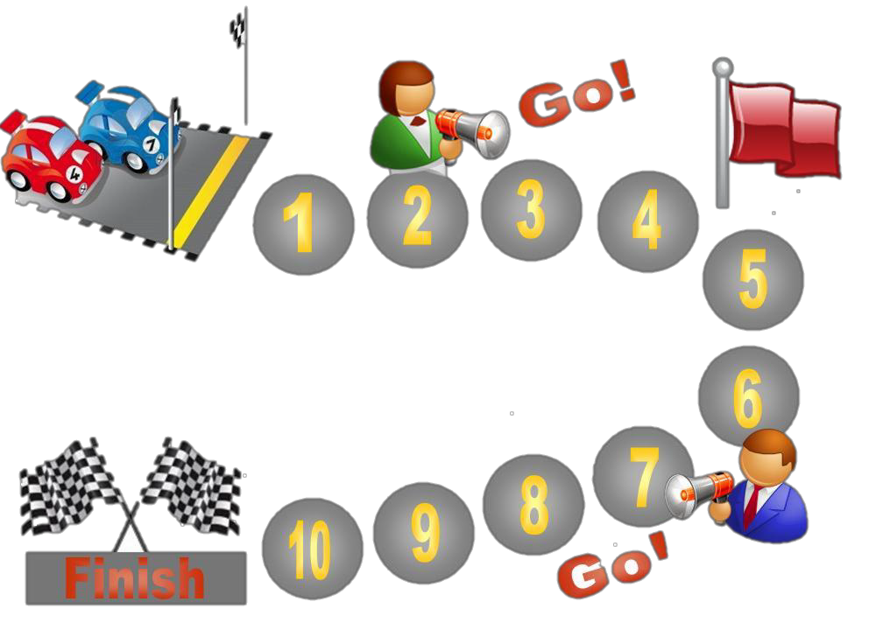

Teacher Directions (TD): 1. If student (S) answers correctly, he/she goes one step forward on the track. If not, the teacher (T) goes one step forward. If S doesn’t follow the classroom rules, he/she goes one step backward. 2. The first to reach the finish line is the winner. 3. The one who gets the most trophies is the winner. 4. T draws reward system on whiteboard or paper to use throughout class

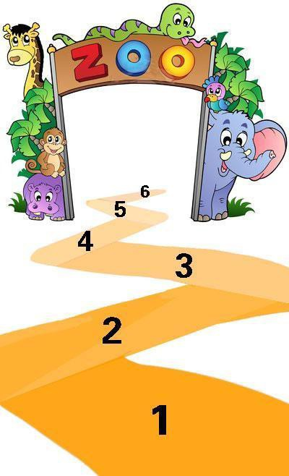

Teacher Directions (TD): 1. If student (S) answers correctly, he/she goes one step forward on the zigzag path. If not, the teacher
(T) goes one step forward. The first to go into the zoo is the winner. 2. If S doesn’t follow the classroom rules, he/she goes one step backward. 3. T draws reward system on whiteboard or paper to use throughout class.

Teacher Directions (TD): 1. If student (S) answers correctly, he/she gets a tooth. If not, T erases a tooth. 2. If S doesn’t follow the classroom rules, S loses a tooth. 3. Count the number of the teeth at the end of class. 4. T draws reward system on whiteboard or paper to use throughout class.

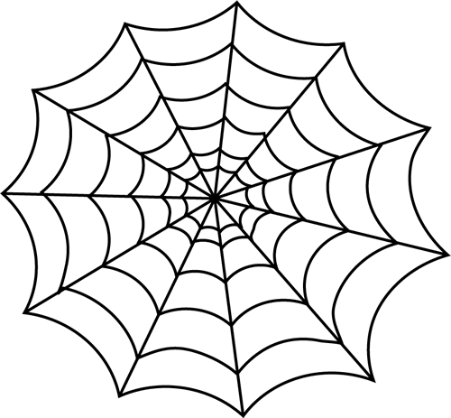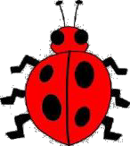

Teacher Directions (TD): 1. If student (S) answers correctly, the bug (student) takes a step away the spider. If the S answers incorrectly or doesn’t follow classroom rules, the spider (T) steps closer to the bug. 3. If the spider catches the bug, the T is the winner If the bug reaches the edge of the web, the S is the winner. 4. T draws reward system on whiteboard or paper to use throughout class.

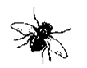

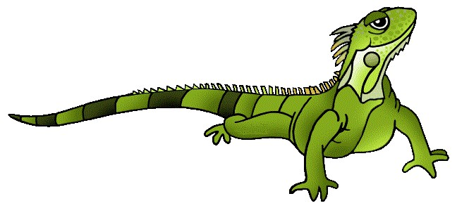

Teacher Directions (TD): 1. If student (S) answers correctly, the iguana eats a fly. If the student answers incorrectly or doesn’t follow the classroom rules, another fly appears on the page. 2. Count the number of the flies that the iguana eats by the end of the class. 4. T draws reward system on whiteboard or paper to use throughout class.

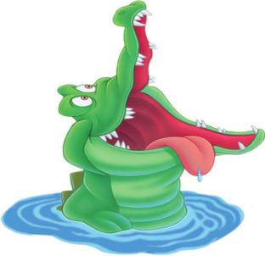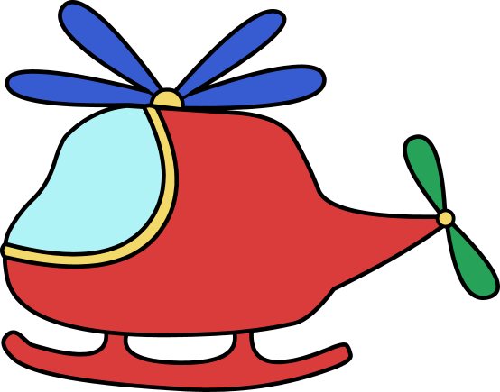
is for student

is for teacher
Student’s score:
Teacher’s score:

Teacher Directions (TD): 1. If student (S) answers correctly, he/she goes up on the ladder. If not, the teacher (T) goes up. 2. If S doesn’t follow the classroom rules, he/she goes down. 3. The one who saves the most people is winner. 4. T draws reward system on whiteboard or paper to use throughout class.

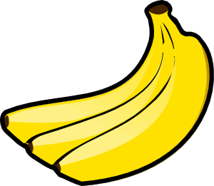

Teacher Directions (TD): 1. If student (S) answers correctly, the monkey gets a banana. If not, it loses one. 2. If S doesn’t follow the classroom rules, the monkey loses one banana, too. 3. Count the number of the bananas that the monkey gets at the end of class. 4. T draws reward system on whiteboard or paper to use throughout class.

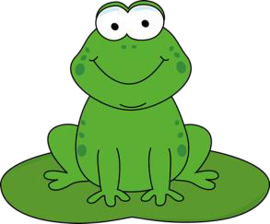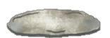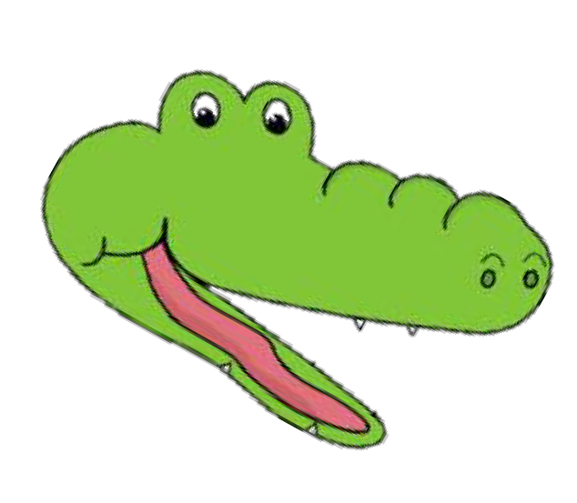T S

Teacher Directions (TD): 1. If student (S) answers correctly, he/she goes one step forward on the lily pad. If not, the teacher (T) goes one step forward. The first to reach the stone is the winner. 2. If S doesn’t follow the classroom rules, he/she goes down. Then begin from the very beginning. 3. T draws reward system on whiteboard or paper to use throughout class.

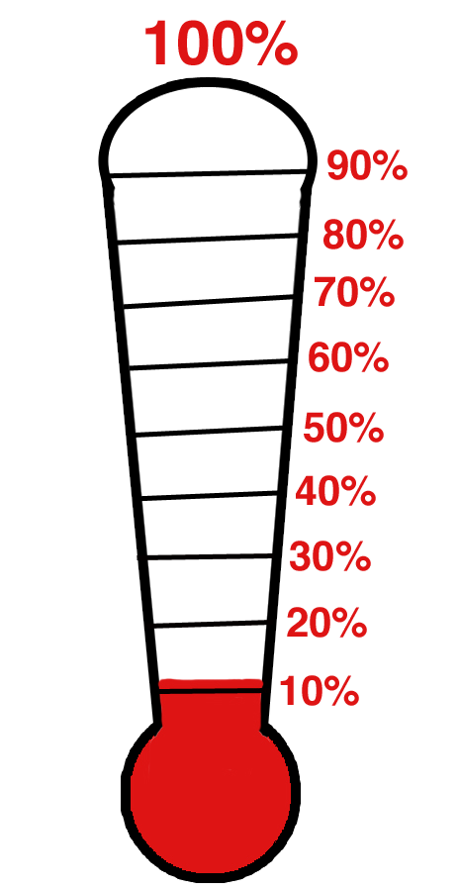
Teacher Directions (TD): 1. If student (S) answers correctly, the teacher (T) colors up to the line for S. If not, T colors his/her own. The first to reach the top is the winner. 2. If S doesn’t follow the classroom rules, T colors his/her own as well. 3. T draws reward system on whiteboard or paper to use throughout class.

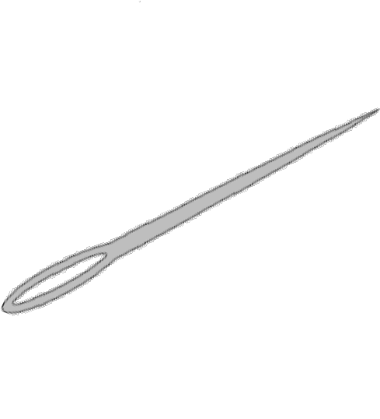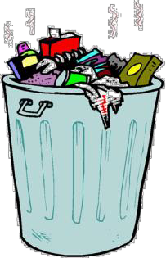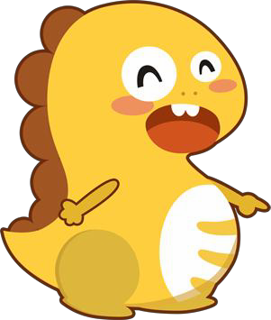Teacher Directions (TD): 1. If student (S) answers correctly, he/she earns one balloon for the dinosaur who’s hung above the garbage can. If not, the teacher (T) will use the needle to pop one balloon. When the dinosaur has five balloons, he is safe. 2. If S doesn’t follow the classroom rules, the cat looses one balloon, too. Count the number of dinosaurs that S saved at the end of the class. 3. T draws reward system on whiteboard or paper to use throughout class.
Dino you saved

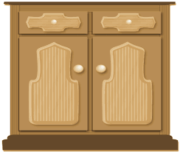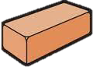
Cake number

Teacher Directions (TD): 1. If student (S) answers correctly, the cat gets one brick for reaching the cake. If not, the cat will loose one. When the cat has five bricks, it can eat the cake. 2. If S doesn’t follow the classroom rules, the cat loose one brick, too. Count the cake number the cat got at the end of the class. 3. T draws reward system on whiteboard or paper to use throughout class.

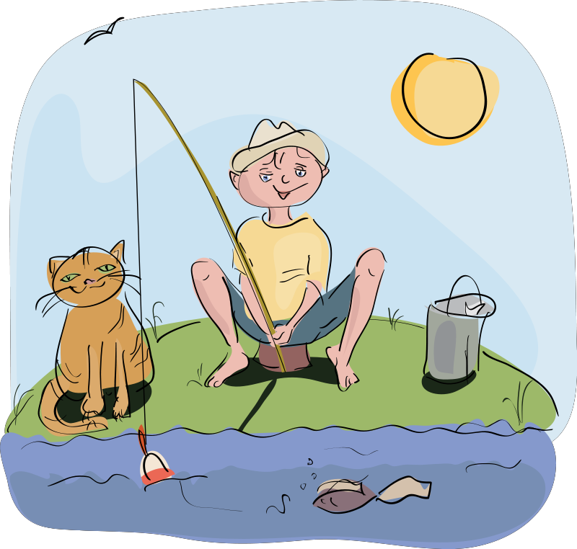
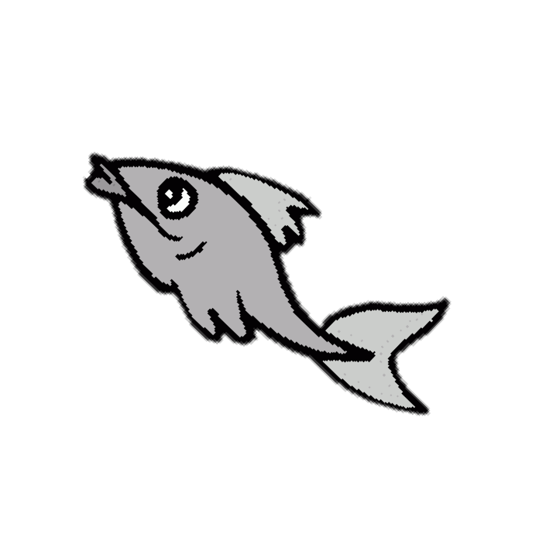
Fish number

Teacher Directions (TD): 1. If student (S) answers correctly, the boy gets one fish. If not, the boy will lose one. 2. If S doesn’t follow the classroom rules, the boy also loses one fish,. Count the number of fish that the boy got by the end of the class. 3. T draws reward system on whiteboard or paper to use throughout class.

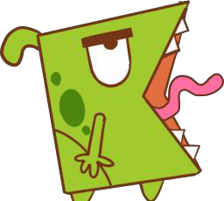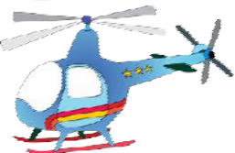Teacher Directions (TD): 1. If student (S) answers correctly, Mike gets one step forward. If not, the monster steps closer to Mike. 2. If S doesn’t follow the classroom rules, the monster gets closer, too. 3. S wins if Mike boards the helicopter. 4. T draws reward system on whiteboard or paper to use throughout class.

