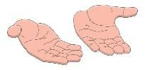
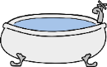
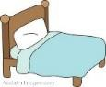
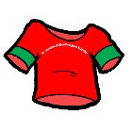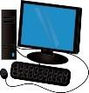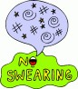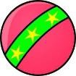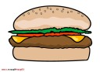My Reward Chart
 | Monday | Tuesday | Wednesday | Thursday | Friday | Saturday | Sunday
I woke up in a good mood
I dressed myself
I didn’t interrupt and waited patiently
I stopped playing the computer and Nabi when told
I used nice words
I kept my hands to myself
I was good in the bath
I didn’t whine or cry
I used my inside voice
I went to bed when I was told
I shared my toys
I listened to adults
I tried all my food
I helped clean up
I was good in the car

Extra

