7-9C:\Users\admininstall\AppData\Local\Microsoft\Windows\INetCache\Content.Word\7-9.pngC:\Users\admininstall\AppData\Local\Microsoft\Windows\INetCache\Content.Word\7-9.png

**Get dressed**

**Brush teeth**



**Use of toilet**

**Exercise**



**Make my bed**

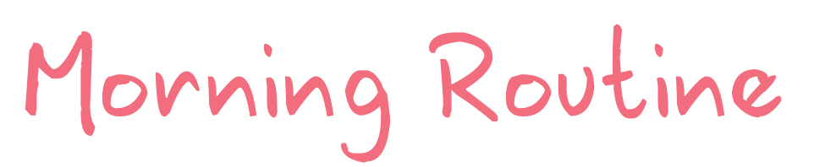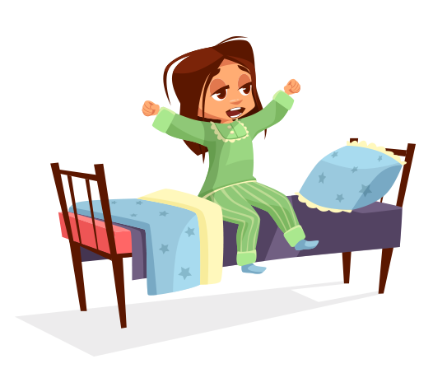

**Sunday**

**Saturday**

**Friday**

**Thursday**

**Wednesday**

**Tuesday**

**Monday**

**Eat breakfast**

