
i $5
n
c

l
u d i n g

T
S

G

In this book:

- choosing a motor driving instructor or an authorised examiner

- the compulsory 75 hour driving experience Log Book

- the vehicle on road test

- competency based training and assessment.

- the hazard perception test

the driving companion for class ‘c’ vehicles

The information contained within this publication has been prepared to help you become better informed about the provisions of the driver licensing system. It should not be taken as a precise interpretation of the law. It does not set out to be complete or a substitute for the legislation made by Parliament.

Recent changes in laws may not be reflected in this publication.

If you require further information please call 13 10 84.

The Driving Companion can also be viewed on mylicence.sa.gov.au

Information on the relevant South Australian legislation may be obtained from the following web site: www.legislation.sa.gov.au

references

- The Driver’s Handbook

- Australian Road Rules

- Road Traffic Act

- Motor Vehicles Act (1959) and Regulations

© Government of South Australia.


This work is licensed under a Creative Commons Attribution 3.0 Australia Licence. A summary of the licence terms is available from http://creativecommons.org/licenses/by/3.0/au/deed.en

ISMF Classification – PUBLIC – I3 – A3

MR195 July 2018

 |  |  |  |  | t
 |  |  |  | an
 |  | uw
 | yo
do |  |  |  |  | ?
 |  |  | all
 |  | kit
ris
to
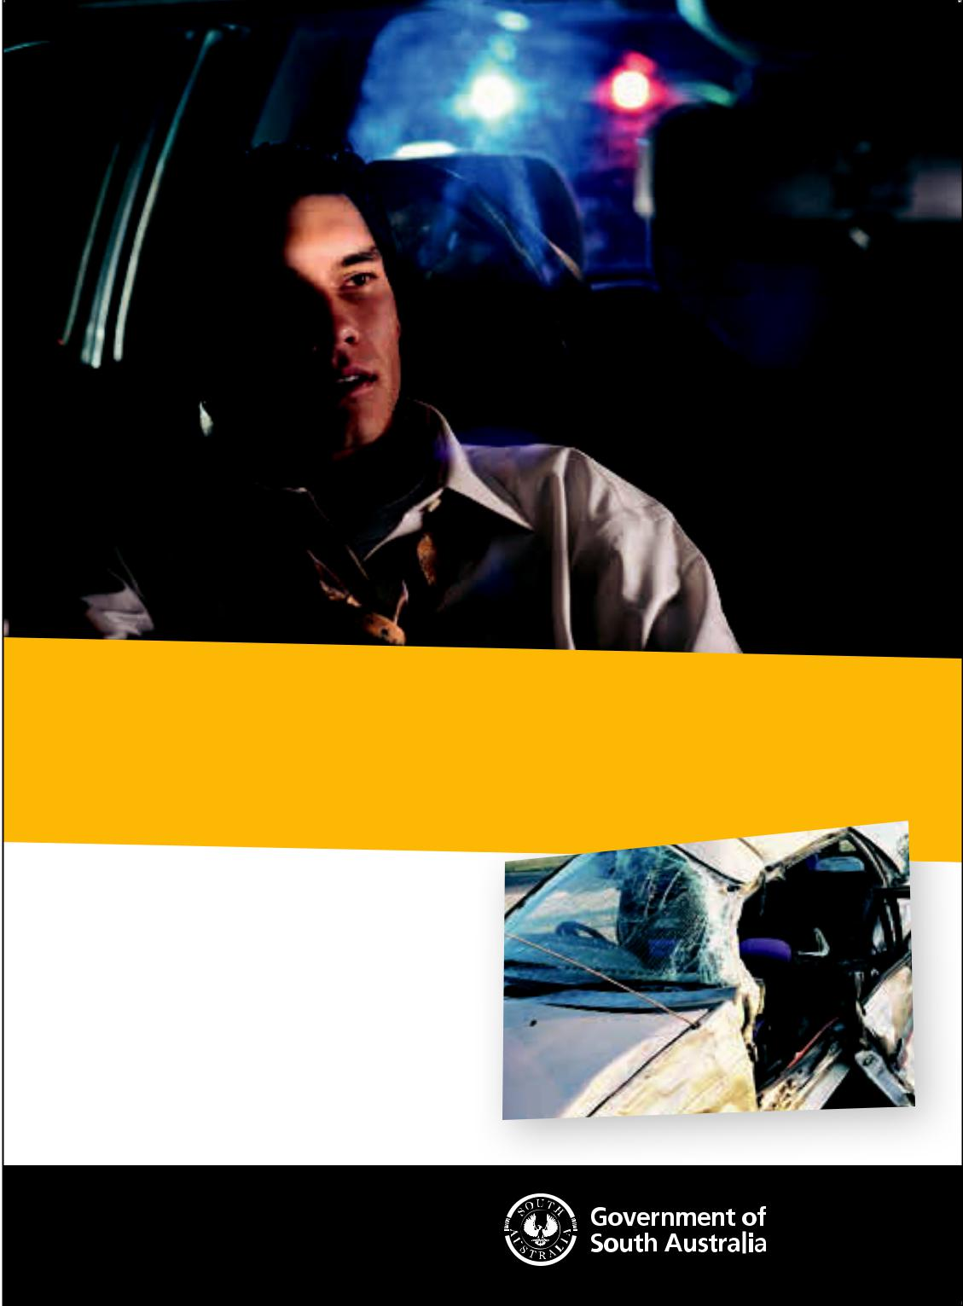
Inexperience on the roads and risk-taking

mean that drivers aged under 25 have up

to three times the death and injury rate of

all drivers.

So stay safe, be smart and avoid the

risks. For more safer driving tips go to

mylicence.sa.gov.au

safer, smarter drivers start at

mylicence.sa.gov.au

Before you drive

The Driving Companion | 2
Learner’s Permit conditions | 3
Who do you choose to instruct you? | 4
Choosing a Qualified Supervising Driver | 4
Choosing a Motor Driving Instructor or an Authorised Examiner | 5
Enquiries and complaints | 6

Graduated Licensing Scheme

Overview | 7
The Hazard Perception Test | 8
Practical driving options to progress to P1 Provisional Licence | 9

Driving

Learning to drive | 10
Vehicle check | 11
System of Car Control | 12
Observation | 15
Rules of braking | 16
Steering | 16
Safe driving strategies | 17
Log Book

How to use your Log Book | 19
Choosing your driving conditions | 19
Frequently asked questions | 19
Sample form | 21
Daytime forms | 22-31
Night-time forms | 32-33
Declaration of driving hours | 34

Vehicle On Road Test (VORT)

Option 1 : Vehicle On Road Test (VORT) | 35
Choosing this option offers the following | 35
Conditions applying to the VORT | 36
Government responsibilities in monitoring the licensing process | 37

Competency Based Training & Assessment (CBT&A) course

Option 2 : Competency Based Training & Assessment (CBT&A) course | 38
Choosing this option has the following advantages | 38
Conditions applying to the CBT&A course | 39
Training and assessment | 40
CBT&A Task index | 41
Task forms | 42-74

What happens next?

 | Obtaining your Provisional Driver’s Licence - P1 & P2 | 75
 | Provisional Licence conditions | 75
 | Safer vehicles | 76

1

Before you drive
The Driving Companion

Congratulations on obtaining your Learner’s Permit. You have taken the first steps towards embarking on a long driving career.

This book is designed to inform you about the journey ahead and help you become a safe and capable driver. Read it thoroughly and keep it safe and secure.

The Driving Companion includes the following sections:

Graduated Licensing Scheme

The Graduated Licensing Scheme is the process of providing new drivers with the skills and experience to safely progress to a full driver’s licence. It is explained in the next section.

Driving

Learning to drive takes a lot longer than most people think. As well as controlling your car, your must learn to make decisions and respond to what’s happening around you. The Driving section explains the skills and process required. - checking the vehicle, car control, observation, planning and defensive strategies.

Log Book

All Learner’s Permit holders must be accompanied by a Qualified Supervising Driver whilst driving and must have at least 75 hours on-road driving experience and pass the Hazard Perception Test before obtaining a P1 Provisional Licence. The Log Book section is the official record of your driving hours.

Vehicle-On-Road Test (VORT) and Competency Based Training & Assessment (CBT&A) course

There are two ways to qualify for your P1 Provisional Licence. You can either pass a practical driving test known as the Vehicle-On-Road Test (VORT) or undertake Competency Based Training & Assessment (CBT&A) course. This book contains the competency standards for both options.

Important - Before you begin to drive

It is your responsibility to operate a motor vehicle within the conditions of your Learner’s Permit and the road rules. You are also responsible for ensuring that anybody who supervises your driving is doing so legally and that you accurately record your driving experience.

Before you begin to drive, read and ensure that you understand the following:

- Your licence conditions

- The road rules described in The Driver’s Handbook guide

- The requirements for your Qualified Supervising Driver

- Choosing a Motor Driving Instructor or an Authorised Examiner

‘L’ Plates

‘L’ plates must display a black letter ‘L’ printed on a yellow background at the size dimensions specified below.
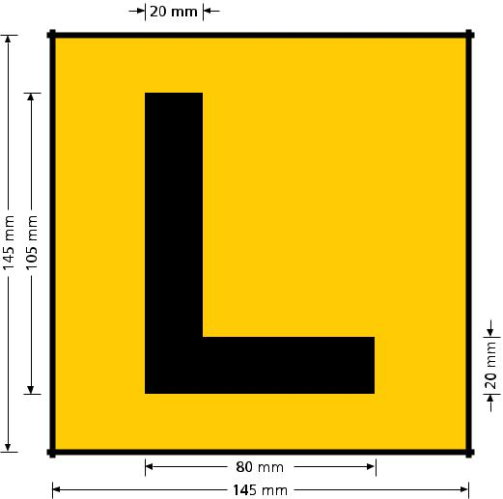

2

Learner’s Permit conditions

Learner’s permits are issued subject to conditions. If you breach a condition you will lose your learner’s permit and be disqualified from driving. This is in addition to any other penalty. The conditions are:

- you must not drive a motor vehicle with any concentration of alcohol

in your blood or the presence of THC (the active component in cannabis), Methylamphetamine (also known as speed, ice or crystal meth) or MDMA (ecstasy) in your blood or oral saliva

- if you commit a speeding offence, you will also commit a breach of your learner’s permit conditions if you exceed the speed limit by 10 km/h or more

- you must drive with a qualified supervising driver in the seat next to the driver

- when riding a motorcycle you must not carry a passenger on the motorcycle, or in a sidecar attached to the motorcycle, unless that person is a qualified supervising driver

- you must not accumulate four or more demerit points during the learner’s permit period

The following laws also apply to the holder of a learner’s permit. If you breach any of these laws you may incur penalties such as fines, demerit points or loss of licence.

- you must only drive the class of motor vehicle stated on your licence

- you must display the correct size ‘L’ plates so that they are clearly visible from the front and rear of the vehicle (rear only for motorcycle)

- you must carry your learner’s permit at all times whilst driving

- you must not drive over 100 km/h even if the local speed limit exceeds 100 km/h

- you must not use any mobile phone function while driving including hands-free mode, Bluetooth technology and loud speaker operation

- holders of a motorcycle learner’s permit who are under 25 years of age

and do not hold a P2 or full licence for another class of vehicle must not ride between midnight and 5am unless a qualified supervising rider is present as
a passenger on the bike or in a sidecar attached to the bike (exemptions apply)

- holders of a motorcycle learner’s permit must not lane filter
Who do you choose to instruct you?

To prepare yourself for the responsibility of driving a motor vehicle, it is recommended that you obtain some professional tuition when learning to drive.

Ideally, training from a Motor Driving Instructor should occur together with lots of practice with a friend or family member who meets the requirements for a Qualified Supervising Driver.

Note, only an Authorised Examiner can assess your driving ability by signing off tasks for CBT&A or completing a VORT.

Choosing a Qualified Supervising Driver

A Qualified Supervising Driver must:

- have an unconditional licence authorising the person to drive a Class C vehicle (or an equivalent foreign licence as approved by the Registrar of Motor Vehicles)

- have held an unconditional/full licence for the last 2 years without disqualification

- not hold a provisional or probationary licence or be subject to the condition of “good behaviour”

- not have a blood alcohol reading of 0.05 or more, or the presence of THC (Cannabis), Methylamphetamine (Speed) or MDMA (Ecstasy) in their blood or oral fluid.

When you are learning to drive, the Qualified Supervising Driver accompanying you is required to:

- instruct you in the safe and efficient operation of the motor vehicle

- instruct you in the correct application of the South Australian road rules

- be seated immediately alongside you at all times while you are driving This also applies to parking practice (even in car parks)

- ensure that the motor vehicle is registered and roadworthy

- comply with the licensing requirements (highlighted above)

Before you drive

3

Before you drive
You should also ensure that they have the following characteristics:

- patience and a calm approach to your learning

- the ability to guide you effectively in your practice.

Being a Qualified Supervising Driver is an important role and this person may face penalties for providing fraudulent information in your Log Book.

If your Qualified Supervising Driver is later found to not have met the requirements to perform this role:

- all of the log book entries relating to this person will be invalid and not count towards your 15 and 75 hour requirements;

- if consequently you do not have enough hours, your licence will be declared void (be cancelled);

- you will be required to surrender your licence;

- you will need to apply for the reissue of a Learner’s Permit.

Note – A Qualified Supervising Driver with a Foreign Licence must:

- have a licence that is issued by a country recognised by South Australia;

- have held the licence for 2 or more years;

- have a licence that is:

an unconditional, full licence to drive a class C vehicle;

current;

written in English or have an English translation;

- be carried by the Qualified Supervising Driver

Things you should ask your Motor Driving Instructor or Authorised Examiner

- Are you a Motor Driving Instructor and only able to provide training or are you an Authorised Examiner and able to train and assess?

- Are you able to assess and sign off tasks when I’m competent using the CBT&A option?

- When should I start driving lessons with an instructor? Does it have to be after I have completed my 75 hours of driving?

- How much do you charge per lesson and will you give a receipt? Please Note: Under Australian Consumer Law they must provide a receipt upon request or on any transaction over $75.00.

- Are there any hidden or extra costs, including Government charges? Please Note: A booking fee is charged by the Registrar to Authorised Examiner’s booking a VORT or final CBT&A assessment. Refer Motor Vehicles Regulations 2010, Fees Schedule 1 Clause 29 for the current fee.

- How long is each lesson and will you record this time in my log book as driving hours?

Please Note: Qualified Supervising Drivers, Motor Driving Instructors and Authorised Examiners must record driving hours including lessons in the log book.

- What type of vehicle do you teach in, a manual or an automatic?

- How frequently do you recommend having lessons?

- Do you have a refund policy for cancellation of lessons?

- Do I need to practice in between lessons? What are the homework expectations?

- Are you able to conduct lessons that may start at home and finish at work or school and vice versa? Or any other location?

- What happens if I change my mind on the testing method or on using the examiner I have chosen, how does this affect me?

4

Choosing a Motor Driving Instructor or an Authorised Examiner

A person who receives a fee or any other reward (payment) for teaching you to drive must hold the appropriate Motor Driving instructor’s licence. These hours count towards your required 75 hours of driving experience and therefore must be entered in your Log Book.

Motor Driving Instructors and Authorised Examiners are required to clearly display their licence, either physical or digital (using the mySA GOV app) while teaching you to drive.

Before choosing either a Motor Driving Instructor or an Authorised Examiner you need to check their licence and ensure that it is current and entitles them to conduct the training and/or assessment you require.

If your Motor Driving Instructor or Authorised Examiner is not appropriately endorsed, all tasks undertaken by you will not be counted towards your licence.

There are three types of Motor Driving Instructors or Authorised Examiners in South Australia.
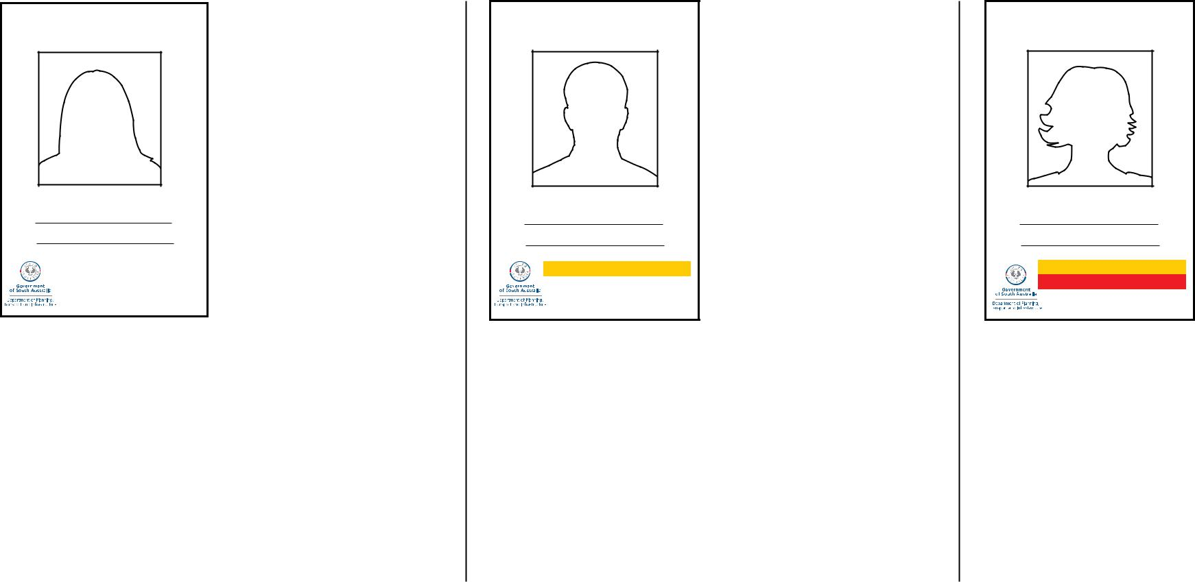

MOTOR DRIVING

INSTRUCTOR (no flash)

2222

JANE CITIZEN

Exp: 01/12/2012

Motor Driving Instructor (no flash)

Driving lessons and training only


Time spent on your driving lessons counts towards your mandatory 75 hours of driving

 Sign off CBT&A tasks

Conduct a Vehicle On Road Test (VORT)

Issue a Certificate of Competency

CBT&A AUTHORISED

EXAMINER (yellow flash)

5555

PETER DAVIS

Exp: 01/12/2012

CBT&A - CAR

CBT&A Authorised Examiner (yellow flash)

Driving lessons and training

Time spent on your driving lessons counts towards your mandatory 75 hours of driving

Assess and sign off tasks in your book (CBT&A) Issue a Certificate of Competency Conduct a Vehicle On Road Test (VORT)



CBT&A & VORT AUTHORISED

EXAMINER (red flash)

9999

CATHY JONES

Exp: 01/12/2012

CBT&A - CAR
VORT - CAR

VORT Authorised Examiner (red flash)


Driving lessons and training

Time spent on your driving lessons counts towards your mandatory 75 hours of driving

Assess and sign off tasks in your book (CBT&A)

Issue a Certificate of Competency

Conduct and assess a Vehicle On Road Test (VORT) but only if they haven’t provided training in preparation of it

Before you drive

5

Before you drive

6

Enquiries and complaints

If you require more information than contained within this guide or wish to lodge a complaint you should:

- If the complaint is in regards to the result of an assessment or test, discuss the issue first with your Motor Driving Instructor/Authorised Examiner;

- If you have been unable to resolve the matter, if the complaint is in regards to the way the assessment was conducted or about the conduct of the Motor Driving Instructor or Authorised Examiner, email: DPTI.licensingbookings@ sa.gov.au; or via the DPTI complaints webpage page https://www.dpti.sa.gov. au/contact_us/compliments_and_complaints;

When lodging a complaint please provide the following information:

  - Your details - name, address, email and contact number

  - Authorised Examiner or Motor Driving Instructor details

  - An overview of what occurred including the date, time and location

  - What attempts have been made to resolve this with your Motor Driving Instructor or Authorised Examiner

- If your enquiry or complaint is in relation to the business practice of instructors, including refusal to issue receipts for payments made, please contact Consumer and Business Services on 13 18 82 or via their website www.cbs.sa.gov.au;

- If your enquiry or complaint relates to:

  - For discrimination refer to the Equal Opportunity Commission by calling

8207 1977 or emailing eoc@agd.sa.gov.au;

- Allegations of criminal behaviour refer to the South Australia Police by calling 131 444; or
- Allegations of corruption, misconduct and malpractice and Independent Commissioner Against Corruption (ICAC)/Office of Public Integrity via phone 8207 1777 or email admin@opi.sa.gov.au

call
one
text
or | be
could
fatal
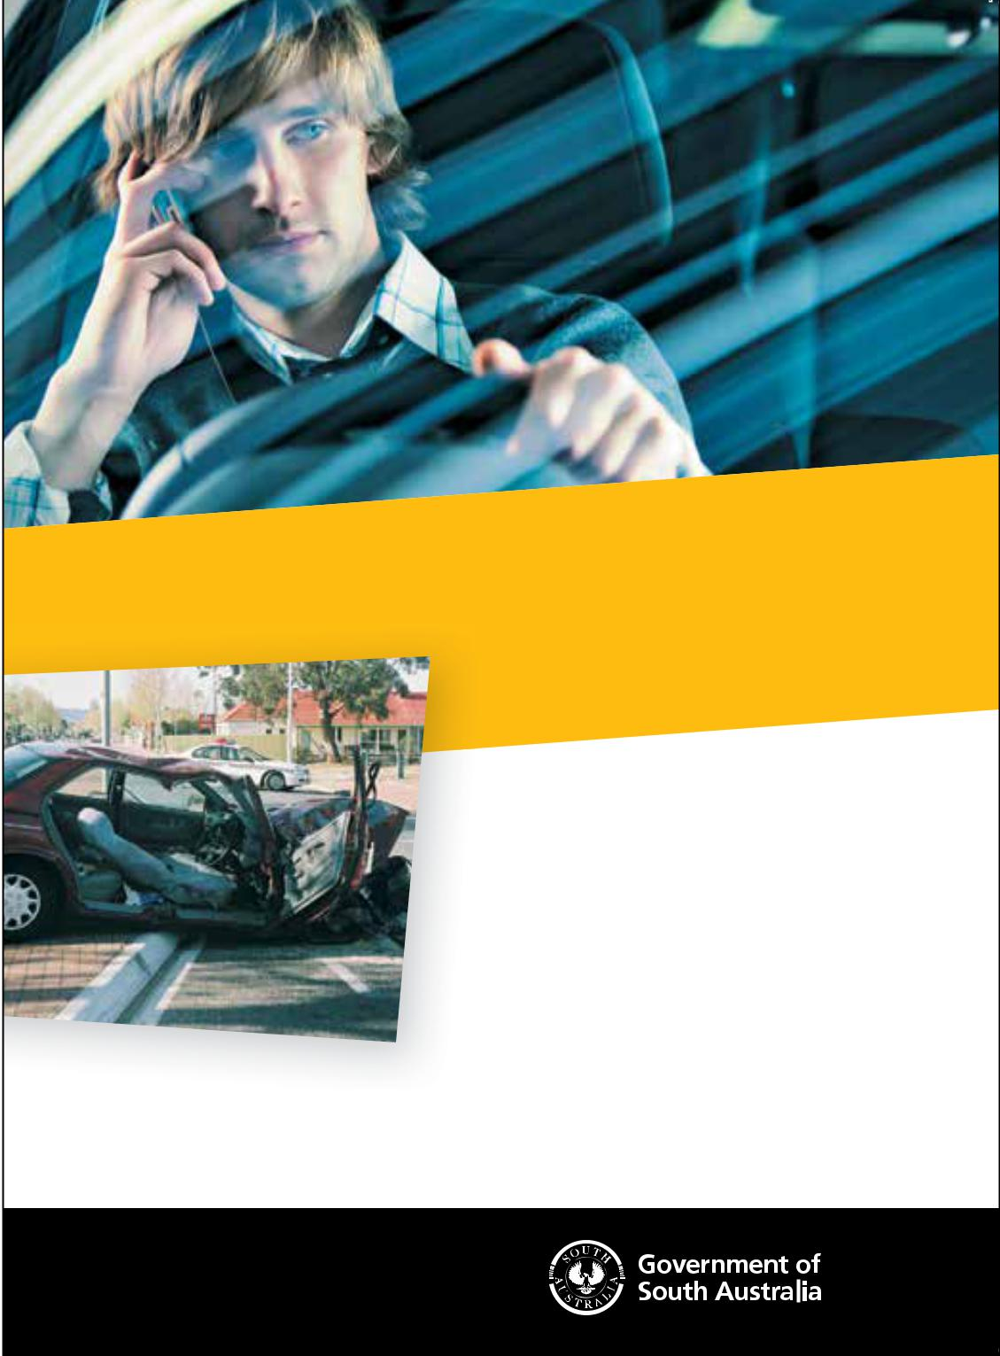
You’re four times more likely to have a crash

if you use your mobile phone while driving.

That’s why L and P1 drivers are banned from

using any mobile phone function when driving,

including text messaging, hands free mode,

loudspeaker operation or GPS. Get used to turning

off your phone before you get in your car.

If you really need to check a message, pull over

and turn the engine off. It’s a small thing that could

save your life, and the lives of your passengers.

So stay safe, be smart and don’t use a mobile phone

while you’re driving. For more safer driving tips to to

mylicence.sa.gov.au

safer, smarter drivers start at

mylicence.sa.gov.au

Graduated Licensing Scheme Overview

Unfortunately statistics show that drivers aged 16 to 24 years are almost twice as likely to be involved in a serious or fatal road crash.

But research has also found that strengthening the driving experiences and supervision of new drivers through graduated licensing schemes can lead to significant reductions in crashes both before and after obtaining a driver’s licence.

The Graduated Licensing Scheme is the process of obtaining a full driver’s licence – a gradual process which involves:

- at least 75 hours of supervised driving during the learner’s permit phase (not required for learner motorcycle riders)
- a compulsory hazard perception test to progress from L to P1

- a two-stage provisional licence (P1 and P2)

L

P

P

NOT DISPLAYED

ON VEHICLE

LPlates • 16 years or older

• pass theory test

LEARNER’S PERMIT • (BIKE class must pass basic Rider Safe)

 P1

PROVISIONAL

LICENCE

 P2

- 17 years or older

- pass hazard perception test

- if you are under the age of 25 you must hold your learner’s permit for at least 12 months.
- if you are aged 25 or over you must hold your learner’s permit for at least 6 months.
- complete 75 hours (includes minimum 15 hours at night) of supervised driving

- pass Vehicle On Road Test (VORT) or Competency Based Training & Assessment (CBT&A) course
- (BIKE class must pass advanced Rider Safe course)

- 18 years or older

- must have held a P1 licence for 12 months
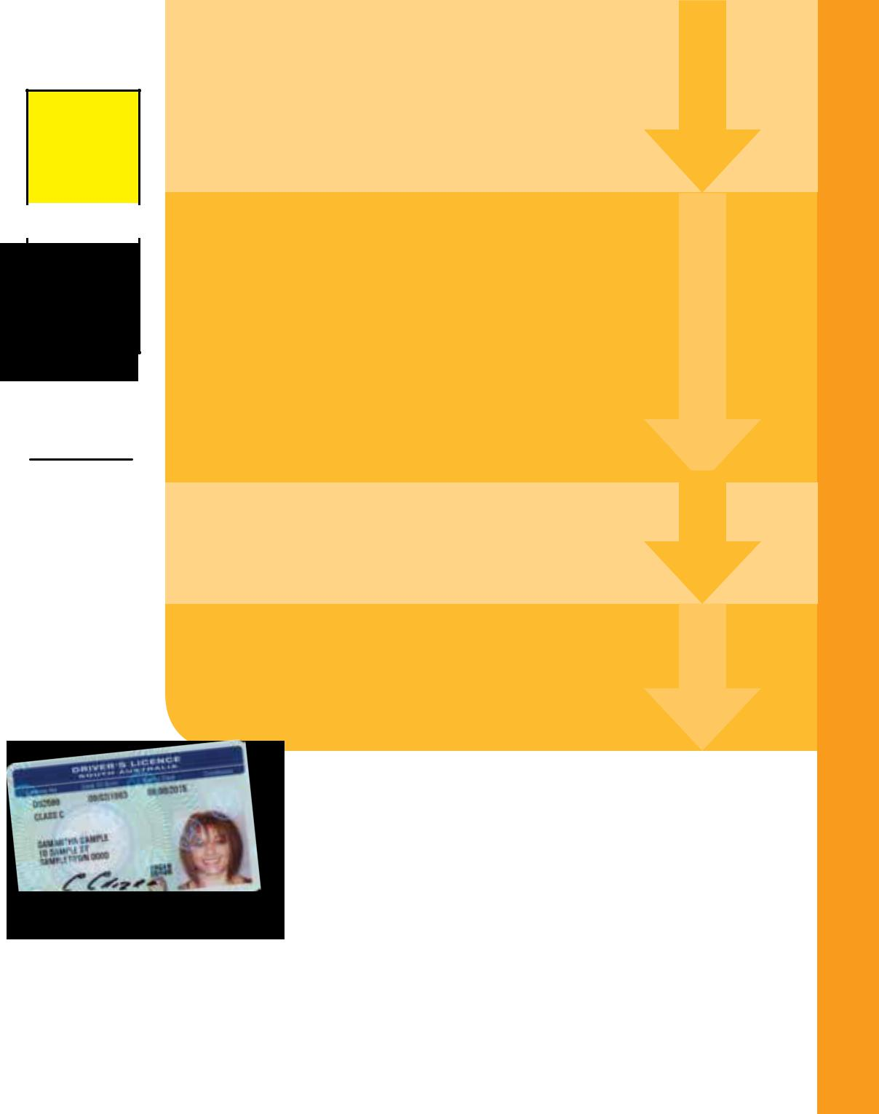

PROVISIONAL
LICENCE
Full • 20yearsorolder _{Licence}•haveheldaP2licencefor2years

Graduated Licensing Scheme

7

Graduated Licensing Scheme
The Hazard Perception Test (HPT)

The HPT is based on the driving situations that lead to the four most common crash types of South Australian provisional drivers.

It involves a touch-screen computer-based test that measures your ability to recognise potentially dangerous situations on the road and react appropriately.

You must pass the HPT to progress from a Learner’s Permit to a P1 licence.

The HPT must be booked and undertaken at a Service SA customer service centre.

If you live more than 100 kilometres (as the crow flies) from a place where the test is conducted, or on Kangaroo Island, you are exempt from having to sit the test.

Why the Hazard Perception Test?

The aim of the HPT is to confirm that learner drivers have enough hazard perception skills to “graduate” to the P1 licence. Research shows that drivers with poor hazard perception skills usually have more crashes.

Research also shows that screen-based hazard perception tests can detect drivers with a higher risk of crash involvement.

Crash patterns of provisional drivers

The four most common crash types for provisional drivers

The majority of all South Australian provisional driver crashes fall within only four crash types:
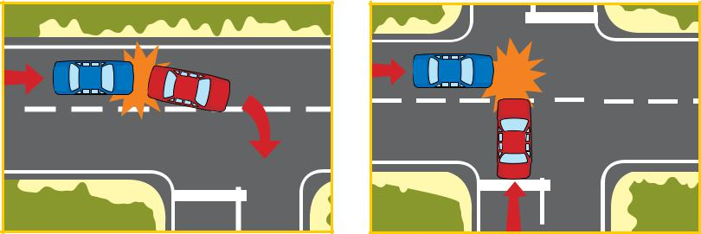

Colliding with the rear of Colliding at right angles.

another vehicle.

Collisions where at least Running off the road and hitting an
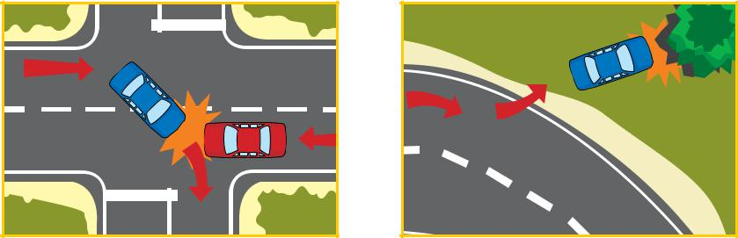
one vehicle is turning right. object, such as a tree, a pole or a

parked vehicle.

Why are provisional drivers involved in high numbers of crashes?

The high involvement of provisional drivers in crashes seems to be partly due to inexperience because driving is a new skill. When we start something new we tend to make mistakes and are not be as skilful as those with lots of experience.

However, new drivers also sometimes do things that can increase their risk of crash involvement. These include:

- travelling too closely behind other vehicles

- driving too fast for the conditions

- not looking far enough ahead when driving

- choosing gaps that are too small when making turns, crossing intersections or overtaking.

- driving with drugs and alcohol in their system

- being distracted by mobile phones

- running red lights.

Avoiding crashes

It is important to know what driving situations are most dangerous for you. You can then identify the skills you need to practise so you can handle these situations safely. Research shows that one of the most important of these skills is good hazard perception.

This is why the Hazard Perception Test has been introduced in South Australia.

For more information and to practise the Hazard Perception Test please visit mylicence.sa.gov.au

8

Options to progress to P1 Provisional Licence

To gain your P1 Provisional Licence you must:

- hold a Learner’s Permit for at least 12 months if under 25 years of age, or at least 6 months if aged 25 or above

- be 17 years or older; and

- have completed at least 75 hours (including 15 hours night driving) with a Qualified Supervising Driver.

- Pass a Hazard Perception Test

However, you may attempt your Vehicle On Road Test (VORT) or final drive (Task 30 in this book) in Competency Based Training & Assessment (CBT&A) at any time.

Option 1 Vehicle On Road Test (VORT)

- Training and practice with a Motor Driving Instructor but no assessment; and

- Driving experience with a Qualified Supervising Driver; and

- Practical driving test with a VORT Authorised Examiner.
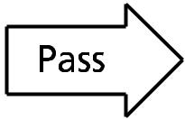

Option 2 Competency Based Training & Assessment (CBT&A)

- Lessons with a CBT&A Authorised Examiner; and

- Driving experience with a Qualified Supervising Driver or Motor Driving Instructor
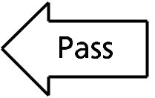

Scheme

Attempt VORT |  | Attempt final drive



Wait 14 days before next attempt |  | Attempt final after 3 days

P1 Provisional Licence
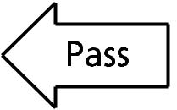

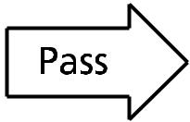

Wait 14 days before next attempt |  | Attempt final after 3 days

Graduated Licensing

9

Driving

Learning to drive

Driving a motor vehicle safely and efficiently is probably one of the most difficult skills that people will learn during their lifetime. It involves a wide variety of skills in the operation of controls, observation and planning.

Driving also requires thinking skills in the assessment of risks, early detection of danger, applying the road rules and protecting your vehicle from others through the use of defensive driving strategies.

In The Driving Companion, ‘full control of the vehicle’ means that the driver will demonstrate satisfactory use of the steering, brakes, accelerator, clutch (if applicable) and any other control ensuring that there is no unnecessary weaving, jerking, stalling or uncontrolled movement of the vehicle, or skidding of any wheel.

Highly skilled and professional drivers show four basic characteristics in their driving as identified below.

- Compliance with road laws is the ability of drivers to understand the meaning of the road rules and to apply those laws correctly to their everyday driving. To improve your skills and knowledge on the road laws, refer to The Driver’s Handbook regularly and discuss any points that are not clearly understood with your Instructor.

- Attitude is demonstrated by your willingness to abide by the road laws and your ability to safely cooperate with other road users with minimal interference to others. Your attitude to the driving task is solely your responsibility and others observe it in the behaviour shown by you when driving.

- Car craft inside the vehicle is the ability or skill of drivers to operate all controls of the motor vehicle in a smooth and competent manner enabling timely adjustment to the vehicle while maintaining full control. Obtaining professional instruction in this area will reduce wear and tear on the mechanical parts of the vehicle while improving the smoothness of ride for the passengers.

- Road craft outside the vehicle provides the method for driving, which connects road law, attitude and car craft together in the most efficient and effective manner. It is the process by which a driver is able to negotiate complex traffic and road conditions in a safe, timely

and systematic manner with confidence, through:

  - Assessing road and traffic conditions early and accurately;

  - Formulating safe and efficient driving plans; and

  - Carrying out those driving plans competently and confidently in the most fuel efficient and environmentally friendly manner.

10

Vehicle check

- You may drive a motor vehicle only of the class that is stated on the Learner’s Permit.

- The motor vehicle, when driven on any public road or public place, must be registered and have third party (bodily injury) insurance.

- The motor vehicle must have ‘L’ plates (see pages 2 and 3) clearly displayed to the front

and to the rear and must not obstruct the Learner’s or the accompanying Qualified Supervising Driver’s view.

- The motor vehicle must be roadworthy (see diagram below).

- Tyres must have clearly visible tread pattern of at least 1.5mm in depth on all parts that come in contact with the road.

- Your vehicle must be registered. The registration expiry date can be checked by telephoning 13 10 84 between 8am and 6pm Monday to Friday, going to www.ezyreg.sa.gov.au or by using an EzyReg smartphone app.

Note: Attention to the items shown before attending the test will avoid the need for the test to be postponed and another booking made.

Driving
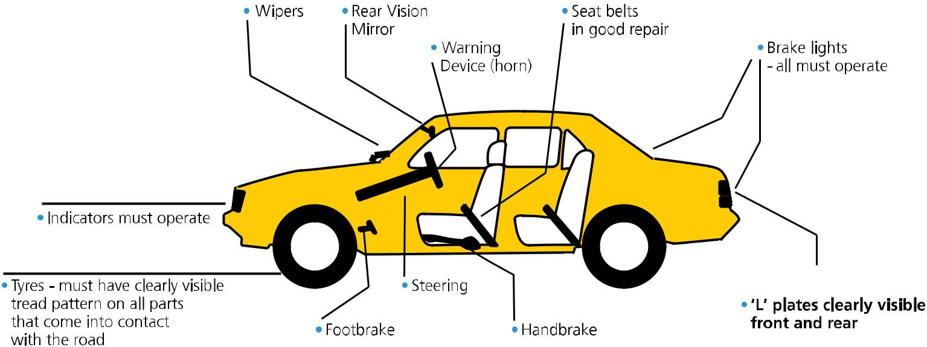

11

Driving

System of Car Control

The method of driving which is described in this chapter is the safest and most efficient way to drive a motor vehicle. When you undertake either the VORT or the CBT&A course you will be expected to drive in this manner when approaching and negotiating road and traffic hazards or other dangerous situations.

Examples of Hazards:

- Intersections, roundabouts and traffic lights;

- Lane changing and overtaking; and

- Any other action by another road user that could affect your progress.

The System of Car Control is a system or drill, each feature of which shall be considered, in sequence, by the driver at the approach to any hazard.

Listed below are the actions of the System of Car Control in the correct sequence in which they should be considered.

FEATURE |  | REASON (OR PURPOSE)
1 | Select the Course; | Choose the safe and legal path through the hazard.
2 | Check Mirrors and then Signal; | To check for following and overtaking traffic (centre and side mirror) and to give warning of your intention.
3 | Brake (adjust speed); | To adjust the speed of the vehicle so it arrives at the hazard at a safe and controllable speed to negotiate the hazard.
 | Decision Point - The Brakes should not be released until the driver can see if it is safe to continue. (If not, your intention is to stop).
4 When safe, select the Gear and check the |  | Select the appropriate Gear to safely negotiate the hazard and check the appropriate side Mirror
 | Mirror(s) (and Blind Spot if applicable); | (and Blind Spot if applicable) for overtaking traffic.
5. Evasive Action is rarely required and is often |  | To take Evasive Action, (e.g. Horn warning just before overtaking or if a vehicle is observed in the Blind Spot).
 | as a result of a mistake in steps 1 - 4; | This should rarely be required if actions 1, 2, 3 and 4 are performed correctly.
6. Accelerate through the hazard to leave |  | To apply appropriate power to leave the hazard quickly and safely having regard for the road surface
 | the hazard quickly and safely. | and traffic conditions.

12

Example 1: The System of Car Control – to turn left or right
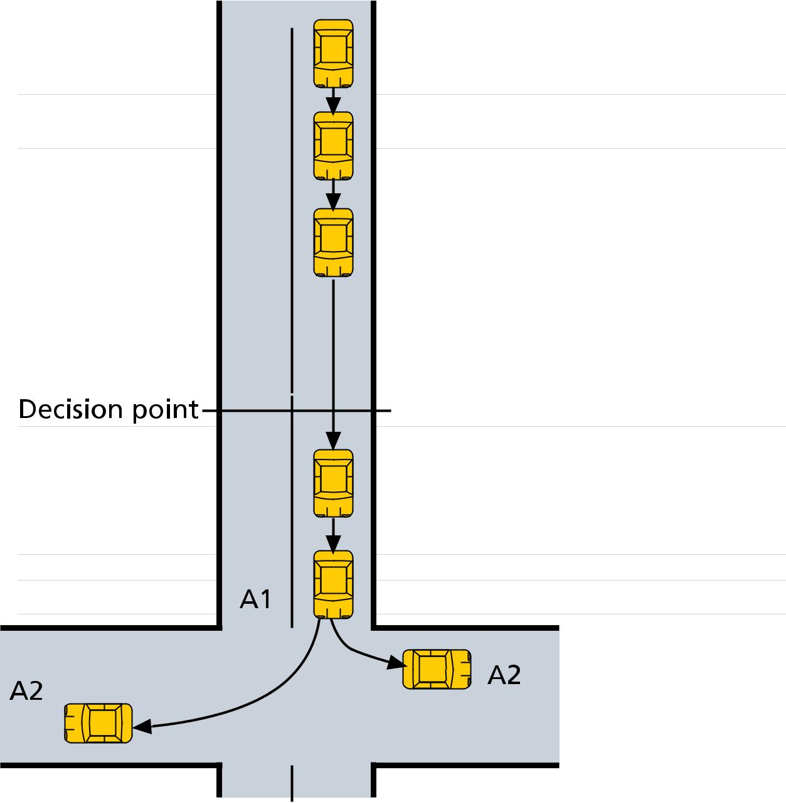

- Course

- Mirror(s) / Signals

- Brakes (Slowing)

- Gear (?) / Mirrors (?)

- Evasive Action (?)

- Acceleration

What is the safe and legal path through the turn?

Who is behind and how close are they to my car?

Tell others what I am about to do!

Slow the vehicle so l can give way if required

and so l can safely turn the corner.

Don’t release the brakes until it is safe to go!

Can I clearly see and is it safe to go?

If yes- Select the correct gear for control and

check the mirror for overtaking traffic; OR

If no- Bring the vehicle to a stop then

move off when safe.

Not usually required.

Accelerate at A1 gently to turn the corner safely

Driving

Accelerate at A2 firmly

to leave the hazard quickly

13

Driving

Example 2: The System of Car Control – to change lanes

1 Course | 2 Mirrors - | 3 Brakes (?) | 4 Gears (?), | 5 Evasive Action (?) - stay in your lane.
 | signal |  | Mirror and Blind | It may be required if a vehicle (dotted)
 |  |  | Spot | is in the blind spot.

6 Acceleration - adjust your speed to | 7 Cancel
that of the new lane as you change | signal
lanes

Example 3: The System of Car Control – to travel straight on at traffic lights

1 Course | 2 Mirror - | 3 Cover the brakes | 4 Gears (?) Mirrors (?) | 6 Accelerate or maintain speed
 | centre only | Have the lights changed? | Yes/No
 |  | Yes - stop! / No - continue
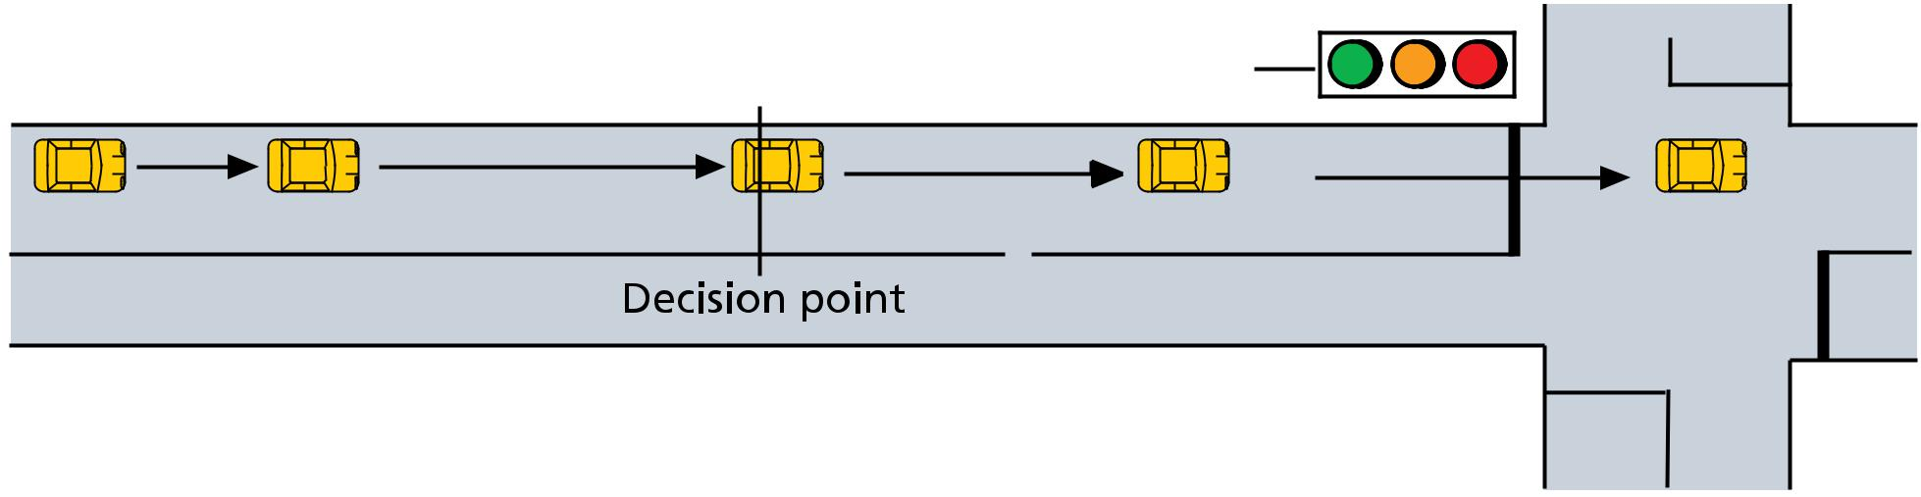

5 Evasive Action (?) - check right and left

Note: ‘(?)’ means that these actions are considered, but are not always used.

14

Observation

(How to use your eyes more effectively)

Most road crashes with other vehicles occur because one or both of the drivers involved did not see the other vehicle in time to take appropriate action. There are five rules for using your eyes more effectively and efficiently.

Rules of observation (for looking)

- Aim high in steering – Look well ahead when driving your vehicle. Steer the vehicle using your lower fringe vision. Look in the direction you want the vehicle to go, especially in bends and corners.

- Keep your eyes moving – Don’t fix your eyes on any single object for more than about 2 seconds. Keep moving your eyes from object to object otherwise danger could threaten your vehicle from another source without you being aware of it.

- Get the big picture – By moving your eyes, you are able to check the far distance, the middle distance and the near distance directly in front. In addition the mirror should be checked on average at least once every 10 to 12 seconds. This constant checking ensures that the driver is fully aware of everything that is going on around the vehicle.

- Leave yourself an ‘out’ – When driving, always have a plan of ‘escape’ should the traffic conditions quickly change. If a vehicle is tailgating, leave more space in front of your vehicle as this reduces your braking requirements. Offset your vehicle where possible to the vehicle travelling alongside. This allows space for other vehicles to ‘escape’ if they should swerve suddenly.

- Make sure other drivers see you – Look at the faces of other drivers

to see if they are looking at you. Get eye contact with those other drivers. Use your signals in plenty of time so they are clearly understood. Position your vehicle in such a way to clearly show your intention (eg. when turning left). Where possible do not travel in blind spot areas of other vehicles. (When you are approaching from behind, if you can see the eyes of other drivers in their mirror they have a better chance of seeing you.)

- Keep a Look Out for Cyclists – The law requires all drivers to allow a minimum of 1 metre clearance, 1.5 metres if travelling over 60 km/h, when passing cyclists.

When you park on the side of a road, before opening the car door, look behind and over your right shoulder to check for cyclists and other vehicles. One way to do this is to open the car door with your left hand, this is known as the Dutch Reach.
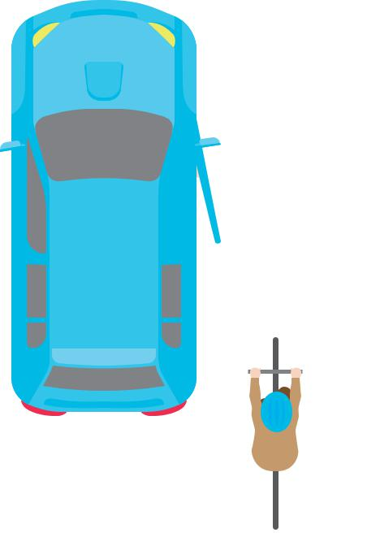

Before opening a car door, look

behind and over your shoulder for

cyclists and other vehicles

- Open the door with the hand furthest from the door handle -
this is known as the Dutch Reach

2. Look over your shoulder to see

whether a cyclist or vehicle

is coming

The Rules of Observation should be used in conjunction with the System of Car Control. Identification of hazards, checking for cross traffic at the appropriate time, use of mirrors and blind spot checking in the appropriate situations are examples of conforming to the Rules of Observation. Remember, when approaching danger (any hazard) keep slowing the vehicle until you can see clearly that it is safe to go before selecting the appropriate gear to proceed.

Driving

15

Driving

Rules of braking

(Using the brakes safely and effectively)

Always comply with the following rules when using

the brakes:

- Brake early and gently where possible (reduces rear end collisions).

- Brake firmly only when travelling in a straight line (for control).

- Vary the braking effort according to the condition of the road surface.

- When going down a long winding hill, apply firm braking on the straight sections of road and brake as lightly as possible in the bends. Select a lower gear at the start of the descent to prevent the speed from building up and over-heating the brakes (especially when towing a trailer).

System of Car Control

When using the brakes, the System of Car Control should also be applied (eg. check what is approaching from behind before applying the brakes especially when you being ‘tailgated’). When approaching danger, check your centre mirror and place your right foot over the brake pedal ready to apply the brake (called ‘covering the brake’). Lightly pressing the brake pedal will also display the brake lights.

Steering

There are two correct methods of steering a vehicle, which are known as the pull-push method or the hand-over-hand method. A Motor Driving Instructor should assist you in determining which method is the most suitable for you.

When steering a motor vehicle the following Rules of Steering should be obeyed:

Rules of Steering

- Position your hands on the steering wheel so they are able to exert maximum leverage when required without resting your arm on the door. (This allows both arms freedom of movement).

- On straight roads, your hands should settle into an effective position on the steering wheel - 10 to 2 or quarter to 3, only tightening your grip when cornering or braking.

- On a greasy or slippery road surface, do not tighten your grip

on the wheel. This tends to roughen your movement of the wheel and could induce skidding.

It should be noted that Rules of Steering 2 (above) implies that when the vehicle is travelling at normal road speeds both hands should be on the steering wheel. Gear changing should be done before the corner and not in the corner (see ‘System of Car Control’) unless the speed of the vehicle is very slow and you might have to stop the vehicle (e.g. turning left through a slip lane or where the view is poor).

16

Safe driving strategies

- ‘A Minimum Safe Following Distance’ occurs when you allow at least three seconds interval between your vehicle and the vehicle in front. This gap should be increased if it is wet, visibility is poor, you are driving downhill, you are being tailgated or if you are tired, unwell or distracted.

To measure the time interval between your vehicle and the vehicle in front, when the vehicle in front passes a stationary mark or shadow, you count
...1001, 1002, 1003... and if your vehicle passes that same mark during that count, you are too close (within three seconds).

- ‘A Minimum Safety Margin’ occurs if a safety ‘cushion’ of at least 1.2 metres is maintained between the side of your vehicle and stationary vehicles, cyclists or other objects, having regard to your speed and the possibility

of danger. By slowing the vehicle considerably, smaller clearances may be given to stationary objects and parked vehicles provided due care is taken.

- ‘Acceleration Sense’ is the ability of the driver to vary the speed of the vehicle by means of accurate use of the accelerator (not gears) where braking is not required. This improves smoothness of ride, vehicle control (especially on unsealed surfaces), and fuel efficiency while reducing wear and tear on the vehicle and tyres.

- ‘Safe Stopping Position Behind Other Vehicles’ When stopping in a line of traffic, the driver should stop his/her vehicle at a distance behind the vehicle in front which would enable the driver to turn away should the vehicle in front break down or becomes unable to proceed. (As a guide, you should be able to see where the tyres of the vehicle in front contact the road).

The advantages in maintaining this space is that it allows:

- Better observation past the vehicle in front (enabling the driver to see into the crossroad or what may be causing the obstruction);

- Space to stop in if the vehicle in front should stall when moving off;

- Any roll back from the vehicle in front giving the driver behind time to take appropriate action (eg. sound the horn);

- If your vehicle is hit from behind, there is less chance of your vehicle being pushed into the vehicle ahead which in turn reduces the risk of both injury to you and damage to the front of your vehicle.

When stopping in a right turning lane, the driver should leave a smaller space than that above to allow for other vehicles behind entering the ‘store’ lane out of the path of following ‘through’ traffic, reducing the possibility of rear end collisions.

- Avoid the temptation of doing other tasks and getting distracted while you are driving. Taking your eyes off the road or diverting your attention even for a few seconds can be fatal. Pull over safely and park before touching your mobile phone or other electronic devices.

- Driver fatigue can cause a driver to drift across lanes and also to the incorrect side of the road, putting you and other road users at risk of a crash. It is important you are aware of the signs of fatigue and plan your travel. Make sure you’ve had a good sleep prior to setting off and take regular 15 minute breaks at least every two hours.

- Be patient and courteous to other road users, including cyclists and pedestrians. Give them plenty of space especially when overtaking, don’t take unnecessary risks and be mindful that they may not see you.

Driving

17

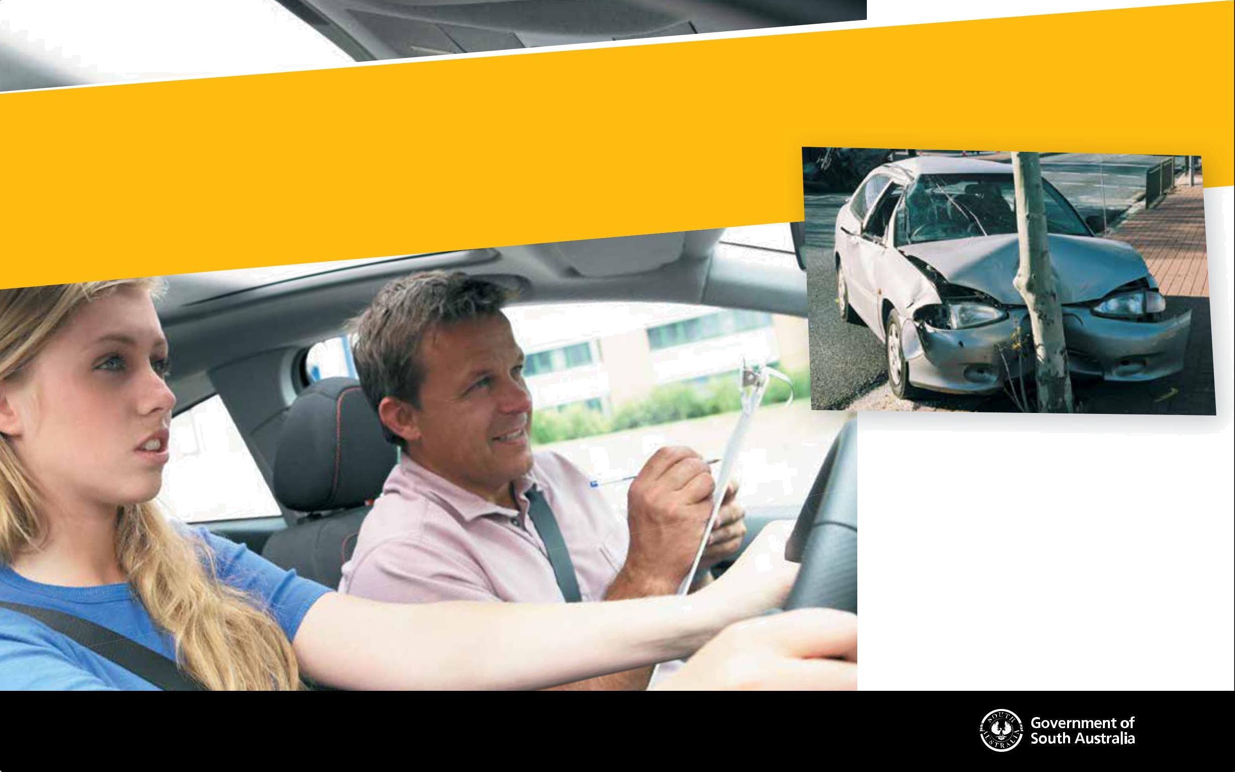
practice
makesperfect

When you fi rst start driving you usually have a lot of

enthusiasm. But you don’t have a lot of experience,

and studies show getting more driving experience

leads to fewer crashes.

Learner drivers must complete at least 75 supervised

driving hours, including 15 hours at night.

So stay safe, be smart and gain as much supervised

driving experience as possible. For more safer driving

tips go to mylicence.sa.gov.au

safer, smarter drivers start at
mylicence.sa.gov.au

How to use your Log Book

Each time you drive a car, you must record the details on the forms that follow. The log book must be completed accurately and honestly. Penalties apply for fraudulent information. Please note; you must record the name of the suburb you drove from and to.

- There are 10 forms allocated to record your daytime driving experience.

- There are 2 forms allocated to record your night-time driving experience.

- Complete the forms as shown in the sample provided.

If additional forms are required you may photocopy a blank form or download a blank form from www.mylicence.sa.gov.au

Choosing your driving conditions

When using your Log Book, it is recommended that you record all of your driving experience in different conditions. This means you can keep track of the type of conditions you have driven in. By the time you go for your driving test, you should have lots of experience in all driving conditions.

Before you commence any practice, your Qualified Supervising Driver should explain each driving task to you.

Start your driving practice on quiet streets and, as your driving gets better, begin to experience a wider range of conditions. You could try driving in different -

- Light conditions (day, night, dawn, dusk)

- Weather conditions (eg rain, fog)

- Types of roads (eg highways, gravel roads)

- Traffic conditions (light or heavy)

Only drive in these conditions when you are comfortable controlling your car. Try one new condition at a time, so you have time to become familiar with each new situation. Don’t combine lots of new driving conditions all at once. Try easier driving conditions first and slowly move to harder conditions when you’re ready.

Frequently asked questions

- What is regarded as ‘driving’?

- When filling out your Log Book, ‘driving’ is any time when you are in the driving seat and your car is moving. Driving also includes being stationary at intersections or in a line of traffic. Driving doesn’t include being in the driver’s seat of a parked vehicle, unless you are practicing a form of parking.

- How do I fill in my Log Book?

- You can only fill it in to show the time that you spent driving. This means that if you drive to the shops, sports practice or anywhere else, you only enter the actual time you spent driving. You must fill in one row for driving to the shops, or sports practice, and another row for driving back. You must enter the name of the suburb you drive to and from.

- What happens if I lose my Driving Companion?

- Your Driving Companion is very important so try not to lose it. If you do, you will need to buy another one.

- What happens if I make an error filling out a row? A Cross out the row and start again on a new row.

- What happens if my Qualified Supervising Driver turns out to not be eligible to be a Qualified Supervising Driver?

- All of the related entries will be invalid and not count. If a provisional licence has been issued, it will be void (cancelled).

- If I pass my test, what happens to my Driving Companion?

- You are required to cut out your log book pages (22 to 34), Declaration and Task pages (41 to 74) and hand them in to a Service SA Centre with your Certificate of Competency when applying for your Provisional P1 Licence. You will keep The Driving Companion.

- What happens if you deliberately fill out the log book incorrectly?

- That part of the logbook will be declared invalid and not count. It is an offence to deliberately provide false information and you could be fined up to $5,000.

Log Book

19

Log Book

20

- What if I state I’ve done 75 hours when I haven’t?

- You are committing an offence and could be fined up to $5,000.

Your Licence will be void and you will need to resit the Theory Test, and accumulate another 75 hours of supervised driving.

- What if I forget to fill out the Log Book and later when I go to fill it out I can’t remember the details?

- If you can’t remember the details, you can’t count that driving time.

The best way to stop this happening is to fill it in when you finish driving.

- Can I have more than one Qualified Supervising Driver complete my log book?

- Yes. Each time you drive you can have the same or a different Qualified Supervising Driver. Your supervising driver must sign your driving hours record. A Licensed Motor Driving Instructor or an Authorised Examiner can be a Qualified Supervising Driver.

- Is there a legal limit to how long I can drive for?

- There is no legal limit, but try not to make your trips too long. If you’re going on a drive, take plenty of breaks. If you get tired, ask your Qualified Supervising Driver to take over the driving.

- I entered that I drove from “home” to the “shops” in my log book and it was refused by Service SA, why?

- You must enter the actual suburb of your home and the shops, or anywhere else you drive, otherwise your log book won’t be accepted.

dangersof drivingatnight
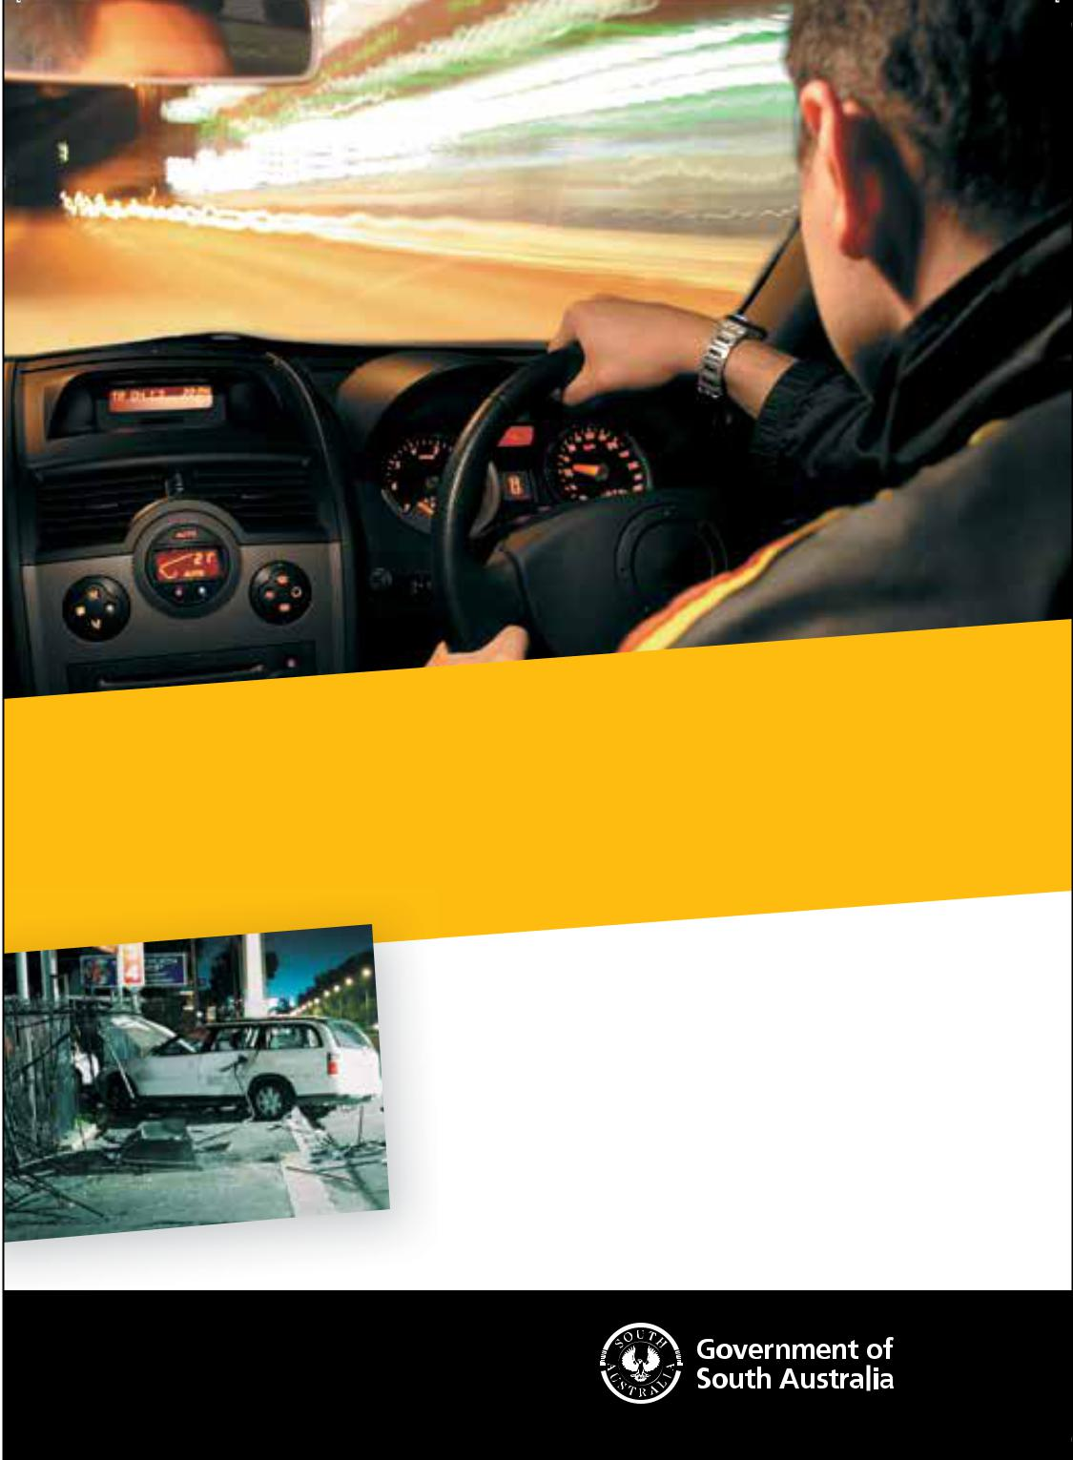

Driving is different at night. You can’t see the road as well, and lights can

be an added distraction. Many fatal crashes involving young drivers happen

late at night, on weekends and with passengers in the car.

The best way to reduce your risk is to get a lot of practice with your

qualifi ed supervising driver by your side.

So stay safe, be smart and get at least 15 hours of supervised driving experience at night. For more safer driving tips go to mylicence.sa.gov.au

P1 Licence holders under the age of 25 years must not drive between midnight

and 5am unless a Qualified Supervising Driver is seated next to them or they

meet the exemption criteria.

safer, smarter drivers start at

mylicence.sa.gov.au

Form # Record of Daytime Driving Hours |  |  |  |  |  |  |  |  |  |  |  |  |  |  | You may use an electronic learner log book app to record your driving hours instead |  |  |  |  |  |  |  |  |  |  |  |  | Daytime
 |  |  |  |  |  |  |  |  |  |  |  |  |  |  | for more information on electronic log books.
 |  |  |  |  |  |  |  |  |  |  |  |  |  |  | of recording them manually in your Driving Companion. The app must offer a print
 |  |  | • |  |  |  |  |  |  |  |  |  |  |  | out with the same information as the paper version. Visit www.mylicence.sa.gov.au
 |  |  |  |  | Time |  |  |  |  |  | Location (Suburb) |  |  |  |  |  | Conditions |  |  |  | Learner’s |  |  |  | Qualified Supervising Driver
Date
 |  |  | Start |  | Finish |  |  |  |  |  |  |  |  |  |  |  |  |  |  |  | Signature
 |  |  |  |  |  |  | Duration |  |  | From |  |  | To |  | Road |  | Weather |  | Traffic |  |  |  |  | Name |  | Licence No. |  | Signature
 |  |  | am/pm |  | am/pm
01/07/06 |  |  | 8.30 am |  | 9.00 am |  | 30 mins |  |  | Mt Barker |  |  | Stirling |  | S ML |  | D |  | M |  | (your signature) |  |  | Joanne Bates |  | T8492 |  | (QSD signature)
05/07/06 |  |  | 4.00 pm |  | 5.00 pm |  | 60 mins |  | Port Adelaide |  |  |  | Glenelg |  | S B |  | W |  | H |  | (your signature) |  |  | Trevor Mason |  | S3468 |  | (QSD signature)
 | In each row, you must record: |  |  |  |  |  |  |  |  |  | In each row, you must record: |  |  |  |  |  |  |  |  |  | In each row, you |  |  |  | After you have completed a row,
 | • the date |  |  |  |  |  |  |  |  |  | • the name of the suburb you drove from |  |  |  |  |  |  |  |  |  | must record: |  |  |  | give the Log Book to your Qualified
 |  |  |  |  |  |  |  |  |  |  |  |  |  |  |  |  |  |  |  |  |  |  |  |  | Supervising Driver or Accredited Instructor.
 | • the time that you started and finished |  |  |  |  |  |  |  |  |  | • the name of the suburb you drove to |  |  |  |  |  |  |  |  |  | • your signature
 |  |  |  |  |  |  |  |  |  |  |  |  |  |  |  |  |  |  |  |  |  |  |  |  | They must record:
 | • how many minutes you have driven |  |  |  |  |  |  |  |  |  | • the road, weather and traffic conditions
 |  |  |  |  |  |  |  |  |  |  |  |  |  |  |  |  |  |  |  |  |  |  |  |  | • their name
 |  |  |  |  |  |  |  |  |  |  |  | using the code at the bottom of the form |  |  |  |  |  |  |  |  |  |  |  |  | • their name
 |  |  |  |  |  |  |  |  |  |  | (* If you do not record the name of the suburb, |  |  |  |  |  |  |  |  |  |  |  |  |  | • their Driver’s Licence number
 |  |  |  |  |  |  |  |  |  |  | your log book will not be accepted). |  |  |  |  |  |  |  |  |  |  |  |  |  | • their signature
 |  |  |  |  |  |  |  |  |  |  |  |  |  |  |  |  |  |  |  |  |  |  |  |  | • if a foreign or interstate licence holder, the
 |  |  |  |  |  |  |  |  |  |  |  |  |  |  |  |  |  |  |  |  |  |  |  |  | detalis below
 | When you have completed each form, add
 | all the minutes in the Duration column
 |  |  |  |  |  |  |  |  |  |  |  |  | Log Book Declaration
 | and place the total in the Sub Total box.
 | This amount can then be entered in to |  |  |  |  |  |  |  |  |  |  |  | When you have accumulated at least 4500 minutes
 |  |  |  |  |  |  |  |  |  |  |  |  | (including at least 900 minutes night-time driving) complete
 | the |  | Declaration of 75 hours Driving form
 |  |  |  |  |  |  |  |  |  |  |  |  | the ‘Declaration of 75 Hours Driving Time’ on page 34 and
 | (page 34) to keep a tally of your driving
 |  |  |  |  |  |  |  |  |  |  |  |  | sign in the section provided.
 | experience progress.
 |  |  |  |  |  |  |  |  |  |  |  |  | You may also ask a Qualified Supervising Driver to add and
 |  |  |  |  |  |  |  |  |  |  |  |  | sign your totals. They may sign and date the declaration.
 | • Record your name and Learner’s Permit number


Log Book

Learner’s | Sub Total | 90 mins
Permit Holder | (minutes) | 90 mins |  |  | Road Type |  |  | Weather |  |  | Traffic Density
Permit Holder | (minutes) |  |  |  | Sealed | S |  | Dry | D |  | Light | L
Name |  |  |  |  | Sealed | S |  | Dry | D |  | Light | L
Name |  |  |  |  | Unsealed | U |  |  |  |  | Medium | M
Name |  |  |  |  | Unsealed | U |  | Wet | W |  | Medium | M
 |  |  |  |  | Quiet Street Q |  |  |  |  |  | Heavy | H
Permit No. |  |  |  |  | Busy Road | B
Permit No. |  |  |  |  | Multi-laned
 |  |  |  |  | Road | ML

Foreign or Interstate Licence

Country/State.......................... Expiry Date / / Yrs Held...................

Warning:
Heavy penalties apply for false entries, please see pages 19 and 20. If the Qualified Supervising Driver’s Licence cannot be validated, the entry will be rejected and any licence issued will be void. Incomplete entries are invalid.

21


You may use an electronic learner log book app to record your driving hours instead
of recording them manually in your Driving Companion. The app must offer a print
Form 1 • Record of Daytime Driving Hours out with the same information as the paper version. Visit www.mylicence.sa.gov.au
for more information on electronic log books.

Daytime

 | Time |  |  | Location (Suburb) |  | Conditions | Learner’s | Qualified Supervising Driver
Date |  |  |  |  |  |  | Learner’s
Date | Finish |  |  |  |  |  | Signature
Start | Finish | Duration | From | To | Road | Weather Traffic | Signature |  | Signature
 |  |  |  |  |  |  | Name | Licence No. | Signature
am/pm | am/pm

Log Book | SENSITIVE: PERSONAL – I3 – A3
 | ISMF Classification when complete –

Learner’s | Sub Total
Permit Holder | (minutes)
Name
Permit No.
22

Road Type |  |  | Weather |  |  | Traffic Density
Sealed | S |  | Dry | D |  | Light | L
Unsealed | U |  |  |  |  | Medium | M
Unsealed | U |  | Wet | W |  | Medium | M
Quiet Street Q |  |  |  |  |  | Heavy | H
Busy Road | B
Multi-laned
Road | ML

Foreign or Interstate Licence

Country/State.......................... Expiry Date / / Yrs Held...................

Warning:
Heavy penalties apply for false entries, please see pages 19 and 20. If the Qualified Supervising Driver’s Licence cannot be validated, the entry will be rejected and any licence issued will be void. Incomplete entries are invalid.

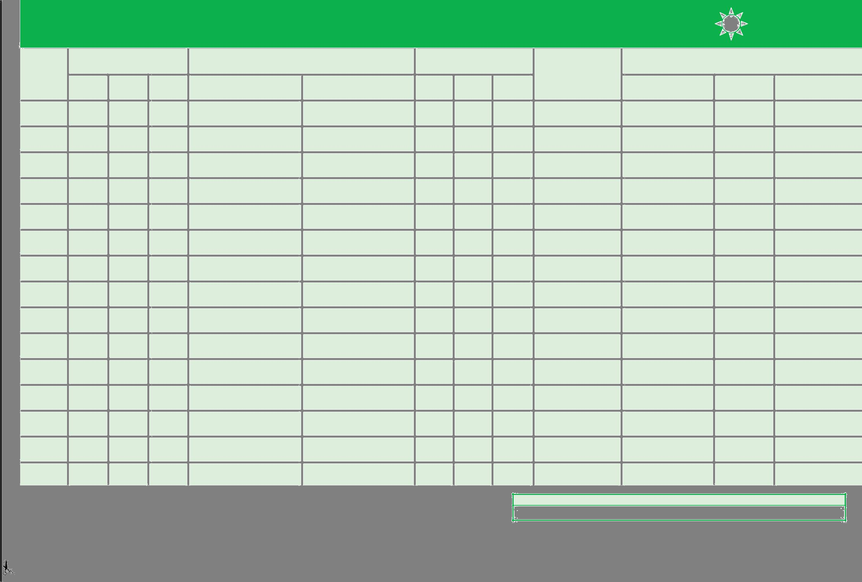
Form 2 • Record of Daytime Driving Hours |  |  |  |  | You may use an electronic learner log book app to record your driving hours instead |  |  | Daytime
 |  |  |  |  | for more information on electronic log books.
 |  |  |  |  | of recording them manually in your Driving Companion. The app must offer a print
 |  |  |  |  | out with the same information as the paper version. Visit www.mylicence.sa.gov.au
 | Time |  | Location (Suburb) |  |  | Conditions | Learner’s | Qualified Supervising Driver
Date |  |  |  |  |  |  | Learner’s
Date | Finish |  |  |  |  |  | Signature
Start | Finish | Duration | From | To | Road | Weather Traffic | Signature |  | Signature
 |  |  |  |  |  |  | Name | Licence No. | Signature
am/pm | am/pm

ISMF Classification when complete – SENSITIVE: PERSONAL – I3 – A3

Log Book

Learner’s | Sub Total
Permit Holder | (minutes)
Name
Permit No.

 | Road Type |  |  | Weather |  |  | Traffic Density
 | Sealed | S |  | Dry | D |  | Light | L
 | Unsealed | U |  |  |  |  | Medium | M
 | Unsealed | U |  | Wet | W |  | Medium | M
 | Quiet Street Q |  |  |  |  |  | Heavy | H
 | Busy Road | B
 | Multi-laned
 | Road | ML

Foreign or Interstate Licence

Country/State.......................... Expiry Date / / Yrs Held...................

Warning:
Heavy penalties apply for false entries, please see pages 19 and 20. If the Qualified Supervising Driver’s Licence cannot be validated, the entry will be rejected and any licence issued will be void. Incomplete entries are invalid.

23

You may use an electronic learner log book app to record your driving hours instead
of recording them manually in your Driving Companion. The app must offer a print
Form 3 • Record of Daytime Driving Hours out with the same information as the paper version. Visit www.mylicence.sa.gov.au
for more information on electronic log books.

Daytime

 | Time |  |  | Location (Suburb) |  | Conditions | Learner’s | Qualified Supervising Driver
Date |  |  |  |  |  |  | Learner’s
Date | Finish |  |  |  |  |  | Signature
Start | Finish | Duration | From | To | Road | Weather Traffic | Signature |  | Signature
 |  |  |  |  |  |  | Name | Licence No. | Signature
am/pm | am/pm

Log Book | SENSITIVE: PERSONAL – I3 – A3
 | ISMF Classification when complete –

Learner’s | Sub Total
Permit Holder | (minutes)
Name
Permit No.
24

Road Type |  |  | Weather |  |  | Traffic Density
Sealed | S |  | Dry | D |  | Light | L
Unsealed | U |  |  |  |  | Medium | M
Unsealed | U |  | Wet | W |  | Medium | M
Quiet Street Q |  |  |  |  |  | Heavy | H
Busy Road | B
Multi-laned
Road | ML

Foreign or Interstate Licence

Country/State.......................... Expiry Date / / Yrs Held...................

Warning:
Heavy penalties apply for false entries, please see pages 19 and 20. If the Qualified Supervising Driver’s Licence cannot be validated, the entry will be rejected and any licence issued will be void. Incomplete entries are invalid.

Form 4 • Record of Daytime Driving Hours |  |  |  |  | You may use an electronic learner log book app to record your driving hours instead |  |  | Daytime
 |  |  |  |  | for more information on electronic log books.
 |  |  |  |  | of recording them manually in your Driving Companion. The app must offer a print
 |  |  |  |  | out with the same information as the paper version. Visit www.mylicence.sa.gov.au
 | Time |  | Location (Suburb) |  |  | Conditions | Learner’s | Qualified Supervising Driver
Date |  |  |  |  |  |  | Learner’s
Date | Finish |  |  |  |  |  | Signature
Start | Finish | Duration | From | To | Road | Weather Traffic | Signature |  | Signature
 |  |  |  |  |  |  | Name | Licence No. | Signature
am/pm | am/pm

ISMF Classification when complete – SENSITIVE: PERSONAL – I3 – A3

Log Book

Learner’s | Sub Total
Permit Holder | (minutes)
Name
Permit No.

 | Road Type |  |  | Weather |  |  | Traffic Density
 | Sealed | S |  | Dry | D |  | Light | L
 | Unsealed | U |  |  |  |  | Medium | M
 | Unsealed | U |  | Wet | W |  | Medium | M
 | Quiet Street Q |  |  |  |  |  | Heavy | H
 | Busy Road | B
 | Multi-laned
 | Road | ML

Foreign or Interstate Licence

Country/State.......................... Expiry Date / / Yrs Held...................

Warning:
Heavy penalties apply for false entries, please see pages 19 and 20. If the Qualified Supervising Driver’s Licence cannot be validated, the entry will be rejected and any licence issued will be void. Incomplete entries are invalid.

25

You may use an electronic learner log book app to record your driving hours instead
of recording them manually in your Driving Companion. The app must offer a print
Form 5 • Record of Daytime Driving Hours out with the same information as the paper version. Visit www.mylicence.sa.gov.au
for more information on electronic log books.

Daytime

 | Time |  |  | Location (Suburb) |  | Conditions | Learner’s | Qualified Supervising Driver
Date |  |  |  |  |  |  | Learner’s
Date | Finish |  |  |  |  |  | Signature
Start | Finish | Duration | From | To | Road | Weather Traffic | Signature |  | Signature
 |  |  |  |  |  |  | Name | Licence No. | Signature
am/pm | am/pm

Log Book | SENSITIVE: PERSONAL – I3 – A3
 | ISMF Classification when complete –

Learner’s | Sub Total
Permit Holder | (minutes)
Name
Permit No.
26

Road Type |  |  | Weather |  |  | Traffic Density
Sealed | S |  | Dry | D |  | Light | L
Unsealed | U |  |  |  |  | Medium | M
Unsealed | U |  | Wet | W |  | Medium | M
Quiet Street Q |  |  |  |  |  | Heavy | H
Busy Road | B
Multi-laned
Road | ML

Foreign or Interstate Licence

Country/State.......................... Expiry Date / / Yrs Held...................

Warning:
Heavy penalties apply for false entries, please see pages 19 and 20. If the Qualified Supervising Driver’s Licence cannot be validated, the entry will be rejected and any licence issued will be void. Incomplete entries are invalid.

Form 6 • Record of Daytime Driving Hours |  |  |  |  | You may use an electronic learner log book app to record your driving hours instead |  |  | Daytime
 |  |  |  |  | for more information on electronic log books.
 |  |  |  |  | of recording them manually in your Driving Companion. The app must offer a print
 |  |  |  |  | out with the same information as the paper version. Visit www.mylicence.sa.gov.au
 | Time |  | Location (Suburb) |  |  | Conditions | Learner’s | Qualified Supervising Driver
Date |  |  |  |  |  |  | Learner’s
Date | Finish |  |  |  |  |  | Signature
Start | Finish | Duration | From | To | Road | Weather Traffic | Signature |  | Signature
 |  |  |  |  |  |  | Name | Licence No. | Signature
am/pm | am/pm

ISMF Classification when complete – SENSITIVE: PERSONAL – I3 – A3

Log Book

Learner’s | Sub Total
Permit Holder | (minutes)
Name
Permit No.

 | Road Type |  |  | Weather |  |  | Traffic Density
 | Sealed | S |  | Dry | D |  | Light | L
 | Unsealed | U |  |  |  |  | Medium | M
 | Unsealed | U |  | Wet | W |  | Medium | M
 | Quiet Street Q |  |  |  |  |  | Heavy | H
 | Busy Road | B
 | Multi-laned
 | Road | ML

Foreign or Interstate Licence

Country/State.......................... Expiry Date / / Yrs Held...................

Warning:
Heavy penalties apply for false entries, please see pages 19 and 20. If the Qualified Supervising Driver’s Licence cannot be validated, the entry will be rejected and any licence issued will be void. Incomplete entries are invalid.

27

You may use an electronic learner log book app to record your driving hours instead
of recording them manually in your Driving Companion. The app must offer a print
Form 7 • Record of Daytime Driving Hours out with the same information as the paper version. Visit www.mylicence.sa.gov.au
for more information on electronic log books.

Daytime

 | Time |  |  | Location (Suburb) |  | Conditions | Learner’s | Qualified Supervising Driver
Date |  |  |  |  |  |  | Learner’s
Date | Finish |  |  |  |  |  | Signature
Start | Finish | Duration | From | To | Road | Weather Traffic | Signature |  | Signature
 |  |  |  |  |  |  | Name | Licence No. | Signature
am/pm | am/pm

Log Book | SENSITIVE: PERSONAL – I3 – A3
 | ISMF Classification when complete –

Learner’s | Sub Total
Permit Holder | (minutes)
Name
Permit No.
28

Road Type |  |  | Weather |  |  | Traffic Density
Sealed | S |  | Dry | D |  | Light | L
Unsealed | U |  |  |  |  | Medium | M
Unsealed | U |  | Wet | W |  | Medium | M
Quiet Street Q |  |  |  |  |  | Heavy | H
Busy Road | B
Multi-laned
Road | ML

Foreign or Interstate Licence

Country/State.......................... Expiry Date / / Yrs Held...................

Warning:
Heavy penalties apply for false entries, please see pages 19 and 20. If the Qualified Supervising Driver’s Licence cannot be validated, the entry will be rejected and any licence issued will be void. Incomplete entries are invalid.

ISMF Classification when complete – SENSITIVE: PERSONAL – I3 – A3 |  |  |  |  | You may use an electronic learner log book app to record your driving hours instead |  |  | Daytime
Form 8 • Record of Daytime Driving Hours |  |  |  |  | for more information on electronic log books.
 |  |  |  |  | of recording them manually in your Driving Companion. The app must offer a print
 |  |  |  |  | out with the same information as the paper version. Visit www.mylicence.sa.gov.au
 | Time |  | Location (Suburb) |  |  | Conditions | Learner’s | Qualified Supervising Driver
Date |  |  |  |  |  |  | Learner’s
Date | Finish |  |  |  |  |  | Signature
Start | Finish | Duration | From | To | Road | Weather Traffic | Signature |  | Signature
 |  |  |  |  |  |  | Name | Licence No. | Signature
am/pm | am/pm

ISMF Classification when complete – SENSITIVE: PERSONAL – I3 – A3

Log Book

Learner’s | Sub Total
Permit Holder | (minutes)
Name
Permit No.

 | Road Type |  |  | Weather |  |  | Traffic Density
 | Sealed | S |  | Dry | D |  | Light | L
 | Unsealed | U |  |  |  |  | Medium | M
 | Unsealed | U |  | Wet | W |  | Medium | M
 | Quiet Street Q |  |  |  |  |  | Heavy | H
 | Busy Road | B
 | Multi-laned
 | Road | ML

Foreign or Interstate Licence

Country/State.......................... Expiry Date / / Yrs Held...................

Warning:
Heavy penalties apply for false entries, please see pages 19 and 20. If the Qualified Supervising Driver’s Licence cannot be validated, the entry will be rejected and any licence issued will be void. Incomplete entries are invalid.

29

You may use an electronic learner log book app to record your driving hours instead
of recording them manually in your Driving Companion. The app must offer a print
Form 9 • Record of Daytime Driving Hours out with the same information as the paper version. Visit www.mylicence.sa.gov.au
for more information on electronic log books.

Daytime

 | Time |  |  | Location (Suburb) |  | Conditions | Learner’s | Qualified Supervising Driver
Date |  |  |  |  |  |  | Learner’s
Date | Finish |  |  |  |  |  | Signature
Start | Finish | Duration | From | To | Road | Weather Traffic | Signature |  | Signature
 |  |  |  |  |  |  | Name | Licence No. | Signature
am/pm | am/pm

Log Book | SENSITIVE: PERSONAL – I3 – A3
 | ISMF Classification when complete –

Learner’s | Sub Total
Permit Holder | (minutes)
Name
Permit No.
30

Road Type |  |  | Weather |  |  | Traffic Density
Sealed | S |  | Dry | D |  | Light | L
Unsealed | U |  |  |  |  | Medium | M
Unsealed | U |  | Wet | W |  | Medium | M
Quiet Street Q |  |  |  |  |  | Heavy | H
Busy Road | B
Multi-laned
Road | ML

Foreign or Interstate Licence

Country/State.......................... Expiry Date / / Yrs Held...................

Warning:
Heavy penalties apply for false entries, please see pages 19 and 20. If the Qualified Supervising Driver’s Licence cannot be validated, the entry will be rejected and any licence issued will be void. Incomplete entries are invalid.

Form 10 • Record of Daytime Driving Hours |  |  |  |  | You may use an electronic learner log book app to record your driving hours instead |  |  | Daytime
 |  |  |  |  | for more information on electronic log books.
 |  |  |  |  | of recording them manually in your Driving Companion. The app must offer a print
 |  |  |  |  | out with the same information as the paper version. Visit www.mylicence.sa.gov.au
 | Time |  | Location (Suburb) |  |  | Conditions | Learner’s | Qualified Supervising Driver
Date |  |  |  |  |  |  | Learner’s
Date | Finish |  |  |  |  |  | Signature
Start | Finish | Duration | From | To | Road | Weather Traffic | Signature |  | Signature
 |  |  |  |  |  |  | Name | Licence No. | Signature
am/pm | am/pm

ISMF Classification when complete – SENSITIVE: PERSONAL – I3 – A3

Log Book

Learner’s | Sub Total
Permit Holder | (minutes)
Name
Permit No.

 | Road Type |  |  | Weather |  |  | Traffic Density
 | Sealed | S |  | Dry | D |  | Light | L
 | Unsealed | U |  |  |  |  | Medium | M
 | Unsealed | U |  | Wet | W |  | Medium | M
 | Quiet Street Q |  |  |  |  |  | Heavy | H
 | Busy Road | B
 | Multi-laned
 | Road | ML

Foreign or Interstate Licence

Country/State.......................... Expiry Date / / Yrs Held...................

Warning:
Heavy penalties apply for false entries, please see pages 19 and 20. If the Qualified Supervising Driver’s Licence cannot be validated, the entry will be rejected and any licence issued will be void. Incomplete entries are invalid.

31

Night-time driving includes driving between sunset on one day and sunrise on the next day

Form 11 • Record of Night-time Driving Hours

You may use an electronic learner log book app to record your driving hours instead

of recording them manually in your Driving Companion. The app must offer a print Night-time out with the same information as the paper version. Visit www.mylicence.sa.gov.au

for more information on electronic log books.

 | Time |  |  | Location (Suburb) |  | Conditions | Learner’s | Qualified Supervising Driver
Date |  |  |  |  |  |  | Learner’s
Date | Finish |  |  |  |  |  | Signature
Start | Finish | Duration | From | To | Road | Weather Traffic | Signature |  | Signature
 |  |  |  |  |  |  | Name | Licence No. | Signature
am/pm | am/pm

Log Book | SENSITIVE: PERSONAL – I3 – A3
 | ISMF Classification when complete –

Learner’s | Sub Total
Permit Holder | (minutes)
Name
Permit No.
32

Road Type |  |  | Weather |  |  | Traffic Density
Sealed | S |  | Dry | D |  | Light | L
Unsealed | U |  |  |  |  | Medium | M
Unsealed | U |  | Wet | W |  | Medium | M
Quiet Street Q |  |  |  |  |  | Heavy | H
Busy Road | B
Multi-laned
Road | ML

Foreign or Interstate Licence

Country/State.......................... Expiry Date / / Yrs Held...................

Warning:
Heavy penalties apply for false entries, please see pages 19 and 20. If the Qualified Supervising Driver’s Licence cannot be validated, the entry will be rejected and any licence issued will be void. Incomplete entries are invalid.


Night-time driving includes driving between sunset on one day and sunrise on the next day |  |  |  |  | You may use an electronic learner log book app to record your driving hours instead |  |  | Night-time
 |  |  |  |  | for more information on electronic log books.
Form 12 • Record of Night-time Driving Hours
 |  |  |  |  | of recording them manually in your Driving Companion. The app must offer a print
 |  |  |  |  | out with the same information as the paper version. Visit www.mylicence.sa.gov.au
 | Time |  | Location (Suburb) |  |  | Conditions | Learner’s | Qualified Supervising Driver
Date |  |  |  |  |  |  | Learner’s
Date | Finish |  |  |  |  |  | Signature
Start | Finish | Duration | From | To | Road | Weather Traffic | Signature |  | Signature
 |  |  |  |  |  |  | Name | Licence No. | Signature
am/pm | am/pm

ISMF Classification when complete – SENSITIVE: PERSONAL – I3 – A3

Log Book

Learner’s | Sub Total
Permit Holder | (minutes)
Name
Permit No.

 | Road Type |  |  | Weather |  |  | Traffic Density
 | Sealed | S |  | Dry | D |  | Light | L
 | Unsealed | U |  |  |  |  | Medium | M
 | Unsealed | U |  | Wet | W |  | Medium | M
 | Quiet Street Q |  |  |  |  |  | Heavy | H
 | Busy Road | B
 | Multi-laned
 | Road | ML

Foreign or Interstate Licence

Country/State.......................... Expiry Date / / Yrs Held...................

Warning:
Heavy penalties apply for false entries, please see pages 19 and 20. If the Qualified Supervising Driver’s Licence cannot be validated, the entry will be rejected and any licence issued will be void. Incomplete entries are invalid.

33

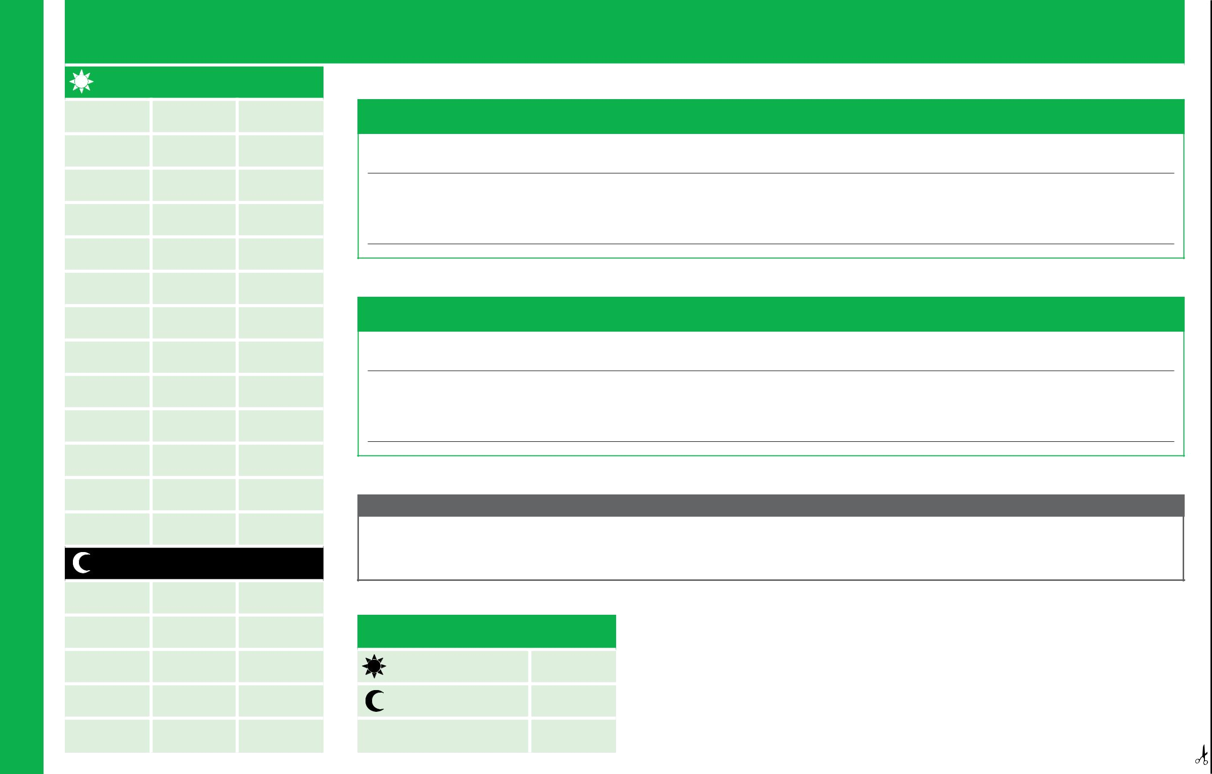
Declaration of 4,500 minutes (75 hours) of driving time

Log Book

complete – SENSITIVE: PERSONAL – I3 – A3

Daytime driving

Form No. | Minutes | Running
Form No. | Sub Total | Total
1
2
3
4
5
6
7
8
9
10
Additional
form(s)
 | Daytime total
Night-time driving
Form No. | Minutes | Running
Form No. | Sub Total | Total

Declaration by Learner Driver (Compulsory)

I,

declare that I have completed 4,500 minutes (75 hours) of driving experience, including at least 900 minutes (15 hours) of night driving.

Signature Learner’s Permit number Date

Declaration by Qualified Supervising Driver (Optional)

I,

declare that I have sighted the 4,500 minutes (75 hours) of driving experience, including at least 900 minutes (15 hours) of night driving.

Signature Driver’s Licence number Date

Warning - heavy penalties apply for false entries

Motor Vehicles Act 1959 - Section 135 (1)

A person must not, in furnishing information or compiling a record pursuant to this Act make, nor include in the record, a statement that is false or misleading in a material particular. Maximum penalty: $5,000 or imprisonment for 6 months.

34

ISMF Classification when

11

12

Additional

form(s)

Night-time
total

Total driving minutes

Daytime total

Night-time total
(minimum 900)

Total (minimum 4,500)

When applying for your Provisional Licence, pages 22 to 34 should be removed from this book and handed to Service SA staff along with your “Certificate of Competency”. If you chose the Competency Based Training and Assessment method your task assessment sheets, pages 41 to 74, must also be handed in.

Option 1: Vehicle On Road Test (VORT)

The Vehicle On Road Test will test your skills and knowledge as a safe and competent driver. Your test will take approximately 45 minutes and you will be required to demonstrate 5 slow speed manoeuvres, (move off on a hill, angle park, U-turn, 3-point turn and reverse parallel park) as well as a general drive. The general drive component will test your driving skills e.g. changing lanes, turning on and from busy roads, turning at traffic lights, negotiating roundabouts, stop and give-way signs, your interaction with other road users and the system of car control.

To pass a VORT you must demonstrate 5 slow speed manoeuvres and in combination with the general drive score a pass mark of 90% or more and not breach any road law during the drive. Any breach of road law will result in an immediate fail and the test will be terminated.

If you are unsuccessful your instructor will debrief you on the reasons why. A copy of the test marking sheet will be given to you detailing your performance.

Choosing this option offers the following:

- The VORT may be taken on any day except Christmas Day and Good Friday;

- The VORT will be conducted on an authorised VORT test route which has been designed to require most of the driving skills contained in the Competency Based Training & Assessment (CBT&A) course; and

- The VORT will result in either a ‘pass’ or a ‘fail’ and is an objective testing system based on your correct responses to road and traffic conditions.

You are not permitted to undertake a VORT with any Authorised Examiner who has contributed to your training. An Authorised Examiner must book your VORT at least two full days prior to the date of the test. If you fail a VORT, you must wait 14 days before attempting another VORT.

1
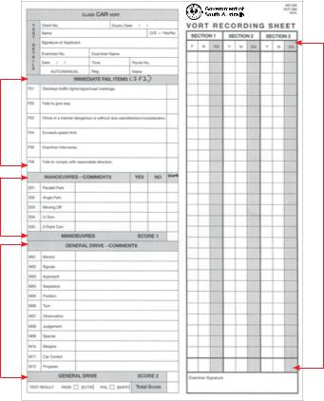

2 | 4

3

1 This section will identify breaches of road law. If you breach a road law during your VORT the Authorised Examiner will cease marking and direct you back to the start point.

2 You must demonstrate each of the following 5 manoeuvres. Each correct manoeuvre scores 2 marks, for a total of 10%

3 Refer to your Driving Companion pages 10 to 17 for explanation of these terms.

4 This section records how well you can drive. Faults will be in the detailed General Drive comments section. You may score a maximum of 90% for your general driving ability. If the test is terminated through an Immediate Fail Item, 2 horizontal lines are placed in this section to identify where the breach occurred.

Vehicle On Road Test (VORT)

35

Vehicle On Road Test (VORT)

Conditions applying to the VORT

You must comply with the following conditions when undertaking a VORT:

- You must comply with all Learner’s Permit conditions.

- You must present your current permit to the VORT Authorised Examiner at the beginning of the test. If the permit does not have a photograph, additional identification such as a passport or other acceptable documentation must be produced.

- You must be punctual or you may forfeit your VORT.

- You must allow an Authorised Person (a Government employee who has clearly identified himself/herself) to observe, from within the test vehicle if requested. The Authorised Person will ask the Instructor to produce your Learner’s Permit.

- You will not be allowed to carry passengers (or animals) during a VORT. (The Authorised Examiner and any Authorised Persons are exempt.)

- You must wear appropriate footwear - no thongs, bare feet, clogs (shoes with soles thicker than 3cm) or shoes without heel support.

Notes: (a) The VORT cannot be started earlier than 5 minutes before or later than 15 minutes after the booked time.

- An interpreter is not permitted to ride within the vehicle during a VORT. Prior to the beginning of the test and with assistance of the interpreter, the Authorised Examiner must explain the meaning of any hand signals to be used during the test. At the end of the test, the Authorised Examiner must explain the test result to the driver with assistance from the interpreter.

- If you do not accept the above conditions, an Authorised Person must conduct the VORT.

- Learner’s Permit conditions still apply until the appropriate licence is obtained from a Service SA Centre even though the test has been passed and a Certificate of Competency has been issued.

- The test is an overview of your knowledge and driving skills. The VORT Authorised Examiner’s role is to observe and progressively record - they must only give directions and parameters as required. The ability to drive and perform manoeuvres is your own responsibility.

- If you are using your own vehicle you must provide evidence that your vehicle is registered. The registration expiry date can be checked by telephoning 13 10 84 between 8am and 6pm Monday to Friday, going to ezyreg.sa.gov.au or by using an EzyReg smartphone app.

36

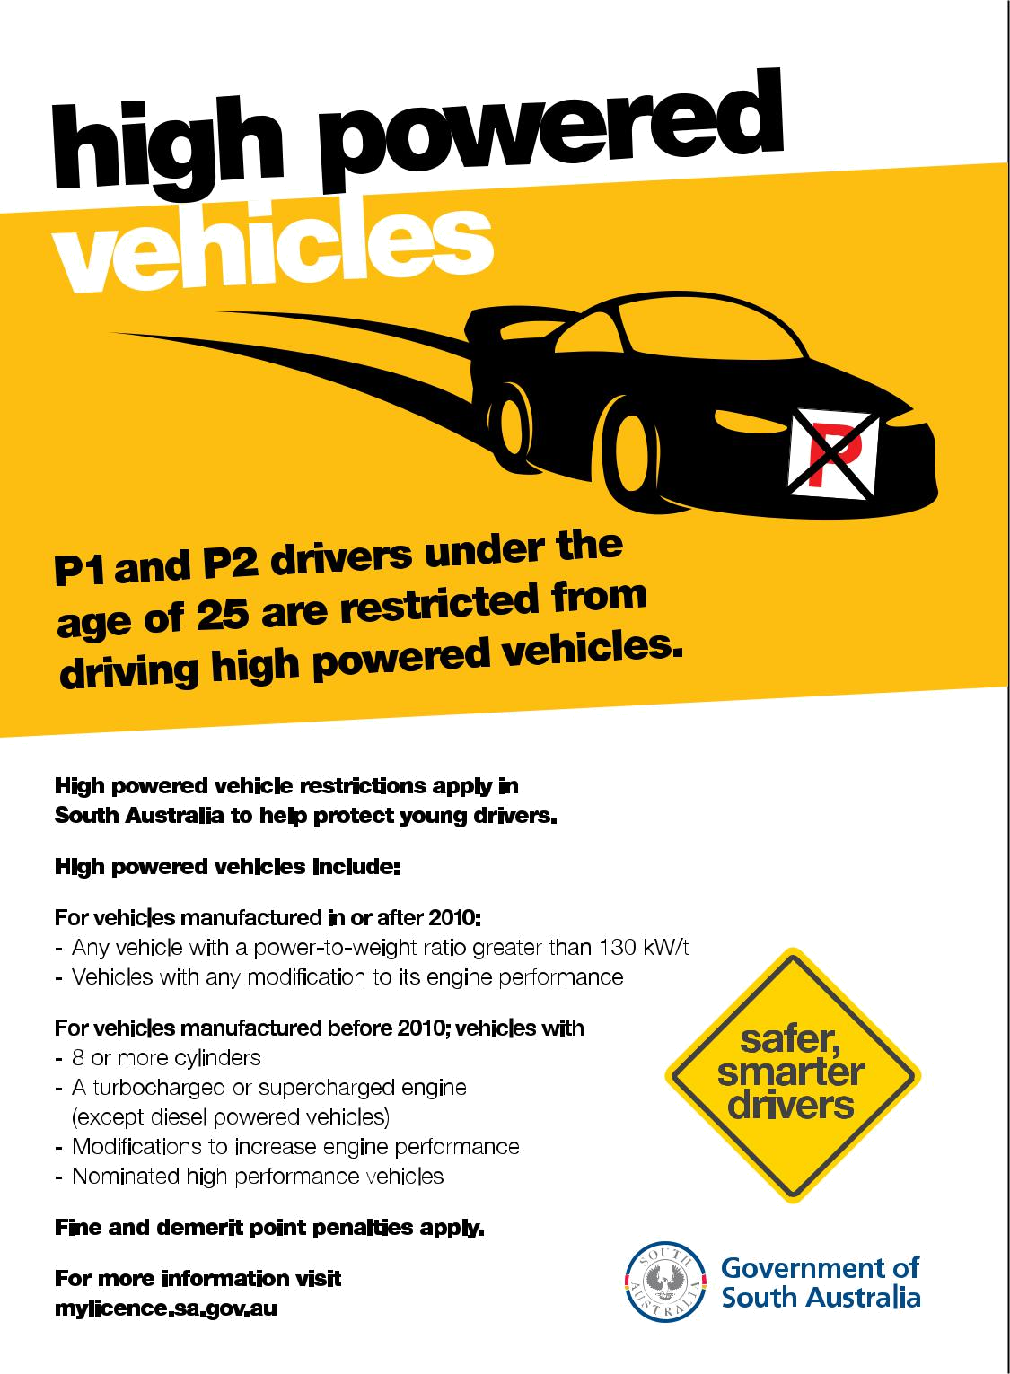
Government responsibilities in monitoring

the licensing process

Government Authorised Persons regularly monitor the standard of training

and assessment being applied by Authorised Examiners. An Authorised Person

may observe any VORT from within the vehicle.

They will identify themselves at the beginning of any VORT and will not

intervene or influence any result stated by your Authorised Examiner. The

Authorised Person will be looking at how your Authorised Examiner conducts

the VORT, and will not take any part in your test.

An Authorised Person may request to look at your Learner’s Permit and your

Driving Companion.

Government Authorised Persons may also further validate the driving skills of

any person not subject to the Graduated Licence Scheme. This usually involves

applicants from countries which do not have sufficiently robust licensing

systems to ensure that drivers are safe and competent.

In these cases, applicants may after completing a VORT with an Authorised

Examiner, be identified to present for an additional assessment with a

Government Authorised Person.

Vehicle On Road Test (VORT)

37

Competency Based Training & Assessment (CBT&A)

Option 2:

Competency Based Training & Assessment (CBT&A) course

This option allows you to undertake training with a CBT&A Authorised Examiner. The Authorised Examiner will conduct your training and assessment in accordance with the Competency Based Training Tasks within this book, The Driving Companion.

As you successfully complete each task in the CBT&A course, your achievement will be recorded on your Task pages by your Authorised Examiner.

Successful performance in all 30 Tasks will result in the training course being completed and a Certificate of Competency issued. The Certificate of Competency will allow you to obtain your Provisional Licence provided you have completed the 75 hours of supervised driving and passed the Hazard Perception Test.

Notes: (a) A Motor Driving Instructor cannot assess and sign-off tasks as

complete, only an Authorised Examiner can do so.

- Recognition of Prior Learning (RPL) refers to training delivered by a third party. All CBT&A assessments must still be undertaken but if you have the skills and knowledge it skips the need for the current Authorised Examiner to provide training before assessments occur. At any time during the CBT&A course you may select Option 1 and take a VORT.

- You may change Authorised Examiners at any time during the CBT&A course. The new Authorised Examiner will be required to check that you can perform all of the Tasks assessed and signed off by your previous Authorised Examiner. This process is called Recognition of Current Competencies (RCC).

- This Driving Companion remains your property and must be presented to the Authorised Examiner at the beginning of each training session and returned to you at the conclusion. An Authorised Person, may ask to inspect your Driving Companion at the beginning or end of any training session.

Choosing this option has the following advantages:

- It is a progressive assessment system. You are assessed as each task is completed.

- The training is designed to cover all aspects of good driving behaviour and the development of good driving attitudes.

- The training allows you to learn at your own pace without a ‘test’ deadline.

- There is no ‘pass’ or ‘fail’ when each task is assessed. If you are unsuccessful in any assessment of a task, the Authorised Examiner can re-train you and then re-assess your performance again in that task within the same or a later driving lesson.

- This CBT&A course will provide you with efficient, structured training in a wide variety of driving experiences including country driving.

- Drivers graduating from this program will be able to demonstrate the confidence and competency needed for today’s road and traffic conditions.

- Entries by your Authorised Examiner in the task forms will provide you with accurate information on your progress in the CBT&A course. The records completed by your Authorised Examiner will also give valuable help and guidance when you are practicing with your Qualified Supervising Driver(s). Practice using the information in the task forms to reduce the cost of your training.

38

Conditions applying to the Competency Based Training & Assessment (CBT&A) course

Any learner driver or overseas licence holder electing to do the training course will be required to comply with the following:

- You must comply with the conditions of the Learner’s Permit, or Temporary Driving Permit.

- You must carry The Driving Companion with you in the vehicle when attending any training session in the CBT&A course for Tasks to be signed off if competent.

- You must produce The Driving Companion, on request, to the Authorised Examiner (providing the training) or to any Authorised Person who may observe the training session. (All Authorised Persons will show their official identification to both the Authorised Examiners and learner driver at the beginning of any training session).

- When requested, you must allow an Authorised Person to ride in the training vehicle during any training session of the CBT&A course being conducted by the Authorised Examiner.

- Other than the record of driving hours forms (Log Book), all other information, marks or details, can only be entered in the task requirement and assessment forms by the Authorised Examiner.

- You must not carry any passengers (or animals) during the last training session except for the Authorised Examiner conducting the training and any Authorised Person observing the training session.

- For safety reasons, you must wear appropriate footwear when driving - no thongs, bare feet, clogs (shoes with soles thicker than 3cm) or shoes without heel support.

Notes: (a) Failing to comply with the above conditions may result in this option being withdrawn.

- Learner’s Permit conditions still apply until the appropriate licence is obtained from a Service SA Centre even though a Certificate of Competency has been issued.

- When applying for your Provisional Licence, pages 41 to 74 should be removed from this book and handed to Service SA staff along with your log book hours, pages 22 to 34, and your Certificate of Competency.

- You may have to provide evidence that your vehicle is registered. The registration expiry date can be checked by telephoning
13 10 84 between 8am and 6pm Monday to Friday, going

to www.ezyreg.sa.gov.au or by using an EzyReg smartphone app.

Competency Based Training & Assessment (CBT&A) course

39

Competency Based Training & Assessment (CBT&A)

40

Training and assessment

Task forms

Each page contains the Task title, the learning outcomes for the Task, the assessment standards and the Task content or requirements that you must achieve to be successful. Each right-hand side of the page contains all the training and assessment records, which will be completed by your Authorised Examiner as your training progresses or at the end of each training session.

CBT&A Authorised Examiner

A CBT&A Authorised Examiner will conduct training and assessment of all Tasks specified in the CBT&A course.

Where a Task requirement cannot be reasonably accessed within a 40 kilometre road distance from the town limit where the CBT&A course is being conducted or 25 minutes of normal driving (whichever is the shorter), the Authorised Examiner will explain the item but will not be required to assess the learner driver in order to sign off the Task.

The Authorised Examiner will note on the assessment page of the particular Task that the Task was not assessed.

Recognition of Prior Learning (RPL) and Recognition of Current Competencies (RCC)

If you feel you already have the driving skills and knowledge, probably gained by previous training, but haven’t yet been assessed, your Authorised Examiner can skip the training component and conduct an assessment. All CBT&A assessment requirements must be met as per The Driving Companion. This process is called Recognition of Prior Learning (RPL).

If you’ve already had Tasks signed off as competent and switch to a new Authorised Examiner for whatever reason, they will need to ensure you can still perform the Task(s) correctly. This process is called Recognition of Current Competencies (RCC).

If any Task is not demonstrated correctly, training will need to be provided and re-assessment as per the conditions must occur.

 |  |  |  |  |  |  |  |  |  | rs
 |  |  |  |  |  |  |  |  | e
 |  |  |  |  |  |  |  | g
 |  |  |  |  |  | n
 |  |  |  | e
 |  | s
 | s
a |  |  |  |  |  |  |  |  |  |  |  |  | u
p |  |  |  |  |  |  |  |  |  |  |  |  | u
 |  |  |  |  |  |  |  |  |  |  |  | o
 |  |  |  |  |  |  |  |  |  |  | ty
 |  |  |  |  |  |  |  |  |  | c
 |  |  |  |  |  |  |  |  | a
 |  |  |  |  |  |  | tr
 |  |  |  |  | is
 |  |  | d
 | n
a
c

The risk of crashing increases when you have your friends in the car.

Lets face it, they can be distracting.

Sometimes peer pressure can also tempt you to take greater or more risks when driving.

But just as important as staying focussed when driving is to be a helpful passenger. This means acting responsibly and not distracting your driver in any way.

So stay safe, be smart, limit your passengers and keep your eyes on the road. For more safer driving tips go to mylicence.sa.gov.au

P1 Licence holders under the age of 25 years must not drive with more than one passenger aged 16 to 20 years (excluding immediate family members) unless a Qualified Supervising Driver is seated next to them or they meet the exemption criteria.

safer, smarter drivers start at
mylicence.sa.gov.au

CBT&A Task index

 | Unit 1 - Basic driving procedures |  | Pg
1 |  | Cabin drill and controls | 43
2 |  | Starting up and shutting down the engine | 44
3 |  | Moving off from the kerb | 45
4 |  | Stopping and securing the vehicle | 46
5 |  | Stop and go (using the handbrake) | 47
6 |  | Gear changing | 48
7 |  | Steering (forward and reverse) | 49
8 |  | Review of all basic driving procedures | 50

 | Unit 2 - Slow speed manoeuvres |  | Pg
9 |  | Moving off up hill | 51
10 |  | The simple U-turn | 52
11 |  | The 3-point turn | 53
12 |  | 90-degree angle park (front to kerb) | 54
13 |  | Reverse parallel parking | 55
14 |  | Review all slow speed manoeuvres | 56

When applying for your Provisional Licence, pages 41 to 74 should be removed from this book and handed to Service SA staff along with your log book hours, pages 22 to 34, and your “Certificate of Competency”.

 | Unit 3 - Basic road skills |  | Pg
15 |  | Vehicle road positioning | 57
16 |  | Lane changing and diverging | 58
17 |  | Turning at corners | 59
18 |  | Turning onto and from laned roads | 60
19 |  | Turning at roundabouts | 61
20 |  | Negotiating traffic lights | 62
21 |  | Light traffic urban driving | 63
22 |  | Country driving (driving at higher speeds) | 64

 | Unit 4 - Traffic management skills |  | Pg
23 |  | Safe driving strategies | 65
24 |  | Lane management in traffic | 66
25 |  | Turning in traffic | 67
26 |  | Managing traffic at roundabouts | 68
27 |  | U-turn in traffic - manoeuvre | 69
28 |  | Negotiating traffic lights in traffic | 70
 | 28A | Driving on unsealed roads | 71
 | 28B | Driving at night | 72

Units 1 and 2 - Review |  | Pg
29 | Review of basic driving skills | 73
Units 3 and 4 - Review |  | Pg
30 | Review of road skills and traffic management | 74

41


Notes | Notes

42
Unit 1: Task 1 – Cabin drill and controls

Learning | (a) | The learner will be able to set up the cabin of the vehicle in order to safely, efficiently
Outcome |  | and effectively drive the vehicle (cabin drill); and
 | (b) | The learner will be able to locate and identify all controls needed to drive
 |  | the vehicle safely.
Assessment | The learner will accurately perform this task without assistance.
Standard | The assessment will be a demonstration on at least two consecutive but separate occasions.

Task 1 Requirements |  | Homework
1 | Ensure the doors are closed (and locked for security – optional);
2 | Check that the handbrake is firmly applied;
3 | Adjust the seat, head restraint and steering wheel (as required);
4 | Adjust all mirrors (electric mirrors, if fitted, may be adjusted
 | after ‘starting the engine’ – Task 2);
5 | Locate, identify and be able to use all vehicle controls (as required)
 | when driving (including ‘climate’ controls);
6 | Fasten and correctly adjust your seatbelt; and
7 | Perform all steps 1 to 6 in sequence.

Controls List

The learner may be asked to explain the function of one control from each of the groups below.

Group 1 (any 1) | Group 2 (any 1) | Group 3 (any 1)
• Brake | • Clutch – | • Heater/demister
• Accelerator | (Manuals only) | • Wipers and washers
• Steering wheel | • Handbrake | • Warning lights (any 3)
• Gear lever | • Warning device | • Vehicle lights
(including autos) | • Signals | • Gauges

Task Assessment Records

Cabin drill

Controls (selected from the respective groups)

Group 1 – control name

Group 2 – control name

Group 3 – control name

Task 1 Sign Off

Driver’s Name

Licence Number

Learner Driver’s Signature

Authorised Examiner Signature

MDI No. Date

Authorised Examiner Notes

ISMF Classification when complete – SENSITIVE: PERSONAL – I3 – A3

T

1

Unit 1 - Basic Driving Procedures

43

T

2

Unit 1 - Basic Driving Procedures

44

Unit 1: Task 2 – Starting up and shutting down the engine

 | Learning |  | (a) The learner will be able to safely start the engine of the vehicle; and
 | Outcome |  | (b) The learner will be able to safely shut down the engine of the vehicle.
 | Assessment |  | The learner will accurately perform parts (a) and (b) of this task without assistance.
 | Standard |  | The assessment will be a demonstration on at least two consecutive but separate occasions.
 | Task 2 Requirements |  |  |  | Homework
 | (a) | Starting the engine
 | 1(a) | If the handbrake is not on, correctly apply it;
 | 2(a) | Clutch down to the floor and keep it down (manuals only);
 | 3(a) | Check gear lever in ‘Neutral’ (manuals) or ‘Neutral/Park’ (autos);
 | 4(a) | Switch the ignition (key) to the ‘ON’ position;
 | 5(a) | Check all gauges and warning lights for operation;
 | 6(a) | Start the engine (without over-cranking the engine);
 | 7(a) | Check all gauges and warning lights for operation; and
 | 8(a) | Performs all steps 1(a) to 7(a) in sequence.
 | (b) | Shutting down the engine
A3 | 1(b) | Bring the vehicle to a complete stop (clutch down-manual/s);
A3 | 2(b) | Secure the vehicle using the handbrake;
I3 – | 2(b)
I3 – | 3(b) | Select ‘Neutral’ (manuals) or ‘Neutral/Park’ (automatics);
– | 3(b)
– | 4(b) | Release brake pedal (to check for rolling);
PERSONAL | 4(b)
PERSONAL | 6(b) | Switch off appropriate controls (eg. lights, air conditioner etc);
 | 5(b) | Release clutch pedal (manuals only);
SENSITIVE:
SENSITIVE: | 9(b) | Perform all steps 1(b) to 8(b) in sequence.
 | 7(b) | Check all gauges and warning lights for operation;
 | 8(b) | Turn ignition to ‘OFF’ or ‘LOCK’ position; and
ISMF Classification when complete –

Task Assessment Records


- Starting the engine

- Shutting down the engine

Task 2 Sign Off

Driver’s Name

Licence Number

Learner Driver’s Signature

Authorised Examiner Signature

MDI No. Date

Authorised Examiner Notes
Unit 1: Task 3 – Moving off from the kerb

Learning The learner will be able to move off from the kerb in a safe and efficient manner with the vehicle Outcome under full control at the first attempt.

Assessment The learner will accurately perform this task without assistance.
^{Standard} The assessment will be a demonstration on at least two consecutive but separate occasions.

Task 3 Requirements |  | Homework
1 | If the handbrake is not on, correctly apply it;
2 | Check the mirror and signal right for at least 5 seconds prior to step 7
 | (when intending to move off to the right);
3 | Push clutch pedal down (manuals) / Right foot on footbrake
 | (automatics) until step 5;
4 | Select first gear (manuals) / Selects ‘Drive’ (automatics);
5 | Apply appropriate power, (and for manuals) clutch to ‘friction point’;
6 | Check the mirror again and over the right shoulder (blind spot check) for traffic;
7 | If safe, release the handbrake and, (for manuals only) at the same time release
 | the clutch slowly until it is fully engaged;
8 | Accelerate smoothly away from the kerb without stalling or rolling back,
 | and cancel the signal; and
9 | Perform all steps 1 to 8 in sequence .

Task Assessment Records

Move off from the kerb

Task 3 Sign Off

Driver’s Name

Licence Number

Learner Driver’s Signature

Authorised Examiner Signature

MDI No. Date

Authorised Examiner Notes

ISMF Classification when complete – SENSITIVE: PERSONAL – I3 – A3

T

3

Unit 1 - Basic Driving Procedures

45

T

- Unit 1: Task 4 – Stopping and securing the vehicle

Learning (a) The learner will bring the vehicle to a smooth and controlled stop at the left kerb

Outcome from 50-60 km/h with safety, without stalling and when requested; and

(b) The learner will correctly secure the vehicle to avoid rolling.

Assessment The learner will demonstrate compliance with road craft concepts at least 80% of the time

 |  | Standard (see pages 10 to 17) and compliance with the law during the assessment without assistance.
 |  | Task 4 Requirements |  |  | Homework
 |  | (a) | Stopping the vehicle (including slowing)
Procedures |  | 1(a) | Select appropriate stopping position (if intending to stop);
Procedures |  | 2(a) | Check the mirror (and signal left if stopping at the left kerb);
 |  | 3(a) | Smoothly slow the vehicle (to just above engine idle speed)
 |  |  | using the footbrake operated by the right foot;
 |  | 4(a) | (For manuals) push the clutch down just before reaching engine
Driving |  |  | idle speed to prevent stalling while maintaining light pressure
Driving |  |  | on the footbrake;
 |  | 5(a) | Bring vehicle to a smooth stop without jerking the vehicle; and
 |  | 6(a) | Perform all steps 1(a) to 5(a) in sequence.
Basic | –I3– A3 | (b) | Securing the vehicle (to prevent rolling)
Basic | –I3– A3 | 1(b) | Check that the vehicle has stopped (as above) and correctly
Unit1- | SENSITIVE:PERSONAL |  | apply the handbrake to prevent rolling;
Unit1- | SENSITIVE:PERSONAL | 2(b) | Select ‘Neutral’ (manuals) or ‘Park’ (automatics);
 |  | 3(b) | Release the brake pedal and then (for manuals) release the clutch;
 |  | 4(b) | Perform all steps 1(b) to 3(b) in sequence; and
 |  | 5(b) | Cancel any signal after stopping.
46 | ISMF Classification when complete –

Task Assessment Records

- Stop the vehicle (including slowing)

- Secure the vehicle to prevent rolling (a prolonged stop)

Task 4 Sign Off

Driver’s Name

Licence Number

Learner Driver’s Signature

Authorised Examiner Signature

MDI No. Date

Authorised Examiner Notes
Unit 1: Task 5 – Stop and go (using the handbrake)

Learning The learner will be able to bring the vehicle to a smooth stop in first gear (manuals only) and, with the Outcome aid of the handbrake, immediately move off smoothly while maintaining full control of the vehicle.

Assessment The learner will accurately perform this task without assistance.
^{Standard} The assessment will be a demonstration on at least two consecutive but separate occasions.

Task 5 Requirements |  | Homework
1 | Select the suitable stopping position on the road (eg. – stop lines,
 | positioning for view, proximity to other vehicles);
2 | Check the mirror and (where appropriate) signal intention;
3 | Slow the vehicle smoothly using the footbrake only;
4 | For manuals only, when the vehicle slows to just above stalling speed,
 | push the clutch down;
5 | For manuals only, just as the vehicle is stopping, select first gear;
6 | When the vehicle comes to a complete stop, apply the handbrake
 | (holding the handbrake button in, where possible*) and release
 | the footbrake (right foot placed over accelerator);
7 | Check that it is safe to move off and apply appropriate power
 | (and for manuals, clutch to friction point);
8 | If safe, release the handbrake which results in the vehicle
 | immediately moving off in a smooth manner under full control; and
9 | Perform all steps 1 to 8 in sequence.

*Note - different types of handbrakes

Task Assessment Records

Stop and go (using the handbrake)

Authorised Examiners Note: This exercise is not ‘stopping at the kerb’ / ‘moving off from the kerb’ but may be assessed when stopping and moving away from

a stop line, or stopping and moving away when turning right or left, or when momentarily stopping on a slight slope in a line of traffic.

Task 5 Sign Off

Driver’s Name

Licence Number

Learner Driver’s Signature

Authorised Examiner Signature

MDI No. Date

Authorised Examiner Notes

ISMF Classification when complete – SENSITIVE: PERSONAL – I3 – A3

T

5

Unit 1 - Basic Driving Procedures

47

T

6

Unit 1 - Basic Driving Procedures

48

Unit 1: Task 6 – Gear changing

Learning (a) The learner will be able to change gears (in either a manual or automatic vehicle) up

Outcome and down in the transmission in a reasonably smooth manner without looking at the gear

lever while maintaining full steering control; and

(b) The learner will be able to accurately select any appropriate gear on demand without looking

at the gear lever (including automatics).

Assessment The learner will accurately perform parts (a) and (b) of this task without assistance.
 | ^{Standard} The assessment will be a demonstration on at least two consecutive but separate occasions.
 | Task 6 Requirements |  |  | Homework
 | (a) | Changing gears (up and down)
 | 1(a) | Move off smoothly from a stationary position in first gear
 |  | (manuals) or ‘Drive’ (automatics);
 | 2(a) | Adjust the speed of the vehicle prior to selecting the new gear;
 | 3(a) | Change gears, one at a time from first gear through to the
 |  | highest gear (manuals only) without clashing, missing the gear,
 |  | unnecessarily jerking the vehicle OR looking at the gear lever;
 | 4(a) | Change gear from a high gear (4th, 5th or ‘Drive’) to various appropriate gears
A3 |  | without significantly jerking the vehicle OR looking at the gear lever/selector; and
A3 | 5(a) | Demonstrate full control (including steering) over the vehicle during gear changing.
I3 – | 5(a)
I3 – | (b) | Accurate selection of appropriate gears for varying speeds
– | (b)
PERSONAL | 2(b) | When the vehicle is moving, demonstrate all gear selections
 | 1(b) | Adjust the speed of the vehicle up and down and then select
 |  | the appropriate gear for that speed (manuals and automatics);
SENSITIVE: |  | jerking of the vehicle or clashing of gears.
 |  | without looking at the gear lever or gear selector; and
 | 3(b) | Demonstrate accurate selection of the gears without significant
ISMF Classification when complete –

Task Assessment Records


- Change gears up and down (80% accurate and a minimum of 5 demonstrations)

- Accurately select appropriate gears for varying speeds (80% compliance and a minimum of 5 demonstrations)

Task 6 Sign Off

Driver’s Name

Licence Number

Learner Driver’s Signature

Authorised Examiner Signature

MDI No. Date

Authorised Examiner Notes

Unit 1: Task 7 – Steering (forward and reverse)

Learning (a) The learner will be able to competently and accurately steer the vehicle on a straight course,

Outcome and turn to the right and to the left through 90 degrees when travelling in a forward direction

while maintaining full vehicle control; and

Task Assessment Records

Demonstration 1

(a) Steer in a forward direction (minimum of 4 left and 4 right turns)

T

7

Assessment Standard

- The learner will be able to competently steer the vehicle on a straight course, and turn to the left through 90 degrees, when travelling in reverse.

The learner will accurately perform parts (a) and (b) of this task without assistance.

The assessment will be a demonstration on at least two consecutive but separate occasions.

• 100% (left)

• 100% (right)

(b) Steer in reverse (minimum of 1 left reverse)

Task 7 Requirements |  | Homework
(a) | Steering in a forward direction
1(a) | Maintain a straight course of at least 100 metres between turns
 | with the hands placed in approximately the “10 to 2” clock position
 | on the steering wheel with a light grip pressure;
2(a) | Demonstrate turning to the left and right through 90 degrees using either
 | the “Pull-Push” or “Hand over Hand” method of steering while maintaining
 | full vehicle control without over-steering;and
3(a) | Look in the direction where the driver is intending to go when turning
 | (First Rule of Observation - Aim high in steering).
(b) | Steering in reverse
1(b) | Reverse the vehicle in a straight line for a minimum of 20 metres
 | with a deviation not exceeding 1 metre, followed by step 2(b);
2(b) | Reverse the vehicle through an angle of 90 degrees to the left
 | followed by reversing in a straight line for 5 metres; and
3(b) | Look in the appropriate directions and to the rear while reversing.

*NOTE: The exercise is to reverse through 90 degrees and then recover to a straight position. It is a steering control exercise and NOT a ‘Reversing Around a Corner’ manoeuvre although a quiet corner may be used.

• 100% (left reverse)

Demonstration 2

(a) Steer in a forward direction (minimum of 4 left and 4 right turns)

• 100% (left)

• 100% (right)

(b) Steer in reverse (minimum of 1 left reverse)

• 100% (left reverse)

Task 7 Sign Off

Driver’s Name

Licence Number

Learner Driver’s Signature

Authorised Examiner Signature

MDI No. Date

Authorised Examiner Notes

ISMF Classification when complete – SENSITIVE: PERSONAL – I3 – A3

Unit 1 - Basic Driving Procedures

49

T

8

Unit 1 - Basic Driving Procedures

50

ISMF Classification when complete – SENSITIVE: PERSONAL – I3 – A3

Unit 1: Task 8 – Review all basic driving procedures (T1 – T7)

Learning The learner will competently demonstrate each of the learning outcomes from Tasks 1 to 7.

Outcome

Assessment The learner will perform one complete example of each of the learning outcomes for Tasks 1 to 7 Standard without assistance. Any learning outcome that does not meet the standard for the task must be

re-trained and re-assessed in accordance with the assessment method and standard for that original task.

Task 8 Requirements | Homework

- Demonstrate Task 1 – cabin drill and controls

- Demonstrate Task 2 – starting up and shutting down the engine

- Demonstrate Task 3 – moving off from the kerb

- Demonstrate Task 4 – stopping and securing the vehicle

- Demonstrate Task 5 – stop and go (using the handbrake)

- Demonstrate Task 6 – gear changing

- Demonstrate Task 7 – control of the steering (forward and reverse)

Task Assessment Records

Instructor to place a tick ‘ ‘ in the appropriate box if the task is performed correctly, and a cross ‘X‘ in the box where the

standard has not been achieved.

(a) (b)

Task 1 – cabin drill and controls

Task 2 – starting up and shutting down the engine

Task 3 – moving off from the kerb

Task 4 – stopping and securing the vehicle

Task 5 – stop and go (using the handbrake)

Task 6 – gear changing

Task 7 – steering (forward and reverse)

Task 8 Sign Off

Driver’s Name

Licence Number

Learner Driver’s Signature

Authorised Examiner Signature

MDI No. Date

Authorised Examiner Notes
Unit 2: Task 9 – Moving off uphill

Learning |  | (a) The learner will be able to smoothly stop and secure the vehicle on any hill; and
Outcome |  | (b) The learner will be able to move off competently and safely on any hill while in full control
 |  | of the vehicle without stalling or rolling backwards.
Assessment |  | The learner will accurately perform parts (a) and (b) of this task together without assistance.
Standard |  | The assessment will be a demonstration on at least two consecutive but separate occasions.
Task 9 Requirements |  |  | Homework
(a) | Stopping and securing the vehicle on a hill
1(a) | Select a suitable safe and legal place on the hill to stop;
2(a) | Bring the vehicle to a stop in accordance with the procedure stated
 | in Task 4, steps 1(a) to 6(a);
3(a) | Secure the vehicle in accordance with the procedure stated
 | in Task 4, steps 1(b) to 5(b);
4(a) | If leaving the vehicle, shut down the engine (in accordance with Task 2,
 | steps 1(b) to 9(b) and select first gear (uphill), or reverse gear (downhill)
 | for manuals, or ‘Park’ for automatics.
(b) | Moving off uphill
1(b) | Check that the handbrake is correctly applied;
2(b) | Check the mirror for a safe gap in the traffic and signal right for at least
 | 5 seconds prior to step 7(b) (where intending to move off to the right);
3(b) | Apply footbrake (automatics), or clutch pedal down (manual);
4(b) | Select ‘Drive’ (automatics), or first gear (manual);
5(b) | Apply sufficient power to prevent rolling backwards and/or stalling,
 | while (for manuals) at the same time, bring the clutch to ‘friction point’
 | absorbing about half of the engine noise.
6(b) | Check the mirror again and over the right shoulder for traffic (from driveways,
 | roads opposite or U-turning traffic);
7(b) | Release handbrake smoothly and apply appropriate power (in manuals)
 | gently release the clutch until fully engaged;
8(b) | Safely and smoothly accelerate away on the first attempt without stalling
 | or rolling back, and then cancel the signal; and
9(b) | Perform the task in sequence from 1(b) to 8(b) while maintaining
 | full control of the vehicle.

Task Assessment Records

- Stop and secure the vehicle on a hill

- Moving off uphill (using the handbrake)

Task 9 Sign Off

Driver’s Name

Licence Number

Learner Driver’s Signature

Authorised Examiner Signature

MDI No. Date

Authorised Examiner Notes

ISMF Classification when complete – SENSITIVE: PERSONAL – I3 – A3

T

9

Unit 2 - Slow Speed Manoeuvres

51

T
10 |  | Unit 2: Task 10 – The simple U-turn
 |  | Learning | (a) The learner will be able to select a suitable and safe location to perform the simple
 |  | Outcome | U-turn (kerb to kerb); and
 |  |  | (b) The learner will be able to turn the vehicle around competently and safely within the confines
 |  |  | of the carriageway of a road without the need for reversing while maintaining full control
 |  |  | of the vehicle.
 |  | Assessment | The learner will accurately perform parts (a) and (b) of this task together without assistance.
 |  | Standard | The assessment will be a demonstration on at least two consecutive but separate occasions.
 |  | Task 10 Requirements |  | Homework
Manoeuvres
Manoeuvres |  | (a) Selecting a location for the simple U-turn
 |  | 1(a) Select a location where the U-turn is lawfully permitted, can be completed
 |  | without reversing and is not in a ‘No Standing’ area or opposite parked vehicles;
 |  | 2(a) Select a location where there is sufficient visibility in all directions to enable
 |  | the U-turn to be done safely; and
Speed |  | 3(a) Stop at the kerb in accordance with Task 4, steps 1(a) to 6(a).
Speed |  | (b) The simple ‘U’ Turn
 |  | 1(b) Comply with the Give Way rules (for U-turn) by giving way to all other traffic
Slow | –I3–A3 | using the road during this manoeuvre;
Slow | –I3–A3 | as stated in Task 3, steps 1 to 7;
 |  | 2(b) Comply with the ‘moving off from the kerb’ procedure where practicable
Unit2- | SENSITIVE:PERSONAL
Unit2- | SENSITIVE:PERSONAL | 5(b) When safe, accelerate smoothly away without over-steering
 |  | 3(b) Move the vehicle slowly forward while turning the steering wheel quickly
 |  | to the right until on full steering lock (if required);
 |  | 4(b) Just before the vehicle points in the opposite direction, start to straighten
 |  | the steering wheel while looking well down the road in the direction of travel
 |  | (Aim high in steering); and
 | – | (avoiding a ‘Question Mark’ turn) while maintaining full control of the vehicle.
52 | ISMF Classification when complete

Task Assessment Records


- Selecting the location for the simple U-turn

- The simple U-turn

Example of a simple U-turn

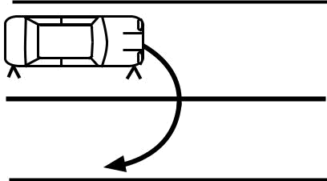

Task 10 Sign Off

Driver’s Name

Licence Number

Learner Driver’s Signature

Authorised Examiner Signature

MDI No. Date

Authorised Examiner Notes
Unit 2: Task 11 – The 3-point turn

Learning |  | (a) The learner will be able to select a safe and suitable location to do the 3-point turn; and
Outcome |  | (b) The learner will be able to turn the vehicle around safely and competently within
 |  | the boundaries of a carriageway that is narrower than the turning circle of the vehicle
 |  | while maintaining full control of the vehicle.
Assessment |  | The learner will accurately perform parts (a) and (b) of this task together without assistance.
Standard |  | The assessment will be a demonstration on at least two consecutive but separate occasions.
Task 11 Requirements |  |  | Homework
(a) | Selecting a location for the 3-point turn
1(a) | Select a safe location in accordance with Task 10, steps 1(a) to 3(a),
 | except reversing to complete the manoeuvre will be required; and
2(a) | Choose a location where there is no obstruction (posts etc.)
 | on the left footpath near the kerb, just forward of the front passenger’s door
 | (reversing area during the 3-point turn).
(b) | The 3-Point turn (U-turn including reversing)
1(b) | Comply with Task 10, steps 1(b) to 3(b) in the simple U-turn;
2(b) | About 1 metre from the right kerb and while keeping the vehicle moving
 | (optional), turn the steering wheel quickly to the left;
3(b) | Stop before touching the kerb;
4(b) | Select reverse gear, apply the handbrake if required
 | (holding the button in - optional) and check both directions and behind;
5(b) | Move off in reverse without rolling or stalling, under full control;
6(b) | About 1 metre from the kerb while keeping the vehicle moving (optional),
 | steer quickly to the right and prepare to move off down the road
 | without additional steering (except for straightening);
7(b) | Stop before touching the kerb;
8(b) | Select first gear* or ‘Drive’**, apply the handbrake if required
 | (holding the button in - optional) and check both ways for traffic;
9(b) | If safe, move off down the road maintaining full control of the vehicle
 | without over-steering (Aim high in steering); and
10(b) | Perform all steps 1(b) to 9(b) in the above sequence.

*MANUAL **AUTOMATICS

Task Assessment Records

- Selecting the location for the 3-point turn

- The 3-point turn (U-turn including reverse)

Example of a 3-point turn
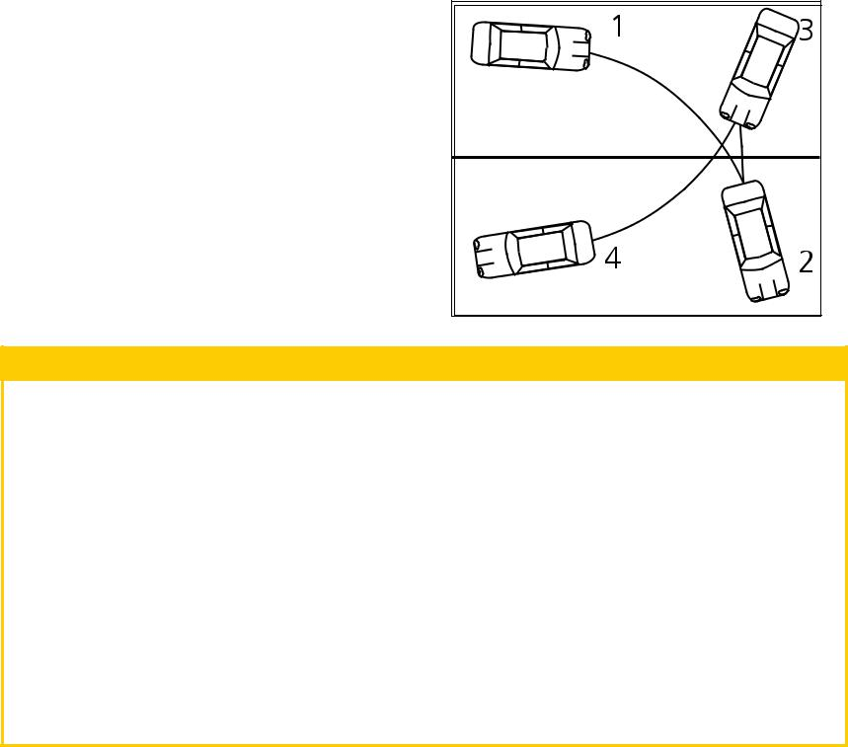

Task 11 Sign Off

Driver’s Name

Licence Number

Learner Driver’s Signature

Authorised Examiner Signature

MDI No. Date

Authorised Examiner Notes

ISMF Classification when complete – SENSITIVE: PERSONAL – I3 – A3

T

11

Unit 2 - Slow Speed Manoeuvres

53

T

- Unit 2: Task 12 – 90 degree angle park (front to kerb)

 |  | Learning |  |  | (a) The learner will be able to enter a 90 degree angle park (if available), front to the kerb,
 |  | Outcome |  |  | safely and competently while maintaining full control of the vehicle; and
 |  |  |  |  | (b) The learner will be able to leave a 90 degree angle park (if available) safely
 |  |  |  |  | and competently while maintaining full control of the vehicle.
 |  | Assessment |  |  | The learner will accurately perform parts (a) and (b) of this task together without assistance.
 |  | Standard |  |  | The assessment will be a demonstration on at least two consecutive but separate occasions.
 |  | Task 12 Requirements |  |  |  | Homework
Manoeuvres
Manoeuvres |  | (a) | (either mirror or shoulder check); and
 |  | (a) | Entering a 90 degree angle park (front to kerb)
 |  | 1(a) | Select a suitable parking bay, check the mirror, signal, and slow the vehicle
 |  |  | to a safe and controllable speed;
 |  | 2(a) | Choose the appropriate gear for control (if required);
 |  | 3(a) | Check vehicle clearance (as applicable) on the inside of the turn
Speed
Speed |  | 4(a) | Correctly position the vehicle, front to kerb, wholly within the bay
 |  |  | while maintaining full control without touching the kerb and is:
 |  |  | (i) | Not more than 300 mm out of parallel with the lines;
Slow | –I3–A3 |  | (ii) | Not more than 300 mm from the kerb or end of parking bay; &
Slow | –I3–A3 |  | (iii) Where practicable, central within the parking bay with the front wheels
 |  |  |  | pointing straight ahead towards the kerb.
Unit2- | SENSITIVE:PERSONAL | (b) | Leaving a 90 degree angle park
 |  | 1(b) | Select reverse gear;
 |  | 2(b) | Constantly check behind, both sides and to the front before moving
 |  |  | and during reversing;
 |  | 3(b) | Reverse slowly under full control of the vehicle and check for clearance
 | – |  | of the front of the vehicle (where appropriate);
 | complete | 4(b) | Reverse the vehicle only for such a distance as is necessary
 | complete |  | to allow the vehicle to safely clear the parking bay alongside;
 |  |  | (Position 2 in diagram) and turn the steering wheel sufficiently
 | when
 | when | 5(b) | Move off in accordance with Task 3, steps (2) to (7) (signalling as appropriate)
 | ISMFClassification |  | with safety and without rolling; and
 | ISMFClassification | 6(b) | Except for straightening the steering wheel, drive forward under full control
 |  |  | in the intended direction of travel requiring less than one turn
 |  |  | of the steering wheel in that direction.
54

Task Assessment Records

- Enter a 90 degree angle parking bay

- Leave a 90 degree angle parking bay

Example of entering an angle park

When reversing out
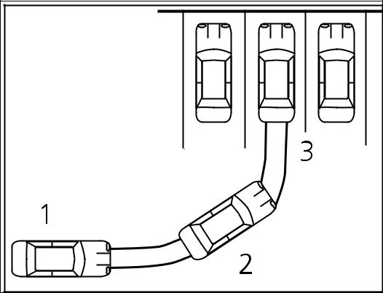

of the angled parking bay,

the vehicle should not

go beyond Position 2

in the diagram

Task 12 Sign Off

Driver’s Name

Licence Number

Learner Driver’s Signature

Authorised Examiner Signature

MDI No. Date

Authorised Examiner Notes
Unit 2: Task 13 – Reverse parallel parking

Learning (a) The learner will be able to leave a confined parallel parking bay safely and competently

Outcome while maintaining full control of the vehicle; and

(b) The learner will be able to park the vehicle in a confined parallel parking bay safely

and competently while maintaining full control of the vehicle.

Assessment The learner will accurately perform parts (a) and (b) of this task together without assistance. Standard The assessment will be a demonstration on at least two consecutive but separated occasions

if training has been given. Two attempts at the manoeuvre are allowed to achieve each successful demonstration.

Task 13 Requirements |  | Homework
(a) | Leaving a confined parallel parking bay
1(a) | Check blind spot and behind by turning around prior to reversing.
2(a) | Check mirror, signal to the right for minimum of five (5) seconds, check blind spot
 | just prior to leaving the bay (use of the handbrake is optional as required).
3(a) | Exit the parking bay without touching the poles and without driving between
 | the pole and the kerb.
4(a) | Stop so that the rear of the vehicle is just past the parking bay’s front pole
 | and parallel to the kerb.
(b) | Parking in a confined parallel parking bay
1(b) | Before reversing check the right blind spot and behind for other road users.
2(b) | Check the right blind spot again, forward and behind prior to turning
 | the wheel to the left when reversing into the bay.
3(b) | Complete the parking exercise with no more than two (2) changes of direction
 | (or three directional movements) after commencing reverse into the bay
 | (i) Reverse into the bay; (ii) Drive forward to the front; and
 | (iii) Reverse to centralise.
4(b) | Parallel park the vehicle so that the left wheels are within 300mm of the kerb
 | and straight, and centrally located (not less than 900mm to the nearest pole);
5(b) | The wheels must not touch the kerb and the vehicle must not touch any pole
 | or pass between any pole and the kerb;
6(b) | Full control of the vehicle is demonstrated (without stalling)

*Note - Two attempts are permitted for a successful attempt at this manoeuvre to be recorded.

Task Assessment Records

- Leave a confined parallel parking bay

- Park in a confined parallel parking bay Example of parallel parking
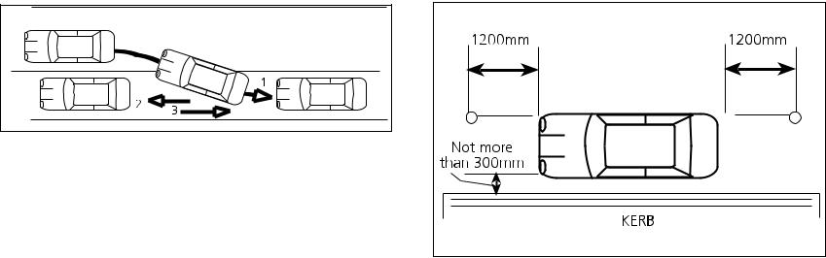

Task 13 Sign Off

Driver’s Name

Licence Number

Learner Driver’s Signature

Authorised Examiner Signature

MDI No. Date

Authorised Examiner Notes

ISMF Classification when complete – SENSITIVE: PERSONAL – I3 – A3

T

13

Unit 2 - Slow Speed Manoeuvres

55

T

14

Unit 2 - Slow Speed Manoeuvres

56

ISMF Classification when complete – SENSITIVE: PERSONAL – I3 – A3

Unit 2: Task 14 – Review all slow speed manoeuvres

Learning The learner will be able to competently demonstrate each learning outcome from Tasks 9 to 13.

Outcome

Assessment The learner will perform one complete example of each of the learning outcomes for Tasks 9 to 13 Standard without assistance. Any learning outcome that does not meet the standard for the task must be

re-trained and re-assessed in accordance with the assessment method and standard for that original task.

Task 14 Requirements |  | Homework
1 | Demonstrate one complete example of Task 9
 | (‘stopping and securing the vehicle on a hill’ and ‘moving off uphill’ procedure)
 | on request;
2 | Demonstrate one complete example of Task 10
 | (‘the simple U-turn’) on request;
3 | Demonstrate one complete example of Task 11
 | (‘the 3-point turn’) on request;
4 | Demonstrate one complete example of Task 12
 | (‘entering and leaving a 90 degree angle park’) on request; and
5 | Demonstrate one complete example of Task 13
 | (‘reverse parallel parking’) on request.*

*Note - Two attempts are permitted for a successful attempt at this manoeuvre.

Task Assessment Records

Instructor to place a tick ‘‘ in the appropriate box if the task is performed correctly, and a cross ‘X‘ in the box where the standard has not been achieved.

(a) (b)

Task 9 – moving off up hill

Task 10 – the simple U-turn

Task 11 – the 3-point turn

Task 12 – 90 degree angle park (front to kerb)

Task 13 – reverse parallel parking

Task 14 Sign Off

Driver’s Name

Licence Number

Learner Driver’s Signature

Authorised Examiner Signature

MDI No. Date

Authorised Examiner Notes
Unit 3: Task 15 – Vehicle road positioning

Learning | (a) | The learner will safely and competently position the vehicle correctly on laned
Outcome |  | and unlaned roads in accordance with the law and safe driving practices;
 | (b) | The learner will maintain safe following distances from other vehicles and safety margins
 |  | when passing stationary objects or cyclists; and
 | (c) | The learner will correctly position the vehicle when turning left or right.

Assessment The learner will demonstrate compliance with road craft concepts at least 80% of the time Standard (see pages 10 to 17) and compliance with the law during the assessment without assistance.

Task 15 Requirements |  | Homework
(a) | Vehicle positioning on laned and unlaned roads
1(a) | Keep the vehicle as near as practicable to the left on unlaned roads
 | without unnecessarily obstructing other traffic;
2(a) | Keep the vehicle wholly within the marked lane when travelling straight
 | or in bends; and
3(a) | Use the space within the lane to maintain safety margins.
(b) | Maintain safe following distances and safety margins
1(b) | Maintain a minimum of three (3) seconds following interval (see page 17)
 | from the vehicle in front;
2(b) | Allow a safety margin of at least 1.2 m (where practicable)
 | when passing objects, vehicles or cyclists; and
3(b) | Stop in a position behind other vehicles allowing sufficient space to turn away
 | from the vehicle in front if necessary.
(c) | Positioning for turns
1(c) | Correctly position the vehicle at ‘Stop’ lines
 | (associated with ‘Stop’ signs, crossings and traffic lights etc.);
2(c) | Adopt correct road position at intersections when the view is obstructed; and
3(c) | Demonstrate the correct approach and turn positions for turning left and right
 | at intersections in accordance with the law.

Range Statement

(A short drive in light traffic only)

Instructor to place a tick ‘‘ in the appropriate box if the task is performed correctly, and a cross ‘X‘ in the box where the standard has not been achieved.

Turns

- Left turn

- Right turn

Wide unlaned

• Straight

Stop sign with a line

• Straight

Laned roads

• Straight

Intersections - poor view

• Straight

Task 15 Sign Off

Driver’s Name

Licence Number

Learner Driver’s Signature

Authorised Examiner Signature

MDI No. Date

Authorised Examiner Notes

ISMF Classification when complete – SENSITIVE: PERSONAL – I3 – A3

T

15

Unit 3 - Basic Road Skills

57

T

- Unit 3: Task 16 – Lane changing and diverging/merging

Learning (a) The learner will be able to change lanes safely and competently to the right and to the left

Outcome while complying with the ‘System of Car Control’; and

(b) The learner will be able to diverge safely and competently to the left or right

or merge with other traffic while complying with the ‘System of Car Control’.

Assessment The learner will demonstrate compliance with road craft concepts at least 80% of the time

 |  | Standard (see pages 10 to 17) and compliance with the law over the complete assessment without assistance.
 |  | Task 16 Requirements |  |  | Homework
 |  | (a) | Changing lanes procedure
 |  | 1(a) | Select a suitable location (not approaching traffic lights etc.);
Skills |  | 2(a) | Accurately apply the ‘System of Car Control’ when changing
Skills |  | 3(a) | Check the appropriate blind spot just before diverging to the new lane.
 |  |  | from one lane to another (either left or right); and
Road
Road |  | (b) | Diverging or merging procedure
Road |  | 1(b) | Ensure that there is no vehicle directly alongside
-Basic |  |  | (where possible keep the vehicle off-set to other vehicles alongside);
-Basic | –A3 | 2(b) | When merging or diverging by more than 1 metre or crossing a lane line,
 |  |  | comply with the ‘Lane Changing Procedure’
 |  |  | (steps 1(a) to 3(a)) above and give way rules; and
3 | I3 | 3(b) | When merging or diverging by less than 1 metre, or diverging over
Unit | PERSONAL– |  | a long distance when passing parked vehicles on an unlaned road,
 |  |  | comply with step 2(a) above except signals and blind spots
 |  |  | may be omitted only if safe.
58 | ISMF Classification when complete – SENSITIVE:

Range Statement


(light traffic only)

Wide unlaned roads

• Passing a parked vehicle

Laned roads

- Lane changes (left)

- Lane changes (right)

Task 16 Sign Off

Driver’s Name

Licence Number

Learner Driver’s Signature

Authorised Examiner Signature

MDI No. Date

Authorised Examiner Notes
Unit 3: Task 17 – Turning at corners

Learning (a+b) The learner will be able to turn safely and competently to the left and to the right

Outcome (with and without a stop) at simple intersections while complying with the ‘System of Car Control’ and the rules for turning and giving way; and

- The learner will demonstrate correct compliance with ‘Stop’ and ‘Give Way’ signs.

Assessment The learner will demonstrate compliance with road craft concepts at least 80% of the time Standard (see pages 10 to 17) and compliance with the law during the assessment without assistance.

Task 17 Requirements |  | Homework
(a) | Turning at corners (with a stop)
1(a) | Demonstrate turning left and right at corners incorporating a stop
 | while complying with the laws for turning;
2(a) | Demonstrate the ‘System of Car Control’ when turning right and left at corners;
3(a) | Demonstrate safe observation patterns (Rules of Observation) while maintaining
 | full vehicle control; and
4(a) | Comply with signalling requirements, ‘Stop’ and ‘Give Way’ signs and lines,
 | and the give way rules at all times.
(b) | Turning at corners (without a stop)
1(b) | Demonstrate turning left and right at corners without a stop where practicable
 | while complying with the laws for turning;
2(b) | Demonstrate the ‘System of Car Control’ when turning right and left at corners;
3(b) | Demonstrate correct and timely observation patterns when turning left
 | and right at corners while maintaining full control of the vehicle; and
4(b) | Comply with signalling and ‘Give Way’ rules.
(c) | Negotiate ‘Stop’ and ‘Give Way’ signs/lines
1(c) | Comply with the ‘System of Car Control’ when negotiating ‘Stop’
 | and ‘Give Way’ signs and lines; and
2(c) | Comply with ‘Stop’ and ‘Give Way’ signs and lines.

Range Statement

(light traffic only)

With a stop

- Left turns

- Right turns

With a ‘Stop’ sign

- Left turns

- Right turns

Without a stop

- Left turns

- Right turns

‘Give way’ sign

- Left turns

- Right turns

Task 17 Sign Off

Driver’s Name

Licence Number

Learner Driver’s Signature

Authorised Examiner Signature

MDI No. Date

Authorised Examiner Notes

ISMF Classification when complete – SENSITIVE: PERSONAL – I3 – A3

T

17

Unit 3 - Basic Road Skills

59

T

18

- Basic Road Skills | – A3
Unit 3 | PERSONAL – I3
60 | ISMF Classification when complete – SENSITIVE:

Unit 3: Task 18 – Turning on to and from laned roads

Learning The learner will be able to demonstrate turning left and right safely on to and from laned roads Outcome using the ‘System of Car Control’ while complying with the ‘Give Way’ rules and the laws relating

to turning.

Assessment The learner will demonstrate compliance with road craft concepts at least 80% of the time Standard (see pages 10 to 17) and compliance with the law during the assessment without assistance

Task 18 Requirements |  | Homework
(a) | Turning left on to and from laned roads
1(a) | Comply with all laws relating to signalling, turning and ‘Giving Way’;
2(a) | Approach every turn at a safe speed under full control;
3(a) | Correct and timely observation of any conflicting traffic when turning left;
4(a) | Apply appropriate acceleration during and after turning when entering
 | the traffic flow of the other road; and
5(a) | Comply with the ‘System of Car Control’
(b) | Turning right on to and from laned roads
1(b) | Comply with all laws relating to signalling, turning and ‘Giving Way’;
2(b) | Approach every turn at a safe speed under full control;
3(b) | Correct and timely observation of any conflicting traffic when turning right;
4(b) | Apply appropriate acceleration during and after turning when entering
 | the traffic flow of the other road; and
5(b) | Comply with the ‘System of Car Control’.

Range Statement

(light traffic only)

On to

- Left turns

- Right turns

From

- Left turns

- Right turns

Compound turns

- Left turn followed by a right turn

- Right turn followed by a left turn

Task 18 Sign Off

Driver’s Name

Licence Number

Learner Driver’s Signature

Authorised Examiner Signature

MDI No. Date

Authorised Examiner Notes
Unit 3: Task 19 – Turning at roundabouts

Learning The learner will be able to turn left, turn right and go straight on safely at unlaned and laned Outcome roundabouts while complying with all laws relating to giving way and positioning on roundabouts,

and the ‘System of Car Control’.

Assessment The learner will demonstrate compliance with road craft concepts at least 80% of the time Standard (see pages 10 to 17) and compliance with the law during the assessment without assistance

Task 19 Requirements |  | Homework
(a) | Turning at unlaned roundabouts
1(a) | Comply with ‘Giving Way’, signalling and positioning laws
 | at unlaned roundabouts;
2(a) | Negotiate every roundabout at a safe speed under full control;
3(a) | Look in the appropriate directions when approaching and during turns
 | at roundabouts; and
4(a) | Comply with the ‘System of Car Control’.
(b) | Turning at laned roundabouts
1(b) | Comply with ‘Giving Way’, signalling, arrows, lanes and positioning laws
 | at laned roundabouts;
2(b) | Negotiate every roundabout at a safe speed under full control;
3(b) | Look in the appropriate directions when approaching and during turns
 | at roundabouts; and
4(b) | Comply with the ‘System of Car Control’.
(c) | Travelling straight on at a roundabout
1(c) | Comply with ‘Giving Way’, signalling, arrows, lanes and positioning laws
 | approaching and in the roundabout;
2(c) | Negotiate every roundabout at a safe speed under full control;
3(c) | Look in the appropriate directions when approaching and proceding
 | through roundabouts; and
4(c) | Comply with the ‘System of Car Control’.

Range Statement

(light traffic only)
Unlaned |  |  |  | ( |  |  | )
• Left turns |  |  |  | ( |  |  | )
• Right turns |  |  |  | ( |  |  | )
• Straight on |  |  |  | ( |  |  | )
Laned
• Left turns
• Right turns
• Straight on
 | Task 19 Sign Off
 | Driver’s Name
 | Licence Number
 | Learner Driver’s Signature
 | Authorised Examiner Signature
 | MDI No. | Date

Authorised Examiner Notes

ISMF Classification when complete – SENSITIVE: PERSONAL – I3 – A3

T

19

Unit 3 - Basic Road Skills

61

T

Unit 3 - Basic Road Skills

62

ISMF Classification when complete – SENSITIVE: PERSONAL – I3 – A3

Unit 3: Task 20 – Negotiating traffic lights

Learning (a+b) The learner will safely negotiate traffic lights (with and without arrows)

Outcome by turning right, left and proceeding straight ahead while complying with all laws and ‘System of Car Control’; and

- The learner will safely demonstrate turning left at slip lanes.

Assessment The learner will demonstrate compliance with road craft concepts at least 80% of the time Standard (see pages 10 to 17) and compliance with the law during the assessment without assistance

Task 20 Requirements |  | Homework
(a) | Turning left and right at traffic lights
1(a) | Comply with the law for traffic light signals, associated stop lines,
 | turning lines and arrows;
2(a) | Enter and correctly position vehicle lawfully within the intersection
 | when standing to give way to opposing traffic;
3(a) | When turning right, keep the front wheels straight (where practicable)
 | while waiting to give way to on-coming traffic; and
4(a) | Comply with Tasks 17 and 18 requirements when turning.
(b) | Following a straight course through traffic lights
1(b) | Comply with the law for traffic light signals, associated stop lines and arrows;
2(b) | Comply with ‘System of Car Control’ approaching lights; and
3(b) | Apply correct stopping procedure (Task 4(a)) when required.
(c) | Turning left through a slip lane
1(c) | Comply with all ‘Give Way’, signalling and turning laws;
2(c) | Comply with turning left requirements for Tasks 17 and 18
 | including safe speed of approach to the turn; and
3(c) | Demonstrate appropriate and timely observation patterns,
 | ‘System of Car Control’ and vehicle control.

Note - If intersections controlled by traffic lights are not reasonably accessible, Task 28A must be conducted instead of Task 20 and 28.

Range Statement


(light traffic only)

No arrows

- Left turns

- Right turns

- Straight on at intersections

Slip lane (no arrows)

• Left turns

Task 20 Sign Off

Driver’s Name

Licence Number

Learner Driver’s Signature

Authorised Examiner Signature

MDI No. Date

Authorised Examiner Notes
Unit 3: Task 21 – Light traffic urban driving

Learning | (a) | The learner will accurately comply with the law while negotiating Emu, Koala
Outcome |  | and Wombat pedestrian crossings and school zones (where available);
 | (b) | The learner will comply with all speed limits associated with speed zones, road works,
 |  | bridges, built-up areas, schools and car parks; and
 | (c) | The learner will demonstrate reasonable progress by keeping up with the flow of traffic
 |  | when it is practicable, legal and safe.

Assessment The learner will demonstrate compliance with road craft concepts at least 80% of the time Standard (see pages 10 to 17) and compliance with the law during the assessment without assistance

Task 21 Requirements |  | Homework
(a) | Pedestrian crossings and school zones
1(a) | Comply with the laws for pedestrian crossings and school zones; and
2(a) | Accurately comply with the ‘System of Car Control’.
(b) | Speed limits
1(b) | Comply with all speed limits in speed zones and built-up areas; and
2(b) | Comply with speed limits for bridges, roadworks, schools, car parks
 | and learner requirements.
(c) | Maintain reasonable progress
1(c) | Where safe and practicable, maintain a speed which is within 5 km/h
 | of the legal speed limit but does not exceed the speed limit;
2(c) | Move off in a line of traffic without any unnecessary delay
 | or obstructing other traffic;
3(c) | Decelerate but not slow excessively or stop unnecessarily at intersections
 | where the view is open and clear, and it is safe to go; and
4(c) | Maintain at least a ‘3 second’ following distance between the vehicle in front
 | and the learner’s vehicle.

Range Statement

(A short drive in light traffic only)

Straight driving

- Operating pedestrian crossing

- School zone

- Speed limit change

- Intersections with a good view and ‘Give Way’ signs

Task 21 Sign Off

Driver’s Name

Licence Number

Learner Driver’s Signature

Authorised Examiner Signature

MDI No. Date

Authorised Examiner Notes

ISMF Classification when complete – SENSITIVE: PERSONAL – I3 – A3

T

21

Unit 3 - Basic Road Skills

63

T

- Unit 3: Task 22 – Country driving (driving at higher speeds)

Learning (a) The learner will demonstrate accurate compliance with the ‘System of Car Control’, Rules

Outcome of Braking, Steering and Observation (see pages 10 to 17) as applied to bends, crests and

overtaking while driving at higher speeds; and

(b) The learner will maintain full control of the vehicle while driving at higher speeds.

Assessment The learner will demonstrate compliance with road craft concepts at least 80% of the time

 |  | Standard (see pages 10 to 17) and compliance with the law during the assessment without assistance
 |  | Task 22 Requirements |  |  | Homework
 |  | (a) | Negotiating bends and crests
 |  | 1(a) | Comply with speed limits, road markings, keeping left and ‘Due Care’
Skills |  |  | requirements while maintaining reasonable progress;
Skills |  | 2(a) | Demonstrate a safe speed and position of approach to all bends and crests;
Road |  | 3(a) | Comply with ‘System of Car Control’ approaching bends and crests
Road |  |  | (including selection of the correct gear before the bend or crest);
 |  | 4(a) | Comply with the Rules of Braking and ‘acceleration sense’
-Basic |  |  | approaching bends and crests;
-Basic | –A3 | 5(a) | Comply with the Rules of Steering when braking and cornering;
 |  | 6(a) | Demonstrate good forward observation (Aim high in steering)
3 |  |  | and complies with the Rules of Observation; and
3 | I3 | 7(a) | Display safe and complete control of the vehicle at all times.
Unit | PERSONAL– | 7(a)
Unit | PERSONAL– | (b) | Overtaking other vehicles
Unit | PERSONAL– | 1(b) | with the law (road markings, sufficient clear view);
 |  | 1(b) | Correctly select a safe and suitable location to overtake while complying
 | SENSITIVE:
 | SENSITIVE: | 3(b) | Comply with the ‘System of Car Control’ while overtaking
 |  | 2(b) | Maintain a reasonable following distance before overtaking
 |  |  | in order to comply with the Rules of Observation; and
 | – |  | using appropriate acceleration; or
 | complete
 | complete | 4(b) | to the Instructor the selection of safe and suitable locations
 |  | 4(b) | If suitable overtaking situations do not occur, verbally demonstrate
 | ISMF Classification when |  | where there is sufficient distance to overtake safely.
64 | ISMF Classification when

Range Statement

(A short drive in light traffic only with a speed limit of 80km/hr or more) Driving at higher speeds

- Entering

- Leaving

• Bends - right

• Bends - left

- Crests

- Overtaking

Task 22 Sign Off

Driver’s Name

Licence Number

Learner Driver’s Signature

Authorised Examiner Signature

MDI No. Date

Authorised Examiner Notes
Unit 4: Task 23 – Safe driving strategies

Learning (a) The learner will competently maintain safe following distances, passing clearances

Outcome and appropriate positioning of the vehicle for improved forward observation

in medium to heavy traffic; and

(b) Demonstrate compliance with the ‘System of Car Control’ when approaching potential

hazards in traffic..

Assessment The learner will demonstrate compliance with road craft concepts at least 80% of the time Standard (see pages 10 to 17) and compliance with the law during the assessment without assistance

Task 23 Requirements |  | Homework
(a) | Safe positioning of the vehicle in traffic
1(a) | Keep at least 3 seconds time interval between the learner’s vehicle
 | and the vehicle in front, increasing this interval for adverse weather conditions
 | or if being closely followed;
2(a) | Keep at least 1.2 metre clearance from parked vehicles, cyclists or other vehicles
 | when passing where safe and practicable;
3(a) | Adjust the vehicle’s position by holding back if the vehicle in front
 | obstructs the view ahead (Observation - Get the big picture);
4(a) | Maintain the vehicle’s position in a line of traffic without obstructing following
 | traffic where it is safe and legal to do so;
5(a) | Avoid unnecessary travel in blind spots of other vehicles
 | (Observation - Leave yourself an OUT);
6(a) | Stop in a position behind other vehicles to allow sufficient space to turn away
 | from the vehicle in front (where practicable);
7(a) | Without obstructing the intersection stop in a line of traffic (road law); and
8(a) | Comply with all appropriate road rules.
(b) | ‘System of Car Control’ as applied to traffic hazards
1(b) | Comply with the features of the ‘System of Car Control’ in the correct sequence
 | when approaching hazards in traffic;
2(b) | Comply with ‘System of Car Control’ when approaching traffic lights
 | (eg. check mirror, cover the brake, etc.);
3(b) | Demonstrate ‘System of Car Control’ when passing stationary buses
 | or other similar hazards; and
4(b) | Demonstrate ‘System of Car Control’ when giving way.

Range Statement

A short drive in medium to heavy traffic, including laned and unlaned roads with traffic lights or other hazards where stopping on at least five (5) occasions is required.

Wide unlaned roads

- Straight drive following traffic (with two stops in a line of traffic)

Laned roads

- Straight drive following traffic (with two stops in a line of traffic)

Task 23 Sign Off

Driver’s Name

Licence Number

Learner Driver’s Signature

Authorised Examiner Signature

MDI No. Date

Authorised Examiner Notes

ISMF Classification when complete – SENSITIVE: PERSONAL – I3 – A3

T

23

Unit 4 - Traffic Management Skills

65

T

- Unit 4: Task 24 – Lane management in traffic

Learning (a) The learner will be able to select the appropriate lane safely and competently well in advance

Outcome to maintain reasonable progress and efficient traffic flow; and

(b) The learner will be able to change lanes safely and competently in traffic while complying

with the ‘System of Car Control’.

Assessment The learner will demonstrate compliance with road craft concepts at least 80% of the time

 |  | Standard (see pages 10 to 17) and compliance with the law during the assessment without assistance
 |  | Task 24 Requirements |  |  | Homework
Skills
Skills |  | (a) | Lane selection in traffic
Skills |  | 1(a) | Identify potential hazards well in advance and take safe
Management |  |  | and appropriate action (Observation - Get the Big Picture);
Management |  | 2(a) | from one lane to another (either left or right);
 |  | 2(a) | Confidently select safe gaps when changing lanes; and
 |  | 3(a) | Select suitable and timely locations when changing lanes
 |  |  | (‘System of Car Control’ - select the course).
 |  | (b) | Lane changing in traffic
 |  | 1(b) | Competently apply the ‘System of Car Control’ when changing
Unit4-Traffic
Unit4-Traffic | SENSITIVE:PERSONAL–I3–A3 | 2(b) | Check the appropriate blind spot just before changing lanes;
Unit4-Traffic | SENSITIVE:PERSONAL–I3–A3 | 3(b) | Co-operate with other drivers by accepting and giving reasonable offers
 |  |  | of courtesy when safe; and
 |  | 4(b) | Change lanes in traffic only when safe without significantly interfering
 |  |  | with the flow of traffic in the newly selected lane.
66 | ISMF Classification when complete –

Range Statement

(medium to heavy traffic)

Laned Roads

- Lane changes (left)

- Lane changes (right)

Task 24 Sign Off

Driver’s Name

Licence Number

Learner Driver’s Signature

Authorised Examiner Signature

MDI No. Date

Authorised Examiner Notes
Unit 4: Task 25 – Turning in traffic

Learning (a) The learner will turn right and left safely and competently in traffic under full control while

Outcome complying with the ‘Give Way’ laws, ‘turning’ laws and the ‘System of Car Control’; and

(b) The learner will competently select safe gaps when entering or crossing a flow

of traffic on busy roads without unnecessary hesitation.

Assessment The learner will demonstrate compliance with road craft concepts at least 80% of the time Standard (see pages 10 to 17) and compliance with the law during the assessment without assistance

Task 25 Requirements |  | Homework
(a) | Turning left on to and from busy roads
1(a) | Display compliance with the ‘Give Way’ and ‘turning’ laws;
2(a) | Maintain full vehicle control throughout each turn
 | (ie. no wide exits, question-mark turns, or stalls);
3(a) | When exiting or entering a busy road, keep as near as reasonably practicable
 | to the left;
4(a) | Comply with the ‘System of Car Control’ throughout the assessment;
5(a) | Display competent selection of safe gaps when entering a traffic flow; and
6(a) | Display competent acceleration skills when entering a gap
 | (See ‘System of Car Control’).
(b) | Turning right on to and from busy roads
1(b) | Display compliance with all ‘Give Way’ and turning’ laws;
2(b) | Maintain full vehicle control throughout each turn
 | (ie. no wide exits, question-mark turns, or stalls);
3(b) | Comply with the ‘System of Car Control’ throughout the assessment;
4(b) | Make early selection of the most appropriate and lawful lane for turning;
5(b) | Display competent selection of safe gaps when entering
 | or crossing a traffic flow when turning right; and
6(b) | Display competent acceleration skills when entering a safe gap
 | or crossing a flow of traffic - (See ‘System of Car Control’).

Range Statement

(medium to heavy traffic)

Unlaned roads

- On to - left turn

- On to - right turn

- From - left turn

- From - right turn

Laned roads

- On to - left turn

- On to - right turn

- From - left turn

- From - right turn

Task 25 Sign Off

Driver’s Name

Licence Number

Learner Driver’s Signature

Authorised Examiner Signature

MDI No. Date

Authorised Examiner Notes

ISMF Classification when complete – SENSITIVE: PERSONAL – I3 – A3

T

25

Unit 4 - Traffic Management Skills

67

T

- Unit 4: Task 26 – Managing traffic at roundabouts

Learning The learner will be able to turn right, left and travel straight-on safely and competently at laned and Outcome unlaned roundabouts in medium to heavy traffic while complying with the law and the ‘System of

Car Control’.

Assessment The learner will demonstrate compliance with road craft concepts at least 80% of the time

 |  | Standard (see pages 10 to 17) and compliance with the law during the assessment without assistance
 |  | Task 26 Requirements |  |  | Homework
Skills |  | (a) | Managing traffic in unlaned roundabouts
Skills |  | 1(a) | Comply with the requirements and standard as laid down
 |  |  | in Task 19 (a) - turning at unlaned roundabouts;
Management |  | 2(a) | Display competent and confident decision making when selecting safe gaps
Management |  |  | in Task 19 (b) - laned roundabouts;
 |  |  | in traffic on the roundabout; and
 |  | 3(a) | Demonstrate competent use of acceleration when joining and leaving
 |  |  | a traffic stream on the carriageway of the roundabout.
 |  | (b) | Managing traffic in laned roundabouts
 |  | 1(b) | Comply with the requirements and standard as laid down
Unit4-Traffic | SENSITIVE:PERSONAL–I3–A3
Unit4-Traffic | SENSITIVE:PERSONAL–I3–A3 | 2(b) | Demonstrate early selection of correct lanes before, during and after turning
 |  |  | or when travelling straight on at the roundabout;
 |  | 3(b) | Display competent and confident decision making when selecting safe gaps
 |  |  | in traffic on the roundabout; and
 |  | 4(b) | Demonstrate competent use of acceleration when joining and leaving
 |  |  | a traffic stream on the carriageway of the roundabout.
68 | ISMF Classification when complete –

Range Statement

(medium to heavy traffic)

Unlaned roads

- Left turn

- Right turn

- Straight on

Laned roads

- Left turn

- Right turn

- Straight on

Task 26 Sign Off

Driver’s Name

Licence Number

Learner Driver’s Signature

Authorised Examiner Signature

MDI No. Date

Authorised Examiner Notes
Unit 4: Task 27 – “U” turn in traffic manoeuvre

Learning (a) The learner will be able to select a safe and suitable location on a busy road and competently

Outcome perform a U-turn with safety without the need for reversing; and

(b+c) The learner will be able to choose a safer option to a U-turn where the turn may be obstructed

due to changing traffic conditions.

Assessment The learner will accurately perform Parts (a) and (b), or (c) of this task without assistance.

Standard The assessment will be a demonstration on at least two consecutive but separate occasions.

Task 27 Requirements |  | Homework
(a) | Selecting a safe U-turn starting position
1(a) | Select a suitable position as for Task 10, steps 1(a) and 2(a);
2(a) | Select a position where only one major flow of traffic is required
 | to be crossed during the U-turn; and
3(a) | Select the most appropriate position that minimises the disruption to overtaking
 | or following traffic for that road (eg. a right turn store lane opposite a quiet road).
(b) | Perform a safe and complete U-turn
1(b) | Comply with all road markings, and the ‘Give Way’ rules for turning
 | and moving off (as required);
2(b) | Confidently select a safe gap in the traffic flow when presented;
3(b) | Use safe stopping areas within the U-turn as required; and
4(b) | Complete the U-turn safely without reversing while maintaining
 | full control of the vehicle.
(c) | Select a safe alternative to the U-turn due to traffic
1(c) | If traffic conditions change where the U-turn could become confusing
 | to other road users, select an acceptable safe option; and
2(c) | Perform the optional action with safety.

Range Statement

(medium to heavy traffic)

- Select a safe U-turn starting position (eg. ‘store’ lane - clear view)

- Perform a safe and complete U-turn on a busy road

- Select a safe alternative to the U-turn due to changing traffic conditions

Task 27 Sign Off

Driver’s Name

Licence Number

Learner Driver’s Signature

Authorised Examiner Signature

MDI No. Date

Authorised Examiner Notes

ISMF Classification when complete – SENSITIVE: PERSONAL – I3 – A3

T

27

Unit 4 - Traffic Management Skills

69

T

28

Unit 4 - Traffic Management Skills

70

ISMF Classification when complete – SENSITIVE: PERSONAL – I3 – A3

Unit 4: Task 28 – Negotiating traffic lights in traffic

Learning | (a) | The learner will be able to travel straight on, turn left and right safely and competently
Outcome |  | at traffic lights (with and without arrows) in medium to heavy traffic in accordance
 |  | with the ‘System of Car Control’; and
 | (b) | The learner will comply with the appropriate road laws governing the operation
 |  | of traffic lights, signalling, turning, positioning the vehicle and ‘Giving Way’.
 | (c) | The learner will comply with the appropriate road laws when negotiating ‘slip’ lanes

Assessment | The learner will demonstrate compliance with road craft concepts at least 80% of the time
Standard | (see pages 10 to 17) and compliance with the law during the assessment without assistance
Task 28 Requirements |  | Homework

- Turning left and right at traffic lights

1(a) Comply with steps 1(a) to 4(a) of Task 20;

2(a) While waiting to turn right, correctly position the vehicle within the intersection when permitted by the traffic lights;

3(a) Demonstrate confident selection of safe gaps when turning into or across a traffic flow;

4(a) Display appropriate use of acceleration for safety during the turn while maintaining full control of the vehicle; and

5(a) Ensure that other vehicles are not unnecessarily obstructed when turning.

- Following a straight course through traffic lights

1(b) Comply with steps 1(b) to 3(b) of Task 20; and

2(b) Display correct and confident decision making on approach to traffic lights having regard for weather, road conditions and following traffic

(type of vehicle and how near they are).

(c) Negotiating ‘slip’ lanes

1(c) Comply with steps 1(c) to 3(c) of Task 20;

2(c) Demonstrate confident selection of safe gaps when turning left through a ‘slip’ lane into a flow of traffic; and

3(c) Display appropriate use of acceleration for safety during and after the turn while maintaining full control of the vehicle.

Range Statement

(medium to heavy traffic)

No arrows

- Left turn

- Right turn

- Straight on

‘Slip lane’ (no arrows)

• Left turn

Task 28 Sign Off

Driver’s Name

Licence Number

Learner Driver’s Signature

Authorised Examiner Signature

MDI No. Date

Authorised Examiner Notes
Unit 4: Task 28A – Driving on unsealed roads

Note This task is a replacement task for locations where there is no reasonable access to traffic lights and replaces Tasks 20 and 28

Learning The learner will be able to negotiate bends, crests and intersections safely and competently on Outcome unsealed roads using the ‘System of Car Control’, Rules of Braking, Steering and Observation while

complying with the law.

Assessment The learner will demonstrate compliance with road craft concepts at least 80% of the time Standard (see pages 10 to 17) and compliance with the law during the assessment without assistance

Task 28A Requirements |  | Homework
1 | Demonstrate compliance with all appropriate road laws
 | (eg. as near as practicable to the left, etc.);
2 | Maintain full control of the vehicle at all times (skidding or sliding at any time
 | is considered to be loss of control - see page 12);
3 | Demonstrate a safe speed of approach to bends, crests and intersections
 | at all times;
4 | Demonstrate safe and correct entry lines into bends
 | (for good view and being seen - Rules of Observation);
5 | Demonstrate safe and correct exit lines from bends
 | (ensuring the vehicle leaves the bend on the correct side of the road);
6 | Comply with the ‘System of Car Control’, Rules of Braking,
 | Steering and Observation;
7 | Correctly adjust speed to that which is suitable to any change of road surface;
8 | Correctly adjust the following distance and use headlights as required
 | when following another vehicle (eg. decreased visibility due to dust etc.); and
9 | Correctly adjust the speed (minimum use of the accelerator)
 | when passing another vehicle travelling in the opposite direction
 | (to reduce the risk of possible windscreen damage).

Range Statement

(A short drive is required)

No arrows

- Left turn

- Right turn

• Bends - left

• Bends - right

• Crests

Task 28A Sign Off

Driver’s Name

Licence Number

Learner Driver’s Signature

Authorised Examiner Signature

MDI No. Date

Authorised Examiner Notes

ISMF Classification when complete – SENSITIVE: PERSONAL – I3 – A3

T

28A

Unit 4 - Traffic Management Skills

71

T
28B |  | Unit 4: Task 28B – Driving at night
 |  |  |  | Note | Task 28B is an optional Task. It is not compusory for the Accredited Instructor to sign. This task has
 |  |  |  |  | been placed in the Driving Companion primarily for the use by the Qualified Supervising Driver for
 |  |  |  |  | guidance when recording the compulsory 15 hours of night driving.
 |  |  | Learning |  | The learner will be able to safely and competently demonstrate the maintenance of safe following
 |  | Outcome |  |  | distances, passing clearances and appropriate position of the vehicle for improved forward
 |  |  |  |  | observation in relation to visual and speed adjustments using the ‘System of Car Control’, Rules of
 |  |  |  |  | Braking, Steering and Observation while complying with the law
Skills |  | Task 28B Requirements |  |  |  | Homework
Skills |  | 1 Recognition of Prior Learning (RPL) - if applicable
Management |  |  | • | Question learner on speed limits, keeping to the left, 3-Second Rule Formula,
Management |  |  |  | Use of headlights, ‘System of Car Control’, Rules of Braking,
 |  |  |  | Steering and Observation; and
 |  | 2 | Driving at night
 |  |  | • | Explain adjustments required in speed and positioning
 |  |  |  | in regard to visual deficiencies.
 |  |  | • | Explain the requirements in relation to clean windscreens and headlights.
Unit4-Traffic | SENSITIVE:PERSONAL–I3–A3 |  | • | Explain the requirements in relation to dipping headlights. (eg when following
Unit4-Traffic | SENSITIVE:PERSONAL–I3–A3 |  |  | within 200m from the rear of other traffic and when approaching vehicle
 |  |  |  | reaches a point 200m from your vehicle or immediately the headlights
 |  |  |  | of an approaching vehicle are dipped (whichever is sooner).
 |  |  | • | Explain the confusion that may occur when driving in built up areas
 |  |  |  | due to the mixture of neon signs, traffic lights, store lights, street lighting, etc.
 |  |  | • | Explain the need to be ‘seen’ (eg do not forget to turn on headlights).
 |  |  |  | Explain the lack of visual eye contact with other road users.
 |  |  | • | Demonstrate correct application of ‘System’.
 | – | 3 | Demonstrate night driving
 | complete
 | complete |  | • | Trainee to demonstrate under full instruction.
 |  |  | • | Trainee to demonstrate with instruction as required; and
 | ISMF Classification when |  | • | Trainee to practice until competent.
72 | ISMF Classification when

Log Book Entry

- Complete the log book entry.

(In the case of training given by an Authorised Examiner)

- Complete the ‘Hours of Driving’ page.

(In the case of training given by a Qualified Supervising Driver or a Motor Driving Instructor).

Sign only if accompanied by an Authorised Examiner.

Task 28B Sign Off

Driver’s Name

Licence Number

Learner Driver’s Signature

Authorised Examiner Signature

MDI No. Date

Authorised Examiner Notes
Units 1-2: Task 29 – Review of basic driving skills

Learning (a) The learner will be able to accurately perform one example of each of the learning

Outcome outcomes for the Basic Driving Procedures as identified in Unit 1, Tasks 1 to 7

without assistance; and

(b) The learner will be able to accurately perform one example of each of the Slow Speed

Manoeuvres as identified in Unit 2, Tasks 9 to 13 without assistance.

Assessment The learner will accurately perform one example of each of the learning outcomes for Tasks 1 to Standard 7 and 9 to 13 without assistance. Any learning outcome that does not meet the standard for the original task must be re-assessed (after any retraining) in accordance with the assessment method

and standard for that original task.

Task 29 Requirements |  | Homework
(a) | Review of all tasks in Unit 1
1(a) | Accurately perform Task 1 - cabin drill and controls
2(a) | Accurately perform Task 2 - starting up and shutting down the engine
3(a) | Accurately perform Task 3 - moving off from the kerb
4(a) | Accurately perform Task 4 - stopping and securing the vehicle
5(a) | Accurately perform Task 5 - stop and go (using the handbrake)
6(a) | Accurately demonstrate Task 6 - gear changing
7(a) | Accurately demonstrate Task 7 - control of the steering (forward and reverse)
(b) | Review of all tasks in Unit 2
1(b) | Accurately perform Task 9 - stopping and securing the vehicle on a hill
 | and moving off uphill
2(b) | Accurately perform Task 10 - the simple U-turn
3(b) | Accurately perform Task 11 - the 3-point turn
4(b) | Accurately perform Task 12 - entering and leaving a 90 degree angle park
5(b) | Accurately perform Task 13 - reverse parallel parking

Authorised Examiner Notes

Task Assessment Records

Instructor to place a tick ‘ ‘ in the appropriate box if the task is performed correctly, and a cross ‘X‘ in the box where the

standard has not been achieved.

(a) (b)

Task 1 – cabin drill and controls

Task 2 – starting up and shutting down the engine

Task 3 – moving off from the kerb

Task 4 – stopping and securing the vehicle

Task 5 – stop and go (using the handbrake)

Task 6 – gear changing

Task 7 – steering (forward and reverse)

Task 9 – moving off up hill

Task 10 – the simple U–turn

Task 11 – the 3–point turn

Task 12 – 90 Degree Angle Park (front to kerb)

Task 13 – reverse parallel parking

Task 29 Sign Off

Driver’s Name

Licence Number

Learner Driver’s Signature

Authorised Examiner Signature

MDI No. Date

ISMF Classification when complete – SENSITIVE: PERSONAL – I3 – A3

T

29

Unit 1-2 - Basic Driving Procedures and Manoeuvres

73

T

30

Units 3-4: Task 30 – Review of road skills and traffic management


Unit 3-4 - Basic Road and Traffic Management Skills

74

ISMF Classification when complete – SENSITIVE: PERSONAL – I3 – A3

Learning The learner will competently demonstrate a safe, efficient drive in medium to heavy traffic where Outcome practicable, of not less than 25 minutes duration without assistance while complying with all road

laws, the ‘System of Car Control’, Rules of Braking, Steering and Observation.

Assessment The learner will demonstrate compliance with road craft concepts at least 80% of the time Standard (see pages 10 to 17) and compliance with the law during the assessment without assistance

Task 30 Requirements |  |  |  | Homework
1 | Comply with all road laws;
2 | Comply with the ‘System of Car Control’ to left and right turns, traffic lights,
 | stopping, lane changes and other potential traffic hazards;
3 | Comply with the Rules of Braking, Steering and Observation; and
4 | Demonstrate appropriate forward planning, correct and timely road positioning,
 | and safe driving strategies.
Have you instructed your client on the following topics? |  | Tick

Do not overtake turning vehicle.

Road work signs and speeds.

Lane(s) closed signs.

Stopping and or queueing over a railway crossing.

Amber traffic lights flashing.

Traffic lights not working.

Giving way to emergency vehicles.

Speed required past a stationary emergency vehicle.

Use of vehicle lights at night (Inc. high beam etc.)

Overtaking at high speed.

What to do in the event of a crash.

Modified T intersections.

Road courtesy versus road rage.

Give way to buses.

Zip lane merging.

Vehicle Check (POWER)

Petrol – How and where.

Oil – Check oil level.

Water – Radiator and washers.

Electrics – Signals and brake lights.

Rubber – Legal tread.

Range Statement

Task 30 – A short drive of not less than 25 minutes duration in medium to heavy traffic.

Task 30 Sign Off

Driver’s Name

Licence Number

Learner Driver’s Signature

Authorised Examiner Signature

MDI No. Date

Authorised Examiner Notes

Obtaining your Provisional Driver’s Licence (P1 & P2)

When you have successfully completed your CBT&A course or a VORT,

your Authorised Examiner will issue a Certificate of Competency to you. After passing your Hazard Perception Test present the Certificate of Competency together with your Learner’s Permit, Log Book forms, Declaration and Task pages to a Service SA Centre and pay a fee for the P1 Provisional Driver’s Licence.

Take care of your Certificate of Competency. If you require a replacement because your certificate has been lost or defaced, a fee will apply.

A temporary P1 provisional driver’s licence will be issued for a period of up to one month. Your photographic licence will be forwarded to you in the mail so make sure that you have provided your correct address.

Refer to the Graduated Licensing Section (page 7) for information on how to progress from P1 to your full licence.

Provisional Licence laws and conditions (P1 & P2)

Provisional licences are issued subject to conditions. If you breach a condition you will lose your licence and be disqualified from driving. This is in addition to any other penalty. The conditions are:

- You must not drive a motor vehicle with any concentration of alcohol

in your blood or the presence of THC (the active component in cannabis), Methylamphetamine (also known as speed, ice or crystal meth) or MDMA (ecstasy) in your blood or oral saliva.

- you must not exceed any speed limit by 10 km/h or more.

- you must not accumulate four or more demerit points during the provisional licence period.

The following laws also apply to the holder of a provisional licence. If you breach any of these laws you may incur penalties such as fines, demerit points or loss of licence.

- you must only drive the class of motor vehicle stated on your licence.

- you must carry your provisional licence at all times whilst driving.

- you must not drive a high-powered vehicle while you are under the age of 25 (unless you have an exemption certificate).

- you must not drive over 100 km/h even if the local speed limit exceeds 100 km/h.

Laws that only apply to holders of P1 provisional licences (these laws do not apply to P2)

- You must display the correct size ‘P’ plates so they are clearly visible from the front and rear of the vehicle (rear only for motorcycles).

- You must not use any mobile phone function while driving, including hands free mode, Bluetooth technology and loud speaker operation.

- If you are under the age of 25 years, you must not drive

  - between midnight and 5am, or

  - with more than one passenger aged 16 to 20 years (excluding immediate family members)
Unless a Qualified Supervising Driver is seated next to you or you meet the exemption criteria*

- Holders of a motorcycle P1 Provisional Licence must not lane filter.

* Please refer to mylicence.sa.gov.au for exemption details.

What happens next?

75

What happens next?

Provisional Licence disqualification

If you do not comply with the above conditions or accumulate 4 or more demerit points you may be fined, have your licence cancelled and your Provisional Licence period extended when you regain your licence.

After disqualification

P1 drivers will be issued with a 3 year provisional licence, (1 year on P1 and two years on P2).

P2 drivers will be issued with a 2 year P2 licence.

‘P’ Plate

‘P’ plates must display a red letter ‘P’ against a white background with the size dimensions shown.
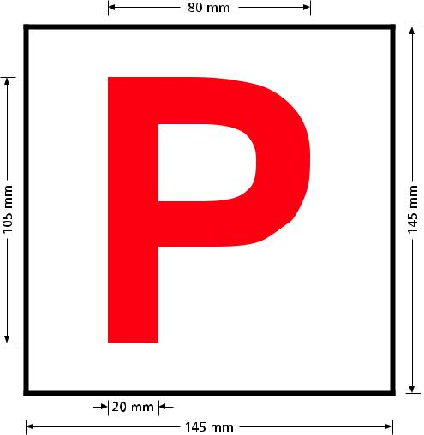

Safer vehicles

Buying a car, whether it’s your first car or not, is a big responsibility.

It is important that your car offers you good protection from injury in a crash

– but it is also important that your car offers good protection to other road users, such as pedestrians, cyclists, motorcyclists or the drivers of other cars involved in a crash.

Choosing a safe vehicle may be one of the most important decisions you will ever make. Driving a car that has recognised safety features and a high safety rating is an essential aspect in ensuring safer travel on our roads.

Buying a safe car doesn’t mean you have to spend a lot of money or sacrifice the look you want. Below is a guide to help make buying a safe car easier.

Safety ratings

It’s important to check the safety rating before you buy a car.

For new and near new vehicles ANCAP (Australasian New Car Assessment Program) undertake crash tests on cars to gauge the level of occupant safety. New car safety is rated on a star system from one to five stars. Pedestrian safety provided by the car is also rated.

For more information on ANCAP star-rated vehicles, visit www.ancap.com.au

For second hand vehicles the Used Car Safety Ratings (UCSR) Buyer’s Guide provides the safety ratings for 197 vehicle models in Australia and New Zealand manufactured between 1996 and 2011. The Used Car Safety Ratings list is derived from reports of actual on-road crashes and represents the ability of the car to protect its driver.

The UCSR Buyer’s Guide (PDF) www.mylicence.sa.gov.au/safe- driving-tips/ safer-vehicles provides you with the crash safety rating for used cars.

You can use safety ratings systems to compare the safety of different brands or models when buying a car. Ensure safety features are given priority when you decide to buy.

Even though a safer car will increase your safety in the case of an accident, it is your responsibility as a driver to maintain safe driving habits to prevent accidents occurring.

76

Buying a safe car

Safety features that may significantly reduce the risk of death or serious injury if you are involved in a crash include:

Service SA Customer Service Centres

Hours of business: Monday, Tuesday, Thursday and Friday 9am to 5pm,Wednesdays 9.30am to 5pm

Registration and Licensing enquiries Call 13 10 84

- crumple zones

- collapsible steering columns

- reinforced door frames

- front, side, curtain and knee airbags

- seat belts designed to work with airbags.

An increasing number of cars are being equipped with safety features that can help you avoid a crash and these should be considered when purchasing a used car.

Some of these features are:

- Electronic Stability Control (ESC)

- Anti-lock Brake System (ABS)

- traction control

- brake assist.

Young Drivers – My First Car

The My First Car Checklist (www.mylicence.sa.gov.au/safe-driving-tips/safer-vehicles) is a comprehensive list of safety features to help you evaluate the safety of the car you are potentially buying. You should buy the highest safety

Metropolitan

Adelaide 108 North Terrace,

Adelaide 5000

Elizabeth Shop 42, North Mall,

Elizabeth Shopping Centre,

Playford Boulevard

Elizabeth 5112

Gawler Cnr Cowan & Murray Streets,

Northern Market Complex,

Gawler SA 5118

Marion 1 Milham Street,

Oaklands Park 5046

Mitcham 15-17 Princes Road,

Torrens Park 5062

Modbury 116 Reservoir Road,

Modbury 5092

Port Adelaide 64 Dale Street,

Port Adelaide 5015

Prospect-Enfield Northpark Shopping Centre

264 Main North Road,

Prospect 5082

Regency Park Kateena Street,

Regency Park 5010

Seaford Meadows 760 Grand Boulevard,

Seaford Meadows 5169

Tranmere-Firle Tranmere Village,

172 Glynburn Road,

Tranmere 5073

Country

Berri 29 Vaughan Terrace,

Berri 5343

Kadina 10 Digby Street,

Kadina 5554

Mount Gambier 11 Helen Street,

Mount Gambier 5290

Murray Bridge 19 Seventh Street,

Murray Bridge 5253

Naracoorte 14 Butler Terrace,

Naracoorte 5271

Port Augusta 9 Mackay Street,

Port Augusta 5700

Port Lincoln 73-75 Tasman Terrace,

Port Lincoln 5606

Port Pirie Flinders Arcade,

72-80 Ellen Street,

Port Pirie 5540

Whyalla 171 Nicolson Avenue,

Whyalla Norrie 5608

www.sa.gov.au

What happens next?

rated car that you can afford.

The Price Comparison Guide (www.mylicence.sa.gov.au/safe-driving-tips/safer-vehicles) provides a comparison of vehicles based on price and ANCAP rating.

If you are using a family car you should drive the safest car in the family.
Note: You must advise the department within 14 days of changing your address or penalties apply.

Visit ezyreg.sa.gov.au for the following services:

• Register your vehicle • Change your address

• Order number plates • Renew your driver’s licence

- Vehicle check

- Fee calculator

77


MR195

07/18

smarter
safer, |  |  | here
 | start |  |  | .au
drivers |  |  |  | .au
 |  |  | .gov
 |  | .sa
mylicence

So, you’ve got your Driving Companion and you’re ready to learn to

drive. But, hang on.

Before you ask for a driving lesson…you need to get your head

around your journey to getting your licence, and how you can be a

safer, smarter driver.

mylicence.sa.gov.au will guide you through your L’s and P’s, and all

the way to your full licence, with heaps of tips along the way.

Plus, subscribing to mylicence will give you helpful safe driving

advice as well.

So, before you get the car keys…get onto mylicence.sa.gov.au

safer, smarter drivers start at

4

mylicence.sa.gov.au

