the PARENT’S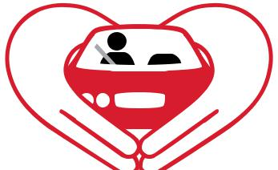
supervised driving program

For the parents of teen drivers

— a requirement for teen licensing
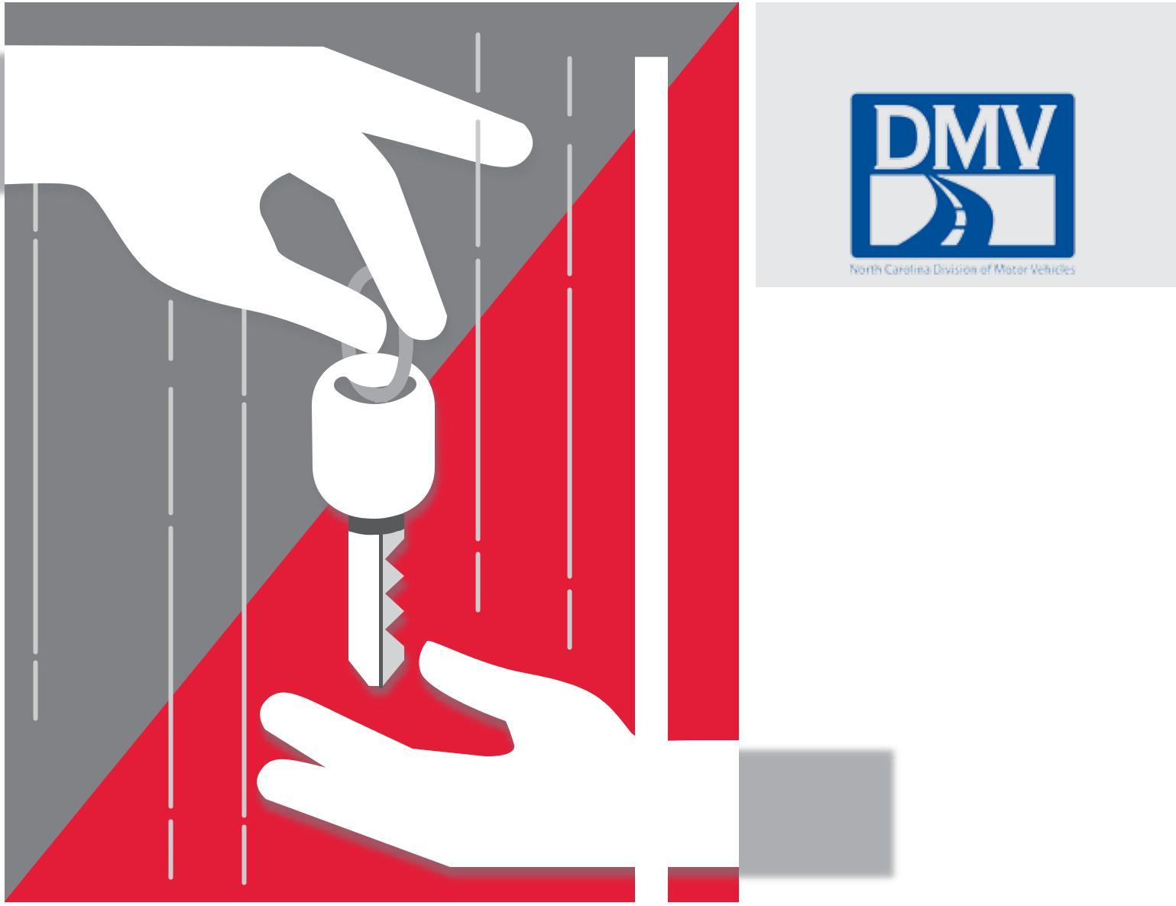

A PROGRAM OF THE NORTH CAROLINA

DIVISION OF MOTOR VEHICLES

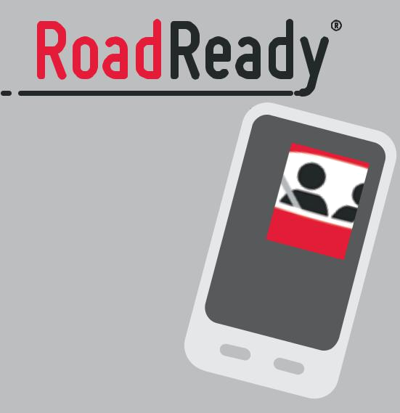

Log your

practice driving

and export your

driving history.

Easy, accurate,

educational.



DOWNLOADOURFREE

MOBILE APP

#RoadReady


WITH SUPPORT FROM

Improving parents’ and

teen drivers’ experience

behind the wheel

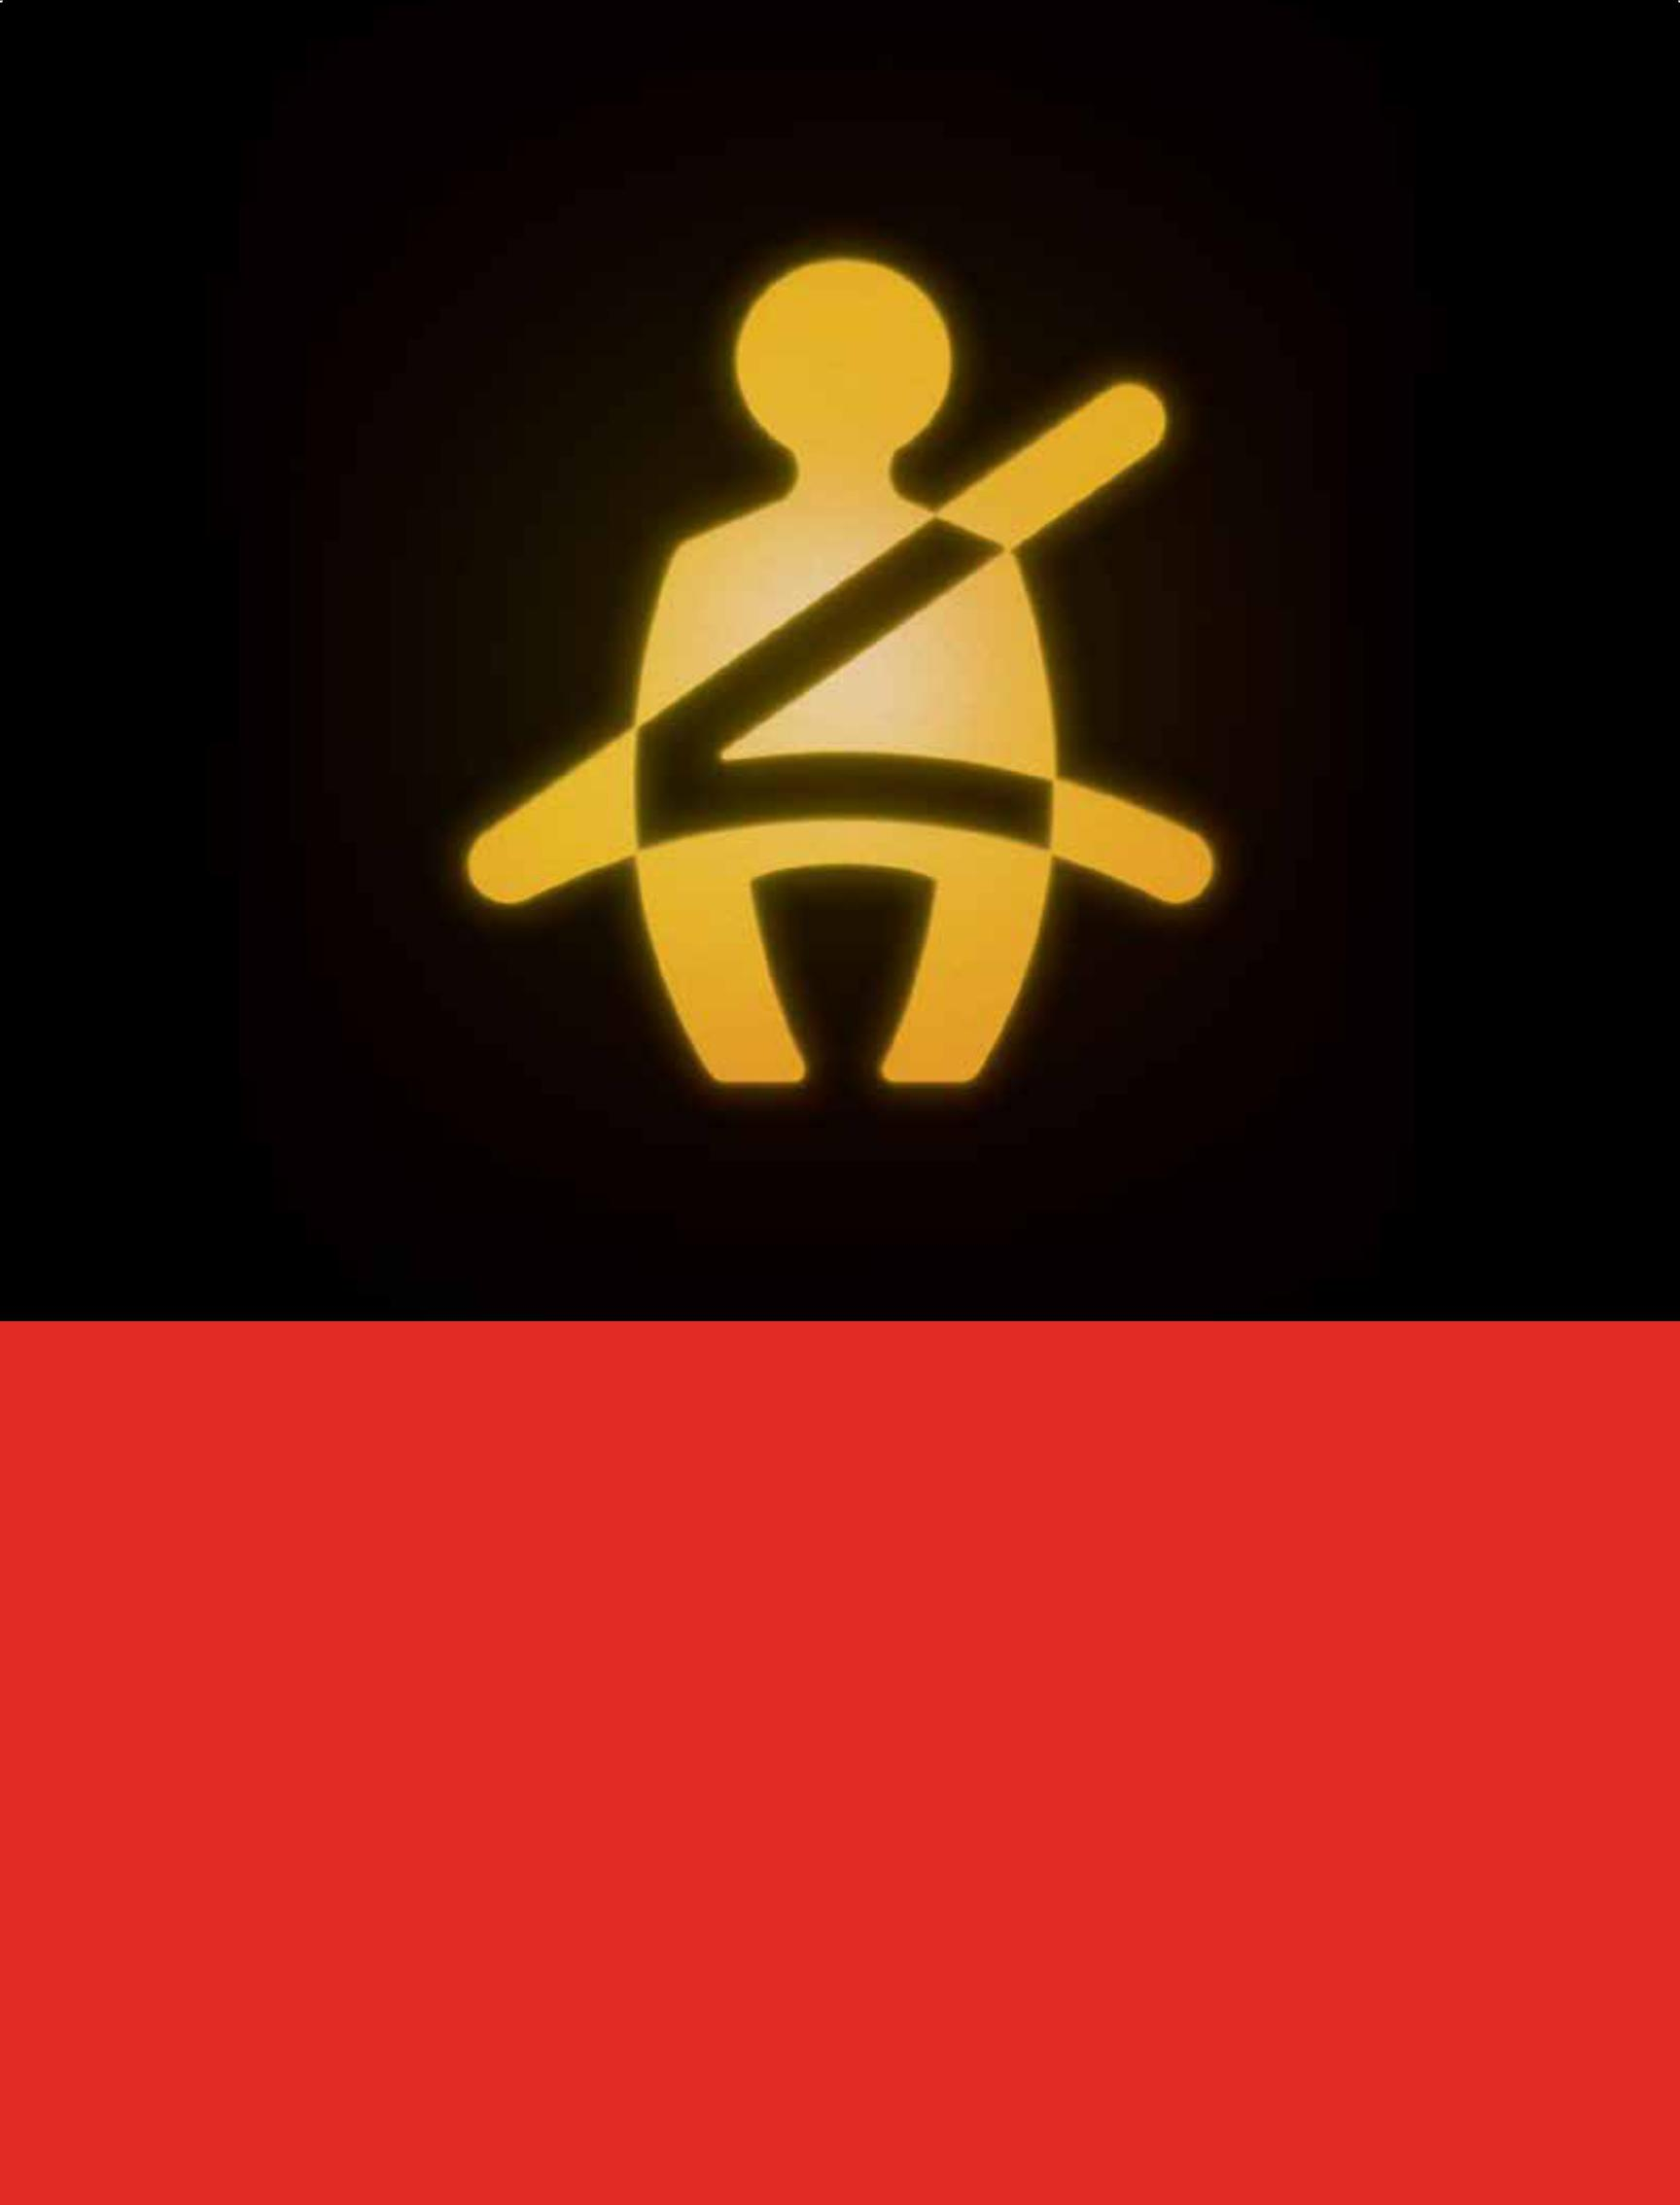

From car seat to driver’s seat.

It’s hard to believe they’re already in the driver’s seat, but one thing hasn’t changed – how much you want to keep them safe. Talk to an agent about our teen driver safety programs and insurance discounts, or get a quote at statefarm.com®. It’s just another way we’re here to help life go right.TM

State Farm Mutual Automobile Insurance Company
State Farm Indemnity Company
Bloomington, IL

State Farm County Mutual Insurance Company of Texas
Richardson, TX

1701321

NORTH CAROLINA DIVISION OF MOTOR VEHICLES

A Message to Parents and Guardians from N.C. DMV

Welcome to the Parent’s Supervised Driving Program.

Thank you for helping your teen become a resourceful, responsible and respectful driver.

These traits have never been more important than they are today. With your help, your teen driver will learn how their actions affect others on the road and recognize ways to prevent accidents.

Your time supervising your young driver is critical. You help them learn to put away their cell phone while they drive. You help set boundaries for avoiding distractions -- boisterous friends in the car, the radio, texts, and phone calls.

This booklet helps parents take an active role in their child’s driving education.

It is designed to assist supervising drivers in documenting young drivers’ time and practice on driving logs that are required by North Carolina’s graduated licensing program.

Thank you for your efforts to teach your child safe, responsible driving behavior. You are helping to keep our highways safe for everyone and preparing your child for a lifetime of success on the road.

Roy Cooper

Governor

James H. Trogdon, III

Secretary of Transportation
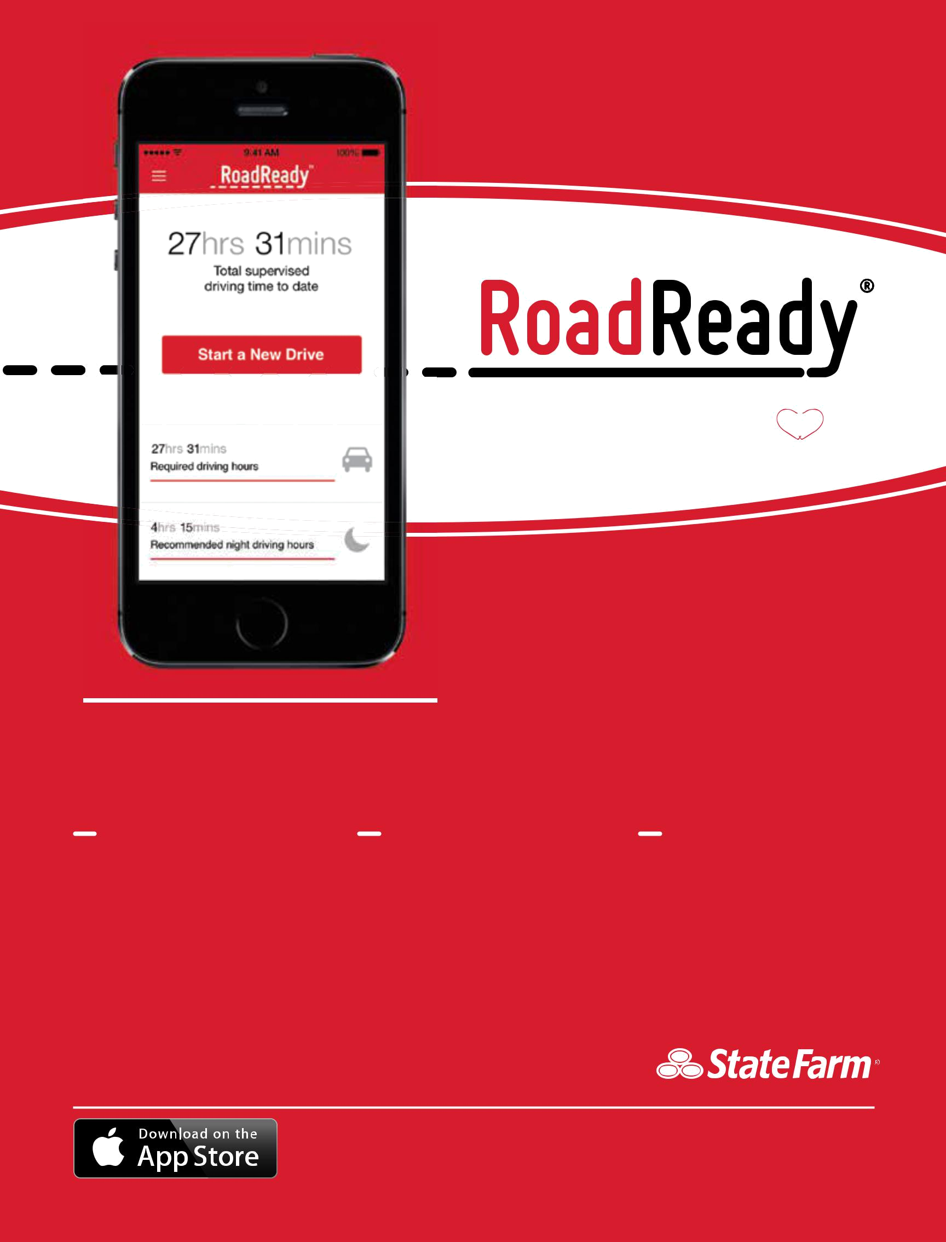
@PSDP_Info thank you!

I love this app so much.

- Twitter Follower

A component of
the PARENT’S 

supervised driving program

Download our FREE mobile app

to log your Learner’s Permit practice driving.

SMART | SOCIAL | SYNC
Log your drives, including | Share drives and | Connect one teen driver’s
driving conditions (road | accomplishments with | practice drive time across
type and weather), | friends on social networks | mutiple phones by using
driving notes, state | with RoadReady’s social | the same log-in on each
requirements & more. | sharing options. | device.

WITH SUPPORT FROM

LEARN MORE AT ROADREADYAPP.COM

Apple, the Apple logo and iPhone are trademarks of Apple Inc., registered in the U.S. and other countries. App Store is a service mark of Apple Inc.

Sponsor message

A driver’s license is a huge milestone in your teen’s life, and one to be celebrated. As a parent, it can also leave you feeling concerned about your child’s safety. State Farm® chose to be a part of The Parent’s Supervised Driving Program to help parents guide a new generation of drivers to become safer, confident and more experienced every time they’re behind the wheel.

State Farm understands that motor vehicle injuries are one of our country’s most important public health problems. In fact, car crashes are the #1 killer of teens, and the first few months of unsupervised driving are the most dangerous.1 As the nation’s leading auto insurer,2 State Farm has been an integral part of landmark teen driver research to help us and others understand how so many of these car crashes can be avoided. We’ve also learned new drivers need and want parental involvement. By providing teens with significant practice on a variety of driving skills and conditions, parents can make a huge impact in keeping the roads safer for everyone.

Through continued research and funding, State Farm is committed to preventing injuries and saving lives. We also work with national and local organizations to bring ongoing attention to auto safety issues and legislation. Across the U.S., more than 18,000 State Farm agents are making a difference too, by increasing awareness around safe driving and the impact new drivers have on the roads.

We encourage you to read this program guide and know that you will make a difference in your teen’s safety, wherever the road takes them. Together, we can make this milestone a real celebration for your child and you.


- – https://www.cdc.gov/motorvehiclesafety/teen_drivers/teendrivers_factsheet.html

- – https://www.statefarm.com/about-us/company-overview/company-profile/fast-facts


About this program

Developed by Safe Roads Alliance, a non-profit dedicated to promoting safer driving through education for drivers of all ages,

The Parent’s Supervised Driving Program is designed to improve teen driver safety by providing parents and guardians with a methodical approach to teaching the requisite driving skills. Each lesson concentrates on a particular sequential skill. Parents are in the best position to help their teens become safe, smart, and skilled drivers.

The Parent’s Supervised Driving Program also includes a website, social media pages, and a mobile app, RoadReady®.

Publisher: Safe Roads Alliance - info@saferoadsalliance.org

Illustrator: Lou Eisenman

Thanks to the following for help in developing this program: Jeff Larason, Travelers Marketing, In Control Family Foundation, Colleen Kelly Carr and Lisa Kennedy-Cox.

Special thanks to Terry Fuller, Charlotte Boyd-Malette, Jennifer Keel, Paula Windley and at the North Carolina DMV.

Published in association with the North Carolina Division of Motor Vehicles with support from State Farm®.

State Farm and the State Farm logo are registered trademarks of State Farm Mutual Automobile Insurance Company.

Copyright © 2017 J.F. Griffin Publishing and Safe Roads Alliance. All rights reserved.

Printed in the United States of America.

Produced by J.F. Griffin Publishing.
the PARENT’S 

supervised driving program

Welcome parents of teen drivers!

The Parent’s Supervised Driving Program is a resource for parents to utilize when teaching their teen to drive.

1. This program is divided into core driving skills.


• Read through each section at home before your teen starts a new skill.

2. Log your driving time. This can be done 2 ways:

• Carry this printed guide with you during the drive and use the printed log section – you or your teen can log the supervised driving hours once the drive is finished.



• Download and use the free  app to track your driving time. RoadReady tracks your teen’s driving hours until you reach the state requirements. Download for free on the App StoreSM.

3. Turn in your log when applying for your license.

This program is also available online at:

PSDPonline.com

Stay Connected with Us!

Follow The Parent’s Supervised Driving Program for expert driving articles, program launch events and additional safety resources.

Facebook


www.facebook.com/ TheParentsSupervisedDrivingProgram

Twitter


www.twitter.com/PSDP_Info

Instagram


www.instagram.com/roadreadyapp


NORTH CAROLINA DIVISION OF MOTOR VEHICLES

Table of contents

Notes for parents/guardians

About supervising teen drivers. . . . . . . . . . . . . . . . . . . . . . . . . . . . . . . . . . . . . . . . . . . 1

Vehicle control for supervisors. . . . . . . . . . . . . . . . . . . . . . . . . . . . . . . . . . . . . . . . . . . .2

Distracted driving and more. . . . . . . . . . . . . . . . . . . . . . . . . . . . . . . . . . . . . . . . . . . . .3

Skills

Skill one: before you start the engine. . . . . . . . . . . . . . . . . . . . . . . . . . . . . . . . . . . . . . . .4

Skill two: moving, steering and stopping. . . . . . . . . . . . . . . . . . . . . . . . . . . . . . . . . . . . . .5

Skill three: how close are you? . . . . . . . . . . . . . . . . . . . . . . . . . . . . . . . . . . . . . . . . . . . .6

Skill four: backing up. . . . . . . . . . . . . . . . . . . . . . . . . . . . . . . . . . . . . . . . . . . . . . . . . 7

Skill five: driving on a quiet street – part one . . . . . . . . . . . . . . . . . . . . . . . . . . . . . . . . . . . 8

Skill five: driving on a quiet street – part two.. . . . . . . . . . . . . . . . . . . . . . . . . . . . . . . . . . . 9

Skill six: looking ahead. . . . . . . . . . . . . . . . . . . . . . . . . . . . . . . . . . . . . . . . . . . . . . . 10

Skill seven: turning around . . . . . . . . . . . . . . . . . . . . . . . . . . . . . . . . . . . . . . . . . . . . . 11

Skill eight: parking – part one. . . . . . . . . . . . . . . . . . . . . . . . . . . . . . . . . . . . . . . . . . . 12

Skill eight: parking – part two. . . . . . . . . . . . . . . . . . . . . . . . . . . . . . . . . . . . . . . . . . . 13

Licensing for drivers 15-18. . . . . . . . . . . . . . . . . . . . . . . . . . . . . . . . . . . . . . . . . . . . . 15 Supervised driving log. . . . . . . . . . . . . . . . . . . . . . . . . . . . . . . . . . . . . . . . . . . . . . . 16

Skill nine: multi-lane roads – part one. . . . . . . . . . . . . . . . . . . . . . . . . . . . . . . . . . . . . . . 21

Skill nine: multi-lane roads – part two. . . . . . . . . . . . . . . . . . . . . . . . . . . . . . . . . . . . . . . 22

Skill ten: city driving – part one. . . . . . . . . . . . . . . . . . . . . . . . . . . . . . . . . . . . . . . . . . 23

Skill ten: city driving – part two. . . . . . . . . . . . . . . . . . . . . . . . . . . . . . . . . . . . . . . . . . 24

Skill eleven: highway driving – part one.. . . . . . . . . . . . . . . . . . . . . . . . . . . . . . . . . . . . . 25

Skill eleven: highway driving – part two. . . . . . . . . . . . . . . . . . . . . . . . . . . . . . . . . . . . . . 26

Beyond the basics

Continuing education. . . . . . . . . . . . . . . . . . . . . . . . . . . . . . . . . . . . . . . . . . . . . . . . 27

Practice in other conditions . . . . . . . . . . . . . . . . . . . . . . . . . . . . . . . . . . . . . . . . . . . . 28

Teens’ biggest dangers. . . . . . . . . . . . . . . . . . . . . . . . . . . . . . . . . . . . . . . . . . . . . . . 29

Sharing the road. . . . . . . . . . . . . . . . . . . . . . . . . . . . . . . . . . . . . . . . . . . . . . . . . . . 30

Sharing the road with bicyclists and pedestrians. . . . . . . . . . . . . . . . . . . . . . . 31

Your opinion matters

Take our program survey and tell us about your experience.

www.theparentssuper-viseddrivingprogram. com/survey

WITH SUPPORT FROM


NOTES FOR PARENTS/GUARDIANS

Stay Focused


At the start of each driving lesson with your teen, leave your problems behind — and make an effort to stay focused. Don’t bring up touchy subjects such as grades, homework, boyfriends/ girlfriends, and anything else that might distract either of you from the task at hand.

About supervising teen drivers

The Parent’s Supervised Driving Program gives you a simple, easy-to-follow plan you can use to help your teen be a safe and responsible driver.

Some thoughts as you begin this exciting experience together:

Make an effort to enjoy the learning process: Driving is a big step toward independence, and your teen is entering a new phase of life. You’ll both remember this experience for years to come. Make it a good memory!

Practice makes perfect: Studies show that the risk of a crash diminishes with experience. The more time you can spend driving with your teen, the less likely it is they’ll crash when they begin driving alone. Driving in a variety of circumstances is equally important. While using this program, you should drive on all types of roads. Make sure your teen gets exposure to a variety of roadways, and in different conditions as well: at night; in rain, fog, and snow; and in heavy and light traffic.

Be a driving role model: It’s not enough to say, “Do as I say.” Children imitate their parents’/guardians’ behavior, so your driving should set a good example for your teen to emulate. Be sure that you:
- Obey all traffic laws.

- Correct any unsafe driving habits (driving aggressively, rolling through stop signs, accelerating through yellow lights, speeding, etc.).

- Refrain from using your cell phone or texting while driving.

Tips for teaching your teen

- Seat belts must always be worn properly by everyone in the vehicle.

- Before each session, discuss the goals of the day’s lesson.

- Before each new lesson, review what was learned during the previous lesson.

- Keep instructions simple and concise. Say where to go and what action to take. For example: “Drive to the corner and turn right.”

- The feedback you give should be calm, precise, and immediate. Be patient and alert at all times. Remember to give positive feedback when your teen succeeds!

- When your teen makes a mistake, which will happen often, do not criticize. Remain calm and simply repeat the maneuver until it’s done correctly. To minimize their frustration, emphasize to your teen that mistakes are a normal part of learning.

- These lessons should be consistent with what is taught by your teen’s driving instructor. If you teach something differently, your teen will be confused and learning will be more difficult. If the lessons in this program are different from the instructor’s, contact them to clarify the discrepancy.

- Remember that students learn at different paces. Make sure your teen has mastered each skill before you move on to the next lesson, even if that means repeating a lesson several times. Patience and practice will pay off in the long run.

- Integrate night driving into as many lessons as possible.

Most importantly, make sure the vehicle you use for training is safe. Confirm that the brakes have been recently inspected, and check to make sure the tires have sufficient tread depth. It’s generally recommended that you do not train in larger vehicles that lack stability control.

1

NOTES FOR PARENTS/GUARDIANS

Vehicle control for supervisors

Teaching a new driver can be stressful, but knowing you have some control can help. Professional driver’s education instructors are taught emergency responses to potential hazards that can crop up with an inexperienced driver behind the wheel. Here are some skills you can learn to help you maintain control from the passenger seat while teaching:

Emergency shifting: In a quiet, large, level, empty area, practice shifting the transmission from drive to neutral.



Taking the wheel: With an experienced driver in the driver’s seat, in a quiet, large, level, empty area, practice steering the car with your left hand from the passenger seat.

Mirrors: Adjust the mirror on the passenger sun visor so you can use it as a rearview
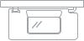

mirror. If the right side mirror is properly adjusted, you can use it to monitor traffic to the rear from the passenger seat.

Awareness: Never assume everything is okay. Always check and re-check mirrors before you give instructions to your teen.


Emergency stopping: Practice stopping the car with the parking brake (if your vehicle’s parking brake is located between the seats). This can be dangerous, even at low speeds, and should only be used as a last resort.
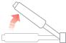

Driving has changed

Chances are, today’s cars are not the same as they were when you learned to drive. To teach your teen effectively, you need to know about a few important recent changes in how cars work, how we drive, and how driving is taught.

Anti -lock Brake System (ABS): Most newer cars offer ABS as either standard or optional equipment. ABS is a dramatic safety improvement that works by letting the tires rotate, rather than lock up, when the brake is engaged. This allows drivers to turn the car in an emergency stop. ABS should be used with firm, continuous pressure. The brakes may shake and grind when applied, which often concerns users – but this is a normal function of ABS. To find out if your car has ABS, check the instrument panel after you turn on the ignition or read the owner’s manual.

Note: When driving a car without ABS, the old rules still apply. Don’t “slam” the brakes. Rather, press the brake pedal firmly. The intention is to stop quickly, but also to avoid locking the brakes and skidding. Skidding causes a loss of control and requires more distance to stop.

Commentary driving

Commentary driving is a great communication tool. Coach your teen to describe their actions, thoughts and observations out loud as they drive, similar to a sports commentator. Throughout the learning process, ask them to verbalize what they see around them, including potential risks and any steps they need to take to avoid those risks.

Arms holding the wheel
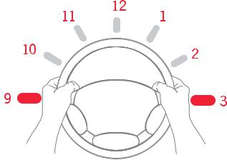
at 9 and 3 o’clock are
not as likely to be hit by
the air bag.

Air bags: Air bags are designed to work with seat belts, which must be worn for the air bags to be effective. Since air bags deploy out of the wheel on impact, it’s important to keep your hands and arms clear.

Steering wheel hand position: Most of us were taught to position our hands at 10 and 2 o’clock on the steering wheel. It’s now suggested that you hold the wheel at 9 and 3 o’clock. This gives you better vehicle control.

2

NOTES FOR PARENTS/GUARDIANS

Eyes on the road


Teens tend to look away from the road and become distracted for longer periods than older drivers. It’s important to train them to keep their eyes on the road ahead. Test your teen on how long they look away when doing various tasks inside the vehicle, such as tuning the radio. Coach them repeatedly on the importance of focusing on the road ahead.

Distracted driving and more

Distracted driving involves any activity, such as cell phone use, that has the potential to distract someone from the task of driving. Distracted driving, alcohol, speeding, and not wearing seat belts can lead to death and injury in crashes. Teens, who are still learning the complex skills of driving, are particularly susceptible to distractions while behind the wheel. Don’t let you or your teen become another statistic. Here are the facts:

- Motor vehicle crashes are the leading cause of death for U.S. teens. Mile for mile, teens are involved in 3 times as many fatal crashes as all other drivers. And 1 in 3 teens who text say they have done so while driving.

- In 2014, 3,179 people were killed and an estimated 431,000 people were injured in crashes involving a distracted driver. That’s an 11 percent increase from the estimated 387,000 injured in 2011.

- A Virginia Tech Transportation Institute study revealed that physically dialing a phone while driving increases the risk of a crash as much as 6 times. Texting is riskier still, increasing collision risk by 23 times.

To combat this growing epidemic, we suggest the following:

- Set a good example: Kids observe and learn from their parents. Put your phone down while driving and only use it when you are safely pulled over. According to the Pew Research Center, 40 percent of teens 12 to 17 say they have been in a car when the driver used a cell phone in a way that put themselves and others in danger.

- Talk to your teen: Discuss the risks and responsibilities of driving and the danger of dividing their attention between a phone call and the road. Show them the statistics related to distracted driving and urge them to share what they learn with their friends.

- Establish ground rules: Set up family rules about not texting while behind the wheel. Enforce the limits set by the Graduated Licensing Program.

- Sign a pledge: Have your teen take action by agreeing to a family contract about wearing safety belts, not speeding, not driving after drinking, and not using a cell phone behind the wheel. Agree on penalties for violating the pledge, including paying for tickets or loss of driving privileges.

- Other dangerous distractions: In addition to cell phone use, distracted driving can include eating, grooming, drinking, listening to or adjusting the radio or MP3 player, using the GPS, talking to passengers, or watching a video, just to name a few activities. Inexperienced drivers are particularly susceptible to these kinds of distractions.

3

SKILL ONE: BEFORE YOU START THE ENGINE

Before you start the engine

Goal: Teach your teen vehicle basics before actual driving begins.

Location: Parked. This is a non-driving lesson.

Lesson one – touring the vehicle

Walk around the outside of the car with your teen. Instruct them to look for leaks and hazards such as broken glass, and to make sure it’s clear behind the vehicle as well as in front of the vehicle.

Have your teen practice these basic skills until they don’t need help:

- Starting and stopping the engine

- Naming and operating all dashboard controls

- Checking oil level

- Checking wiper fluid

- Checking tire pressure

Lesson two – mirror settings

The method below provides the best view of adjacent lanes, for maximum safety.

- Inside mirror: Have your teen sit up straight in the driver’s seat and adjust the inside mirror

so that it frames the entire rear window. This is the main mirror for viewing what is behind the vehicle.

- Left-side mirror: Have your teen lean their head toward the left-side window, and set the left mirror so they can barely see the side of the car. When they sit up straight, the car should no longer be visible in the mirror.

- Right-side mirror: Do the same to the right. Have your teen lean to the right over the car’s center console, and set the right mirror so they can barely see the right side of the car.

Understanding hand signals

It is important for your teen to understand hand signals in case the vehicle signals are not working and to ensure the safe sharing of the road with cyclists.

Proper mirror setting

In the past, drivers were often taught mirror settings that caused overlap between the rear and side mirrors, which was less safe. This is a great opportunity to update your own driving skills while teaching your teen!

Lesson three – checking blind spots

Additionally, teach your teen how to look over their shoulder to check the “blind spot” on each side of the car that cannot be seen in the mirrors.

Lesson four – seating position

The proper seat position is important to safely control the vehicle. Your teen should sit with their back firmly against the seat. There should be at least 10 inches between the steering wheel and the driver’s chest, with the air bag pointing at the chest. The top of the steering wheel should be no higher than the shoulders. Move the seat forward or backward so that the driver’s heel touches the floor and can pivot between the brake and accelerator. Shorter drivers may need a seat cushion or pedal extenders to sit safely 10 inches from the air bag. The head restraint should be at the center of the driver’s head.

The most effective way to deal with blind spots is to briefly turn and look.
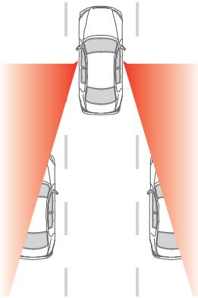

Skill completed

supervisor initials

driver initials

#RoadReady

4

SKILL TWO: MOVING, STEERING, AND STOPPING

Reducing speed


New drivers tend to use the brake too much and the accelerator too little to control speed. Coach your teen about easing up on the gas pedal as a way to reduce the car’s speed.

Moving, steering, and stopping

Goal: Teach your teen to consistently start, stop, and turn smoothly with full vehicle control.

Location: A large, level, mostly empty area.

Everyone in the vehicle must be properly buckled up.

Before starting, coach your teen to always signal and check mirrors and blind spots before changing the speed, position, or direction of the car. Remind them when needed.

Have your teen drive around the perimeter of the lot several times at a slow speed. Have them stop and start frequently, practicing smooth hand-to-hand steering, braking, and accelerating.

Pick several targets in the large, level, empty practice area, and have your teen drive to them at specific speeds. For example, “Drive to the stop sign at 15 mph.” Focus on steady speed and smooth starts and stops.

Once your teen is braking smoothly, practice “hard, smooth stops” at slightly higher speeds (approximately 25–30 mph). Hint: Curling toes back just before braking results in smoother stops. It eases the pressure on the brake.

Lesson one – steps toward turning

Turning right Turning left
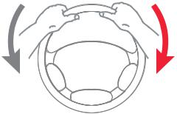
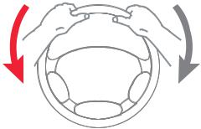

Step 1

Left hand Right hand Left hand Right hand

slides down pulls down pulls down slides down
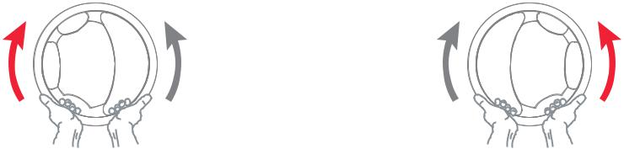

Skill completed

supervisor initials

driver initials

#RoadReady

Step 2

Left hand Right hand Left hand Right hand

pushes up slides up slides up pushes up
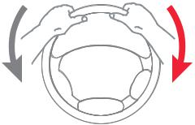
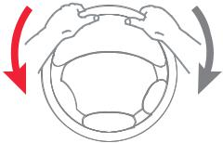

Step 3

Left hand Right hand Left hand Right hand

slides down  pulls down pulls down slides down

With hand-to-hand steering your hands do not cross each other.

Lesson two – turning techniques

- Ease off the accelerator or use the brake to reduce speed before entering a curve; use gentle acceleration to overcome inertia and pull the vehicle out of the curve.

- Use smooth, continuous steering wheel movements when approaching a turn and when returning (sliding) the wheel through the hands until the vehicle is in the proper post-turn position.

- Coach your teen to pick a target near the center of the intended travel path. This target can be used as a visual aid to aim at while steering through turns.

5

SKILL THREE: HOW CLOSE ARE YOU?

How close are you?

Goal: Teach your teen how to tell where their vehicle is in relation to other vehicles or objects.

Location: A large, level, mostly empty area with clearly painted pavement lines and curbs.

Reference points

Explain to your teen that reference points are visual guides to help them judge the car’s distance from curbs, lines, other objects, and vehicles.


Lesson one – driver’s side curb (or line)

Making your
teen safer

View out the front windshield. Reference points will be different for everyone, depending on the vehicle and the height of the driver.
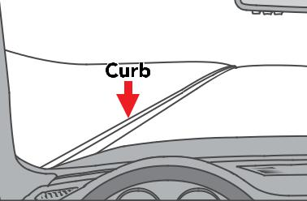
- Choose a pavement curb (or line), and tell your teen that the goal is to pull the driver’s side of the vehicle 6–12 inches away. Coach them to slowly pull up parallel to the line, getting gradually closer, and stop when they think they are 6–12 inches away. Have them look at where the line intersects in the front window.

- Have your teen put the car in park and get out to check if the driver’s side wheels are 6–12 inches from the line. If it’s not the right distance, have them do it again, checking the reference points.

It takes more than

15 minutes every day for six months to complete 50 hours of practice driving. For 100 hours, it’s more than 30 minutes a day for six months. Studies show that the more time you drive together, the safer your teen will be when driving alone.

Lesson two – passenger’s side curb (or line)

View out the front windshield.
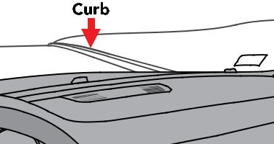
Reference points will be different
for everyone, depending on the
vehicle and the height of the driver.

- Choose another curb (or line) parallel to the passenger’s side, again pulling up slowly to within 6–12 inches. Use the same gradual pull-up method, but for this side, coach your teen to stop when the curb appears to intersect the center of the hood.

- Again, have your teen get out of the vehicle to check whether the tires are 6–12 inches from the curb. Keep practicing and making adjustments, noticing the reference point, until they can do it consistently.

Lesson three – front curb (or line)

View out the driver’s side window.
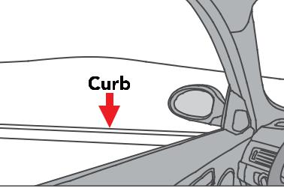
Reference points will be different
for everyone, depending on the
vehicle and the height of the driver.

- Teach your teen to align the front bumper between 6–12 inches from a pavement curb (or line). Have them drive slowly straight toward the curb. Coach them to stop when the curb appears under the passenger’s side mirror.

- Have your teen get out of the vehicle to check whether the front bumper is 6–12 inches from the curb. If not, have them adjust the reference point as needed and keep practicing.

Skill completed

supervisor initials

driver initials

#RoadReady

6

SKILL FOUR: BACKING UP

The driver’s view out of the back passenger window. Reference points will be different for everyone, depending on the vehicle and the height of the driver.

Backing up

Goal: Teach your teen how to safely drive backwards in a straight line and while turning.

Location: A large, level, mostly empty area.

Slow and consistent


Emphasize that backing up must be done at slow but consistent speeds.
It’s harder to maintain control of the car when it’s in reverse.

Lesson one – before moving the vehicle

- Coach your teen that they must turn around and look backwards through the rear window when backing up. Using mirrors or backup cameras doesn’t give a full view.

- Have your teen shift their hips and turn around until they get a good view behind the vehicle. They should drape their right arm over the back of the seat and grasp the top of the steering wheel with their left hand.

Lesson two – backing up in a straight line

- Check all areas behind the vehicle prior to and while backing up.

- Grasp the steering wheel with the left hand and look over the right shoulder through the rear window.

- First release the brake, then use the accelerator gently, and only when necessary, to control speed. Keep it slow.

Lesson three – backing up in a turn

- If turning to the left, grasp the steering wheel with the right hand, or with the left hand if turning to the right. Remind your teen to turn the wheel in the direction they want the car to travel.

- Look in the direction the car is moving through the rear side windows.

- Back into the turn slowly, first releasing the brake, then using the accelerator if needed.

Lesson four – aligning rear bumper to a curb

- Choose a curb (or line) for a target.
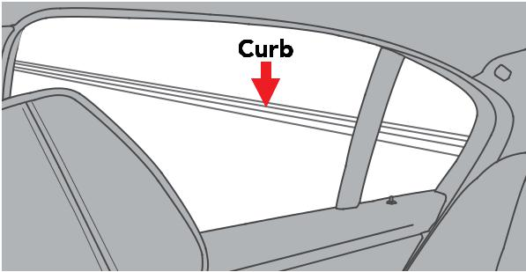

• Have your teen back up toward the target, coaching them to stop when the curb appears near the middle of the rear right window when looking over their right shoulder.

• Have your teen put the car in park and set the emergency brake.

- Have your teen get out of the car to see whether the rear bumper is close to the target.

• If adjustments are needed, have your teen try again, establishing a new reference point.

• Repeat as often as needed until your teen can

consistently come within close proximity to the target.

Skill completed

supervisor initials

driver initials

#RoadReady

7

SKILL FIVE: DRIVING ON A QUIET STREET – PART ONE

Driving on a quiet street – part one

Goal: Teach your teen to move and stop a vehicle safely and with confidence on quiet roads.

Location: Start in a large, level, mostly empty area. Move to a quiet neighborhood street when indicated. Out of respect to our neighbors, please do not use official state road test courses for practice.

Before moving out onto the road, make sure that your teen has reviewed the driver’s manual and is familiar with street signs, signals, pavement markings, and yield and speed laws.


Skill review

Starting in a quiet, large, level, empty area, review the skills learned so far. Have your teen drive several laps around the lot, practicing smooth braking and accelerating, maintaining steady speeds, steering into right and left turns, and using reference points to align the car with curbs (or lines).

Lesson one – commentary driving

Coach your teen to use “commentary driving” (see sidebar on page 2) throughout this lesson, if possible.

Lesson two – lane position

When you and your teen feel ready, move to a quiet street.

With your teen behind the wheel, first have them practice driving straight in three different lane positions. Do this for several miles, practicing each position at least 10 times:

Emergency
vehicles

Make sure your teen understands what to do if they encounter emergency vehicles. First, turn down the radio to listen for the direction of the emergency vehicle(s). Stay calm and pull over to the nearest curb, clear of intersections, and wait for the emergency vehicle(s)

Center position ➊: The most common position, with the vehicle centered within the lane. Coach your teen that they should stay in the center position under most circumstances.

Left position ➋: The vehicle positioned to the left side of the lane. This is best used when approaching a hill or curve.

Right position ➌: The vehicle positioned to the right side of the lane. This is usually done when making a right turn to allow for a safety margin on the left side of the vehicle.

➌
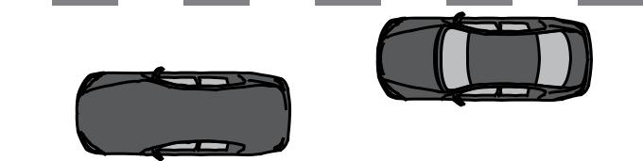

➊ 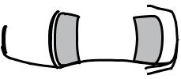



➋

Most driving is done in lane position number one.

to pass.

Lesson three – intersections

Coach your teen on these techniques for safely approaching an intersection:

- Search for vehicles, pedestrians, signs, and traffic signals.

- Check the rearview mirror for any potential hazards behind the car.

- If it’s an intersection with traffic signals, identify who has the green light.

- If turning, put on the turn signal four seconds before making the turn.

- If a stop is required, stop behind the white stop line.

- Select the best lane for the intended direction of travel.

- Yield the right-of-way to pedestrians and other vehicles.

Skill completed

supervisor initials

driver initials

#RoadReady

8

SKILL FIVE: DRIVING ON A QUIET STREET – PART TWO

Driving on a quiet street – part two

Goal: Teach your teen to turn both right and left safely and with confidence on quiet roads.

Location: A quiet block of single-lane roads, ideally without traffic signals at the intersections.

Focus


Most drivers have a tendency to steer in the direction they look. If their eyes move to one side, the car may drift in that direction, too. Remind your teen to focus on a path line in the middle of their travel lane – and not fixate on lane lines or other objects. The rest of the area should be scanned quickly but frequently.

Lesson one – right turns

When your teen is comfortable with lane positions and intersections, it’s time to practice turns. Start with right turns. Have your teen drive clockwise around the block 10–12 times:

- Pick a line at the center of the intended travel path while steering through a turn. Make sure your teen does not fixate on one specific spot, but instead focuses on a broader path.

- Focus on smooth braking into the turn and acceleration out of the turn, as previously practiced in the large, level, empty area.

- Always check mirrors before turns and signal 100 feet before turning.
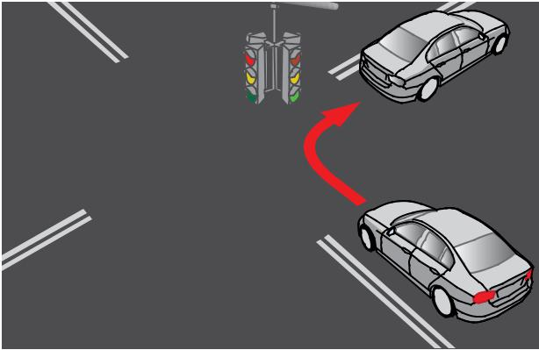

Have your teen drive around the block making right turns
10–12 times. When they are proficient, drive around the

block 10–12 times making left turns.

Skill completed

supervisor initials

driver initials

#RoadReady

Lesson two – left turns

When your teen is proficient at right turns, move on to left turns. Have your teen drive counterclockwise around the block 10–12 times, coaching them on these techniques for safe left turns:

- Position the vehicle close to the yellow line in the middle of the road.

- If there is a stop sign or red light, stop with wheels pointed straight ahead before the stop line, crosswalk or intersection.

- Search the intersection in all directions for vehicles, pedestrians, signs, and signals.

- Select a gap in traffic and pull straight forward toward the middle of the intersection.

Coach your teen to avoid hesitating.

- Use the yellow line on the street being turned onto as a target. Turn into the travel lane closest to the yellow line.

- When the turn is complete, let the steering wheel slide back through the hands.

- Pick a new target 15–20 seconds ahead in the center of the travel path and accelerate gradually.

Be sure to practice with your teen in a variety of conditions, including at night and in inclement weather, as much as possible.

9

SKILL SIX: LOOKING AHEAD

Looking ahead

Goal: Teach your teen to develop defensive driving techniques and higher-level visual and anticipatory driving skills before moving on to more complex driving situations. In order to avoid last-second reactions and spot potential hazards, have your teen always look 12–15 seconds down the road. When they are looking far enough ahead, they will be able to spot hazards early and be well prepared to react to them.

Location: Start on a quiet neighborhood street. Out of respect to our neighbors, please do not use official state road test courses for practice. Move onto a road with light traffic when your teen is ready.

Lesson one – IPDE system

Teach your teen the IPDE system, a simple system to help new drivers recognize, anticipate and avoid risks before they turn into problems. IPDE stands for:

Identify potential risks, like oncoming vehicles, pedestrians, obstacles, or intersections.

Predict when and where there will be a conflict or problem.

Decide on the best course of action.

Execute that action.

Have your teen use commentary driving as they practice the IPDE system. As they drive, ask them to verbally describe their thoughts and actions in order to identify potential risks they see, predict problems these risks could cause, decide what to do to avoid a problem, and then execute the maneuver.

Lesson two – stopping-distance rule

Teach your teen the stopping-distance rule, for the safest distance to stop behind another vehicle. When your vehicle stops, you should be far enough away from the car in front of you that you can see where its tires make contact with the ground. Any closer is too close.

Lesson three – three-second rule

Teach your teen the three-second rule for the appropriate following distance when driving behind other vehicles. The three-second rule is an important safety measure designed to give drivers enough time to safely steer or brake to avoid problems that occur in front of them on the road.

- Start counting when the rear bumper of the vehicle in front of you passes an object.

- Count “one thousand ONE, one thousand TWO, one thousand THREE.”

- Your front bumper should not pass that same object before you’ve reached “three.”

Have your teen practice the three-second rule at least 10–12 times, counting out loud to check whether their following distance is appropriate.
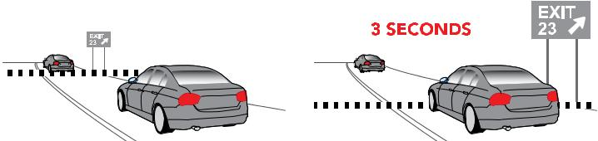

Minimize risks


Rear-end collisions are the most common form of a car crash. Emphasize to your teen that increasing following distance behind other vehicles is the single best thing they can do to minimize the risk of a crash.

Skill completed

Your front bumper should not pass before you’ve reached “three.”
supervisor initials
driver initials
#RoadReady

10

SKILL SEVEN: TURNING AROUND

Turning around

Goal: Teach your teen the best ways to turn a vehicle around in various circumstances.

Location: Start on a quiet neighborhood street with accessible driveways. Please be respectful of neighbors and private property. Move to a multi-lane road for U-turns, if legally allowed in your area.

Legal U-turns


U-turns are illegal in many locations. Make sure you and your teen only practice legal U-turns. U-turns should never be made across a double yellow line or where a sign indicates that they are prohibited.

Lesson one – turning around safely

Start by coaching your teen that the safest and easiest way to turn around is to drive around the block.

Since that’s not always possible, it’s important to practice other ways to turn around.

Lesson two – three-point turns

This is a more challenging turn and your teen needs to understand that it should only be performed when the street is narrow, with good visibility, with no public driveways, when traffic is light, when it’s legal, and when there is no other option.

- Position yourself as close as possible to the right edge of the curb. Signal a left turn. Check for traffic and pedestrians in both directions (including your blind spot). Wait until there is a 20-30 second gap to complete the turn.

- Move slowly and turn the steering wheel quickly to the
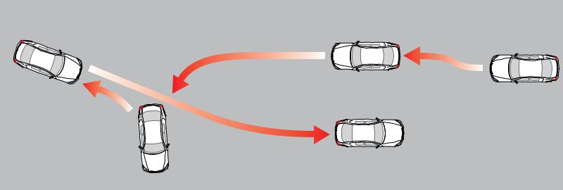
left. This will bring the vehicle
perpendicular to the street | ➋
about two feet from the curb. | ➋
Come to a stop. | ➊
• Turn the steering wheel fully | ➊
• Turn the steering wheel fully | ➌
to the right. Check for traffic | ➌
in both directions (including | Practice three-point turns at least 10 times each.
your blind spot). Shift into

reverse and start backing up,

while looking over your right shoulder.

- Back up to the opposite curb, stopping just before the curb.

- Check again for traffic in both directions (including your blind spot). Signal a left. Shift into drive (or for manual cars, first gear) and accelerate to the proper speed.

Lesson three – U-turns

First explain that U-turns can be very dangerous, and should only be done where they are legal.

- Begin the U-turn in the left lane, closest to the center line or median.

- Be sure there is enough room to make the turn without hitting the curb or any parked cars.

- Signal to indicate the direction of the turn, checking carefully for oncoming traffic.

- Move forward, turning the wheel sharply to turn around.

- Finish the U-turn in the opposite direction and accelerate to an appropriate speed.

Skill completed

supervisor initials

driver initials

#RoadReady

11

SKILL EIGHT: PARKING – PART ONE

Parking – part one

Goal: Teach your teen to master angle and perpendicular parking.

Location: Start in large, level, mostly empty areas. You will need angled and perpendicular spaces.

Before your teen starts parking practice, review “Skill Three: How Close Are You?”

and “Skill Four: Backing Up.”

Lesson one – angle parking

The gentler turn makes this the easiest type of parking for new drivers.

Hint: Choosing a parking spot on the left side of the car can provide more room to maneuver and a better view of traffic when backing out.

Practice makes

perfect

- Signal to indicate intent to turn into a parking space.

- Move forward until the steering wheel is aligned with the first pavement line marking the space.

- Look at the middle of the parking space and turn the wheel sharply at a slow, controlled speed.

- Steer toward the center of the space, straightening the wheel upon entry.

- Stop when the front bumper is six inches from the curb or from the end of the space.

Turn when the front of your vehicle reaches the edge of the space. Stay alert for cars backing out to leave their space.
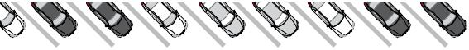
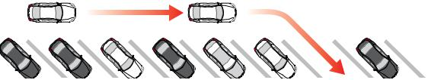

Plan to spend a good amount of time on parking practice with your teen — it’s a difficult skill to learn. Many crashes happen in parking lots, and mastering parking skills is an important way to help avoid collisions. Have your teen practice angle and perpendicular parking 15–20 times each.

- After you’ve parked, put the gear in park for automatic transmissions (for manual transmissions, put the car either in first or reverse) and set the parking brake. Shut off the ignition and remove the key. Check for traffic prior to getting out. Lock the doors.

Lesson two – perpendicular parking

The steps are the same as angle parking, but the sharper turn into perpendicular spaces may require more practice.

Lesson three – exiting parking spaces

- With a foot on the brake, shift into reverse, which will signal that you will be backing up.

Turn when your outside mirror reaches the edge of the space. Always finish with your wheels straight and your car centered in the space.
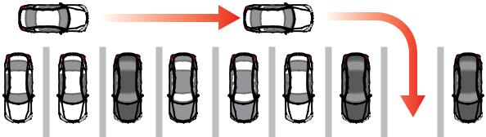

- Turn around to look for oncoming traffic.

- For angled spaces, back up straight until the driver’s seat is even with the bumper of the next vehicle on the turning side. For perpendicular spaces, back up straight until the windshield is aligned with the bumper of the next vehicle.

- Quickly turn the wheel in the direction that the rear of the car needs to go.

- Glance forward to make sure the front bumper is clear of the car on the other side.

- When the front bumper clears the other vehicle, stop, shift into drive, and pull forward to complete the exit.

Skill completed

supervisor initials

driver initials

#RoadReady

12

SKILL EIGHT: PARKING – PART TWO

Parking – part two

Goal: Teach your teen to master parallel parking.

Location: A street with marked parallel parking spaces at a time of day when traffic is light.

Park in reverse


When practicing parallel parking, your teen will probably hit the curb several times. Tell them not to worry – even the best parallel parkers do this often. Coach them to pull out of the space and try again, adjusting their turning angle as needed.

Lesson one – parallel parking

Parallel parking is a difficult maneuver for new drivers, so patience is key. Many drivers never learn to do

it well, especially in areas where it’s not common. Because of the difficulty of learning parallel parking, and because there are several different teaching methods, this skill is sometimes best taught by a professional driving instructor. Assess your own parallel parking skills and your teen’s abilities before

beginning.

 | • Select an available space on the
 | passenger’s side of the car.
 | • Signal when approaching the space and check
 | mirrors for traffic behind the vehicle.
 | • Move forward past the space until lined up
 | directly parallel to the car parked in front, 2–5
 | feet away. Being too close or too far
 | away will make parking more difficult.
 | • With a foot on the brake, shift to reverse
 | and turn around to check for traffic and
 | make sure the travel path is clear.
Start by practicing with cones. | • Release the brake, start backing up slowly,
Start by practicing with cones. | and start to make an “S” turn, turning first
 | right and then left.
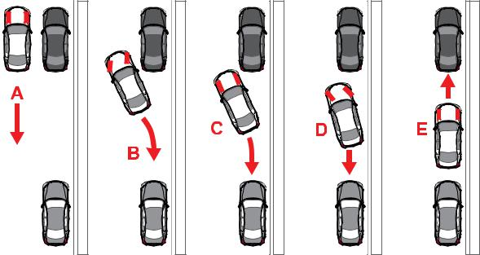

- Glance both forward and backward repeatedly to check the space around the car while turning.

- Once the rear of the car is mostly in the space, start turning in the other direction to straighten out.

- Adjust the vehicle’s position as needed to center it in the space.

- Check to see if the wheels are 6–12 inches from the curb. If not, pull out and try again.

- Always check for passing vehicles and cyclists before you open your door.

Lesson two – exiting a parallel parking space

- With a foot on the brake, shift to reverse, turn around, and back as close as possible to the vehicle behind you.

- Check for traffic, signal, and shift into drive.

- Make sure the travel path is clear, then move slowly forward while steering rapidly out of the space.

Skill completed

supervisor initials

driver initials

#RoadReady

Lesson three – parallel parking on a hill

Always make sure to set the parking brake and leave the vehicle in gear when parking on a hill in a car with a manual transmission. If the car has an automatic transmission, shift into park and set the parking break. You must turn your front wheels in the proper direction to stop it from rolling into traffic if the brake fails. Instruct your teen to turn the front wheels as follows:

- If no curb, turn the wheels inwards, toward the edge of the road.

- If uphill against a curb, turn the wheels outward, toward the travel lane.

- If downhill against a curb, turn the wheels inward, toward the curb.

13



Now, they’re in the driver’s seat.

From mirrors and blind spots to seatbelts and speed, new drivers have a lot to think about. As a parent, you have their safety to think about. One of the best things you can do is set a good example when you’re behind the wheel.

State Farm® wants to help you keep them safe too. Find interactive safety programs, tips and more at teendriving.statefarm.com. Just one more way we’re here to help life go right.TM

State Farm Mutual Automobile Insurance Company
State Farm Indemnity Company
Bloomington, IL

State Farm County Mutual Insurance Company of Texas
Richardson, TX

1701322
LICENSING FOR DRIVERS 15-18

Licensing for drivers 15-18

Limited Learner Permit

- During the first six months, a level one permit authorizes you to drive between the hours of 5 a.m. and

9 p.m., while accompanied by your supervising driver.

- Six months from level one issuance, you are eligible to drive anytime with a supervising driver.

- You must hold this permit for 12 months prior to applying for a Limited Provisional License.

- A Driving Log must be completed detailing a minimum of 60 hours of operation. At least 10 hours must occur during nighttime hours. Only 10 hours per week may be counted towards the 60 hours requirement. The log must be signed by the supervising driver and submitted to the Division at the time of application for the Limited Provisional License.

- All passengers must be restrained by seat belt or child safety seat.

- No one except the driver and the supervising driver are allowed in the front seat.

- You are not permitted to use a mobile telephone or other additional technology associated with a mobile telephone while operating a motor vehicles on a public street or highway or public vehicular area. Exception: You can use it to call the following regarding an emergency situation: an emergency response operator; a hospital, physician’s office or a health clinic; a public or privately owned ambulance company or service; a fire department; a law enforcement agency; your parent, legal guardian or spouse.

NOTE: Before graduating to level two, you must have no convictions of motor vehicle moving violations or seat belt/mobile telephone infractions within the preceding six months.

SUPERVISING DRIVER: A supervising driver must be a parent, grandparent or guardian of the permit/ license holder, or a responsible person approved by the parent or guardian. A supervising driver must hold a valid driver license and must have been licensed for at least five years.

15

NORTH CAROLINA DIVISION OF MOTOR VEHICLES

Supervised driving log

Parents or guardians are responsible for making certain that their teen has completed no less than 60 hours of supervised driving, with 10 of those hours completed at night to advance to Level 2 and 12 hours with 6 of those hours completed at night to advance to Level 3. Sample driving logs to track this time have been made available in this guide. Your local DMV will provide you the applicable log for your phase in the licensing process or you may visit www.ncdot.gov/dmv to download it. The log will help to ensure that your teen has a diverse supervised driving experience. You want your teen to be as prepared as possible for their Junior Operator’s License.
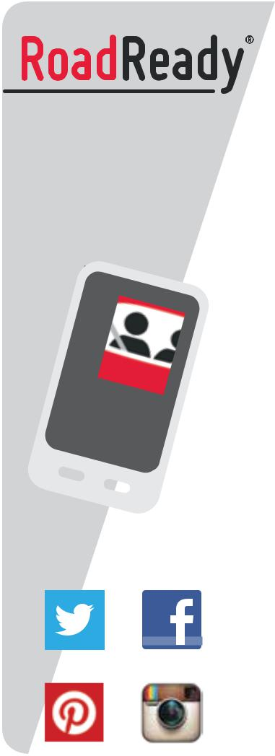

WITH SUPPORT FROM


Log your practice

driving and export

your driving history.

Easy, accurate,

educational.

DOW | NLOAD
OUR | NLOAD
MOBI | FREE
LE APP

#RoadReady


DOWNLOAD

OUR FREE

MOBILE APP

16

SUPERVISED DRIVING LOG

LOG YOUR DRIVES ON THE FORM BELOW

OR DOWNLOAD THE FREE MOBILE APP

Form DL‐4A | 09/2011
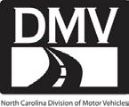

DRIVING LOG TO ADVANCE TO N.C. LEVEL 2 LIMITED PROVISIONAL DRIVER LICENSE

REQUIREMENTS:
- Complete a minimum of 60 hours of driving.
- No more than 10 hours per week may count toward the 60 hours.
- At least 10 of the 60 hours must be at night.

- The log must be signed by a supervising driver and turned in to DMV upon application for the Level 2 driver license.

- A supervising driver must be a parent, grandparent, or guardian of the permit holder or a responsible person approved by the parent or guardian, and must be a licensed driver who has been licensed for at least five years.

Customer Name: |  |  |  |  |  | Customer’s DL Number:
 |  | (Please Print Name)
I |  |  |  | , do certify that the information on this form is true and accurate and is
 | (Print Supervising Driver’s Name)
in accordance with N.C. G.S. 20‐11(d), |  |  |  |  |  |  |  |  |  |  | / | /
 |  |  |  |  | (Supervising Driver’s Signature) |  |  |  |  |  |  | (Date)

Notice: If the Division has cause to believe that a driving log has been falsified, the limited learner’s permit holder shall be
required to complete a new driving log with the same requirements and shall not be eligible to obtain a limited provisional license for six months.

 |  |  |  |  |  | AMOUNT OF |  | SUPERVISING
 |  |  | TIME OF |  | TIME OF | AMOUNT OF |  | SUPERVISING
 | DATE |  | TIME OF |  | TIME OF | DRIVING TIME | SUPERVISING DRIVER’S PRINTED NAME | DRIVER’S DL
 | DATE |  | DAY |  | NIGHT | DRIVING TIME | SUPERVISING DRIVER’S PRINTED NAME | DRIVER’S DL
 |  |  | DAY |  | NIGHT | (E.G. # HOURS) |  | (Number and State)

17
1
of
2

SUPERVISED DRIVING LOG

LOG YOUR DRIVES ON THE FORM BELOW
OR DOWNLOAD THE FREE MOBILE APP

Form DL‐4A |  |  |  |  | 09/2011
DATE | TIME OF | TIME OF | AMOUNT OF | SUPERVISING DRIVER’S PRINTED NAME | SUPERVISING
DATE | TIME OF | TIME OF | DRIVING TIME | SUPERVISING DRIVER’S PRINTED NAME | DRIVER’S DL
DATE | DAY | NIGHT | DRIVING TIME | SUPERVISING DRIVER’S PRINTED NAME | DRIVER’S DL
 | DAY | NIGHT | (E.G. # HOURS) |  | (Number and State)

Total Day Hours Driven: _ Total Night Hours Driven: _ Grand Total:______________

2
of
2 18

SUPERVISED DRIVING LOG


LOG YOUR DRIVES ON THE FORM BELOW
OR DOWNLOAD THE FREE MOBILE APP

Form DL‐4B | 09/2011

DRIVING LOG TO ADVANCE TO N.C. LEVEL 3 FULL PROVISIONAL DRIVER LICENSE

REQUIREMENTS:
- Complete a minimum of 12 hours of driving.
- At least 6 of the 12 hours must be at night.

- The log must be signed by a supervising driver and turned in to DMV upon application for the Level 3 driver license.

- A supervising driver must be a parent, grandparent, or guardian of the license holder or a responsible person approved by the parent or guardian, and must be a licensed driver who has been licensed for at least five years.
Note: A limited provisional level 2 license allows the license holder to drive without supervision (a) from 5:00 a.m. to 9:00 p.m.,

- when driving directly to or from work, and (c) when driving directly to or from an activity of a volunteer fire department, volunteer rescue squad, or volunteer emergency medical service, if the driver is a member of the organization.

Customer Name: |  |  |  |  |  | Customer’s DL Number:
 |  | (Please Print Name)
I |  |  |  | , do certify that the information on this form is true and accurate and is
 | (Print Supervising Driver’s Name)
in accordance with N.C. G.S. 20‐11(f), |  |  |  |  |  |  |  | / |  | /
 |  |  |  |  | (Supervising Driver’s Signature) |  |  |  |  | (Date)

Notice: If the Division has cause to believe that a driving log has been falsified, the limited provisional licensee shall be required to complete a new driving log with the same requirements and shall not be eligible to obtain a full provisional license for six months.

 |  |  |  |  |  |  |  |  | AMOUNT OF |  | SUPERVISING DRIVER’S |  | SUPERVISING
 |  |  |  |  | TIME OF |  |  | TIME OF | AMOUNT OF |  | SUPERVISING DRIVER’S |  | SUPERVISING
 |  | DATE |  |  | TIME OF |  |  | TIME OF | DRIVING TIME |  | PRINTED NAME |  | DRIVER’S DL
 |  | DATE |  |  | DAY |  |  | NIGHT | DRIVING TIME |  | PRINTED NAME |  | DRIVER’S DL
 |  |  |  |  | DAY |  |  | NIGHT | (E.G. # HOURS) |  | (for times requiring supervision) |  | (Number and State)

Total Day Hours Driven: _______ |  |  | Total Night Hours Driven:_______ |  | Grand Total:_______
1
of
1

19

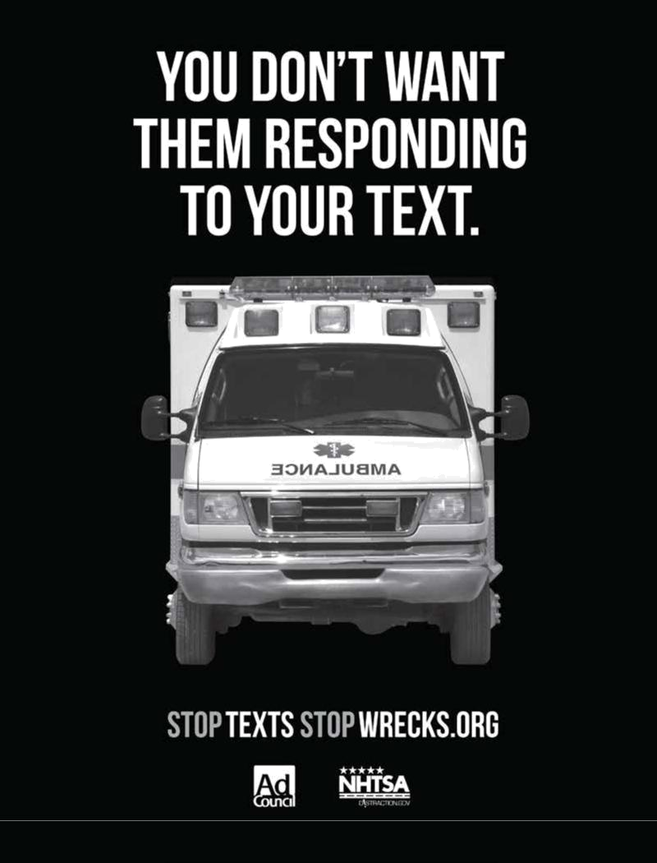
SKILL NINE: MULTI-LANE ROADS – PART ONE

Multi-lane roads – part one

Goal: Teach your teen to drive safely and with confidence on busier, more complex, multi-lane roads.

Location: A busier, multi-lane road. Choose a time with limited traffic, such as a weekend morning.

Reasonable

distance

Motorcycles, bicyclists, and pedestrians are more difficult to see than cars because they are smaller
– and drivers tend to focus on looking for cars.
Traffic, weather, and road conditions require cyclists to react differently than car drivers. It can be difficult for young drivers to judge and predict their actions. Always give them a wide berth.

Skill review

By now, your teen should be comfortable driving on quiet roads. Before starting multi-lane road practice, it’s important to review some key information from previous lessons. The following skills are crucial to safe driving on busier, more complicated roads.

Lesson one – mirror positioning, monitoring and blind spots

Refer to Skills One and Two. Clearly seeing the adjacent traffic is especially important on multi-lane roads. Remind your teen to check the mirror positions when entering the car, and to constantly monitor the traffic around them.

Lesson two – stopping distance

Refer to Skill Six. Remind your teen that when stopping their vehicle behind another one, they should be far enough back to see where the other car’s tires meet the road.

Lesson three – following distance

Refer to Skill Six. Review the three-second rule with your teen, emphasizing that increasing following distance is the single best way to reduce crash risk. This gives the driver visibility, time, and space to avoid crashes.

Lesson four – safe lane changing
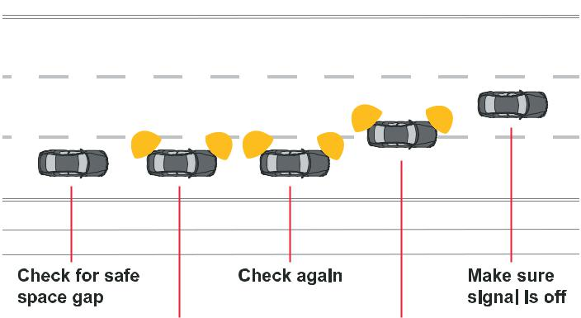

First, coach your teen not to change lanes unnecessarily. Studies show that while it may not look like it, most travel lanes flow at around the same rate. Changing lanes in an effort to save time doesn’t actually save time, but it does increase crash risk.

Ask your teen to list valid reasons to

change lanes. Good answers include:

to make a turn, to avoid an obstacle,

to exit the road, to park, or to pass

another vehicle.

Have your teen practice these lane

change steps 15–20 times:

- Check traffic to the rear and the sides for an appropriate gap.

When changing lanes, always recheck traffic with a glance over the shoulder at the blind spot.



Skill completed

supervisor initials

driver initials

#RoadReady

- Signal to indicate intention to change lanes.

- Recheck traffic, including a glance over the shoulder at the mirror blind spot area.

- Maintain speed or accelerate slightly before and during the lane change.

- Gradually move into the new lane.

- Adjust following distance, using the three-second rule.

21

SKILL NINE: MULTI-LANE ROADS – PART TWO

Multi-lane roads – part two

Goal: Teach your teen to drive safely and with confidence on busier, more complex, multi-lane roads.

Location: A busier, multi-lane road. Choose a time with limited traffic, such as a weekend morning.

Lesson one – right turns

Start with right turns, which are fairly simple. Right turns are always made from the right lane of the current road to the first, open lane of the new road. Look for signs and signals that indicate whether “right on red” is allowed. Practice right turns 10–12 times before moving on to left turns.

Lesson two – left turns

Don’t turn the wheel until you’re ready to make the turn.
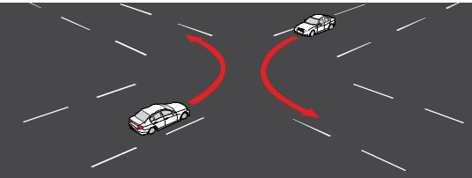

Making left turns


Left turns are one of the hardest maneuvers for teens to master. Be patient. New drivers often

Left turns should almost always begin and end in the closest lane to the right of the yellow line. The yellow line in the lane being turned into should be your teen’s target. There are three types of left turns:
- Protected left turns with a designated left turn lane and left turn signal

- Semi-protected left turns made from a center or shared turn lane

- Unprotected left turns made from an active travel lane

Protected left turns should be made from the designated lane when the left turn signal displays a green arrow, using the yellow line in the lane being turned into as the steering target.

For semi-protected and unprotected left turns, coach your teen on these steps:

- Make sure the vehicle is in the correct lane to make a left turn.

- Signal the turn and begin slowing down at least 100 feet from the intersection.

- Move carefully into the intersection. Don’t turn the wheel until you’re ready to make the turn.

- Yield to any vehicles, bicycles, or pedestrians.

- When there is sufficient space with no oncoming traffic, move ahead into the turn.

- Choose a steering path line in the middle of the closest lane to the right of the yellow line.

Lesson three – safe passing procedures

Discourage your teen from passing other cars unnecessarily. If passing is necessary, the following steps should be observed:

- Position your vehicle more than three seconds behind the vehicle to be passed.

- Check mirrors and blind spots for oncoming traffic.

- Check the passing lane ahead to make sure there’s plenty of space before you try to pass.

- Signal intent to pass and accelerate quickly to match the speed of traffic flow.

- While passing, monitor the space in front of and behind your vehicle and check the rearview mirror for the front of the car being passed.

- When you see the front of the passed car in the rearview mirror and your vehicle is well clear, signal intent, gently and slowly move back to the original lane, cancel the signal, and maintain speed.

have difficulty judging the speed and distances of multiple lanes of oncoming traffic. Practice judging oncoming vehicles’ distance from your vehicle by counting out loud the time it takes for them to reach your car from a designated point.

Skill completed

supervisor initials

driver initials

#RoadReady

22

SKILL TEN: CITY DRIVING – PART ONE

City driving – part one

Goal: Teach your teen to drive safely and confidently in the complex environment of city driving.

Note: City driving takes hundreds of hours, if not several years, to master.

Location: Busy, urban streets. Start at times when traffic is light, moving on to heavier traffic times as your teen gains practice.

Scan first


Keep reminding your teen that constant awareness and looking ahead are the keys
to learning to drive safely on city streets. Emphasize the idea that a green light means, “Scan the intersection first, then go.”

Skill review

Since the busy, crowded environment of city driving is challenging for new drivers,
this is a good time to review key driving skills. The most important skill for drivers is the ability to make good decisions.

City driving forces drivers to make lots of decisions quickly. The three things they need to drive safely in the city are:

- Visibility: To see potential problems in all directions

- Space: To maneuver around obstacles and avoid hazards

- Time: To anticipate risks and make adjustments to speed or position

Looking ahead, identifying and anticipating potential problems is crucial for safe driving.
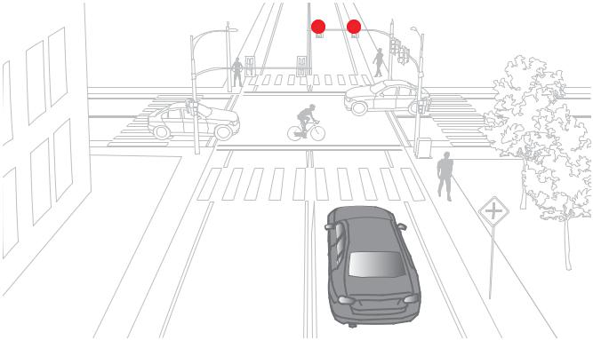

Skill completed

supervisor initials

driver initials

#RoadReady

Lesson one – maximizing visibility and space

As you practice, have your teen focus on making decisions that will maximize visibility and space around the vehicle, increasing the available reaction time.
- Looking ahead (refer to Skill six): Congested city driving leaves very little room for error. Identifying and anticipating potential problems is crucial.

- Covering the brake: Coach your teen that when they spot a hazard, they should “cover” the brake by taking their foot off the accelerator and holding it over the brake. This will prepare them to slow down or stop suddenly. Make sure they don’t “ride” the brake. Riding the brake confuses other drivers and puts unnecessary wear on the brakes.

Lesson two – identifying hazards

As you begin city driving practice, have your teen drive through several blocks to identify and name common hazards on busy, congested streets. Ask them to describe how they will safely deal with each hazard they identify.

Such hazards may include:

- Parked cars, cars entering or exiting parking spaces, and car doors opening

- Delivery trucks stopping suddenly, with drivers racing to and from the trucks

- Buses making frequent stops, loading and unloading passengers

- Blind alleys, with cars or cyclists darting out

- Pedestrians and cyclists moving unpredictably, crossing streets illegally, etc.

- Limited visibility and intersections spaced at shorter intervals

- Aggressive drivers competing for lane space and parking spots

- Stop-and-go traffic flow

23

SKILL TEN: CITY DRIVING – PART TWO

City driving – part two

Goal: Teach your teen to drive safely and confidently in the complex environment of city driving.

Note: This is not a goal that will be achieved in a single session. Spend as much time as possible with your teen practicing safe city driving skills.

Location: Busy urban streets. Start at times when traffic is light, moving on to heavier traffic times as your teen gains practice.

Lesson one – avoiding obstacles

Focus on lane position to avoid obstacles: City driving involves many circumstances in which travel lanes are shared, congested, and partially or fully blocked. During practice sessions on busy city roads, have your teen identify these steps to safely avoid obstacles:

- Identify right-lane obstacles, such as stopped buses, parked cars, delivery trucks, and cyclists.

- Identify left-lane obstacles, such as vehicles waiting to make a left turn, or cars traveling in the opposite direction drifting over the center line.

- Identify the least-congested travel lane. Hint: On a three-lane road, this is usually the center lane.

- Position the vehicle in the lane at the greatest distance possible from any obstacles.

It can be tempting to pass vehicles on congested streets, when obstacles or traffic volume slow traffic. However, this can be dangerous, due to closely spaced intersections, irregular traffic flow, cars entering and exiting parking spots, etc. Coach your teen to avoid passing on busy city streets.

Lesson two – deadly distractions

More is better


City driving skills take a long time to acquire. Spend as much time and drive in as many circumstances with your teen (night, inclement weather) as you are able. Plan trips to less-familiar places where you might not normally travel.

What happens inside the car can

be just as dangerous as what happens outside. Engaging in distracting activities while driving can be deadly, especially for young drivers. Ask your teen to list

dangerous driving distractions. Their answers should include:

- Talking or texting

- Changing radio stations or streaming/shuffling music—or dialing a phone

- Passengers, pets, or objects moving in the car

Remind your teen to stay alert, scan their
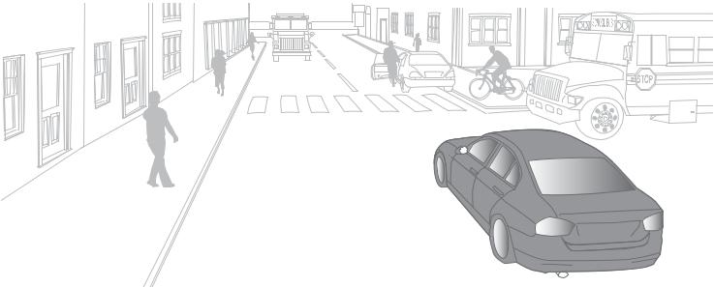
surroundings, and not fixate on any one thing.

- Eating, drinking, or smoking

- Searching for an item

- Intense or emotional conversations

- Putting on makeup or looking in the mirror

Coach your teen to avoid distracting activities whenever possible, but especially in busy, congested environments. Remind them to focus on keeping as much space as possible around the vehicle at all times.

Skill completed

supervisor initials

driver initials

#RoadReady

24

SKILL ELEVEN: HIGHWAY DRIVING – PART ONE

Highway driving – part one

Goal: Teach your teen highway basics and how to safely enter and exit a highway.

Location: Start on a multi-lane highway with easily accessible exits, at a time when traffic is light, such as a weekend morning. Move on to practice at heavier traffic times when your teen is ready.

Worthy of

repetition

Practice merging and exiting 10–12 times each, or more if needed for your teen to feel comfortable. Keep coaching your teen that constant awareness and

Lesson one – observation

Before your teen gets behind the wheel on the highway, have your teen spend some time on highways with you as the driver and your teen as the passenger. Emphasize the importance of looking ahead to anticipate potential problems, and explain key highway features, such as:

- The different kinds of interchanges

- The meanings of highway signs and signals

There is plenty of time to merge. If a gap doesn’t present itself immediately, adjust your speed in order to find one.
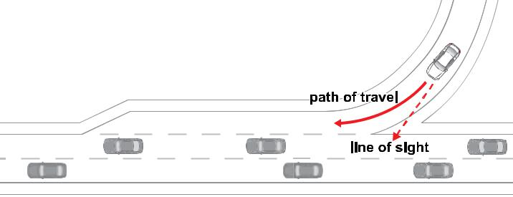

looking ahead are the keys to learning to drive safely.

Skill completed

supervisor initials

driver initials

#RoadReady

- The meanings of different lane lines and markings

Lesson two – on-ramp segments

Explain the three segments of on-ramps, and how they’re used:

- Entrance area: This stretch allows the driver time to search the highway and evaluate how much space they have to enter and what speed is needed.

- Acceleration area: The driver brings the vehicle up to the speed of highway traffic flow.

- Merge area: The driver uses this space to merge into the traffic flow.

Lesson three – merging

Teach the steps for merging onto a highway:

- Check for on-ramp speed signs.

- At the entrance area, make quick glances at the highway, scanning for vehicles and entry gaps.

- In the acceleration area, signal to show intent to enter the highway and adjust speed to match the traffic flow.

- In the merge area, enter the flow of traffic, checking mirrors and blind spots.

- Turn off the turn signal and begin looking ahead to anticipate problems or upcoming lane changes.

- Do not completely stop in the entrance area unless absolutely necessary.

Lesson four – exiting

Teach the steps for exiting a highway:

- Identify the exit well ahead of time.

- Scan traffic for problems when approaching the exit, but don’t slow down on the highway.

- Start to signal four to six seconds before reaching the ramp.

- Upon entering the ramp, tap the brakes and begin rapidly reducing speed.

- Slow down to the posted exit ramp speed limit before reaching the curve.

25

SKILL ELEVEN: HIGHWAY DRIVING – PART TWO

Highway driving – part two

Goal: Teach your teen to maneuver safely in complex highway driving environments at higher speeds.

Location: Start on a multi-lane highway with easily-accessible exits, at a time when traffic is light, such as a weekend morning. Move on to practice at heavier traffic times when your teen is ready.

Lesson one – steering technique
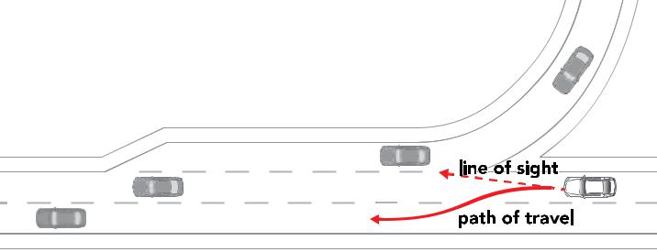

Once on the highway, coach your teen on steering technique. At fast highway speeds, excessive steering can be dangerous and lead to loss of control. Remind your teen to steer gently on highways.

Lesson two – lane changing

In the high-speed, complex highway environment, lane-changing skills are very important. Have your teen spend several miles practicing the

For the first several lane changes you may need to talk your teen through the decision-making process. Double-check all mirrors to make sure that the lane is clear.

Focal point


Early in the training process, parental instruction tends to focus on vehicle handling. As your teen’s skills improve, try to focus on “higher order” instruction, such as scanning ahead, hazard detection, and

lane-changing and passing skills previously learned in “Skill Nine: multi-lane roads,” until they are comfortable performing them at highway speeds. Remind your teen to:

- Watch for merging vehicles and move one lane left to make space for them when needed.

- Change lanes one at a time only.

- Watch mirrors for tailgaters and move to another lane to let them pass.

Lesson three – three-second rule

Review the three-second rule for following distance, learned in “Skill Six: looking ahead.” Additionally, coach your teen to use a four-second rule for these highway driving circumstances:

- Merging onto a highway

- Changing lanes

- Exiting a highway

Lesson four – challenging road conditions

Coach your teen to adjust travel speed and vehicle position based on weather and road conditions. Once your teen is comfortable with and proficient at highway driving in good conditions, spend some practice time on highways under more challenging conditions, such as rain. Coach them to always use appropriate caution, as conditions can change quickly.

anticipating the other driver’s behavior.

Lesson five – road trips

Consider planning some short day trips with your teen to a destination two to three hours away. Have them drive there and back. Find an event or place that you will both enjoy and have fun.

Skill completed

supervisor initials

driver initials

#RoadReady

26

BEYOND THE BASICS

Inspire


Even after your teen is licensed, use your time driving with them to instill habits of good judgment, accurate hazard anticipation, and smart decision-making.

Continuing education

Learning doesn’t stop when your teen has received their license. It’s important to continue teaching and building upon the skills they have learned. As you continue the supervision process, think about these three areas of focus:

- Spend as much time as possible driving with your teen.

- Drive in a wide variety of conditions (weather, time of day, different traffic volumes, etc.).

- Focus on “higher level” learning: scanning ahead, recognizing hazards, and learning to anticipate the behavior of other drivers.

Now that your teen has become proficient in the basic operational skills of driving, it is essential that you ensure they be exposed to a wide variety of driving circumstances and conditions. Make a point of finding circumstances to drive with them that they have not yet experienced, and do it for all types of roads – quiet neighborhood streets, multi-lane roads, and highways. Drive with them at different times of the day, in poor weather, and with varying levels of traffic. It’s much better that they experience these conditions with you, rather than alone or with other teens.

Much of what has been discussed to this point has related specifically to the basic skills your teen will need to be a safe driver. Now, your goal is to ensure your teen is thinking intelligently and making the right decisions as a driver. Sometimes after teens become proficient with the basic skills, parents/ guardians will often “step back,” becoming less involved in their teen’s supervision. But there’s still a lot to learn; their teen’s education is not complete.

Be clear with your teen that the training process is ongoing and that you will continue to provide input into their development so that you both stay in the learning/teaching mode.

Even the best new drivers are likely to make mistakes. These mistakes are great teachable moments for “higher order” instructions. So instead of saying, “Stop sooner,” advise your teen to try to focus on
looking ahead and anticipating events, with an emphasis on good judgment, good decision making, and hazard perception. The shift from a basic comment to a more advanced focus is perhaps the most essential element of educating your teen at this point in the learning process.

As your teen drives, talk to them about specific hazard areas, possible areas of conflict, and blind spots where trouble may hide. Teens tend not to be as good at anticipating these trouble areas as experienced drivers. A good exercise is to have your teen describe the blind spots and possible areas of conflicts they see. It will let you know that they are thinking, anticipating, and driving intelligently.

27

BEYOND THE BASICS

Practice in other conditions

For new drivers, it can be challenging to drive in new and unfamiliar conditions such as inclement weather, different times of day, and varying traffic volume. It’s best that you provide guidance before they experience these conditions on their own.

Night driving

A driver’s reaction depends on their vision, which is limited at night making it difficult to make judgments and see pedestrians, bicyclists, and other obstacles. Some tips to keep in mind:

- Glare from headlights makes it difficult to see. Looking toward the right side of the road and flipping the rearview mirror can help to reduce glare.

- Headlights should be turned on before the sun goes down to increase visibility.

- High beams should only be used when other drivers won’t see them, such as on roads with little traffic.

- To compensate for reduced visibility, drive more slowly and at a greater following distance.

Wet/slippery roads

Coach your teen to practice the following:

- Turn on the wipers as soon as the windshield becomes wet.

- Turn on the low-beam headlights; this helps others see you.

- Drive 5 to 10 mph slower than normal and increase your following distance to five or six seconds.

- Be more cautious, and slow down on curves and when approaching intersections.

- Turn the defroster on to keep windows from fogging over.

Hydroplaning

Hydroplaning occurs as a result of water on the road that is deeper than the tire tread. This reduces friction and can result in the loss of control. If you can see deep water, reflections on the pavement, or the car ahead leaves no tracks on the water, these are indications your car could hydroplane. Slow down.

Fog

Use low-beam lights or fog lights if your vehicle has them. Don’t use high beams – they reflect off the fog causing reduced visibility. Slow down until your speed matches your ability to see, even if it means slowing to a crawl.

Snow

Make sure your vehicle is clear of snow and ice before driving. Driving can cause snow/ice to slide and block your view, or fly off and strike other vehicles.

- When starting to drive in snow, keep the wheels straight ahead and accelerate gently to avoid spinning the tires.

- Decrease your speed to make up for a loss of traction. Accelerate and decelerate gently, and be extra careful when braking.

- Stopping distances can be 10 times greater in ice and snow. Begin the slowing-down process long before a stop. Brake only when traveling in a straight line.

- Look ahead for danger spots, such as shaded areas and bridge surfaces that may be icy when the rest of the road is clear.

- Stay far behind the vehicle ahead so you will not need to come to a sudden stop, which can cause skidding.

Alertness


After becoming proficient in basic driving skills, teens can become overconfident and begin to drive faster, follow too closely, brake abruptly, etc. Gently and continuously remind your teen to stay three seconds back from other vehicles and to always drive with caution.

28

BEYOND THE BASICS

Teens’ biggest dangers

Newly licensed teens crash much more often than older, more experienced drivers. These are the circumstances that are the most common trouble areas for young drivers.

GDL systems


Graduated Driver Licensing (GDL) systems are intended to provide teen drivers with practice under the safest conditions, exposing them to more situations only as their skills and experience grow.

Other teens

Research is clear on the fact that risky teen driving behaviors increase in the presence of teen passengers. A teen who is driving with other teens in the car is more likely to crash. And the more kids there are in the car, the stronger the likelihood of a crash. This is the primary reason many states have passed laws that restrict the ability of teens to drive with their peers.

Seat belts

The unfortunate reality is that teens buckle up far less frequently than adults. Recent studies show that belt use amongst teens is the lowest of any age group, just 76 percent compared to a national average of 85 percent. In fact, the majority (58 percent) of young people 16 to 20 years old involved in fatal crashes are unbuckled.

Drugs and alcohol

Teens are at far greater risk of death in an alcohol-related crash than the overall population. This is despite the fact that they cannot legally purchase or publicly possess alcohol in any state. When alcohol is added to the inexperience of teen drivers, the results can be deadly. Drunk male teenage drivers are 18 times more likely than a sober male teen driver to be killed in a single-vehicle crash. Drunk female teenage drivers are 54 times more likely to be killed than a sober counterpart.

Fatigue

As teens get older their bedtimes get later, but waking times do not tend to change. From age 13 to 19, nightly sleep is reduced by 40–50 minutes. Teen drivers who sleep less than 8 hours a night are 33 percent more likely to crash than teens who get more than 8 hours of sleep. This lack of sleep results in depressive moods, more risk-taking behaviors, and lower grades. It further reduces a person’s ability to process information, be attentive, and have good reflexes, which are all crucial to driving skills. Studies have shown that being awake for 18 hours has a similar impact to having a blood alcohol concentration (BAC) level of 0.08.

Distracted driving

A driver’s primary responsibility when behind the wheel is to focus on the act of driving. Any behavior that distracts from that activity increases the risk of a collision. In this age of electronic communication, the dangers of distractions have increased significantly. Use of electronic devices for any purpose, to send or receive communications, to surf the web, to view images, video, or anything at all, should absolutely be avoided.

Inexperience

Just as it takes years to perfect any skill – athletic, artistic, or otherwise – it also takes years to be a truly good driver. Until teens are much more experienced, they run a greater risk of crashing, being hurt, and potentially dying. A driver’s license makes them a driver. Experience makes them good drivers.

Night driving

For teens, the most severe crashes occur at night and on weekends. Night driving is challenging for all drivers, but novice drivers do not have the experience to anticipate and react when visibility is reduced. When teens drive at night, it is more often with a lack of adult supervision, with other teen passengers, and at high speeds – all of which increase risk.

29

BEYOND THE BASICS

Sharing the road

Sharing the road means being a courteous, alert and knowledgeable driver, making the roads safer for all.

Bicycles, motorcycles, buses, trucks and pedestrians all deserve a share of the road.

Bicycles and Motorcycles

Motorists must be on the lookout for bicycles and motorcycles and anticipate sudden and unexpected moves from them. Motorcycles are entitled to the same full lane width as other vehicles.

Bicycles and motorcycles are smaller, harder to see and can move faster and stop faster than expected. Their control is more easily hampered by road defects and debris. You should watch for bicycles and motorcycles, use extra caution when driving around either and increase your following distance.

Pedestrians

Pedestrians are those people standing, walking or using a wheelchair on public streets, highways and private property. Pedestrians have the right-of-way at crosswalks and intersections whether the crosswalks are marked or not.

Trucks

If you cut in front of another vehicle, you may create an emergency-braking situation for the vehicles around you, especially in heavy traffic. Trucks and buses take much longer to stop in comparison to cars. When passing, look for the front of the truck in your rearview mirror before pulling in front, and avoid braking situations.

Large trucks have blind spots, or “no-zones,” around the front, back, and sides of the vehicle. These No-Zones make it difficult for the driver to see. Avoid being caught in a truck’s no-zone. If you can’t see the truck driver in the truck’s mirror, the truck driver can’t see you.

Be careful of trucks making wide right turns. If you try to get in between the truck and the curb, you’ll be caught in a “squeeze” crash. Truck drivers sometimes need to swing wide to the left in order to safely negotiate a right turn. They can’t see cars directly behind or beside them. Cutting in between the truck and the curb increases the possibility of a crash. So pay attention to truck signals, and give them lots of room to maneuver.

Work zones

Work zones can be very dangerous, especially when traveling on the highway. It’s important to be alert and prepared to slow down or stop in a work zone. Slowing down and allowing others to merge will ensure a safe passage through work zones. Here are a few tips on work zone safety:

- Stay alert: Work zones are busy places where construction vehicles and workers are always moving. Be alert, and stay on the safe path that is designated throughout the work zone.

- Take your cues from trucks: Work zones often pop up suddenly. If you are not paying attention to the signs, you could find yourself in a serious accident. Since trucks have a height advantage and can see ahead of traffic, their brake light activity can provide a good signal of a slow-down or work zone ahead. Truck drivers know the stopping limitations of their trucks and pay close attention to traffic.

- Merge gently: Aggressive drivers can be extremely dangerous while driving in work zones. Work zones require time and courtesy. For a smooth passage through work zones, allow others to merge in front of you. Be especially considerate to trucks. They require more space to merge and are the least maneuverable vehicles on the road.

Source: U.S. Department of Transportation, Federal Motor Carrier Safety Administration

Emergency

vehicles

When you hear sirens and see flashing lights, you should get out of the way as quickly and safely as possible. First, check the traffic around you and slow down. If traffic allows, signal and then pull to the right, clear of an intersection, and stop. Remain there until the emergency vehicle has passed.

30

BEYOND THE BASICS

Sharing the road with bicyclists and pedestrians

- Scan the street for wheels and feet: Be especially careful to look for people walking and biking before turning at intersections and driveways

- Yield to pedestrians: Pay attention to the pedestrian signal and give people walking the right-of-way.

- Double threat: Never pass another vehicle that has stopped or is slowing down for a pedestrian. Remember, you might not be able to see the pedestrian when you approach a stopped vehicle so be aware.

- Watch for bikes: People riding bikes have the right to be on the road (and are often prohibited from riding on sidewalks), so respect their right to be there.

- Passing safely: Stay at least three feet away from bicyclists (and other vulnerable road users, such as garbage collectors, police officers, and tow truck operators) when passing, and don’t return to the right until well clear of the person. If there isn’t enough room to safely pass in the same lane, you must use another lane or wait for a safe opportunity to pass. Do not pass a person on a bike and then immediately turn right.

- Avoid the “right hook”: Look for and yield to people biking on the right when turning right

- Avoid the “left cross”: Look for and yield to people walking across the street and yield to oncoming people on bikes when turning left

- Visibility: Look for bicyclists at night, watch for their reflectors or lights.

- Check blind spots: Watch for bicyclists coming from behind, especially before turning right.

- Doors are dangerous: Before opening your car door or moving, look in your mirror and physically turn your body to make sure no bicyclists are coming. Practice the Dutch Reach.
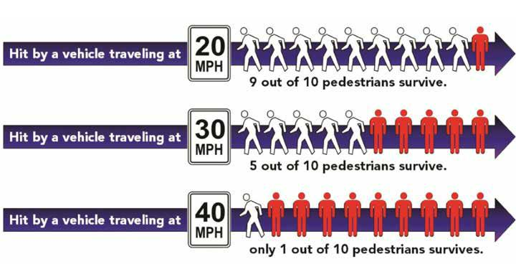

31

NOTES

32

NOTES

33

NOTES

34

NOTES

35

NOTES

36


LOG YOUR DRIVES.

FOCUS ON YOUR TEEN.
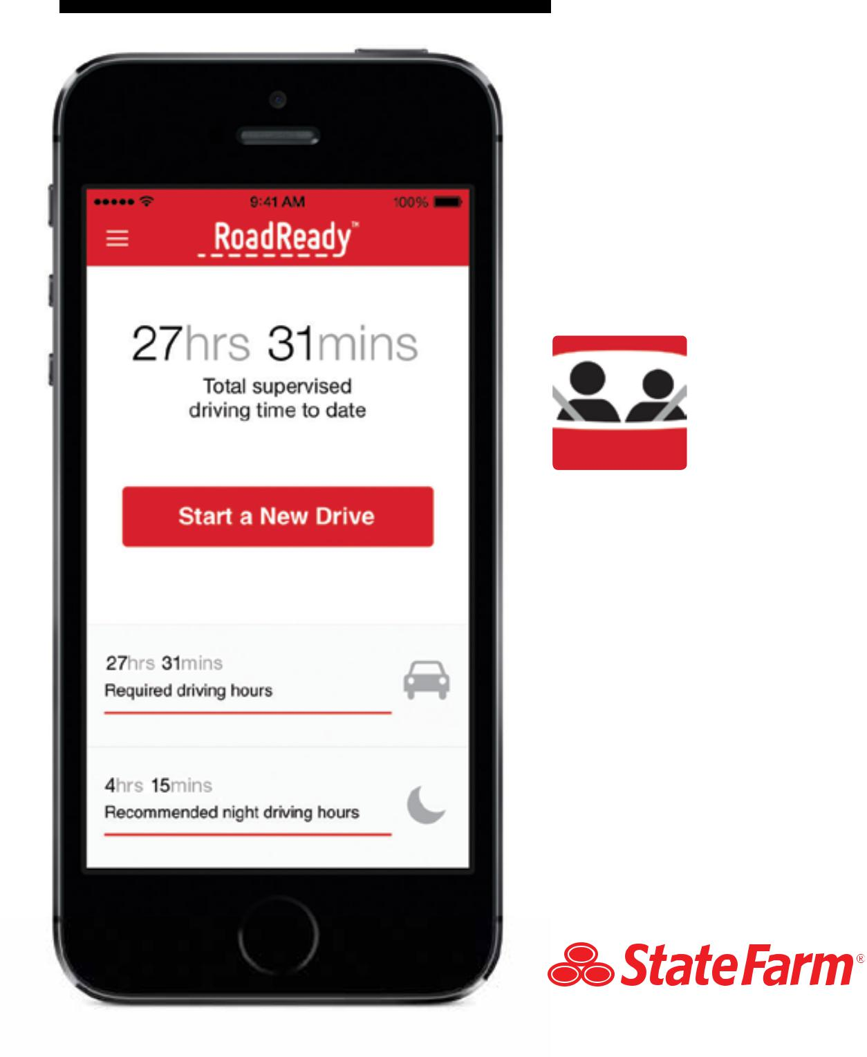

Teaching your teen to drive presents enough challenges. With RoadReady, your focus can remain where it needs to be: on your teen and on the road. “Start a New Drive” and RoadReady will log the rest. Download your log to verify you’ve completed your state requirement.

WITH SUPPORT FROM


A component of

the PARENT’S 
supervised driving program

Apple, the Apple logo and iPhone are trademarks of Apple Inc., registered in the U.S. and other countries. App Store is a service mark of Apple Inc.

