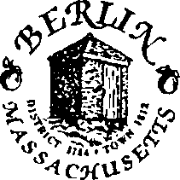
Exit Interview Form/Notification of Termination
Name of Employee: Date of exit interview: _ Employee Supervisor: _

Please be advised that (Name) , Employee # , has terminated employment with the Town of Berlin for the following reasons(s);

Quit, reason unknown
Quit, starting employment elsewhere
Discharged for Misconduct
Failed to meet performance standards
Lack of Work
Employee is retiring
Other:

Do you expect to recall this employee? Yes No

Employee is no longer considered an employee of the Town of Berlin for any reason (not eligible to return at all).
Employee is no longer a permanent employee but may return from time to time as part-time employee in my department.
Employee is no longer employed in our department, but remains working as a town employee in the following capacity:

On-Call Patrolman or Dispatcher
Law Enforcement – Details/Special Duty
Election Worker
Highway – On-call snow plowing/tree removal/storm damage
Call Firefighter
EMT/First Responder
Substitute Teacher
Other:

Effective Date of Termination/Retirement: / /

Has employee been advised of COBRA rights if applicable? Yes No N/A

Items to be returned (where applicable): employee to date and initial:
Keys Computer Equipment
Blackberrry Town Phone
Other items:

Signature of Former Town Employee: Date:

Signature of Supervisor: Copy provided to Personnel Committee (date):
Copy provided to Town Treasurer (date):
Date:

