I am committed to
providing a safe,
supportive and
grace-filled
environment in
which individuals,
couples and families
can address the
situations and
struggles they face
in their lives.
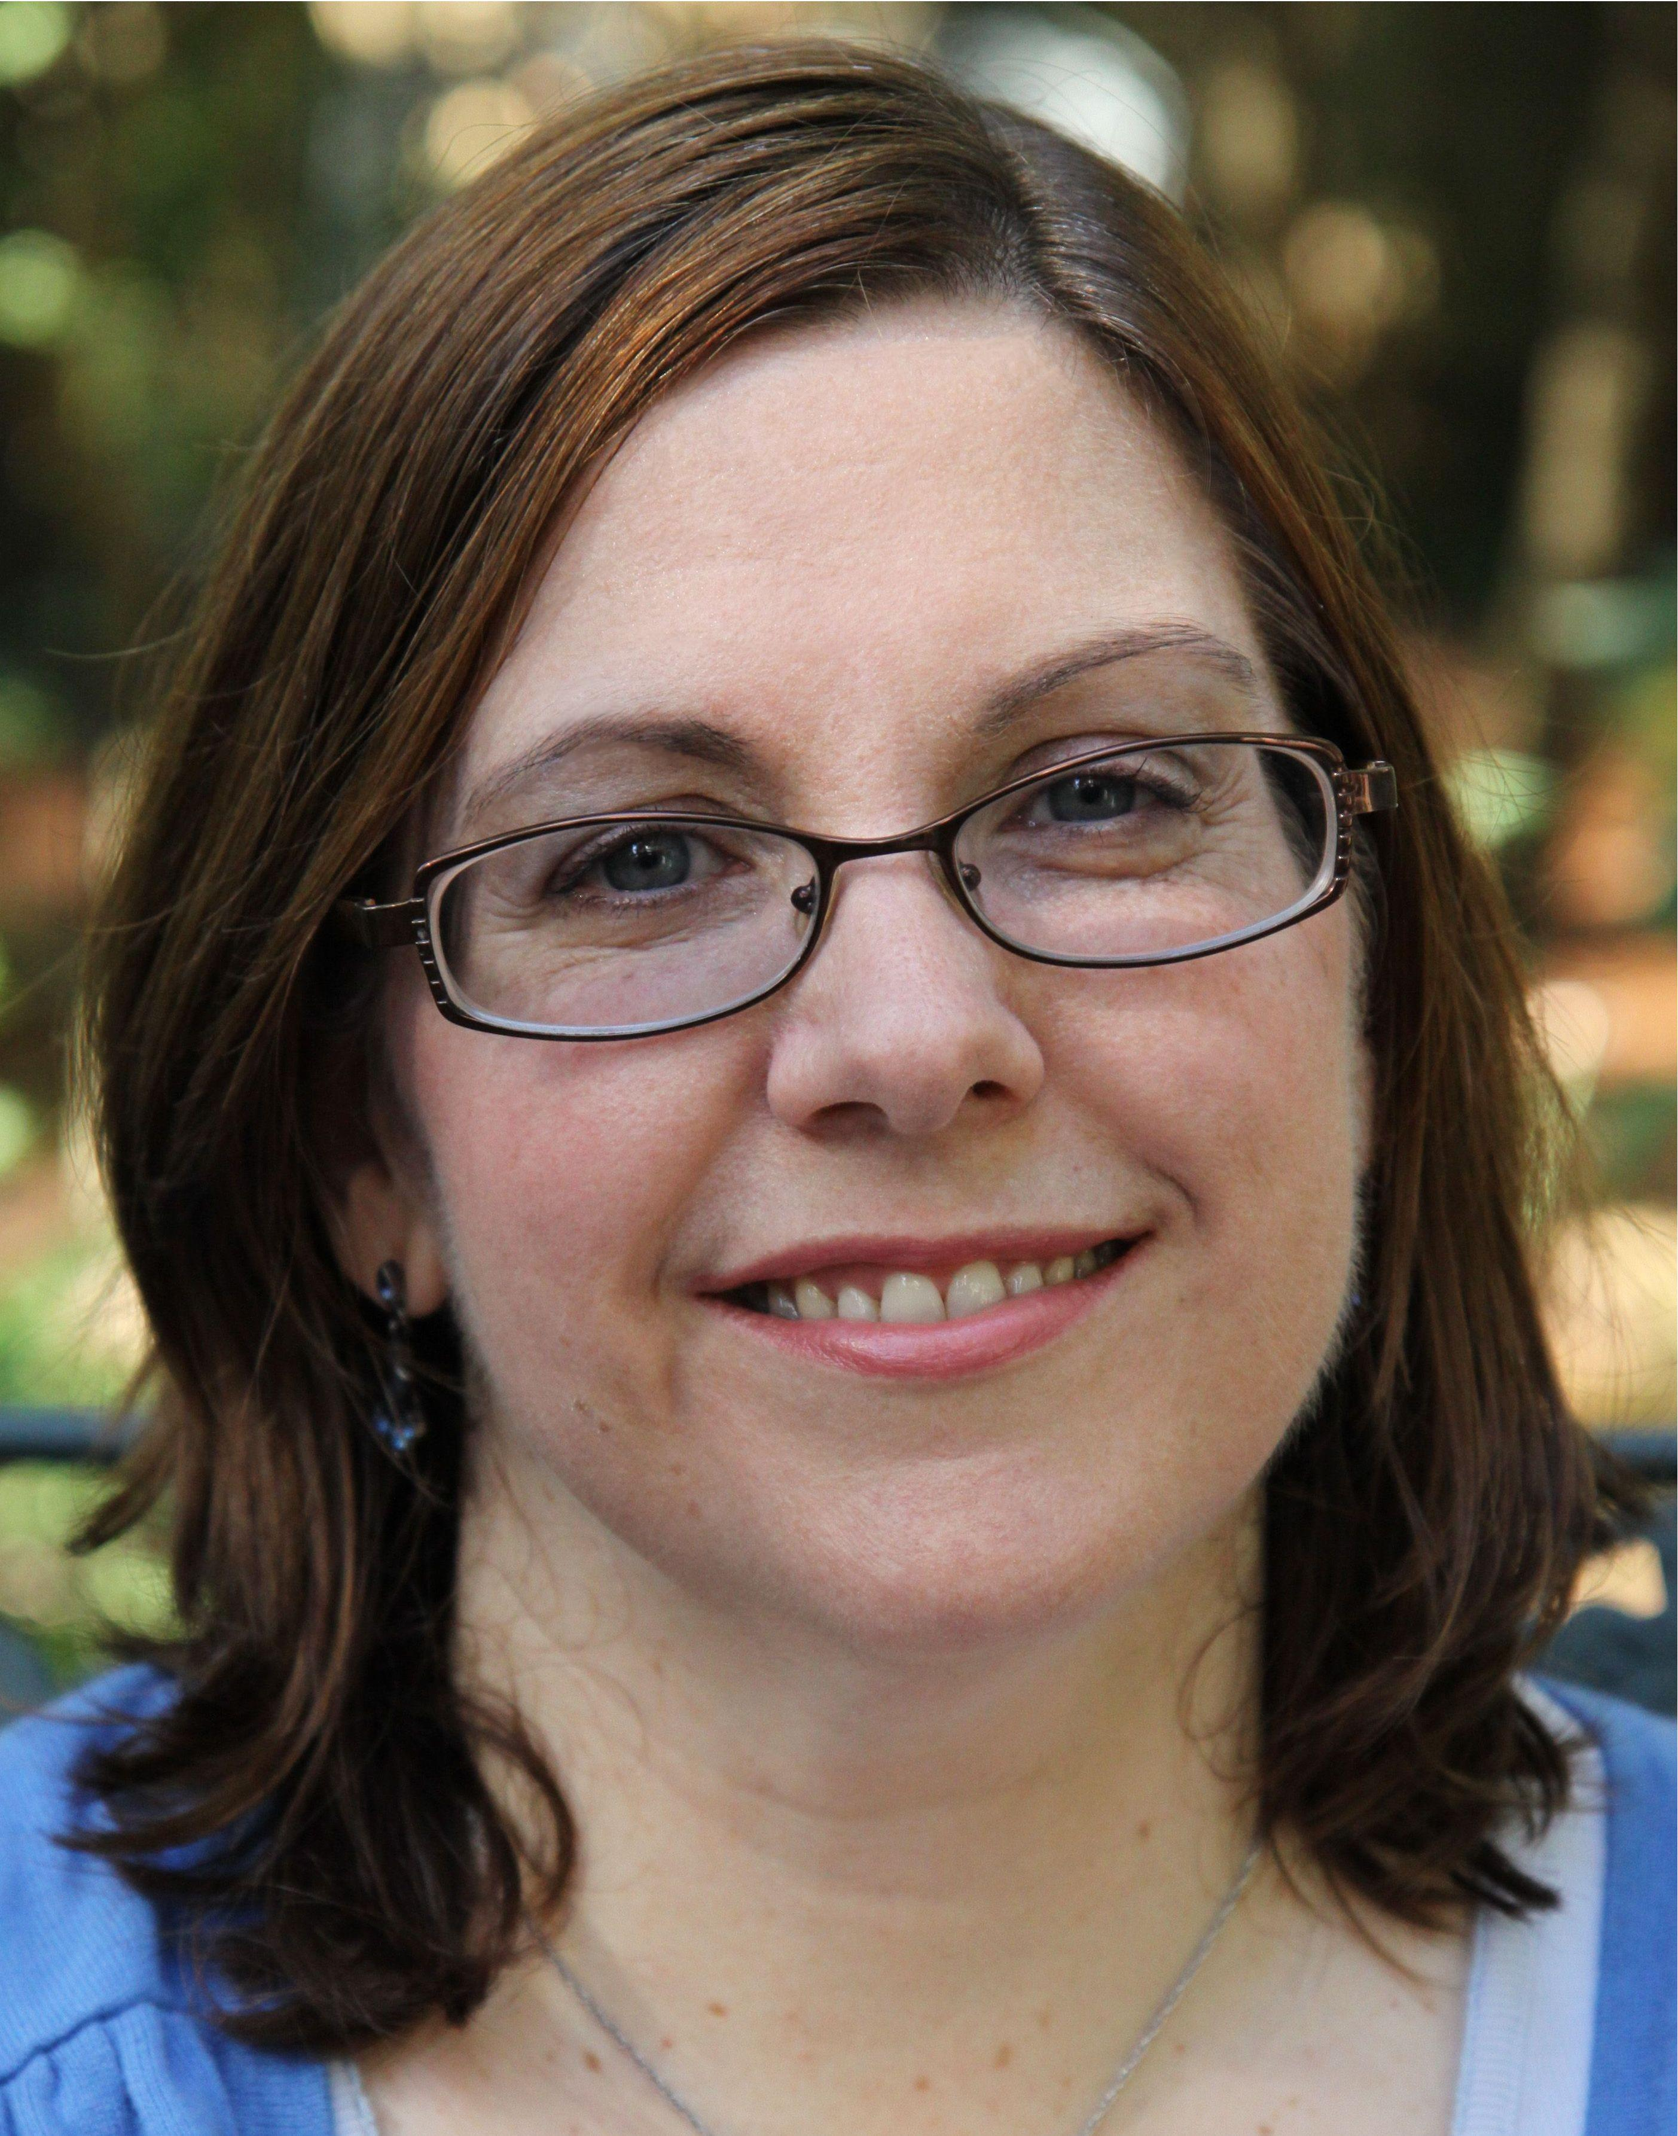

Isaiah 61:1-7

Anne M. Causey, M.A., LPC

26113 Oakridge Dr.
The Woodlands, TX 77380
(832) 492-5068

Anne M. Causey, M.A., LPC

26113 Oakridge Dr.
The Woodlands, TX 77380
(832) 492-5068



Compassion
Growth

Healing



Counseling for Individuals

Support, Insight and Guidance

Sometimes when we experience loss, hurts or major challenges in life we can feel overwhelmed and alone. In individual counseling I strive to provide a warm and supportive environment in which clients can explore their hurts and struggles, as well as receive insight, tools and perspective which promote healing and growth.

Anne M. Causey has 25 years of

professional counseling
experience. She has worked in both the Church setting and in private practice. Mrs. Causey received her Masters of Counseling at Northeastern Illinois University. She has been a member of White Stone Associates in the Woodlands, TX since 2002.

Marriage/Couples Counseling

Restoring closeness and healing
emotional bonds

The special emotional closeness and intimacy couples feel early on in their relationships enable them to commit to one another. But disappointments, hurts and stressful circumstances can leave partners feeling isolated and alone. In couples counseling I work together with you to recognize negative patterns of interacting that are damaging to one another, and to restore feelings of trust, safety and closeness.
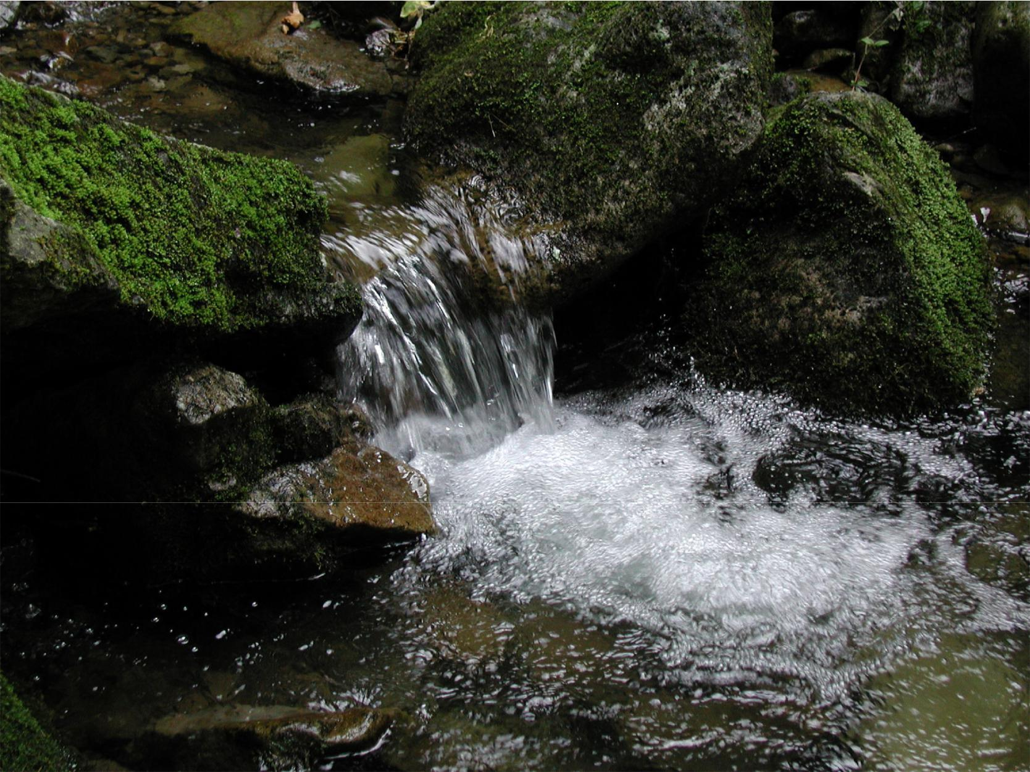

Child & Family Counseling


Fostering healthy relationships between parents and children

The culture we live in presents enormous obstacles for parents and families. My goal in Family and Child therapy is to partner with parents and guide and support children through the unique difficulties each are facing. At the heart of my approach is the belief that healthy and secure family relationships are powerful for the healing and growth of all family members.

If you have any questions about

my services or would like to
schedule an appointment, I

would love to speak with you.
Please feel free to call me at

(832) 492-5068

