Equipment Rental Agreement

To rent the MAPC Sound Equipment for Simultaneous Interpretation, fill out all the information requested, sign the liability agreement on the back of this form and email or fax the form to confirm availability. If you have any questions please contact Blyss Cleveland at bcleveland@mapc.org/617-933-0751.

Renter Information

Organization:

Name of Primary Contact:

Street Address:

City: State: Zip Code:

Email: Phone:

Items Requested & Dates of Rental

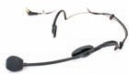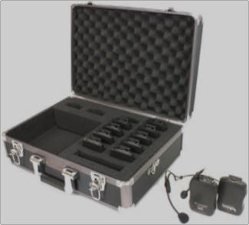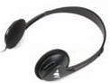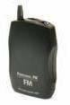MAPC provides Williams Sound Equipment for Simultaneous Interpretation (“Equipment”) for rent. Please check and list the quantity of Equipment requested:

- Transmitter (max. amount: 3) - Quantity:

- Noise Canceling Headset Microphone (max. amount: 3) - Quantity:

- Receiver, 8 Channels (max. amount: 25) - Quantity:

- Folding Headphones (max. amount: 25) - Quantity:

- Large System Case (max. amount: 1) - Quantity:

- Small System Case (max. amount: ) - Quantity:

Rental Period (includes date of pick up and drop off):

Name of person who will pick up and drop off the Equipment:

Location where Equipment will be used:

(Read and sign RENTAL TERMS AND CONDITIONS on back of this form)

Replacement Costs
(Prices dated September 23, 2011 and do not include shipping)

Transmitter - Will PPA T36 Williams Sound 16 channel portable transmitter… $363.00
Noise Canceling Headset Microphone - Will Mic 100 Noise-canceling headset mic $84.75
Receiver Will PPA R35-... 8 Ch. WB 3V Receiver with belt clip, no batteries, no earphone $117.38
Folding Headphones - Will HED 021 Deluxe Folding Headphone $10.88
System Case - Will CCS 030 System Carry Case $149.25

RENTAL TERMS AND CONDITIONS
RENTER hereby agrees as follows:

- RENTER shall keep the Equipment in a good state of repair, normal wear and tear excepted, and is responsible for any damage to, loss or theft of the Equipment occurred during the Rental Period.

- RENTER shall pay MAPC full compensation for replacement and/or repair of any Equipment (transmitters, headsets, receivers and accessories and any components thereof) that may be damaged, lost or stolen during the Rental Period. MAPC’s invoice for replacement or repair costs is conclusive as to the amount RENTER shall pay under this paragraph for repair or replacement.

- RENTER shall not remove the Equipment from the address of RENTER or the location shown herein as the place of use of the equipment without prior written approval of MAPC.

- The equipment shall be picked up by RENTER and returned to MAPC at the RENTER’s risk, cost and expense.

- No allowance will be made for any rented Equipment or portion thereof which is claimed not to have been used. Acceptance of returned Equipment by MAPC does not constitute a waiver of any of the rights MAPC has under the rental agreement.

- MAPC may terminate this agreement immediately upon the failure of RENTER to make rental payments when due.

- MAPC makes no warranty of any kind regarding the rented Equipment, except that MAPC may replace the Equipment with identical or similar Equipment if the Equipment fails to operate in accordance with the manufacturer’s specifications and operation instructions but only if MAPC has available Equipment in its possession. Such replacement shall be made as soon as practicable after RENTER returns the non-conforming Equipment.

- RENTER indemnifies and holds MAPC harmless for any and all injuries or damage due to the use of Equipment and for all consequential and special damages for any claimed breach of warranty.

- RENTER shall pay all reasonable attorney and other fees, the expenses and costs incurred by MAPC in protection of its rights under this rental agreement and for any action taken by MAPC to collect any amounts due to MAPC under this rental agreement.

- These terms are accepted by RENTER upon delivery of the terms to the RENTER or the agent or other representative of RENTER.

RENTER: Date:

